AI for Chemistry Project

The crucial part of becoming a machine learning scientist is developing a working model that addresses a challenge in your field. As a part of the course, you will develop a machine learning model for an application related to your field or your interest. As part of the assignment, you will write a proposal and handed it on 2024-05-02 and you will present your model starting from 2024-06-10. Below are guidelines for the proposal and presentation.

# Machine Learning Model Proposal

For the topic of your choice, you will submit a 1-page proposal for your model. The topics involving your research, or your interests will serve you the best. You will need to state what challenge you are addressing, how you will obtain the data, and a description of your first models. All this may change between the proposal and the presentation. The proposal is meant for you to think about how you will build the model, and for the instructor to give you feedback. Hints: data acquisition is the most time-consuming part of data science. It is recommended that you use existing databases, or extract them from journal articles, or you should choose topics where you can quickly make data. The proposal is due on 2024-05-02 through the Assignments menu in syllabus. Late submission will not be accepted. The proposal should have the following format:

Project Title

The first paragraph should include background and motivation of the proposed project/research.

The second paragraph should be short and contain hypothesis statement about your machine learning model task.

The third paragraph should discuss how you will obtain database and a rough draft of the model architecture.

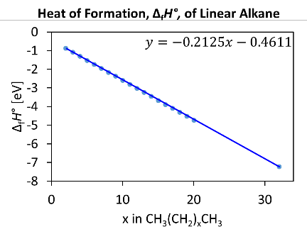

**Figure 1.** You can include a figure to illustrate your proposal. The caption should include a helpful pointers and significance of the figure.

The final paragraph should discuss the expected outcome and its significance. Please copy paste this format and make an edit directly.

# Project Presentation

Each student will give a 15 minutes presentation of your project followed by 5 minutes of Q&A session**.** Detailed guideline is as follows.

## Guideline

* Presentation date: 2024-06-10 ~ 2024-06-13
* Presentation time: 15 minutes. You will lose 10% of the grade for going overtime.
* Submission: please upload your presentation on Assignments menu
* The presentation should be broken down into the following sections:
  + Introduction: background of your work, motivation, and prior work
  + Objective: introduction summary and goals of your work
  + Method: dataset, how you obtained your dataset, data representation, model architecture, other technical details including training and validation
  + Results: challenges in model development and model performance
  + Conclusion: summary, and future work
* Keep the presentation professional.