深圳大学考试答题纸
二○二三～二○二四学年度第 二 学期 2024年5月10日
课程编号 | 2801000049 | 课序号 |  |  |  | 课程名称 |  | 机器学习 |  | 主讲教师 |  | 评分
学 号 | 2022280327 |  | 姓名 |  | 古炜 |  | 专业年级 |  | 22电子信息工程

Indicate the method I use to solve the problem：
Minimum heap:（最小堆）
The minimum heap is a binary tree structure where the value of each node is less than or equal to the value of its child nodes. In this code, we use the minimum heap to store the distance between each person and others, and keep the pile always with the closest five distances. The benefit of doing this is that we can efficiently find everyone's closest friends. By maintaining the closest five distances in the heap, we can ensure that only the closest five friends need to be retained in each calculation, without sorting or comparing all possible friends.
Distance calculation:（距离计算）
To determine the distance between each person and others, we used a simple absolute value function abs() to calculate the distance between positions.
Visualization:（可视化）
Finally, we used the Matplotlib library to achieve visualization. Matplotlib is a Python drawing library that can be used to create various types of graphics, including scatter plots, line graphs, and more. In this code, we use Matplotlib to draw the position of each person and their relationship with their closest friends, so that the results can be visually displayed in a graphical manner.

problem-solving process
(1). Create data structure:
We first defined a list of people, which includes each person's name and their position on a number axis.
(2). Calculate distance:
Next, we traverse each person and calculate the distance between each person and others. Here, we use the absolute value function abs() to calculate the distance.
(3). Use minimum heap:
For each person, we used a minimum heap to store the five people closest to them. Here we use the heapq module in Python, which provides an implementation of heap data structures. We first create an empty heap of closest_friends, and then for each other person, calculate the distance and add it to the heap.
(4). Select recent friends:
When there are more than five elements in the heap, we delete the top element (i.e. the farthest friend) to ensure that the five closest friends are always retained in the heap. In this way, the elements in the pile are always the closest five people between the current person and others.
(5). Visualization:
Finally, we use the Matplotlib library to visualize each person's location and their relationships with recent friends. We use a scatter plot to represent the position of each person.

visualization results:
Each person's five friends and distance:
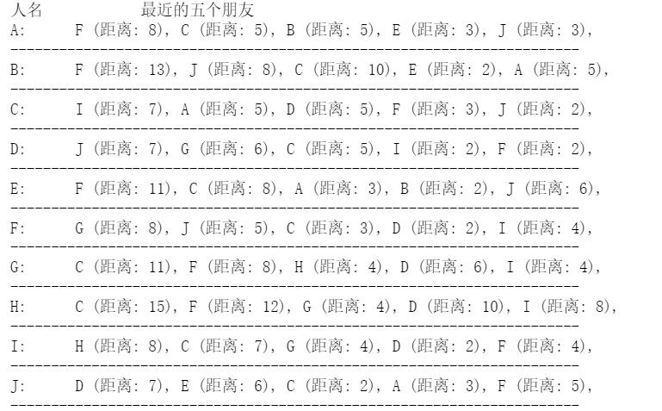
Everyone's positional relationship:
