Exercise sheet 02

1.1: DalCTF 2026
1.1.2.web.
1.1.2.web.1: Challenge “Baby Web”

I generated the site, got to it, saw a large text, pressed CTRL + SHIFT + C to open Dev tools, save a paragraph with hidden=”true”, which I then opened, and it had the flag in it.
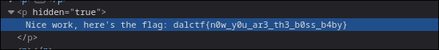
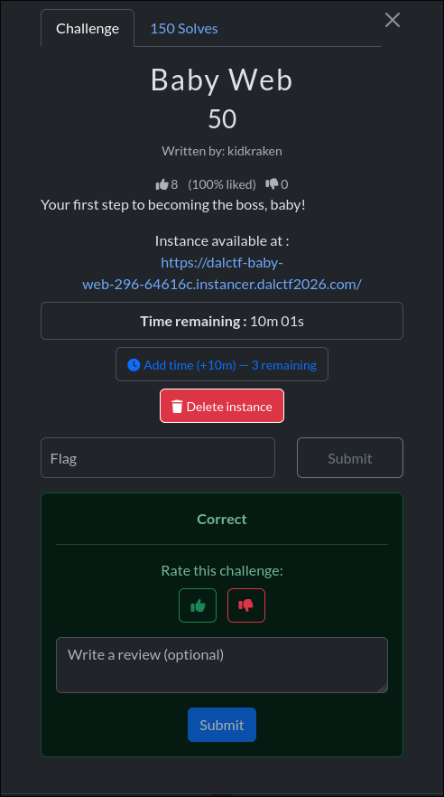

1.2: GPN CTF 2026
1.2.2.web.2: Challenge “Fancy food notifications”
I entered a webhook as URL, which then got me the Authorization Bearer Token, which I then decode with the HS256 algorithm, so that I can encode a payload with “vip”: true, “id”: <its id> and can create a second order with the newly encoded payload and key @127.0.0.1\@<some website>/../vip-meal to get to the vip meal flag.
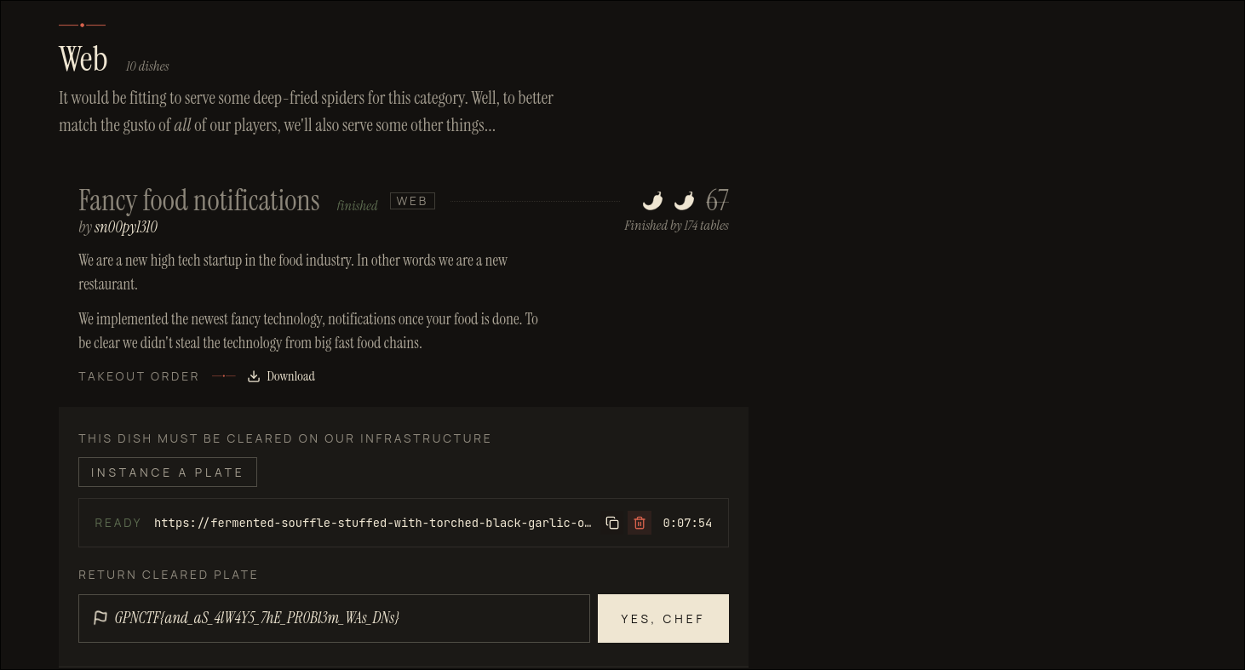

1.2.2.misc.pwning: Challenge “Recipe for Disaster”
I inspected the C code, saw that the note has a max size of 32 characters, I repeated the procedure until it got to an overflow and resulted in a negative price so that I could get a coupon with the flag in it.
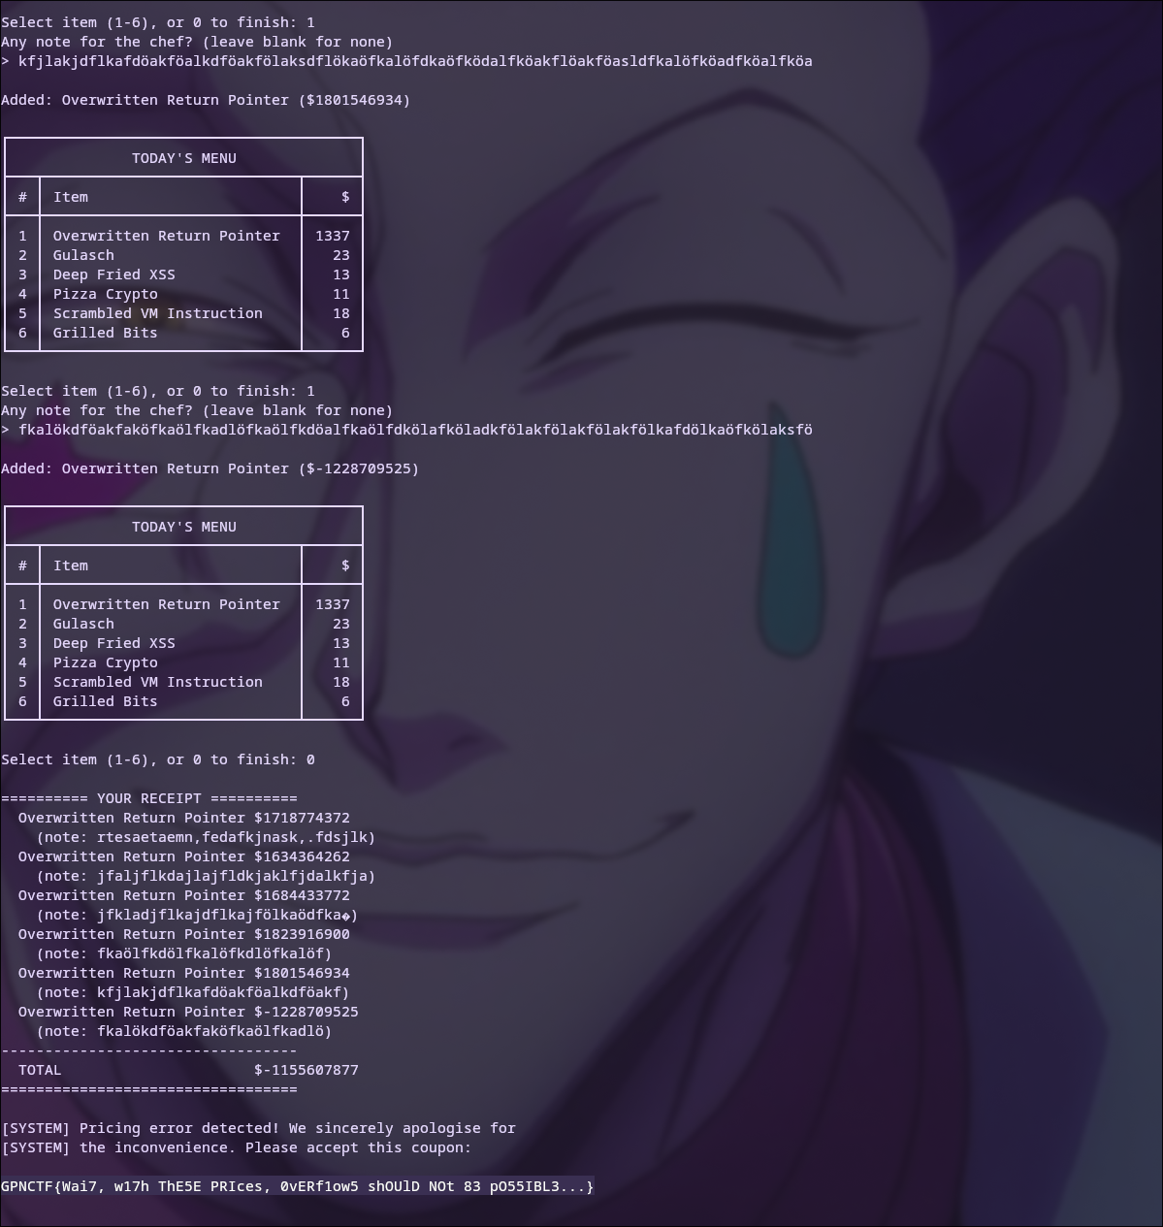

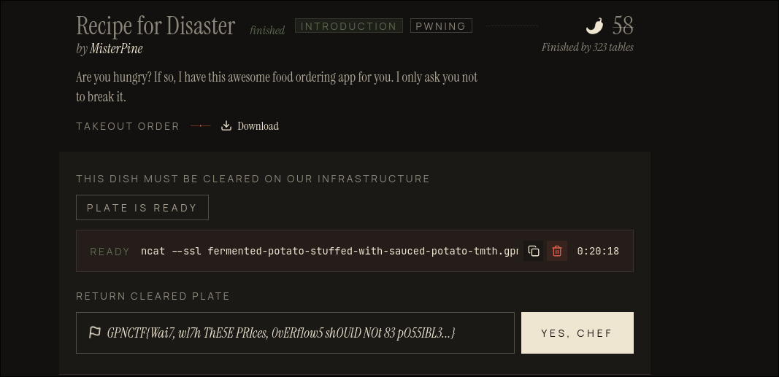
2.
2.1. Format: CVE ID (EUVD ID): CVSS Score v3.1
I. CVE-2025-9230 (EUVD-2025-31729): 7.5
II. CVE-2025-9231 (EUVD-2025-31728): 6.5
III. CVE-2025-9232 (EUVD-2025-31727): 5.9
IV. CVE-2025-4575 (EUVD-2025-16128): 6.5
V. CVE-2024-12797 (EUVD-2024-51115): 6.3
VI. CVE-2024-13176 (EUVD-2024-51400): 4.1

Vulnerability chosen for further tasks: CVE-2025-9230

2.2.
Vulnerability: check of the inlen inside the key_unwrap_key() function is off by 8 bytes which enables to possibility to overread up to 8 bytes and thus overwrite up to 4 bytes.
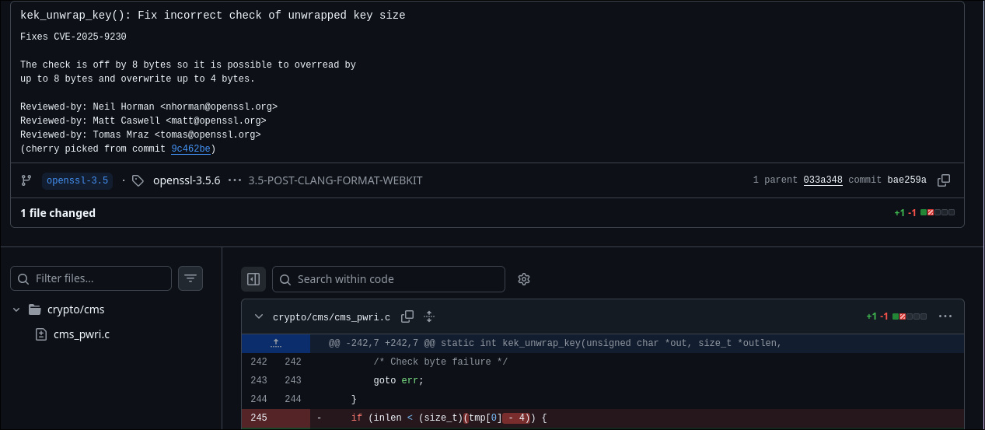
2.3
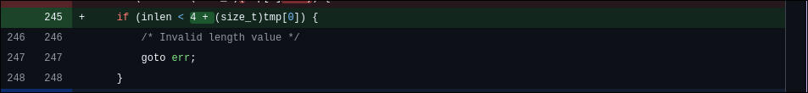
Fix: Instead of subtracting 4, 4 is added. Enough buffer so that no data is overwritten.

2.4.
CWE-125 Out-of-bounds Read, CWE-787 Out-of-bounds Write.

2.5. This vulnerability most definititely could have been found earlier and reminds me of some kind of off-by-one error, where they subtract instead of adding 4. But it also could have been avoided by using typesafe and memory safe languages like Rust where such bugs become compile-time errors (so they can be found easily) or become straight-up impossible to be caused, and avoid unsafe languages like C.
Developers also can learn from this to always test their code to avoid such grave memory safety bugs.

