From r-exercises

## Hacking statistics Exercises Part 1

#### Exercise 1

Use rnorm() to generate 100 points, then plot those points in an histogram.For normal distribution, there is two parameters, which is $N(μ,σ^{2})$ The normal density equation:

$$f(x)=\frac{1}{\sqrt{2π}σ}e^{−\frac{(x−μ)^{2}}{2σ^{2}}}$$

x <- rnorm(100)  
hist(x)

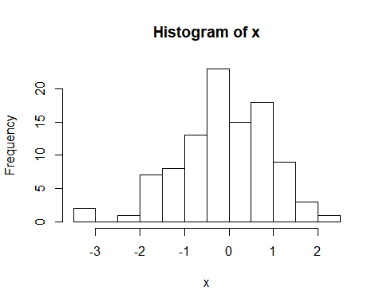

#### Exercise 2

Repeat exercise 1, but this time with, 500, 1000 and 10000 points.

a <- rnorm(500)  
b <- rnorm(1000)  
c <- rnorm(10000)  
par(mfrow =c(1,3))  
hist(a)  
hist(b)  
hist(c)

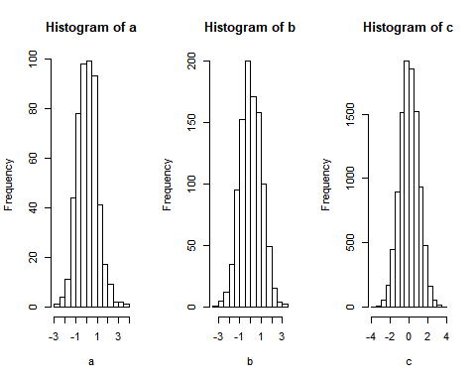

We see that the more points, the more the histgram become symmetric and certered around 0.

#### Exercise 3

Use the dnorm() function to plot the density function of a normal distribution of mean 0 and standard deviation of 1 and add it to the last histogram you plot.

x <- seq(-4, 4, 0.1)  
hist(rnorm(10000), prob=TRUE)  
curve(dnorm(x, mean=0, sd=1), add = TRUE)

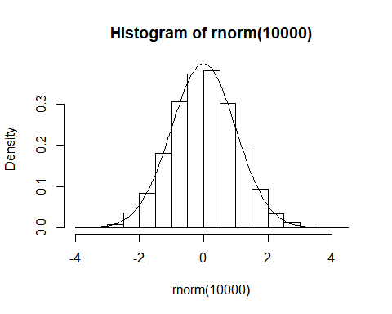

#### Exercise 4

We use the shape to verify if a random process is a normal process. use pnorm() to plot empirical cumulative distribution function (ECDF) curve.

hist.cum.sum <- hist(rnorm(10000))

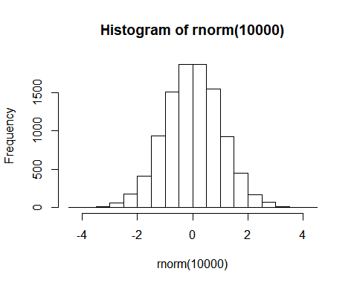

hist.cum.sum$counts <- cumsum(hist.cum.sum$counts)  
plot(hist.cum.sum)  
curve(pnorm(x, mean=0, sd =1), add=TRUE)

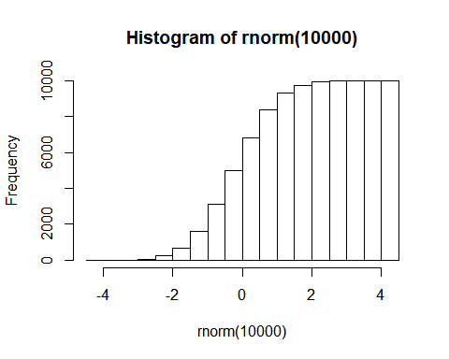

#### Exercise 5

Let's see other distribution, not the normal. For exponential distribution, is the only parameter.

#Exponential  
  
interval.exp <- seq(0,10,0.01)  
plot(interval.exp, dexp(interval.exp, rate=0.5))  
lines(interval.exp,dexp(interval.exp,rate=1),col="red")  
lines(interval.exp,dexp(interval.exp,rate=2),col="blue")  
lines(interval.exp,dexp(interval.exp,rate=10),col="green")

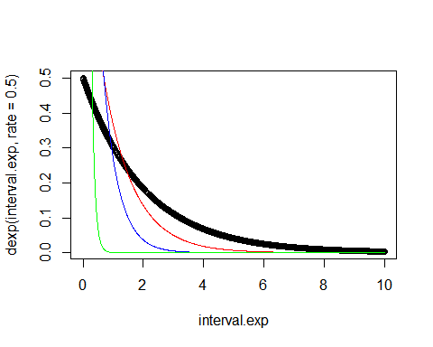

#Gamma  
interval.gamma<-seq(0, 20, 0.01)  
plot(interval.gamma,dgamma(interval.gamma,shape=1,scale=2))  
lines(interval.gamma,dgamma(interval.gamma,shape=2,scale=2),col="red")  
lines(interval.gamma,dgamma(interval.gamma,shape=5,scale=2),col="blue")  
lines(interval.gamma,dgamma(interval.gamma,shape=5,scale=0.5),col="green")

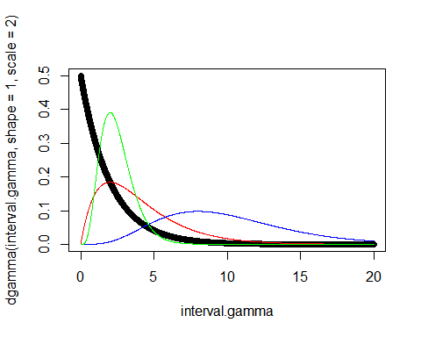

#Student  
interval.t<-seq(-10,10, 0.01)  
plot(interval.t,dt(interval.t,10))  
lines(interval.t,dt(interval.t,5),col="red")  
lines(interval.t,dt(interval.t,2),col="blue")  
lines(interval.t,dt(interval.t,1),col="green")

