

SEMESTER 1
2022-2023

EE302FZ
Embedded and Real-Time Systems

Dr. Wu Lijun, Prof. Ronan Farrell, Dr. Martin Hayes

Time allowed: 2 hours

Answer three questions
All questions carry equal marks.

Instructions

 | Yes | No
Log Books Allowed |  | Χ
Formula Tables Allowed |  | Χ
Other Allowed (enter details):Non-programmable calculator | Χ

General (enter details)

[33 marks]
1 | (a) | An embedded system has been specified based around an 8-bit CPU that supports up to 16 bit memory addresses and uses memory mapped I/O. However only the least significant 13 bits of the CPU memory addresses are connected in this particular system.  In this system RAM is mapped starting at address 0x0 and up to 6KiB is supported but just 4 KiB is installed. The boot loader ROM is mapped to the highest numbered 512 addresses supported in this system. Firmware EEPROM (1 KiB supported and installed) is mapped at address 0x1800. I/O devices are mapped in the range 0x1C00-1CFF.  The system has just 2 I/O devices installed: a UART with 4 addressable registers and an inertial sensor with 10 addressable registers.  (i) According to the specifications given, how many I/O device registers could potentially be mapped to memory locations (in decimal)?  (ii) Design and sketch an appropriate address map for the system as described. Clearly label all significant addresses and state all assumptions and design decisions.  (iii) Derive the algebraic expression for selecting the boot loader ROM, EEPROM, and the inertial sensor in accordance with the address map, clearly showing your workings. State any assumptions you make. | [18marks]
 | (b) | (i) Essentially all mechanical switches bounce and require some debounce treatment to avoid registering multiple switch state transitions in very quick succession. Switch debounce may be implemented in hardware or software. With the aid of a sketch describe one possible software solution to switch debounce.  (ii) List two important requirements of bus-aware devices in an embedded computer system.  (iii) assume ADCON0 is currently 0b10110001 and that the channel we want to select channel 4. Breaking the statement into its parts to demonstrate how it works. | [15 marks]

[33 marks]
2 | (a)
A PIC microcontroller is connected to a 1KiB serial EEPROM using SPI. The EEPROM’s 7-bit I2C address is 0x53
Before reading data from the EEPROM, the microcontroller must first set the EEPROM internal address pointer by writing 2 bytes to EEPROM formatted as follows:
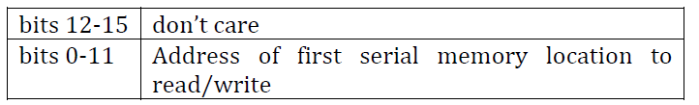
In response, the EEPROM sets its internal address pointer to the address/location specified by the microcontroller.
To read data from the requested address (and consecutive addresses) the microcontroller must initiate an I2C read operation. The first data byte returned by the EEPROM will be from the current location addressed by the internal address pointer. The internal address pointer of the EEPROM is incremented after each data byte is read so that each subsequent data byte returned will be read from the next consecutive memory location.
(i) List two differences between synchronous serial communications and asynchronous serial communications.
(ii) Sketch a clearly labelled diagram showing all relevant connections between the microcontroller and EEPROM.
(iii) List the I2C protocol elements required to read the data at EEPROM locations 0x470 and 0x481. (Assume the data values are 0x81 and 0x82 respectively.) Clearly indicate the sender (master or slave) at each step.
(iv) Sketch a detailed timing diagram showing the states of all connected lines when requesting the EEPROM to set its internal address pointer to 0x470. State any assumptions made. [18 marks](b)

Consider a sensor system using asynchronous serial communications with a serial specification of 9600, 8, O, 2. The sensor transmits at regular intervals according to the format ‘A’(0x41) followed by an 8-bit unsigned integer sample value.

(i) Explain the meaning of each element of the serial specification given.
(ii) Sketch and carefully label a timing diagram that shows the levels of the transmit (Tx) line during transmission of the sample value 0x8. Clearly state any assumptions you make.
(iii) Calculate the maximum rate at which the data from sensor can be transmitted using this scheme. Clearly show how you worked this out. [15 marks]

[33 marks]
3 | (a) | Consider a system in which a force sensitive resistor (FSR) placed in the sole of a shoe is used to measure foot contact during walking. The FSR circuit takes the form of a resistor divider whose output voltage can be described by the equation:        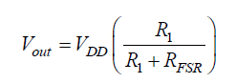  where RFSR is the (variable) resistance of the FSR, R1 is 10 kOhm and VDD is 5V. The output of the FSR circuit has a voltage range between approximately 0-3V over the range of forces expected.  The FSR circuit output is connected to the internal ADC of a PIC16 family microcontroller used as an 8-bit ADC.  (i) Briefly explain the relevance of the number of bits per sample and the voltage reference values for such an ADC.  (ii) Choose appropriate voltage reference levels for the input signal. Then, assuming VDD=5V and VSS=0V, sketch a circuit that could be used to provide these voltage reference levels specifying component values where possible.  (iii) Based on the reference levels chosen in (ii), specify the ADC signal resolution, i.e. the minimum voltage step size that can be resolved.  (iv) Determine the ADC value produced when RFSR is 20 kOhm.  (v) Determine the RFSR resistance corresponding to an ADC value of 208. | [15 marks]
 | (b) | An analogue signal is connected to the internal comparator peripheral of a microcontroller as follows:  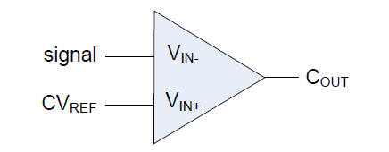  The signal voltage ranges from 0 to 2.5V with the signal being considered ON above a nominal threshold of 1.1V and OFF below it. The comparator reference voltage (CVREF) is controlled by a hardware circuit and the comparator output (COUT) is HIGH when the signal (at VIN-) is less than CVREF (at VIN+) and LOW otherwise.  (i) Hysteresis is often used in comparator circuits. With the aid of a diagram, briefly explain the problem that comparator hysteresis addresses and how it solves it.  (ii) Sketch a hardware circuit that could be used to implement the appropriate voltage reference level (CVREF) with hysteresis and briefly explain the operation of this circuit.  (iii) Assuming VDD=3.3V and VSS=0V, the signal is subject to additive noise that varies less than ±0.2 V around the true signal level. Specify possible values for all the components in the reference voltage circuit given in (ii). | [18 marks]

[33 marks]
4 | (a) | Consider the following daisy chained interrupt configuration:  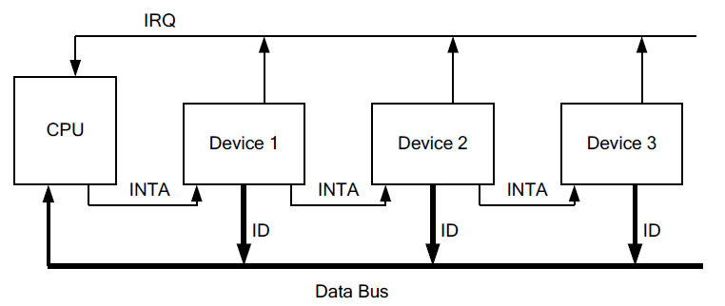  (i) Describe in detail the entire sequence of interrupt handling signals and operations that would occur if device 2 and device 3 generated interrupts simultaneously.  (ii) Using pseudocode, show how you would implement the same interrupt priority using polled interrupts.  (iii) List two key differences between polled interrupts and software polling for device I/O. | [15 marks]
 | (b) | An embedded system is being designed around a PIC16 family microcontroller. The microcontroller oscillator frequency (fOSC) is 10 MHz.  On this microcontroller, Timer1 is an internal 16-bit timer that has a prescaler (1:1, 1:2, 1:4, or 1:8). The source clock for the timer is fOSC/4.  An interrupt flag, TMR1IF is set each time the Timer1 value rolls over (from 0xFFFF to 0x0000).  (i) Briefly explain the operation of a timer prescaler and contrast this with the operation of a postscaler.  (ii)Calculate both the maximum timeout period and the timeout resolution supported by Timer1 with the minimum and maximum prescaling factors applied.  (iii)Calculate appropriate prescaler and timer register values to ensure that a task will be executed repeatedly at a rate of 18 Hz assuming it takes 3 microseconds for the timer interrupt code to execute and reset the timer to the appropriate value.  (iv)Calculate the actual frequency achieved by the settings chosen in (iii) and the percentage error that this represents. Explain why it is not possible to achieve the desired frequency exactly? | [18 marks]

