The format should be like this:

**SELECT User.user_name FROM User where user_id = $user_id;**

**$user_id** is the input variable of PHP.

1. **For client page:**

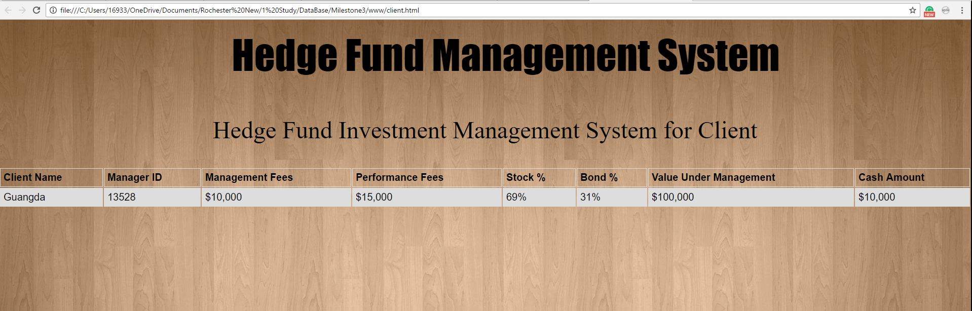

**Input**: $user_id

**Outputs**: user_name, manager_id, management_fee, performance_fee, stock%, bond%, value_under_management, cash_amout

You can also get the outputs by many MySQL statements since there is only one line for client page.

1. **For manager page:**

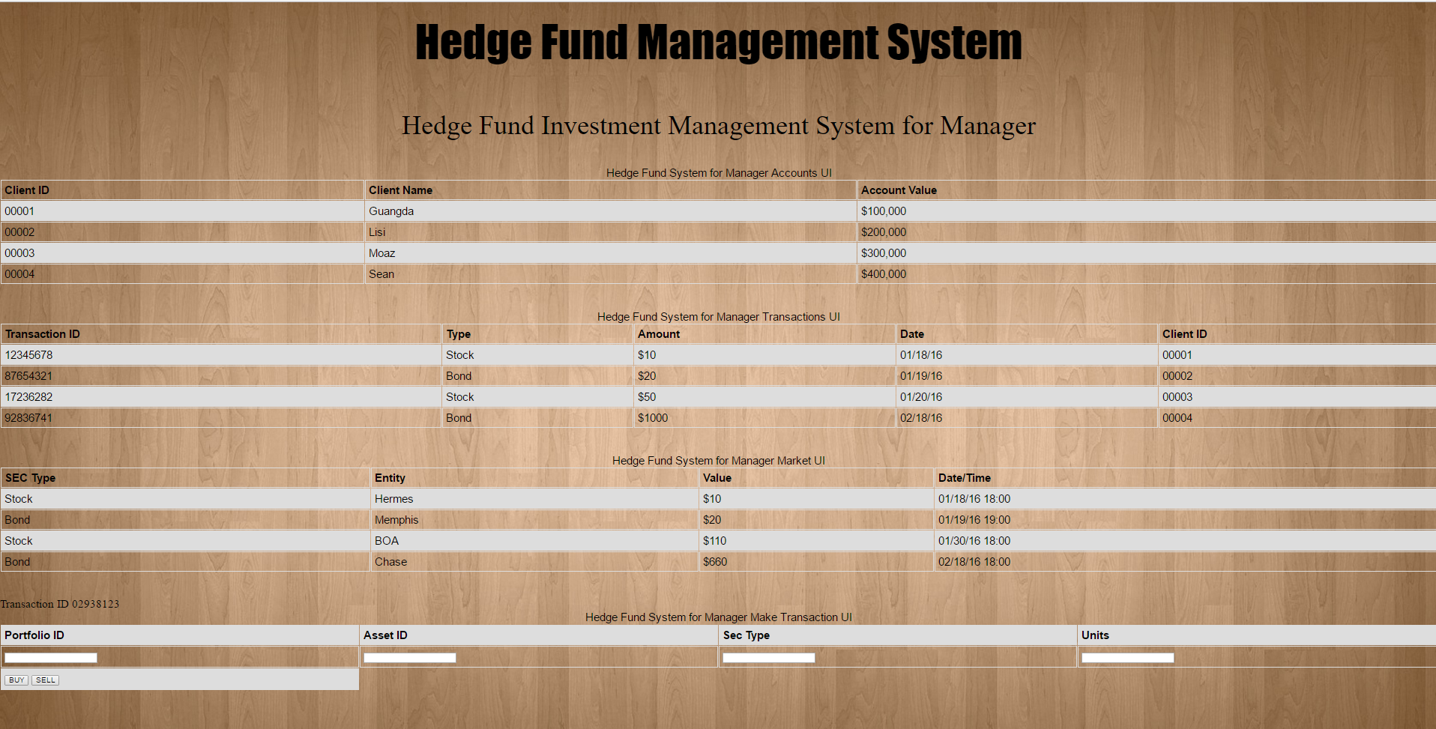

1. Input: $user_id (the user_id of the manager)

Outputs: (the attributes shown on the tables)

Each table has one MySQL statement, there are 3 tables, so we need 3 MySQL statements for this.

1. After click on the button (BUY)

Inputs: $portfolio_id, $asset_id, $SEC_type, $buy_amount , $trans_time

(note: $SEC_type is Asset.type; $trans_time is transaction time)

No output, just update the tables

User_id is the id for this manager

1. After click on the button (SELL)

Inputs: $portfolio_id, $asset_id, $SEC_type, $sell_amount , $trans_time

No output, just update the tables

1. **The MySQL statements above are used to interact with PHP files, we also need triggers to operate under the hood**
2. MySQL statements that used to insert values to all tables once you get the data sources.