PvButton Documents Release v1.1 (Draft)
By Guangwei_Jiang@Aug31'10

Content:
1. OverView
2. How-TO merge the PvButton Class to your Project
3. HOW-TO use
4. Tips
4.1 Implement “Sub-Menu Marker” feature

1. OverView
The PvButton inherits from "View", it has below custom feature,
1.1 Application can change the PvButton’s size and background,
1.2 set image,
1.3 set text, include the text content, size and color.
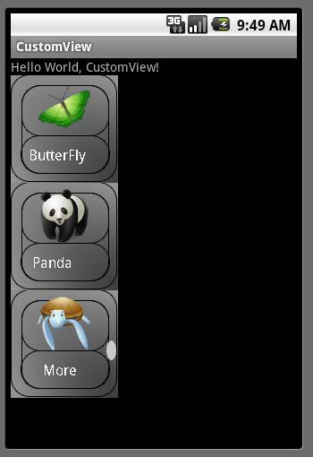

2. How-TO merge the PvButton Class to your Project:
2.1 add PvButton attributes to attrs.xml as below,
<declare-styleable name="PvButton">
<attr name="text" format="string" />
<attr name="textColor" format="color" />
<attr name="textSize" format="dimension" />
<attr name="imageDrawable" format="reference" />
<attr name="backGround" format="integer" />
</declare-styleable>
2.2 import the PvButton.java to your project, and change the package name to yourself.

3. HOW-TO use:
3.1 add the “PvButton” view in your layout resource,
1st, remeber add "xmlns" for your own custom view, the last part is your package name
(in this example, the package name is "com.wistron.CustomView")
xmlns:PvButton="http://schemas.android.com/apk/res/com.wistron.CustomView"
2nd, set the attributes for the PvButtons, you can refer sample codes as below,
<LinearLayout
xmlns:android="http://schemas.android.com/apk/res/android"
xmlns:PvButton="http://schemas.android.com/apk/res/com.wistron.CustomView"
android:orientation="vertical"
android:layout_width="fill_parent"
android:layout_height="fill_parent"
>
<com.wistron.CustomView.PvButton
android:id="@+id/mPvButton01"
android:layout_width="120dip"
android:layout_height="120dip"
android:background="@drawable/btn_bg"
PvButton:text="ButterFly"
PvButton:textColor="#FFFFFFFF"
PvButton:textSize="16dip"
PvButton:imageDrawable="@drawable/butterfly60x60"
/>
</LinearLayout>

3.2 add "ClickListener" for the PvButton, please refer codes as below,
mPvButton01 = (PvButton)findViewById(R.id.mPvButton01);
mPvButton01.setOnClickListener(new View.OnClickListener() {
public void onClick(View v) {
Toast.makeText(CustomView.this, "I'm ButterFly, who are you?",
Toast.LENGTH_LONG).show();
}
}
);

4. Tips
4.1 Implement “Sub-Menu Marker” feature
Currently, we suggest change the different background picture to implement the “Sub-Menu Marker”.
1st, Init the background picture in the layout xml file,
android:background="@drawable/btn_bg_left_mark"

2nd, Change the background picture in your codes,
mPvButton03.setOnClickListener(new View.OnClickListener() {
public void onClick(View v) {
Drawable drawable = getResources().getDrawable(R.drawable.btn_bg_left_mark_pressed);
mPvButton03.setBackgroundDrawable(drawable);
}
}

