Aegis Nexus – The next era of cloud gaming

1. Executive Summary
The problem. AAA games now exceed 80 GB, far beyond the free storage on most mid-range smartphones. Gamers must uninstall existing titles, skip new releases, or endure a forty-five-minute download, and full-game cloud streaming resolves the space problem but reintroduces latency, which degrades competitive play.
The product. Aegis Nexus is an AI-enabled cloud asset-streaming platform, which keeps game logic on the user's device while textures, audio, and geometry stream from the nearest edge node on demand. An approximately 200 MB shell replaces the 20 to 128 GB conventional install, and an AI zone-predictor preloads assets ahead of player movement.
The target and the case. The priority segment is Premium-Heavy mobile gamers, the cohort most constrained by device storage and willing to pay for higher fidelity. A 100,000-user CLV (Customer Lifetime Value) simulation gives a portfolio CLV-to-CAC (Customer Acquisition Cost) ratio of 2.02, and the Premium-Heavy cohort reaches 3.32 with a 4.9-month payback.
Why now. The cloud-gaming market is projected to grow from $14 billion to $241 billion by 2033 (Coherent Market Insights, 2026), and smartphones now hold 38.7% of cloud-gaming device share, the class Aegis Nexus targets.
The ask. Approve a Phase-1 MVP for Premium-Heavy users in Months 1 through 3, gated by CLV-to-CAC of at least 2.0 on the first 500 acquired users, with playable-ad creative as the primary channel and an in-phase A/B test to inform Phase-2 spend.

2. Product Description

2.1 What Aegis Nexus Is and What It Is Not
Aegis Nexus streams only the graphical and audio assets a game requires at a given moment, including textures, geometry, and sound files, rather than transmitting a rendered video feed of server-side gameplay, which is how full-game cloud streaming services such as GeForce NOW and Xbox Cloud Gaming operate. In those services, each player action must travel to a remote server, be processed, and return as a new video frame, a round trip that adds perceptible input lag. Aegis Nexus keeps all physics, game logic, and input processing on the local device, so responsiveness depends only on the hardware in the user's hands. An approximately 200 MB runtime shell replaces the 20 to 128 GB conventional install, and an AI zone-predictor monitors movement patterns and preloads the assets for the area the player is most likely to reach next, reducing loading pauses to near zero.

2.2 The User Experience
A player arriving at the Aegis Nexus product demo browses a catalog in which every title shows its traditional download size crossed out alongside the Aegis Nexus bootstrap size (Figure 1). Subscription tier and genre filters allow players to narrow the catalog before committing. Each title card presents a stark comparison: a conventional download of up to 128 GB against a bootstrap install measured in megabytes, at the same graphical fidelity once the game is running.
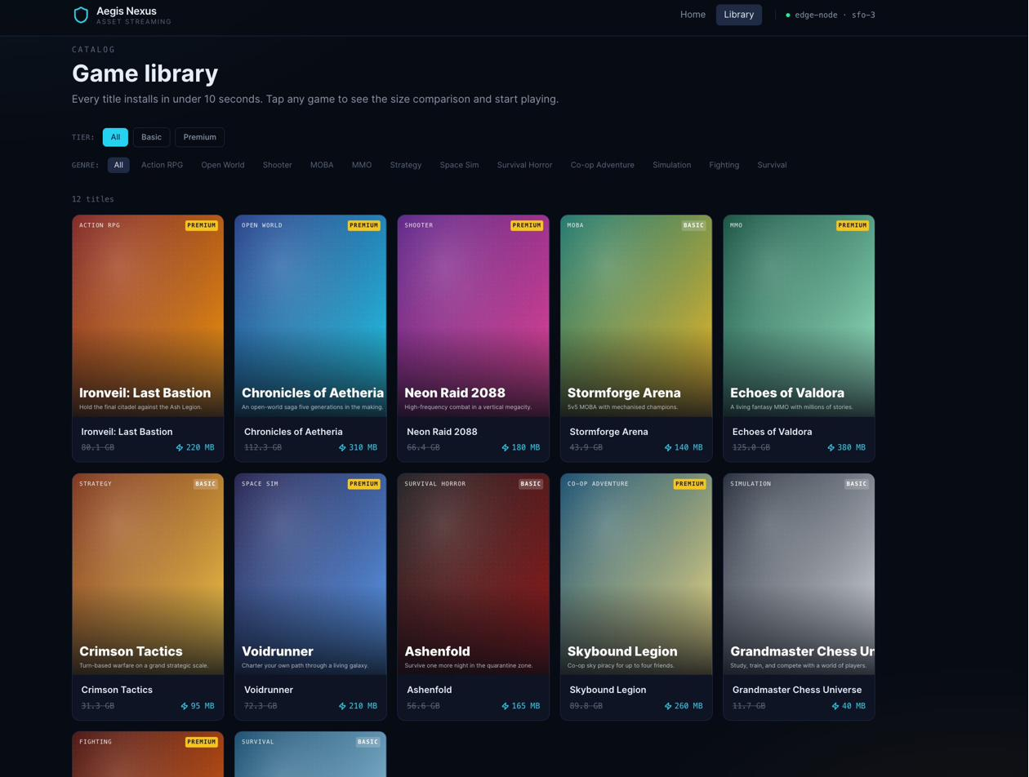
Figure 1. The game library. Each card shows the traditional download size (strikethrough) alongside the Aegis Nexus bootstrap size, across 12 titles spanning 10 genres and both subscription tiers.
Selecting a title opens a detail page that places both install options side by side. For a title such as Ironveil: Last Bastion, a conventional download of 80.1 GB taking approximately 45 minutes appears next to an Aegis Nexus install of 220 MB completing in about 8 seconds (Figure 2). Tapping Install triggers a six-stage bootstrap sequence in which the client connects to the nearest edge node, receives the runtime shell, and primes the AI predictor for the opening zone, presenting a ready-to-play prompt in around 8 seconds. Once in session, a streaming HUD (Heads-Up Display) overlay shows individual assets arriving in real time, with gold-highlighted entries marking files the predictor fetched before the player needed them.
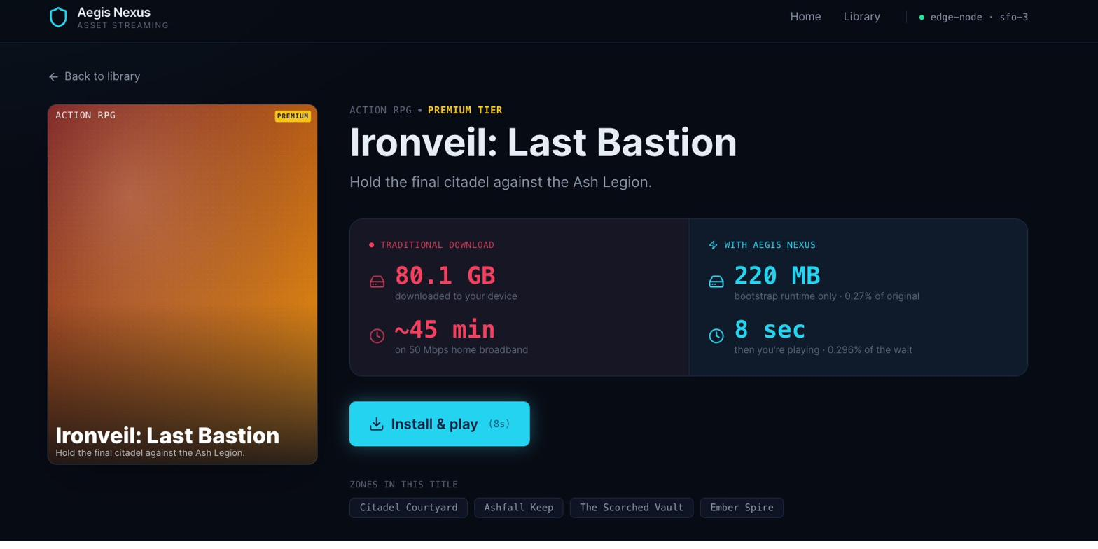
Figure 2. Game detail page for Ironveil: Last Bastion. Traditional download (80.1 GB, approximately 45 minutes) versus Aegis Nexus bootstrap (220 MB, about 8 seconds).

2.3 Technical Architecture
Three layers deliver the experience. The edge layer consists of geographically distributed CDN (Content Delivery Network) nodes that cache game assets close to the player's location; on a 5G connection, round-trip latency to a regional node typically falls below 30 milliseconds. The local layer is an approximately 200 MB plugin compatible with Unreal Engine and Unity, where physics, collision, AI-controlled characters, and input handling execute at full hardware speed with no frame rendered remotely. The prediction layer is an AI model that monitors zone-transition events during a session and queues a preload burst of upcoming assets when confidence on the most likely next area crosses a threshold set by a human operator, a governance mechanism described further in Section 9.

3. Market Analysis

3.1 Market Opportunity and Timing
The global cloud gaming market was valued at approximately $14 billion in 2026 and is projected to reach $241 billion by 2033, a 50% CAGR (Compound Annual Growth Rate) that outpaces both mobile gaming and broader cloud infrastructure growth (Coherent Market Insights, 2026). North America accounts for 47.8% of current revenue, making it the natural geographic anchor for Phase-1 operations. Smartphones now represent 38.7% of cloud-gaming devices, a share that continues to grow as 5G rollout reduces the round-trip latency that historically limited mobile streaming quality.
Three structural enablers converge in 2026 to make this the right launch window. 5G penetration in major North American urban centres has reached the threshold at which asset-fetch latency falls reliably below 30 milliseconds. Mature edge-CDN infrastructure from providers such as AWS CloudFront and Cloudflare enables low-cost geographic asset distribution without proprietary hardware investment. And mobile game file sizes have grown from casual titles under 100 MB to AAA releases routinely exceeding 40 GB, widening the gap between what gamers want and what mid-range devices can hold.

3.2 Customer Needs and Pain Points
Three pain points create the opportunity. First, a storage crisis disproportionately affects mid-range smartphone users: AAA mobile titles now range from 24 to 72 GB (Gravizon, n.d.), while typical mid-range devices carry 64 to 128 GB total. Community data from HoYoLAB (2023) shows a representative iPhone with 99.28 GB of 128 GB already consumed, with Genshin Impact occupying 32.44 GB and Honkai: Star Rail a further 15.16 GB, leaving fewer than 29 GB available for new titles. Players facing this constraint regularly delete titles they value to make room for new releases, a forced trade-off that depresses both engagement and publisher revenue.
Second, full-game cloud streaming introduces perceptible input lag from server-side rendering, which limits adoption largely to casual, low-skill-ceiling content — the category least likely to sustain premium subscription fees (STL Partners, 2023; Kim, 2026). Third, large file sizes generate abandoned installs and depress conversion from discovery to paying subscriber, creating a supply-side incentive for publishers to participate in any platform that demonstrably removes the storage barrier.

3.3 Competitive Landscape
Three strategic groups compete for the storage-constrained mobile gamer (Table 1). No commercial product currently occupies the asset-streaming position. Aegis Nexus enters the low-latency, low-storage quadrant that no existing competitor can reach without an architectural change, and Samsung Gaming Hub's existing distribution of GeForce NOW and Xbox Cloud Gaming confirms that device manufacturers embed cloud gaming services as platform differentiators (Samsung Newsroom Australia, n.d.).
Strategic group | Key services | Storage | Latency | Mobile suitability
Traditional install | Steam, App Store, Google Play | Very high (20-72 GB) | Near zero | Poor — storage forces uninstall on mid-range devices
Full-game cloud streaming | GeForce NOW, Xbox Cloud, Amazon Luna | None | High (server round-trip) | Limited — input lag degrades fast-paced genres
Subscription with download | Game Pass (download), Apple Arcade | High (full install) | Near zero | Poor — download retains the storage constraint
Aegis Nexus (asset streaming) | Aegis Nexus | Very low (approx. 200 MB) | Near zero | Excellent — resolves both constraints simultaneously
Table 1. Strategic group comparison. Aegis Nexus is the only option that resolves both storage burden and input latency simultaneously.

3.4 Company Capabilities
Four capabilities are required. CDN partnerships to serve assets at sub-30-millisecond latency can be sourced from existing cloud providers on a variable-cost basis, so infrastructure spending scales proportionally with the subscriber base rather than requiring upfront capital expenditure. Publisher licensing to stream game assets on demand is the single largest strategic risk, discussed in Section 12. An AI prediction model targeting approximately 87% zone-prediction accuracy serves as the near-term benchmark, trained on anonymised play-session data the platform generates natively. A game engine plugin compatible with Unreal Engine and Unity, distributed through their respective marketplaces, lowers the integration burden for publishers who wish to participate at launch.

4. Target Segmentation and Positioning

4.1 Segmentation Logic
The launch plan segments users across two dimensions drawn from the CLV simulation: subscription tier and activity level. Tier proxies willingness to pay and service quality, while activity level (Light under 5 hours per week, Medium 5 to 15 hours, Heavy over 15 hours) drives per-user infrastructure cost and correlates negatively with monthly churn, as heavier users are more deeply embedded in the platform's content library. Their interaction produces a 2-by-3 grid of six addressable segments. Launch-day activity mix is modelled as 35% Light, 45% Medium, and 20% Heavy; tier mix is set conservatively at 28% Premium and 72% Basic, calibrated against Xbox Game Pass and GeForce NOW adoption patterns. Both parameters are live inputs in the
Both parameters are live inputs in the Analytical Dashboard, where the effect of alternative assumptions on portfolio CLV can be observed in real time.

4.2 CLV-Driven Segment Priority
Segment | Avg CLV | Avg CAC | CLV-to-CAC | Payback (mo) | Tier
Premium-Heavy | $110.44 | $35 | 3.32x | 4.9 | Priority
Premium-Medium | $96.76 | $35 | 2.93x | 3.9 | Priority
Premium-Light | $80.77 | $35 | 2.43x | 3.6 | Priority
Basic-Medium | $44.41 | $27 | 1.74x | 6.2 | Secondary
Basic-Heavy | $44.11 | $27 | 1.73x | 8.3 | Secondary
Basic-Light | $41.65 | $27 | 1.63x | 5.3 | Secondary
Table 2. Segment unit economics, base-case simulation. CLV-to-CAC thresholds: Priority ≥ 2.0x, Secondary 1.5–2.0x.
All six segments clear the 1.5-times secondary floor, so no cohort is excluded from paid acquisition. Premium-Heavy leads on every dimension: $110.44 CLV, a 3.32-times ratio, and a 4.9-month payback period. Phase-1 spend concentrates entirely on this cohort, whose fast cash recovery funds Phase-2 expansion into Premium-Medium and Basic-Heavy without external capital. Basic segments qualify for lower-cost social retargeting but are not viable targets for the higher-cost playable-ad format.

4.3 Positioning Statement

For mobile gamers with limited storage who refuse to compromise on game quality, Aegis Nexus is the only asset-streaming platform that delivers instant, full-fidelity gameplay without the download.

Two frames of reference anchor the statement. Against full-game cloud streaming services, Aegis Nexus wins on latency, because local compute eliminates the server round-trip entirely. Against traditional and subscription-plus-download options, it wins on storage burden, because the approximately 200 MB shell means the player never faces a forced uninstall decision.

4.4 Perceptual Map
Figure 3 maps the competitive set on two axes representing the principal trade-offs each solution imposes: storage burden and input latency. Aegis Nexus occupies the low-latency, low-storage quadrant, which is currently unoccupied by any commercial competitor and is only accessible through an asset-streaming architecture.
 | Low latency | High latency
Low storage burden | AEGIS NEXUS (asset streaming) | Full-game cloud streaming (GeForce NOW, Xbox Cloud Gaming)
High storage burden | Subscription + download (Game Pass, Apple Arcade) | Traditional install (Steam, App Store, Google Play)
Figure 3. Perceptual map of the competitive set on storage burden and input latency.

5. Pricing and Revenue Model
 | Basic | Premium
Monthly price | $11.99 | $18.99
Streaming quality | Standard | High fidelity + priority
Avg CLV (base case) | $43.38 | $93.88
Avg CAC | $27 | $35
Infrastructure cost range | $3.00–$6.40 / mo | $4.80–$9.40 / mo
Table 3. Two-tier pricing summary with base-case CLV and CAC from the simulation.
The Basic tier at $11.99 per month positions against Xbox Game Pass Core (approximately $9.99) plus a streaming premium, while Premium at $18.99 aligns with GeForce NOW Priority (approximately $19.99). Revenue per subscriber is the monthly price minus cloud infrastructure cost, which ranges from $3.00 for a Light-activity Basic user to $9.40 for a Heavy-activity Premium user. Revenue sharing with game publishers is excluded from the contribution-margin calculations, a conservative assumption flagged in Limitations that makes the maximum sustainable CAC a lower bound rather than a ceiling.

5.1 CLV Model and Pricing Logic
The pricing tiers are evaluated against a discounted contribution-margin CLV model, which treats each user's value as the present value of the stream of gross margin they generate over an assumed infinite horizon under a constant monthly retention probability. The closed-form expression is shown below.

CLV = m ÷ ( 1 − r ÷ (1 + d) )
Symbol | Variable | Definition
CLV | Customer Lifetime Value | Discounted contribution-margin value of a user over an infinite horizon
m | Monthly contribution margin | Monthly price minus monthly cloud infrastructure cost per user (USD)
r | Monthly retention probability | Probability the user remains a subscriber in any given month; modelled as constant per segment
d | Monthly discount rate | Set to 1% per month (approximately 12.7% annually) to reflect early-stage risk

This formulation is preferred over revenue-only CLV because infrastructure cost is real and variable, and ignoring it would overstate the maximum sustainable CAC. The formula makes explicit that CLV is jointly determined by margin, retention, and the discount rate; the sensitivity analysis in Section 8 demonstrates that a 3 percentage-point change in retention has a larger effect on CLV than a 20% change in infrastructure cost, making retention the dominant pricing and product lever.

5.2 Platform Fee Constraints and Revenue Capture
Platform fees from Apple App Store and Google Play (15% to 30% of subscription revenue) reduce effective margin and must be reflected in CAC ceilings for mobile-acquired users. For a Premium subscriber paying $18.99, a 30% fee reduces monthly net revenue to $13.29 before infrastructure costs, compressing the contribution margin from $9.59 to $3.89 for a Heavy-activity user. Pursuing web-based subscription management can avoid fees for returning subscribers, though iOS terms restrict this pathway for new installs. Phase-2 pricing strategy should evaluate the trade-off between in-app convenience and platform fee exposure before scaling Premium acquisition spend.

6. Channel Strategy
Stage | Channel | Mechanism
Discover | Meta / TikTok playable ads | User plays a 60-second streamed demo inside the ad unit before tapping to install
Evaluate | In-ad gameplay experience | Self-selects high-intent users; playable format tests the product-market fit hypothesis for ad creative
Install | App Store / Google Play | Approximately 200 MB bootstrap client; single-tap flow minimises friction
Subscribe | In-app upgrade prompt (D3) | Premium CTA surfaced after the first full session; D3 is the peak-engagement window before early churn
Retain | AI churn model | Automated win-back offers for at-risk users; Premium-Heavy cohort routes to manual review
Table 4. Five-stage customer acquisition and retention funnel with channel and mechanism by stage.
The playable ad format is the linchpin of the strategy because it collapses the Discover and Evaluate stages into a single touchpoint: the user experiences approximately 60 seconds of actual asset-streamed gameplay inside the Meta or TikTok ad unit before tapping to install. This self-selection mechanism produces a higher-intent cohort compared with standard video ads, the hypothesis tested in the A/B experiment described in the technical appendix A10. The approximately 200 MB install then removes friction from the App Store conversion step, so the user moves from playing inside the ad to playing on their device in under 10 seconds.
Samsung Gaming Hub provides a second discovery surface in Phase 2. Samsung already distributes GeForce NOW and Xbox Cloud Gaming on its Galaxy devices and televisions (Samsung Newsroom Australia, n.d.), confirming that device manufacturers integrate cloud gaming services as platform differentiators. Aegis Nexus targets this channel as a complementary entry addressing the latency objection that constrains adoption of existing services in competitive contexts.

7. Marketing Communications Plan

7.1 Campaign Concept and Message Architecture
The campaign theme "Your Game, Your Device. No Storage, No Compromise" organises all creative across three channels around a rational-to-emotional hierarchy. The rational hook is storage freedom ("free up 70 GB on your phone"), the emotional payoff is instant play ("tap and play in 8 seconds"), and publisher breadth provides social proof of catalog quality. This hierarchy maps directly to the buyer journey: storage frustration creates awareness, the speed of the install creates desire, and the breadth of the catalog converts the user. The product homepage (Figure 4) expresses this hierarchy visually, leading with the headline "Play AAA games. Skip the 80 GB download." and immediately contextualising it with the storage calculator that quantifies the benefit in each visitor's specific device context.
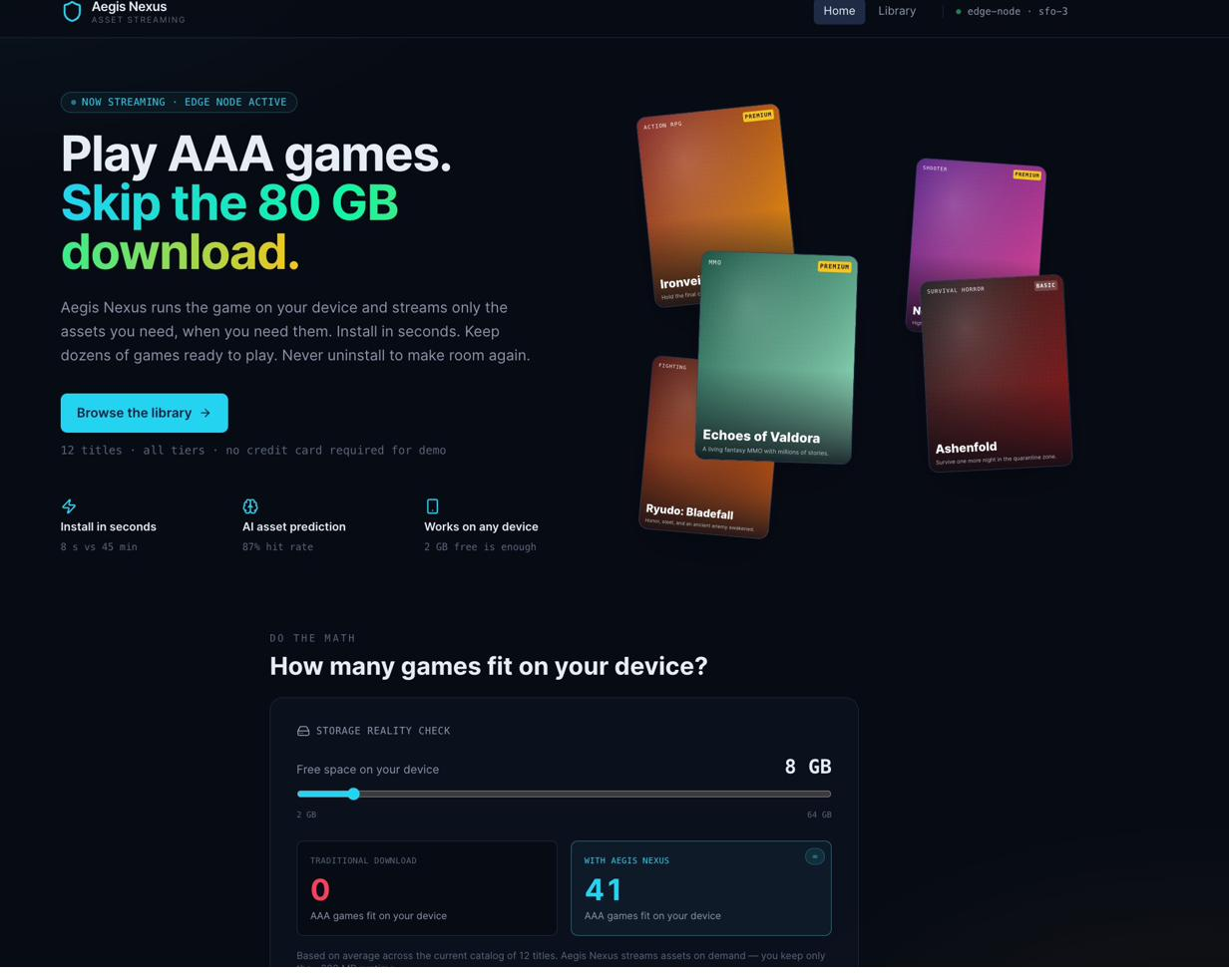
Figure 4. The Aegis Nexus homepage, which serves as the campaign landing page. The headline "Play AAA games. Skip the 80 GB download." expresses the rational hook directly; the storage calculator below personalises the benefit for each visitor.

7.2 Creative Executions
Playable ads on Meta and TikTok are the primary acquisition format. A 60-second streamed demo of an Aegis Nexus title runs directly inside the ad unit so the user experiences the product before being asked to install. The call to action reads "Start Playing Now, 200 MB Install." Because the user has already played, the install request is a commitment to continue rather than an invitation to try, which produces higher conversion intent than a standard video ad. This self-selection mechanism justifies the higher CPI (Cost Per Install) of the playable format and is the hypothesis evaluated in the A/B experiment.
Influencer seeding targets gaming micro-influencers with followings between 100,000 and 1 million on TikTok and YouTube Shorts. The content brief centres on the "I freed up 70 GB on my phone" narrative, which makes the storage-freedom benefit tangible and shareable within gaming communities. This format benefits from high organic reach at low production cost and provides authentic social proof that the platform works on real mid-range devices.
App Store optimisation and Google UAC (Universal App Campaigns) capture intent-based demand. ASO (App Store Optimisation) targets keywords such as "play without downloading" and "game without install" to reach users actively searching for a solution to the storage problem. Google UAC campaigns targeting heavy-gaming genres reach users whose in-app behaviour signals high-engagement propensity. Lapsed mobile gamers who previously uninstalled large titles are a high-value retargeting audience and receive a dedicated creative variant emphasising the storage-recovery benefit.

8. Analytics Section

8.1 Data Description
Because Aegis Nexus has not launched, the analysis relies on a synthetic dataset of 100,000 users generated from an explicit DGP (Data-Generating Process) documented in the technical appendix A3, A4. Users are drawn independently from a 2-by-3 segment grid: subscription tier (Basic at 72%, Premium at 28%) crossed with activity level (Light at 35%, Medium at 45%, Heavy at 20%). Within each cell, individual-level values for monthly retention probability, CAC, and infrastructure cost are drawn from truncated Normal distributions around segment-specific means, using a fixed random seed (42) for full reproducibility. Parameter choices are calibrated against analogous platforms: Basic price ($11.99) against Xbox Game Pass Core, Premium price ($18.99) against GeForce NOW Priority, and CAC values ($27 Basic, $35 Premium) against AppsFlyer 2024 mobile gaming acquisition benchmarks. The full dataset and interactive dashboard are accessible at the Analytical Dashboard, which allows all 15 simulation parameters to be adjusted and the results observed in real time.

8.2 Method
CLV is estimated as discounted contribution-margin CLV, as defined in Section 5. This formulation is preferred over revenue-only CLV because infrastructure cost is real and variable, and ignoring it would overstate the maximum sustainable CAC. Payback period is the first month at which cumulative discounted margin equals or exceeds CAC, evaluated vectorised over a 36-month horizon.

8.3 Headline Results
The base-case simulation produces a portfolio average CLV of $57.52 against a CAC of $29.24, yielding a net CLV after CAC of $28.28 and a CLV-to-CAC ratio of 2.02. Ninety-five percent of users recover their acquisition cost within 12 months, and 98% do so within 24 months. Premium users generate $93.88 average CLV against $43.38 for Basic users; segment-level unit economics are presented in Table 2.

8.4 Sensitivity Analysis
Five scenarios stress-test the base case by shifting each key lever independently (Figure 5). Retention is the dominant value driver: a 3 percentage-point reduction in monthly retention lowers portfolio CLV from $57.52 to $47.71, a decline of $9.81 per user. By contrast, a 20% increase in infrastructure costs reduces CLV by only $6.09. A 2 percentage-point improvement in retention raises CLV to $67.05, while shifting the Premium tier mix from 28% to 35% adds $5.08 to the portfolio average. Because retention outweighs infrastructure cost as a CLV lever, investment in onboarding quality, content freshness, and latency performance produces a higher ROI than cost-cutting during the launch period.
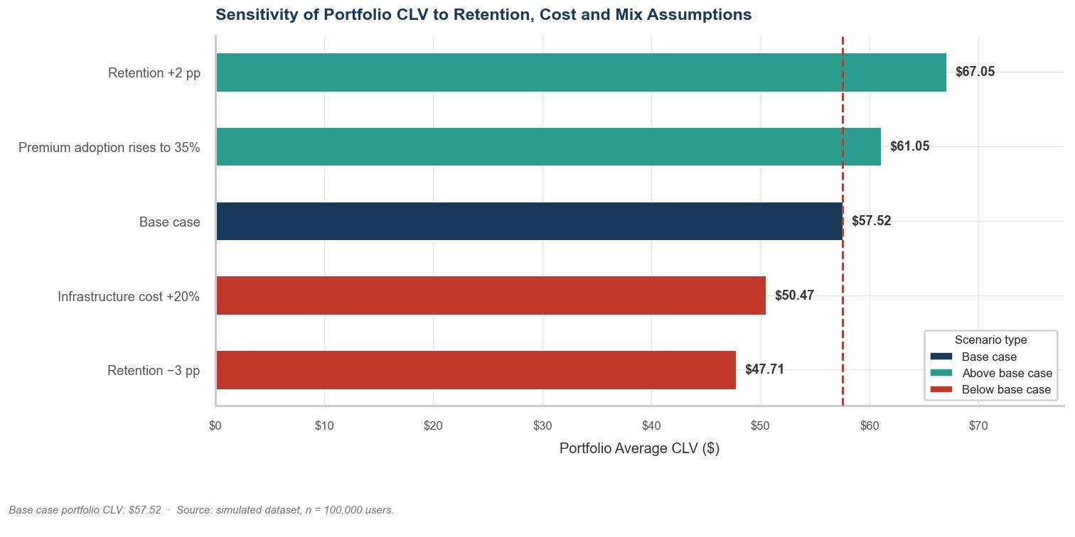
Figure 5. Sensitivity analysis: portfolio average CLV under five scenarios. Bars show deviation from the base case of $57.52.

8.5 Analytics-to-Decision Linkage
The simulation directly drives one concrete launch decision: Phase-1 acquisition concentrates entirely on Premium-Heavy rather than distributing spend across all six segments. Without the CLV analysis, an equal-spend approach would allocate roughly one-sixth of budget to Premium-Heavy. The CLV-to-CAC comparison in Table 2 shows that Premium-Heavy's 3.32-times ratio is more than twice the 1.63-times ratio of Basic-Light. Concentrating Phase-1 spend on Premium-Heavy recovers acquisition cost in 4.9 months on average, funding Phase-2 expansion from operating cash rather than external capital. This is the primary analytical output of the simulation and the quantitative foundation for the rollout in Section 10.

9. AI in Marketing
System | Automated | Human oversight | Key data inputs
Bid optimiser | Real-time CPI bids within CAC ceiling | Sets CLV-to-CAC floors (2.0x Priority, 1.5x Secondary) | Ad platform logs, CLV simulation outputs
Creative generation | Variant generation; auto-rejects low-CTR creative | Approves all new concepts and final variants | Creative performance data, brand guidelines
Churn prediction | Monthly scoring; auto win-back for Pr(churn) above threshold | Sets threshold; Premium-Heavy at-risk routes to manual review | In-app events, billing records, device identifiers
Table 5. Three AI systems at launch with automation boundaries and human oversight responsibilities.

9.1 Data Sources
The bid optimiser draws on ad platform impression and click logs from Meta, TikTok, and Google UAC, combined with in-app event attribution and the CLV simulation's CAC ceiling outputs. The creative generation system uses historical creative performance data, including CTR (Click-Through Rate), conversion rate, and view-through rate, alongside human-approved brand guidelines. The churn prediction model consumes in-app behavioural events, including session frequency, play hours, and zone-transition data, alongside subscription billing records. All in-app data is consent-gated under PIPEDA (Personal Information Protection and Electronic Documents Act) and Apple ATT (App Tracking Transparency) frameworks, as discussed in Section 12.

9.2 Human-in-the-Loop Design
No AI system has authority to set or override a CAC ceiling, change pricing, or approve a creative concept unilaterally. Human review cadence tightens in Phase 1 to weekly manual review of all CAC and creative decisions and loosens progressively as post-launch training data accumulates, reaching monthly anomaly-flagging only by Phase 3. Premium-Heavy users flagged as high churn-risk are routed to a manual retention conversation, ensuring the highest-value cohort receives personal attention during the period when the churn model's calibration is newest and least reliable. The CLV-to-CAC floors in Table 2 are the quantitative foundation for the bid optimiser's operating envelope and can be adjusted only through a documented human approval process.

10. Rollout Plan
 | Phase 1 (Months 1-3) | Phase 2 (Months 4-9) | Phase 3 (Month 10+)
Target segment | Premium-Heavy (mobile-first) | Premium-Medium + Basic-Heavy; PC beta | All segments + publisher expansion
CLV-to-CAC gate | ≥ 2.0x on first 500 users | ≥ 1.5x across expanded segments | Stable 1.5x at 90-day cohort
AI systems | Bid optimiser (Priority ceiling only) | Bid optimiser (all tiers) + churn model v1 | Full stack + creative A/B automation
Human oversight | Weekly manual review | Bi-weekly; human approves ceiling changes | Monthly; automated anomaly flags only
Table 6. Three-phase sequenced launch gated by CLV-to-CAC checkpoints derived from the simulation.
The three-phase rollout sequences acquisition spend by profitability, using each phase's cash recovery to fund the next without external capital. Phase 1 concentrates entirely on Premium-Heavy because the 4.9-month payback is fast enough that accumulated cash from the first cohort funds Phase-2 spend before month 9. The A/B test comparing playable ads against standard video runs during Phase 1, so results inform Phase-2 creative decisions before scale. Phase 2 introduces Basic-Heavy and Premium-Medium while launching a PC beta, expanding the addressable market and providing a second revenue stream ahead of full launch. Phase 3 transitions to full ML-driven automation with monthly human oversight, by which point the churn model has accumulated sufficient training data to be reliably calibrated.

11. Non-Market Constraints
Data privacy. The churn prediction model and bid optimiser consume in-app behavioural data governed by Canada's PIPEDA and the forthcoming Bill C-27 (Consumer Privacy Protection Act). Consent flows must be implemented at onboarding, and plain-language disclosure of data collection purposes is mandatory. Apple ATT opt-in rates, which average around 25 to 30% across mobile gaming apps, will reduce attribution signal quality for the bid optimiser, requiring the model to remain robust to sparse first-party data in the iOS channel.
Publisher licensing. Streaming game assets on demand requires per-title licensing agreements with game publishers, the single largest strategic risk at launch. A thin content library disproportionately affects Premium-Heavy users, who exhaust a small catalog most quickly. Phase-1 targeting assumes 15 to 25 participating titles from three to five publishers, with the library growing as subscriber data provides publishers with evidence of incremental revenue uplift from reduced install abandonment.
Digital equity. Asset streaming presupposes reliable 5G or high-speed LTE connectivity that is unevenly distributed across geographies (Kim, 2026). Phase-1 geography is therefore limited to high-penetration urban markets in North America, where connectivity risk is lowest and the base-case retention assumptions are most defensible. The simulation's retention parameters implicitly assume adequate connectivity, so CLV estimates for lower-connectivity markets should be treated as optimistic until post-launch cohort data is available.

12. Limitations
Three limitations most materially bound the analysis. First and most fundamentally, all user data is synthetic and calibrated against market analogues rather than observed behaviour; every CLV figure and CAC ceiling should be read as a scenario-based guardrail, and the first post-launch cohort of 500 users should be used to re-calibrate the simulation parameters before Phase-2 spend scales. Second, the retention model assumes a constant monthly churn probability per user with no cohort effects or content-driven spikes; a time-varying retention model incorporating early-lifecycle churn should be implemented once 90-day cohort data is available. Third, the contribution-margin calculation omits publisher revenue-sharing, which in practice reduces the margin available to fund acquisition and makes the reported maximum sustainable CAC an upper bound; negotiating revenue-share terms before Phase 2 is a prerequisite for setting defensible bid ceilings.

13. References
Coherent Market Insights. (2026, March 16). Cloud gaming market analysis & forecast: 2026–2033 (Report No. CMI4600). https://www.coherentmarketinsights.com/market-insight/cloud-gaming-market-4600
Gravizon. (n.d.). Mobile game storage size comparison [Video]. YouTube. Retrieved April 17, 2026, from https://www.youtube.com/
HoYoLAB. (2023). iPhone storage: Genshin Impact and HoYoverse games [User screenshot]. HoYoLAB Community. https://www.hoyolab.com/article/22376334
Kim, R. (2026, February 25). Cloud gaming: A viable alternative, or a cloudy future? USC Viterbi Illumin. https://illumin.usc.edu/cloud-gaming-a-viable-alternative-or-a-cloudy-future/
Osborne, H. (2023, April). What's the problem with cloud gaming? STL Partners. https://stlpartners.com/articles/consumer/whats-the-problem-with-cloud-gaming/
Samsung Newsroom Australia. (n.d.). Samsung levels up cloud gaming experiences by unleashing Gaming Hub down under [Photograph]. Samsung Newsroom. Retrieved April 17, 2026, from https://news.samsung.com/au/samsung-levels-up-cloud-gaming-experiences-by-unleashing-gaming-hub-down-under
Stockton, M. D. (2023, December 4). Understanding cloud gaming: Pros and cons. Medium. https://medium.com/@stocktonmattdavies/understanding-cloud-gaming-pros-and-cons-f0c77ff1a743

Technical Appendix
This technical appendix documents the data-generating process, parameter choices, modelling methodology, and analytical outputs supporting the Aegis Nexus launch plan. The appendix covers the a) relevant code snippet in Python, b) walkthrough of explaining how to reproduce the results, c) accompanying tables and figures. It is intended to serve as a companion to the analytical notebook Marketing_Individual.ipynb. The appendix focuses on the quantitative core: the synthetic dataset, the CLV model, the exploratory analytics, the sensitivity analysis, and the measurement plan.
A.0 Project Structure
The python files and project README is documented in the github repository: Marketing Project Aegis Nexus github
Companion deliverable | File | Role
Launch plan (main report) | Aegis_Nexus_Full_Report_launch.docx | Strategic narrative; this appendix attaches to it
Analytical notebook | Marketing_Individual.ipynb | Executable source for every number and figure reproduced here
Product Demo | product demo | Demonstration of product main features
README | README.md | Document the use of analytical notebook, dashboard and product demo and more details in reproducing results
Analytical dashboard | Streamlit deployment (see README)  analytical dash board | Interactive exploration of the same parameter space

A.1 Scope and Reproducibility of Results
Because Aegis Nexus has not launched, the analytical module in this appendix relies on a synthetic dataset of 100,000 users generated from an explicit data-generating process (DGP). The appendix documents that DGP in full, the parameter values used to drive it, the CLV (Customer Lifetime Value) model that operates on the resulting user table, the exploratory analysis that summarises segment-level unit economics, the sensitivity analysis that stress-tests the base case, and the A/B test that operationalises the dominant retention lever identified by the sensitivity analysis. Every figure and number in the launch plan is reproducible end-to-end by running the notebook top-to-bottom with the fixed random seed 42.
The guiding principle is that a simulation-based launch plan is only as credible as the DGP underlying it.
A.2 Environment and Dependencies
The notebook requires Python 3.10 or later. Five packages are used: numpy for vectorised random draws and numerical computation, pandas for tabular aggregation, matplotlib and seaborn for visualisation, and scipy.stats for the z-test critical values used in the A/B test power calculation. No external data files are required; the entire dataset is generated inside Cell 2 of the notebook.
# Minimal reproducible environment
python -m venv .venv
source .venv/bin/activate # Windows: .venv\Scripts\activate
pip install numpy>=1.26 pandas>=2.1 matplotlib>=3.8 seaborn>=0.13 scipy>=1.11

# Then open Marketing_Individual.ipynb, edit OUTPUT_DIR in Cell 0, and
# run all cells top to bottom (Kernel > Restart Kernel and Run All Cells).

The random seed is fixed at the top of Cell 0 via numpy.random.default_rng(42). Re-running the notebook from a clean kernel always produces numerically identical results.
A.3 Data-Generating Process
Each simulated user is drawn from a 2-by-3 segment grid: subscription tier (Basic or Premium) crossed with activity level (Light, Medium, or Heavy). Tier and activity are drawn independently, so the six-cell segment distribution is the outer product of the two marginals. Within each cell, individual-level values for monthly retention probability, CAC, and monthly cloud infrastructure cost are drawn from truncated Normal distributions around segment-specific means. Monthly price is deterministic: $11.99 for Basic and $18.99 for Premium.
A.3.1 Segment Assignment
The two categorical variables are drawn with numpy.random.Generator.choice, which respects the probability weights defined in the assumption block. The vectorised call produces all 100,000 assignments in a single pass.
# Cell 2 — segment assignment (fully vectorised)
users = pd.DataFrame({
'user_id' : np.arange(1, N_USERS + 1),
'subscription_tier': rng.choice(
list(tier_mix.keys()), size=N_USERS, p=list(tier_mix.values())
),
'activity_level' : rng.choice(
list(activity_mix.keys()), size=N_USERS, p=list(activity_mix.values())
),
})
users['monthly_price'] = users['subscription_tier'].map(tier_price)

A.3.2 Random (Stochastic) Variable Draws
The three stochastic variables are produced by first assembling per-user mean and standard-deviation arrays through segment-key lookups, then executing a single rng.normal call per variable. Hard clipping enforces economically meaningful bounds: retention is bounded to [0.65, 0.97], CAC has a floor of $8.00, and infrastructure cost has a floor of $1.00.
# Per-user mean / sd arrays by segment-key lookup
tier_arr = users['subscription_tier'].to_numpy()
act_arr = users['activity_level'].to_numpy()

ret_mean_arr = np.array([base_retention[(t, a)] for t, a in zip(tier_arr, act_arr)])
ret_sd_arr = np.array([retention_sd[a] for a in act_arr])
cac_mean_arr = np.array([cac_mean[t] for t in tier_arr])
cac_sd_arr = np.array([cac_sd[t] for t in tier_arr])
infra_mean_arr = np.array([infra_cost_mean[(t, a)] for t, a in zip(tier_arr, act_arr)])
infra_sd_arr = np.array([infra_cost_sd[a] for a in act_arr])

# One vectorised draw per variable, clipped to enforce bounds
users['monthly_retention_prob'] = np.clip(
rng.normal(ret_mean_arr, ret_sd_arr), 0.65, 0.97)
users['cac'] = np.clip(
rng.normal(cac_mean_arr, cac_sd_arr), 8.00, None)
users['monthly_infrastructure_cost'] = np.clip(
rng.normal(infra_mean_arr, infra_sd_arr), 1.00, None)

A.4 Parameter Choices and Justification
All parameters are concentrated in Cell 1 of the notebook. Table A-1 documents each parameter, its base-case value, and the calibration reasoning.
Parameter | Base value | Calibration rationale
N_USERS | 100,000 | Sample large enough to reduce Monte-Carlo noise on segment-level CLV estimates to under 0.5 percent.
MONTHLY_DISCOUNT_RATE | 1.0% / month | Approximately 12.7% annually; risk-adjusted rate for an early-stage subscription business.
PAYBACK_HORIZON_MONTHS | 36 months | Standard three-year evaluation window for SaaS unit economics; longer than expected median lifetime in all segments.
tier_mix (Basic / Premium) | 0.72 / 0.28 | Conservative split calibrated against Xbox Game Pass Core vs. Ultimate adoption; Premium kept below 30%.
tier_price (Basic / Premium) | $11.99 / $18.99 | Basic above Xbox Game Pass Core (~$9.99); Premium aligns with GeForce NOW Priority (~$19.99).
activity_mix (Light / Medium / Heavy) | 0.35 / 0.45 / 0.20 | Reflects a typical mobile-gaming engagement curve.
base_retention (6 cells) | 0.79 - 0.92 | Floor (Basic/Light) reflects ~21% monthly churn; ceiling (Premium/Heavy) reflects high-engagement streaming subscribers.
retention_sd (by activity) | 0.020 / 0.018 / 0.015 | Heavy users show less heterogeneity due to deeper platform embedding.
cac_mean (Basic / Premium) | $27 / $35 | Mid-range mobile gaming CPI benchmarks (AppsFlyer 2024); Premium higher due to higher-CPM ad formats.
cac_sd (Basic / Premium) | $6.00 / $7.50 | Reflects bid-variance in programmatic mobile-gaming acquisition auctions.
infra_cost_mean (6 cells) | $3.00 - $9.40 | Lower than full-rendering platforms ($8-15/user/mo); Heavy users pull more bytes per session.
infra_cost_sd (by activity) | $0.45 / $0.65 / $0.90 | Heavy users show larger cost variance due to more variable streaming intensity.
CLV_CAC_FLOOR_PRIORITY | 2.0 x | Human-set floor for priority paid acquisition; below 3x rule-of-thumb but acceptable at launch.
CLV_CAC_FLOOR_SECONDARY | 1.5 x | Minimum viable threshold; below 1.0x means acquiring users at a loss.
CAC_BUDGET_RATIO_PRIMARY / SECOND | 0.50 / 0.35 | Per-segment CAC ceiling as fraction of CLV; 50% priority, 35% secondary.
Table A-1. Full parameter set with base values and calibration rationale.

A.5 Validation Framework
Cell 3 runs three validation passes before any downstream modelling: bounds on individual variables, segment-mix alignment between observed and expected shares, and a retention-ordering assertion (heavy-activity users must retain better than light-activity users within each tier).
# 5a — Bounds checks
validation = pd.DataFrame({
'Check': [
'All retention probabilities in [0, 1]',
'All monthly prices > 0',
'All CAC values > 0',
'All infrastructure costs > 0',
'Observed Premium share within +/- 2 pp of target (28%)',
],
'Result': [
users['monthly_retention_prob'].between(0, 1).all(),
(users['monthly_price'] > 0).all(),
(users['cac'] > 0).all(),
(users['monthly_infrastructure_cost'] > 0).all(),
abs(obs_premium_share - tier_mix['Premium']) < 0.02,
],
})

# 5c — Retention ordering: Heavy must exceed Light within each tier
for tier in ['Basic', 'Premium']:
light_ret = users.loc[
(users.subscription_tier == tier) & (users.activity_level == 'Light'),
'monthly_retention_prob'].mean()
heavy_ret = users.loc[
(users.subscription_tier == tier) & (users.activity_level == 'Heavy'),
'monthly_retention_prob'].mean()
assert heavy_ret > light_ret, f'FAIL: {tier} heavy < light'
print(f'{tier}: Light = {light_ret:.3f}, Heavy = {heavy_ret:.3f} OK')

All checks pass at seed 42. Observed Premium share differs from the 28% target by less than one percentage point across all six cells.
A.6 CLV Model — Derivation and Implementation
The notebook uses discounted contribution-margin customer lifetime value under a constant-retention Markov model. In month t, user i remains active with probability r raised to the power t-1 (geometric survival), and each month yields contribution margin m. The expected present value is the infinite geometric series:
CLV = m / ( 1 − r / (1 + d) )
where m is monthly subscription price minus monthly infrastructure cost, r is the individual monthly retention probability, and d is 1% per month at base case. Contribution-margin CLV is preferred over revenue-only CLV because ignoring infrastructure cost overstates the maximum sustainable CAC. The average CLV is the upper bound on acquisition spend.
A.6.1 Core Functions
def discounted_clv(monthly_margin, monthly_retention, monthly_discount):
"""Closed-form infinite-horizon discounted contribution-margin CLV."""
survival_factor = monthly_retention / (1 + monthly_discount)
return monthly_margin / (1 - survival_factor)

def discounted_payback_months(monthly_margin, monthly_retention, cac,
monthly_discount, horizon):
"""Exact (loop-based) discounted payback period.
Returns the first month T at which cumulative discounted margin >= CAC.
Returns NaN when not reached within `horizon` months.
"""
ds = monthly_retention / (1 + monthly_discount)
cumulative = np.zeros(len(monthly_margin))
payback = np.full(len(monthly_margin), fill_value=np.nan, dtype=float)
active = np.ones(len(monthly_margin), dtype=bool)

for month in range(1, horizon + 1):
cumulative[active] += monthly_margin[active] * np.power(ds[active], month - 1)
reached = active & (cumulative >= cac)
payback[reached] = month
active = active & ~reached
return payback

def payback_approx(monthly_margin, monthly_retention, cac, monthly_discount):
"""Closed-form payback approximation (cross-check against loop version).
Solves: m * (1 - ds^T) / (1 - ds) = cac for T.
"""
ds = monthly_retention / (1 + monthly_discount)
with np.errstate(divide='ignore', invalid='ignore'):
ratio = 1 - cac * (1 - ds) / monthly_margin
T = np.where(
(monthly_margin > 0) & (ratio > 0),
np.log(ratio) / np.log(ds),
np.nan
)
return np.ceil(T)

Providing two implementations confirms correctness: the loop version is exact; the closed-form solves the partial-sum geometric-series identity analytically. Both agree within one month for all 100,000 users.

A.7 Computed User-Level Variables
Cell 4b appends seven computed columns to the user table: gross margin per month, expected lifetime (undiscounted), discount rate (stored for auditability), CLV, net CLV after CAC, CLV-to-CAC ratio, and payback period.
users['gross_margin_per_month'] = (
users['monthly_price'] - users['monthly_infrastructure_cost'])
users['expected_lifetime_months'] = 1 / (1 - users['monthly_retention_prob'])
users['discount_rate'] = MONTHLY_DISCOUNT_RATE
users['clv'] = discounted_clv(
users['gross_margin_per_month'],
users['monthly_retention_prob'],
MONTHLY_DISCOUNT_RATE)
users['net_clv_after_cac'] = users['clv'] - users['cac']
users['clv_to_cac_ratio'] = users['clv'] / users['cac']
users['max_sustainable_cac'] = users['clv']
users['payback_months'] = discounted_payback_months(
users['gross_margin_per_month'].to_numpy(),
users['monthly_retention_prob'].to_numpy(),
users['cac'].to_numpy(),
MONTHLY_DISCOUNT_RATE,
PAYBACK_HORIZON_MONTHS)
A.8 Exploratory Analytics
A.8.1 Headline Metrics
Metric | Base-case value
Average CLV (contribution-margin) | $57.52
Average CAC | $29.24
Average net CLV after CAC | $28.28
Average CLV-to-CAC ratio | 2.02 x
Average monthly gross margin | $8.32
Average expected lifetime | 7.5 months
Share of users paying back within 12 months | 95.1%
Share of users paying back within 24 months | 98.7%
Priority acquisition segment (highest CLV-to-CAC) | Premium | Heavy
Table A-2. Headline base-case unit economics. Exported to table_headline_metrics.csv.
A.8.2 CLV and Unit-Economics Overview
Figure A-1 combines four views. Panel A shows the full CLV distribution: bimodal, with modes around each tier average. Panel B shows CLV by the full segment grid, confirming tier dominates activity as the first-order driver. Panel C shows average discounted payback by tier: Premium recovers in ~4 months vs 6.3 months for Basic. Panel D shows the retention-vs-CLV relationship for a 5,000-user sample: positive and convex, the expected signature of the infinite-horizon model.
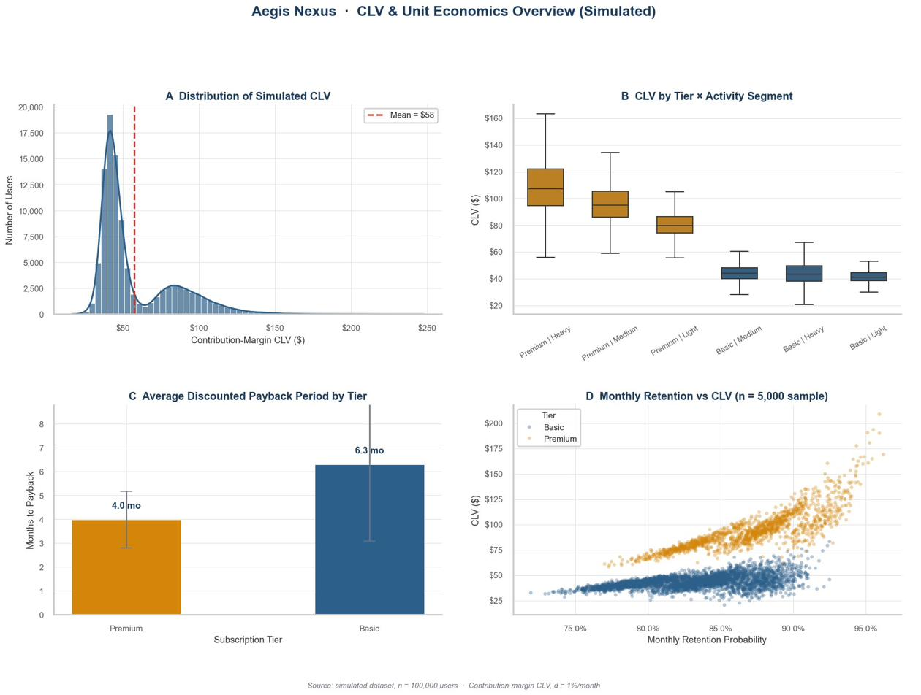
Figure A-1. CLV and unit economics overview. Source: Marketing_Individual.ipynb.
A.8.3 Payback-Period Cumulative Distribution
Figure A-2 reports the cumulative distribution of discounted payback period by subscription tier. 100% of Premium users pay back within 12 months; 93% of Basic users do so in the same window. The gap motivates concentrating Phase-1 spend on Premium-Heavy users, whose payback tail is effectively absent under base-case assumptions.
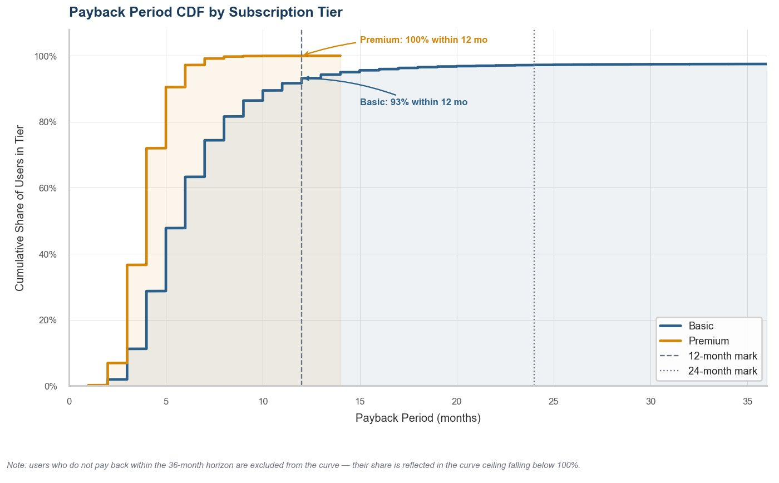
Figure A-2. Payback-period CDF by subscription tier. Source: Marketing_Individual.ipynb.
A.9 Sensitivity Analysis
Five scenarios stress-test the base case. Each shifts a single lever while holding all others constant, re-runs the full CLV computation, and reports portfolio average CLV.
# Cell 7a — scenario definitions and evaluation
scenarios = [
('Base case', 0.00, 1.00, tier_mix['Premium']),
('Retention -3 pp', -0.03, 1.00, tier_mix['Premium']),
('Retention +2 pp', 0.02, 1.00, tier_mix['Premium']),
('Infrastructure cost +20%', 0.00, 1.20, tier_mix['Premium']),
('Premium adoption rises to 35%', 0.00, 1.00, 0.35),
]
for label, ret_shift, infra_mult, prem_share in scenarios:
s_retention = np.clip(users['monthly_retention_prob'] + ret_shift, 0.55, 0.98)
s_margin = users['monthly_price'] - (users['monthly_infrastructure_cost'] * infra_mult)
s_clv = discounted_clv(s_margin, s_retention, MONTHLY_DISCOUNT_RATE)
# aggregate by tier, apply premium-share re-weighting for portfolio average ...

A -3 pp shock to retention reduces portfolio CLV by $9.81 per user; a +20% infrastructure cost increase reduces it by only $6.09. Retention is the dominant lever.
Scenario | Portfolio avg CLV | Delta vs. base | Share payback <= 12 mo
Base case | $57.52 | - | 95.1%
Retention - 3 pp | $47.71 | - $9.81 | 92.4%
Retention + 2 pp | $67.05 | + $9.53 | 96.3%
Infrastructure cost + 20% | $51.43 | - $6.09 | 93.2%
Premium adoption rises to 35% | $62.60 | + $5.08 | 95.8%
Table A-3. Sensitivity of portfolio CLV to five scenarios.
A.10 Measurement Plan and A/B Test Design
The measurement plan has two components: a three-tier KPI framework with targets derived from the base-case simulation, and an A/B test targeting D30 retention — the dominant lever from Section A.9.
A.10.1 KPI Framework
Tier | KPI | Target / guardrail | Cadence
North Star | Portfolio contribution-margin CLV | >= $57.52 (base-case mean) | Monthly
North Star | CLV-to-CAC ratio | >= 2.0 x (human-set floor) | Monthly
Weekly Ops | Monthly paid subscriber count | Track trend; no hard floor at launch | Weekly
Weekly Ops | Blended CPI (cost per install) | <= $29.24 (base-case CAC) | Weekly
Weekly Ops | D30 retention rate | >= 85.4% (base-case mean) | Weekly
Weekly Ops | Median payback period | <= 9 months (base-case median) | Weekly
Diagnostic | Premium tier conversion rate | >= 28% (base-case share) | Monthly
Diagnostic | Churn-model precision at operating threshold | >= 0.70 | Monthly
Diagnostic | Infrastructure cost per user per month | <= $6.52 (base-case mean) | Monthly
Table A-4. KPI framework with simulation-derived targets. Exported to table_kpi_dashboard.csv.
A.10.2 A/B Test Design
Element | Specification
Control arm | Standard video ad -> install
Treatment arm | Playable ad (60-second streamed demo) -> install
Primary metric | D30 retention rate
Secondary metric | CPI (cost per install)
Target segment | Premium | Heavy (Priority acquisition segment)
Platform | Meta Advantage+, ad-format split under matched targeting
Minimum detectable effect (MDE) | + 3 percentage points on D30 retention
Significance level (alpha) | 0.05, two-sided
Statistical power (1 - beta) | 0.80
Allocation | 50 / 50 control / treatment
Test method | Two-proportion z-test (normal approximation)
Table A-5. A/B test specification.
A.10.3 Sample-Size Calculation
# Cell 11b — two-proportion z-test power calculation
from scipy import stats

p_control = users.loc[
(users['subscription_tier'] == 'Premium') & (users['activity_level'] == 'Heavy'),
'monthly_retention_prob'].mean()

MDE_PP = 0.03
p_treatment = p_control + MDE_PP
ALPHA, POWER = 0.05, 0.80

z_alpha2 = stats.norm.ppf(1 - ALPHA / 2) # = 1.96
z_beta = stats.norm.ppf(POWER) # = 0.842

n_per_arm = math.ceil(
(z_alpha2 + z_beta) ** 2 *
(p_control * (1 - p_control) + p_treatment * (1 - p_treatment)) /
(p_treatment - p_control) ** 2
)

Decision rule: if the observed D30 lift is at least the MDE and the p-value is below 0.05, playable ads are scaled as the primary creative format for Phase-2 expansion.

A.11 Supplementary Tables
The following tables are produced by the notebook but not reproduced in the main report body.
A.11.1 Retention and Infrastructure Cost Parameters by Segment
Tier | Activity | Retention mean | Retention SD | Infra cost mean ($/mo) | Infra cost SD
Basic | Light | 0.79 | 0.020 | $3.00 | 0.45
Basic | Medium | 0.84 | 0.018 | $4.60 | 0.65
Basic | Heavy | 0.88 | 0.015 | $6.40 | 0.90
Premium | Light | 0.83 | 0.020 | $4.80 | 0.45
Premium | Medium | 0.88 | 0.018 | $6.80 | 0.65
Premium | Heavy | 0.92 | 0.015 | $9.40 | 0.90
Table A-6. Segment-level retention and infrastructure cost parameters driving the DGP.
A.11.2 Segment Unit Economics (Base Case)
Tier | Activity | Avg CLV | Avg CAC | CLV-to-CAC | Payback (mo) | Targeting tier
Premium | Heavy | $110.44 | $35 | 3.32 x | 4.9 | Priority
Premium | Medium | $96.76 | $35 | 2.93 x | 3.9 | Priority
Premium | Light | $80.77 | $35 | 2.43 x | 3.6 | Priority
Basic | Medium | $44.41 | $27 | 1.74 x | 6.2 | Secondary
Basic | Heavy | $44.11 | $27 | 1.73 x | 8.3 | Secondary
Basic | Light | $41.65 | $27 | 1.63 x | 5.3 | Secondary
Table A-7. Full 2-by-3 segment grid.
A.11.3 AI-in-Marketing Framework — Human-in-the-Loop Design
Marketing function | Automated by AI | Requires human judgment | Key data inputs
Paid acquisition bid optimisation | Real-time CPI bid adjustments within approved per-segment CAC ceiling; creative rotation; budget pacing. | Marketers set CAC ceiling per segment from CLV-to-CAC floors. Any ceiling change requires human approval. | Impression-level auction data; in-app events (install, trial start, subscription); segment labels.
Ad creative generation | Generating playable-ad A/B variants; automatic rejection of low-CTR creatives after minimum impression threshold. | Creative director approves all new concepts before live deployment; final variant selection is a human decision. | Historical CTR / CVR by creative; brand guidelines; competitor creative signals.
Retention and churn management | Monthly churn scoring; automated push notifications when churn probability exceeds threshold; threshold re-calibrated monthly. | Human sets churn probability threshold and offer parameters. Premium-Heavy at-risk users routed to manual review. | In-app session data (play hours, frequency, last-active); subscription age; tier; device specs.
Table A-8. AI-in-Marketing framework with explicit human-in-the-loop boundaries.

