Optimization of the regression CpG

Guannan Shen

October 14, 2018

Table of Contents

## set up workspace  
library(knitr)  
library(tidyverse)  
options(stringsAsFactors = F)  
options(dplyr.width = Inf)  
getwd()

## [1] "/home/guanshim/Documents/gitlab/ECCHO_github/Code"

"%nin%" <- Negate("%in%")

## [1] 588 320

## [1] 10002 10004 10010 10012 10014 10015

## [1] 10661 10696 10723 10791 11408

## [1] 583 320

## [1] 305 320

## [1] 278 320

## [1] "cg16884940"

## [1] "cg16884940 are not in the TOP300 M values CpG list"

## [1] 583 140

## [1] "now the CpGs are 120 and whole sample size is 583"

## [1] 305 140

## [1] 278 140

################################################## fix the kable format with lapply ########## add the  
################################################## male/female tag ########## function for 1 out of 300 CpGs  
################################################## and other covariates equal length of outcomes and  
################################################## covariates  
cpg_reg <- function(outcome, data, name, Topn, Gender, ncpg) {  
   
 ## outcome lm  
 outcome_lm = lapply(21:(ncpg + 20), function(i) {  
 lm = lm(outcome ~ data[, i] + maternal_age + race_4 +   
 Bcell + CD4T + CD8T + Gran + Mono + NK + nRBC, data = data)  
 coef = round(summary(lm)$coefficients[2, ], 4)  
 return(coef)  
 })  
 outcome_lm = data.frame(matrix(unlist(outcome_lm), ncol = 4,   
 byrow = TRUE, dimnames = list(c(colnames(data)[21:(ncpg +   
 20)]), c("Estimate", "Std.Error", "t.statistic",   
 "p.value"))))  
   
 # adjusted p-value  
 outcome_lm = outcome_lm %>% mutate(FDR = p.adjust(p.value,   
 "BH", ncpg), names = colnames(data)[21:(ncpg + 20)]) %>%   
 select(names, everything())  
 # sort by p.value  
 outcome_lm = outcome_lm[order(outcome_lm$p.value), ]  
   
 ## sample size  
 size = length(outcome) - sum(is.na(outcome))  
   
 ## summary table  
 kable(head(outcome_lm, Topn), caption = paste("Top10 CpGs from ",   
 ncpg, " for ", name, " of ", Gender, " by p.value", " (Sample Size = ",   
 size, ") ", sep = "", collapse = ""))  
   
}  
  
## test with birthweight_ no log tran outcome, data, name,  
## Topn cpg_reg(pfas_male$birth_weight, pfas_male,  
## 'birth_weight', 10, 'Male')  
  
## outcomes 'birth_weight', 'ipv3_pp_fm_pct', 'Chol_IPV3',  
## 'FFA_IPV3', 'Gluc_IPV3', 'HDL_IPV3', 'Insu_IPV3'  
## 'Trig_IPV3', 'Leptin_actual__ng_ml_'  
Outcomes <- colnames(pfas_male)[5:13]  
  
# the regression summary table for original outcomes  
lapply(Outcomes, function(x) {  
 cpg_reg(pfas_male[, x], pfas_male, x, 10, "Male", 300)  
})

[[1]]

Top10 CpGs from 300 for birth_weight of Male by p.value (Sample Size = 305)

|  |  |  |  |  |  |  |
| --- | --- | --- | --- | --- | --- | --- |
|  | names | Estimate | Std.Error | t.statistic | p.value | FDR |
| 67 | cg25195288 | 617.5309 | 178.8037 | 3.4537 | 0.0006 | 0.105 |
| 49 | cg16725984 | -214.4233 | 62.3691 | -3.4380 | 0.0007 | 0.105 |
| 167 | cg16495448 | -322.2102 | 114.9889 | -2.8021 | 0.0054 | 0.540 |
| 184 | cg25137968 | 321.1630 | 121.5742 | 2.6417 | 0.0087 | 0.546 |
| 71 | cg16672637 | 682.8201 | 260.0944 | 2.6253 | 0.0091 | 0.546 |
| 22 | cg00784263 | 324.0121 | 130.1053 | 2.4904 | 0.0133 | 0.588 |
| 204 | cg15045292 | 143.5404 | 58.8695 | 2.4383 | 0.0154 | 0.588 |
| 115 | cg10436026 | -315.9962 | 132.3827 | -2.3870 | 0.0176 | 0.588 |
| 83 | cg20741567 | 485.0189 | 205.0994 | 2.3648 | 0.0187 | 0.588 |
| 160 | cg07338658 | 222.4751 | 94.8196 | 2.3463 | 0.0196 | 0.588 |

[[2]]

Top10 CpGs from 300 for ipv3_pp_fm_pct of Male by p.value (Sample Size = 292)

|  |  |  |  |  |  |  |
| --- | --- | --- | --- | --- | --- | --- |
|  | names | Estimate | Std.Error | t.statistic | p.value | FDR |
| 190 | cg10832304 | -1.3764 | 0.4887 | -2.8164 | 0.0052 | 0.8300000 |
| 112 | cg24366087 | -2.8604 | 1.0272 | -2.7846 | 0.0057 | 0.8300000 |
| 139 | cg08743751 | 2.4044 | 0.9045 | 2.6583 | 0.0083 | 0.8300000 |
| 203 | cg15066197 | -2.7461 | 1.1057 | -2.4836 | 0.0136 | 0.8577273 |
| 145 | cg06404838 | -3.2570 | 1.4188 | -2.2956 | 0.0224 | 0.8577273 |
| 78 | cg17878951 | -2.7455 | 1.2236 | -2.2438 | 0.0256 | 0.8577273 |
| 282 | cg08732300 | 1.7152 | 0.7712 | 2.2242 | 0.0269 | 0.8577273 |
| 205 | cg12149692 | -1.6533 | 0.7551 | -2.1895 | 0.0294 | 0.8577273 |
| 171 | cg09461851 | 2.7168 | 1.2644 | 2.1488 | 0.0325 | 0.8577273 |
| 106 | cg24833819 | 1.4435 | 0.6961 | 2.0738 | 0.0390 | 0.8577273 |

[[3]]

Top10 CpGs from 300 for Chol_IPV3 of Male by p.value (Sample Size = 287)

|  |  |  |  |  |  |  |
| --- | --- | --- | --- | --- | --- | --- |
|  | names | Estimate | Std.Error | t.statistic | p.value | FDR |
| 254 | cg22692511 | 7.3339 | 2.3245 | 3.1551 | 0.0018 | 0.4500000 |
| 266 | cg12857407 | 12.7608 | 4.3384 | 2.9414 | 0.0035 | 0.4500000 |
| 112 | cg24366087 | -13.4676 | 4.7067 | -2.8614 | 0.0045 | 0.4500000 |
| 271 | cg08162803 | 13.9785 | 5.2616 | 2.6567 | 0.0084 | 0.6300000 |
| 95 | cg17850055 | -25.2736 | 9.9181 | -2.5482 | 0.0114 | 0.6550000 |
| 49 | cg16725984 | 5.8155 | 2.3296 | 2.4964 | 0.0131 | 0.6550000 |
| 188 | cg17500055 | -7.5809 | 3.4673 | -2.1864 | 0.0296 | 0.9558301 |
| 279 | cg17132124 | 7.8791 | 3.6082 | 2.1837 | 0.0298 | 0.9558301 |
| 28 | cg12872489 | -6.6322 | 3.1104 | -2.1323 | 0.0339 | 0.9558301 |
| 211 | cg00893875 | 3.1589 | 1.5298 | 2.0648 | 0.0399 | 0.9558301 |

[[4]]

Top10 CpGs from 300 for FFA_IPV3 of Male by p.value (Sample Size = 265)

|  |  |  |  |  |  |  |
| --- | --- | --- | --- | --- | --- | --- |
|  | names | Estimate | Std.Error | t.statistic | p.value | FDR |
| 96 | cg21215576 | 85.5313 | 31.5071 | 2.7147 | 0.0071 | 0.7233333 |
| 4 | cg21853587 | -169.4280 | 63.6719 | -2.6610 | 0.0083 | 0.7233333 |
| 163 | cg26074111 | -137.5420 | 52.6373 | -2.6130 | 0.0095 | 0.7233333 |
| 156 | cg13858106 | 115.1969 | 47.6076 | 2.4197 | 0.0162 | 0.7233333 |
| 148 | cg13598480 | 98.4861 | 41.4387 | 2.3767 | 0.0182 | 0.7233333 |
| 9 | cg20510724 | 173.5722 | 73.2384 | 2.3700 | 0.0185 | 0.7233333 |
| 257 | cg16529483 | 37.7580 | 15.9996 | 2.3599 | 0.0190 | 0.7233333 |
| 54 | cg19529074 | -97.7491 | 44.5172 | -2.1958 | 0.0290 | 0.7233333 |
| 166 | cg26275850 | 99.8055 | 46.0601 | 2.1669 | 0.0312 | 0.7233333 |
| 126 | cg05390685 | -69.1883 | 32.2068 | -2.1483 | 0.0326 | 0.7233333 |

[[5]]

Top10 CpGs from 300 for Gluc_IPV3 of Male by p.value (Sample Size = 295)

|  |  |  |  |  |  |  |
| --- | --- | --- | --- | --- | --- | --- |
|  | names | Estimate | Std.Error | t.statistic | p.value | FDR |
| 145 | cg06404838 | 27.8293 | 8.5762 | 3.2449 | 0.0013 | 0.390 |
| 248 | cg11196848 | -15.4932 | 5.6032 | -2.7651 | 0.0061 | 0.915 |
| 27 | cg17519749 | 11.9003 | 4.5717 | 2.6030 | 0.0097 | 0.957 |
| 59 | cg20324199 | 11.7255 | 5.0620 | 2.3164 | 0.0213 | 0.957 |
| 150 | cg14163408 | 11.2703 | 4.9082 | 2.2962 | 0.0224 | 0.957 |
| 16 | cg06873590 | -32.8116 | 14.6902 | -2.2336 | 0.0263 | 0.957 |
| 217 | cg01816336 | -18.6640 | 8.3752 | -2.2285 | 0.0266 | 0.957 |
| 135 | cg17171260 | -15.4994 | 6.9575 | -2.2277 | 0.0267 | 0.957 |
| 77 | cg23478547 | 8.0446 | 3.7237 | 2.1603 | 0.0316 | 0.957 |
| 287 | cg26781129 | 11.1011 | 5.1475 | 2.1566 | 0.0319 | 0.957 |

[[6]]

Top10 CpGs from 300 for HDL_IPV3 of Male by p.value (Sample Size = 261)

|  |  |  |  |  |  |  |
| --- | --- | --- | --- | --- | --- | --- |
|  | names | Estimate | Std.Error | t.statistic | p.value | FDR |
| 49 | cg16725984 | 3.1869 | 1.0240 | 3.1122 | 0.0021 | 0.420 |
| 42 | cg15355952 | -6.0829 | 2.0162 | -3.0171 | 0.0028 | 0.420 |
| 236 | cg04061372 | 1.8844 | 0.6629 | 2.8427 | 0.0048 | 0.480 |
| 271 | cg08162803 | 5.7800 | 2.3310 | 2.4796 | 0.0138 | 0.624 |
| 52 | cg19549232 | 5.4550 | 2.2171 | 2.4604 | 0.0146 | 0.624 |
| 290 | cg00798281 | -3.8588 | 1.5881 | -2.4298 | 0.0158 | 0.624 |
| 211 | cg00893875 | 1.6940 | 0.7023 | 2.4122 | 0.0166 | 0.624 |
| 26 | cg03452190 | 6.7903 | 2.8704 | 2.3656 | 0.0188 | 0.624 |
| 145 | cg06404838 | -6.7840 | 2.8739 | -2.3605 | 0.0190 | 0.624 |
| 281 | cg22946159 | -7.7197 | 3.3193 | -2.3257 | 0.0208 | 0.624 |

[[7]]

Top10 CpGs from 300 for Insu_IPV3 of Male by p.value (Sample Size = 282)

|  |  |  |  |  |  |  |
| --- | --- | --- | --- | --- | --- | --- |
|  | names | Estimate | Std.Error | t.statistic | p.value | FDR |
| 169 | cg17501712 | 9.4827 | 2.9603 | 3.2033 | 0.0015 | 0.45000 |
| 233 | cg02887248 | -12.1537 | 4.9282 | -2.4662 | 0.0143 | 0.97275 |
| 61 | cg04569429 | 5.2440 | 2.1851 | 2.3998 | 0.0171 | 0.97275 |
| 242 | cg06922635 | 4.8725 | 2.0975 | 2.3230 | 0.0209 | 0.97275 |
| 141 | cg04476891 | 5.8881 | 2.6196 | 2.2477 | 0.0254 | 0.97275 |
| 199 | cg21261158 | -9.0426 | 4.1281 | -2.1905 | 0.0293 | 0.97275 |
| 195 | cg23785275 | -1.5089 | 0.7142 | -2.1128 | 0.0355 | 0.97275 |
| 191 | cg25138412 | -3.3363 | 1.6094 | -2.0730 | 0.0391 | 0.97275 |
| 20 | cg00210042 | 7.8195 | 3.8186 | 2.0478 | 0.0416 | 0.97275 |
| 259 | cg06407657 | -4.7374 | 2.4084 | -1.9670 | 0.0502 | 0.97275 |

[[8]]

Top10 CpGs from 300 for Trig_IPV3 of Male by p.value (Sample Size = 284)

|  |  |  |  |  |  |  |
| --- | --- | --- | --- | --- | --- | --- |
|  | names | Estimate | Std.Error | t.statistic | p.value | FDR |
| 291 | cg09630142 | -28.5560 | 8.8703 | -3.2193 | 0.0014 | 0.4200000 |
| 19 | cg00128386 | 46.0613 | 19.1020 | 2.4113 | 0.0166 | 0.9601351 |
| 221 | cg19682786 | -34.4736 | 14.6589 | -2.3517 | 0.0194 | 0.9601351 |
| 259 | cg06407657 | -23.2915 | 10.5568 | -2.2063 | 0.0282 | 0.9601351 |
| 277 | cg05227616 | -27.5430 | 12.5315 | -2.1979 | 0.0288 | 0.9601351 |
| 72 | cg16659510 | -34.0438 | 15.8133 | -2.1529 | 0.0322 | 0.9601351 |
| 160 | cg07338658 | -20.5353 | 9.5978 | -2.1396 | 0.0333 | 0.9601351 |
| 197 | cg14349977 | -13.9236 | 6.5433 | -2.1279 | 0.0342 | 0.9601351 |
| 50 | cg27124293 | 16.5983 | 7.8096 | 2.1254 | 0.0345 | 0.9601351 |
| 95 | cg17850055 | -51.3194 | 26.7983 | -1.9150 | 0.0565 | 0.9601351 |

[[9]]

Top10 CpGs from 300 for Leptin_actual_*ng_ml* of Male by p.value (Sample Size = 252)

|  |  |  |  |  |  |  |
| --- | --- | --- | --- | --- | --- | --- |
|  | names | Estimate | Std.Error | t.statistic | p.value | FDR |
| 49 | cg16725984 | -6.7660 | 1.9892 | -3.4013 | 0.0008 | 0.24 |
| 22 | cg00784263 | 12.7822 | 4.0909 | 3.1245 | 0.0020 | 0.30 |
| 134 | cg05906144 | 7.5689 | 2.8135 | 2.6903 | 0.0076 | 0.51 |
| 209 | cg24280832 | 9.6746 | 3.6116 | 2.6787 | 0.0079 | 0.51 |
| 19 | cg00128386 | -16.7009 | 6.2969 | -2.6523 | 0.0085 | 0.51 |
| 135 | cg17171260 | -11.0590 | 4.4405 | -2.4905 | 0.0134 | 0.57 |
| 104 | cg10119082 | -5.4035 | 2.2213 | -2.4325 | 0.0157 | 0.57 |
| 116 | cg21183455 | 5.2068 | 2.1589 | 2.4117 | 0.0166 | 0.57 |
| 85 | cg23572459 | -15.4853 | 6.4529 | -2.3997 | 0.0172 | 0.57 |
| 260 | cg17284440 | -18.8377 | 7.9789 | -2.3609 | 0.0190 | 0.57 |

## raw outcomes  
par(mfrow = c(2, 2))  
lapply(Outcomes, function(x) {  
 hist(pfas_male[, x], freq = TRUE, breaks = 30, main = paste(x,   
 " (Male)", sep = ""), xlab = x)  
})

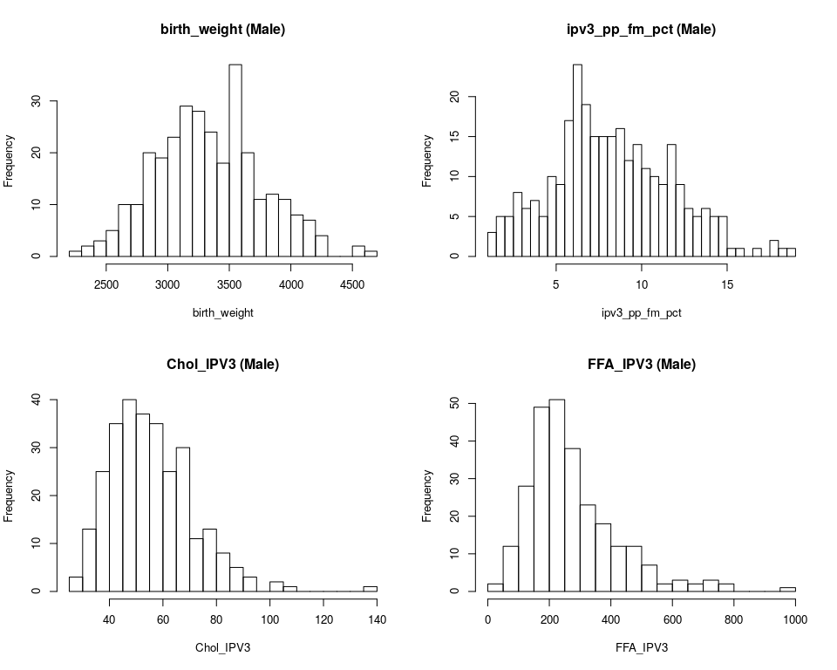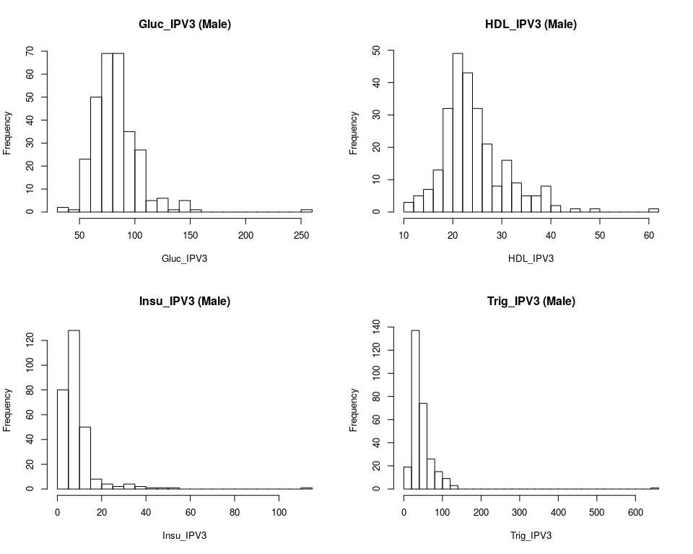[[1]] $breaks [1] 2200 2300 2400 2500 2600 2700 2800 2900 3000 3100 3200 3300 3400 3500 [15] 3600 3700 3800 3900 4000 4100 4200 4300 4400 4500 4600 4700

$counts [1] 1 2 3 5 10 10 20 19 23 29 28 24 18 37 20 11 12 11 8 7 4 0 0 [24] 2 1

$density [1] 3.278689e-05 6.557377e-05 9.836066e-05 1.639344e-04 3.278689e-04 [6] 3.278689e-04 6.557377e-04 6.229508e-04 7.540984e-04 9.508197e-04 [11] 9.180328e-04 7.868852e-04 5.901639e-04 1.213115e-03 6.557377e-04 [16] 3.606557e-04 3.934426e-04 3.606557e-04 2.622951e-04 2.295082e-04 [21] 1.311475e-04 0.000000e+00 0.000000e+00 6.557377e-05 3.278689e-05

$mids [1] 2250 2350 2450 2550 2650 2750 2850 2950 3050 3150 3250 3350 3450 3550 [15] 3650 3750 3850 3950 4050 4150 4250 4350 4450 4550 4650

$xname [1] “pfas_male[, x]”

$equidist [1] TRUE

attr(,“class”) [1] “histogram”

[[2]] $breaks [1] 1.0 1.5 2.0 2.5 3.0 3.5 4.0 4.5 5.0 5.5 6.0 6.5 7.0 7.5 [15] 8.0 8.5 9.0 9.5 10.0 10.5 11.0 11.5 12.0 12.5 13.0 13.5 14.0 14.5 [29] 15.0 15.5 16.0 16.5 17.0 17.5 18.0 18.5 19.0

$counts [1] 3 5 5 8 6 7 5 10 9 17 24 19 15 15 15 16 12 14 11 10 9 14 9 [24] 6 5 6 5 5 1 1 0 1 0 2 1 1

$density [1] 0.020547945 0.034246575 0.034246575 0.054794521 0.041095890 [6] 0.047945205 0.034246575 0.068493151 0.061643836 0.116438356 [11] 0.164383562 0.130136986 0.102739726 0.102739726 0.102739726 [16] 0.109589041 0.082191781 0.095890411 0.075342466 0.068493151 [21] 0.061643836 0.095890411 0.061643836 0.041095890 0.034246575 [26] 0.041095890 0.034246575 0.034246575 0.006849315 0.006849315 [31] 0.000000000 0.006849315 0.000000000 0.013698630 0.006849315 [36] 0.006849315

$mids [1] 1.25 1.75 2.25 2.75 3.25 3.75 4.25 4.75 5.25 5.75 6.25 [12] 6.75 7.25 7.75 8.25 8.75 9.25 9.75 10.25 10.75 11.25 11.75 [23] 12.25 12.75 13.25 13.75 14.25 14.75 15.25 15.75 16.25 16.75 17.25 [34] 17.75 18.25 18.75

$xname [1] “pfas_male[, x]”

$equidist [1] TRUE

attr(,“class”) [1] “histogram”

[[3]] $breaks [1] 25 30 35 40 45 50 55 60 65 70 75 80 85 90 95 100 105 [18] 110 115 120 125 130 135 140

$counts [1] 3 13 25 35 40 37 35 25 30 11 13 8 5 3 0 2 1 0 0 0 0 0 1

$density [1] 0.0020905923 0.0090592334 0.0174216028 0.0243902439 0.0278745645 [6] 0.0257839721 0.0243902439 0.0174216028 0.0209059233 0.0076655052 [11] 0.0090592334 0.0055749129 0.0034843206 0.0020905923 0.0000000000 [16] 0.0013937282 0.0006968641 0.0000000000 0.0000000000 0.0000000000 [21] 0.0000000000 0.0000000000 0.0006968641

$mids [1] 27.5 32.5 37.5 42.5 47.5 52.5 57.5 62.5 67.5 72.5 77.5 [12] 82.5 87.5 92.5 97.5 102.5 107.5 112.5 117.5 122.5 127.5 132.5 [23] 137.5

$xname [1] “pfas_male[, x]”

$equidist [1] TRUE

attr(,“class”) [1] “histogram”

[[4]] $breaks [1] 0 50 100 150 200 250 300 350 400 450 500 550 600 650 [15] 700 750 800 850 900 950 1000

$counts [1] 2 12 28 49 51 38 23 18 12 12 7 2 3 2 3 2 0 0 0 1

$density [1] 0.0001509434 0.0009056604 0.0021132075 0.0036981132 0.0038490566 [6] 0.0028679245 0.0017358491 0.0013584906 0.0009056604 0.0009056604 [11] 0.0005283019 0.0001509434 0.0002264151 0.0001509434 0.0002264151 [16] 0.0001509434 0.0000000000 0.0000000000 0.0000000000 0.0000754717

$mids [1] 25 75 125 175 225 275 325 375 425 475 525 575 625 675 725 775 825 [18] 875 925 975

$xname [1] “pfas_male[, x]”

$equidist [1] TRUE

attr(,“class”) [1] “histogram”

[[5]] $breaks [1] 30 40 50 60 70 80 90 100 110 120 130 140 150 160 170 180 190 [18] 200 210 220 230 240 250 260

$counts [1] 2 1 23 50 69 69 35 27 5 6 1 5 1 0 0 0 0 0 0 0 0 0 1

$density [1] 0.0006779661 0.0003389831 0.0077966102 0.0169491525 0.0233898305 [6] 0.0233898305 0.0118644068 0.0091525424 0.0016949153 0.0020338983 [11] 0.0003389831 0.0016949153 0.0003389831 0.0000000000 0.0000000000 [16] 0.0000000000 0.0000000000 0.0000000000 0.0000000000 0.0000000000 [21] 0.0000000000 0.0000000000 0.0003389831

$mids [1] 35 45 55 65 75 85 95 105 115 125 135 145 155 165 175 185 195 [18] 205 215 225 235 245 255

$xname [1] “pfas_male[, x]”

$equidist [1] TRUE

attr(,“class”) [1] “histogram”

[[6]] $breaks [1] 10 12 14 16 18 20 22 24 26 28 30 32 34 36 38 40 42 44 46 48 50 52 54 [24] 56 58 60 62

$counts [1] 3 5 7 13 32 49 43 32 21 8 16 9 5 5 8 2 0 1 0 1 0 0 0 [24] 0 0 1

$density [1] 0.005747126 0.009578544 0.013409962 0.024904215 0.061302682 [6] 0.093869732 0.082375479 0.061302682 0.040229885 0.015325670 [11] 0.030651341 0.017241379 0.009578544 0.009578544 0.015325670 [16] 0.003831418 0.000000000 0.001915709 0.000000000 0.001915709 [21] 0.000000000 0.000000000 0.000000000 0.000000000 0.000000000 [26] 0.001915709

$mids [1] 11 13 15 17 19 21 23 25 27 29 31 33 35 37 39 41 43 45 47 49 51 53 55 [24] 57 59 61

$xname [1] “pfas_male[, x]”

$equidist [1] TRUE

attr(,“class”) [1] “histogram”

[[7]] $breaks [1] 0 5 10 15 20 25 30 35 40 45 50 55 60 65 70 75 80 [18] 85 90 95 100 105 110 115

$counts [1] 80 128 50 8 4 2 4 2 1 1 1 0 0 0 0 0 0 [18] 0 0 0 0 0 1

$density [1] 0.0567375887 0.0907801418 0.0354609929 0.0056737589 0.0028368794 [6] 0.0014184397 0.0028368794 0.0014184397 0.0007092199 0.0007092199 [11] 0.0007092199 0.0000000000 0.0000000000 0.0000000000 0.0000000000 [16] 0.0000000000 0.0000000000 0.0000000000 0.0000000000 0.0000000000 [21] 0.0000000000 0.0000000000 0.0007092199

$mids [1] 2.5 7.5 12.5 17.5 22.5 27.5 32.5 37.5 42.5 47.5 52.5 [12] 57.5 62.5 67.5 72.5 77.5 82.5 87.5 92.5 97.5 102.5 107.5 [23] 112.5

$xname [1] “pfas_male[, x]”

$equidist [1] TRUE

attr(,“class”) [1] “histogram”

[[8]] $breaks [1] 0 20 40 60 80 100 120 140 160 180 200 220 240 260 280 300 320 [18] 340 360 380 400 420 440 460 480 500 520 540 560 580 600 620 640 660

$counts [1] 19 137 74 26 15 9 3 0 0 0 0 0 0 0 0 0 0 [18] 0 0 0 0 0 0 0 0 0 0 0 0 0 0 0 1

$density [1] 0.0033450704 0.0241197183 0.0130281690 0.0045774648 0.0026408451 [6] 0.0015845070 0.0005281690 0.0000000000 0.0000000000 0.0000000000 [11] 0.0000000000 0.0000000000 0.0000000000 0.0000000000 0.0000000000 [16] 0.0000000000 0.0000000000 0.0000000000 0.0000000000 0.0000000000 [21] 0.0000000000 0.0000000000 0.0000000000 0.0000000000 0.0000000000 [26] 0.0000000000 0.0000000000 0.0000000000 0.0000000000 0.0000000000 [31] 0.0000000000 0.0000000000 0.0001760563

$mids [1] 10 30 50 70 90 110 130 150 170 190 210 230 250 270 290 310 330 [18] 350 370 390 410 430 450 470 490 510 530 550 570 590 610 630 650

$xname [1] “pfas_male[, x]”

$equidist [1] TRUE

attr(,“class”) [1] “histogram”

[[9]] $breaks [1] 0 5 10 15 20 25 30 35 40 45 50 55 60 65 70 75 80 [18] 85 90 95 100 105 110 115 120 125 130

$counts [1] 60 79 38 21 18 16 10 4 1 3 0 1 0 0 0 0 0 0 0 0 0 0 0 [24] 0 0 1

$density [1] 0.0476190476 0.0626984127 0.0301587302 0.0166666667 0.0142857143 [6] 0.0126984127 0.0079365079 0.0031746032 0.0007936508 0.0023809524 [11] 0.0000000000 0.0007936508 0.0000000000 0.0000000000 0.0000000000 [16] 0.0000000000 0.0000000000 0.0000000000 0.0000000000 0.0000000000 [21] 0.0000000000 0.0000000000 0.0000000000 0.0000000000 0.0000000000 [26] 0.0007936508

$mids [1] 2.5 7.5 12.5 17.5 22.5 27.5 32.5 37.5 42.5 47.5 52.5 [12] 57.5 62.5 67.5 72.5 77.5 82.5 87.5 92.5 97.5 102.5 107.5 [23] 112.5 117.5 122.5 127.5

$xname [1] “pfas_male[, x]”

$equidist [1] TRUE

attr(,“class”) [1] “histogram”

## log10  
par(mfrow = c(2, 2))

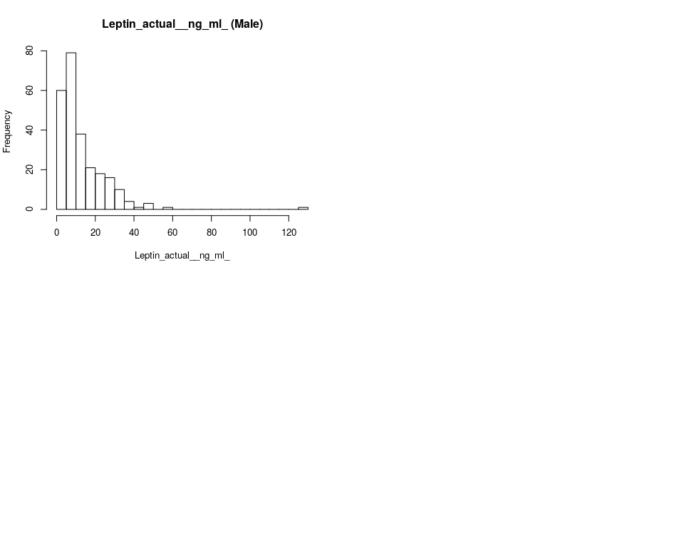

lapply(Outcomes, function(x) {  
 hist(log10(pfas_male[, x]), freq = TRUE, breaks = 30, main = paste(x,   
 " (Male log10)", sep = ""), xlab = x)  
})

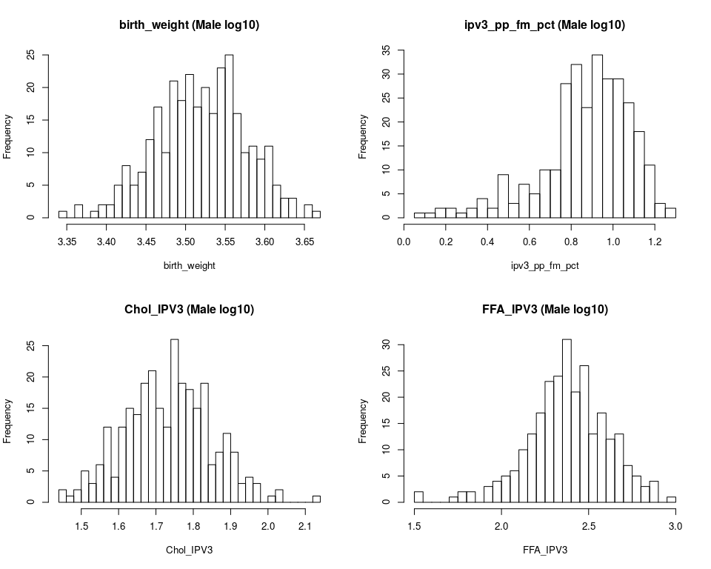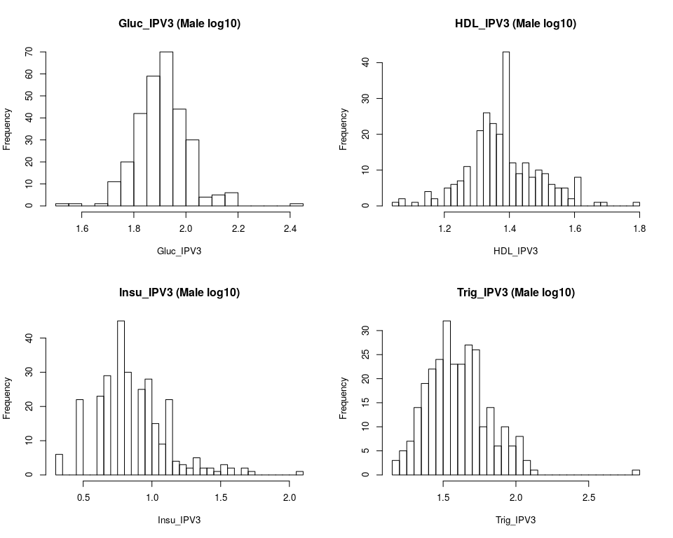[[1]] $breaks [1] 3.34 3.35 3.36 3.37 3.38 3.39 3.40 3.41 3.42 3.43 3.44 3.45 3.46 3.47 [15] 3.48 3.49 3.50 3.51 3.52 3.53 3.54 3.55 3.56 3.57 3.58 3.59 3.60 3.61 [29] 3.62 3.63 3.64 3.65 3.66 3.67

$counts [1] 1 0 2 0 1 2 2 5 8 5 7 12 17 10 21 18 22 17 20 16 23 25 16 [24] 10 11 9 11 5 3 3 0 2 1

$density [1] 0.3278689 0.0000000 0.6557377 0.0000000 0.3278689 0.6557377 0.6557377 [8] 1.6393443 2.6229508 1.6393443 2.2950820 3.9344262 5.5737705 3.2786885 [15] 6.8852459 5.9016393 7.2131148 5.5737705 6.5573770 5.2459016 7.5409836 [22] 8.1967213 5.2459016 3.2786885 3.6065574 2.9508197 3.6065574 1.6393443 [29] 0.9836066 0.9836066 0.0000000 0.6557377 0.3278689

$mids [1] 3.345 3.355 3.365 3.375 3.385 3.395 3.405 3.415 3.425 3.435 3.445 [12] 3.455 3.465 3.475 3.485 3.495 3.505 3.515 3.525 3.535 3.545 3.555 [23] 3.565 3.575 3.585 3.595 3.605 3.615 3.625 3.635 3.645 3.655 3.665

$xname [1] “log10(pfas_male[, x])”

$equidist [1] TRUE

attr(,“class”) [1] “histogram”

[[2]] $breaks [1] 0.05 0.10 0.15 0.20 0.25 0.30 0.35 0.40 0.45 0.50 0.55 0.60 0.65 0.70 [15] 0.75 0.80 0.85 0.90 0.95 1.00 1.05 1.10 1.15 1.20 1.25 1.30

$counts [1] 1 1 2 2 1 2 4 2 9 3 7 5 10 10 28 32 23 34 29 29 24 18 11 [24] 3 2

$density [1] 0.06849315 0.06849315 0.13698630 0.13698630 0.06849315 0.13698630 [7] 0.27397260 0.13698630 0.61643836 0.20547945 0.47945205 0.34246575 [13] 0.68493151 0.68493151 1.91780822 2.19178082 1.57534247 2.32876712 [19] 1.98630137 1.98630137 1.64383562 1.23287671 0.75342466 0.20547945 [25] 0.13698630

$mids [1] 0.075 0.125 0.175 0.225 0.275 0.325 0.375 0.425 0.475 0.525 0.575 [12] 0.625 0.675 0.725 0.775 0.825 0.875 0.925 0.975 1.025 1.075 1.125 [23] 1.175 1.225 1.275

$xname [1] “log10(pfas_male[, x])”

$equidist [1] TRUE

attr(,“class”) [1] “histogram”

[[3]] $breaks [1] 1.44 1.46 1.48 1.50 1.52 1.54 1.56 1.58 1.60 1.62 1.64 1.66 1.68 1.70 [15] 1.72 1.74 1.76 1.78 1.80 1.82 1.84 1.86 1.88 1.90 1.92 1.94 1.96 1.98 [29] 2.00 2.02 2.04 2.06 2.08 2.10 2.12 2.14

$counts [1] 2 1 2 5 3 6 12 4 12 15 14 19 21 15 12 26 19 18 15 19 6 8 11 [24] 8 3 4 3 0 1 2 0 0 0 0 1

$density [1] 0.3484321 0.1742160 0.3484321 0.8710801 0.5226481 1.0452962 2.0905923 [8] 0.6968641 2.0905923 2.6132404 2.4390244 3.3101045 3.6585366 2.6132404 [15] 2.0905923 4.5296167 3.3101045 3.1358885 2.6132404 3.3101045 1.0452962 [22] 1.3937282 1.9163763 1.3937282 0.5226481 0.6968641 0.5226481 0.0000000 [29] 0.1742160 0.3484321 0.0000000 0.0000000 0.0000000 0.0000000 0.1742160

$mids [1] 1.45 1.47 1.49 1.51 1.53 1.55 1.57 1.59 1.61 1.63 1.65 1.67 1.69 1.71 [15] 1.73 1.75 1.77 1.79 1.81 1.83 1.85 1.87 1.89 1.91 1.93 1.95 1.97 1.99 [29] 2.01 2.03 2.05 2.07 2.09 2.11 2.13

$xname [1] “log10(pfas_male[, x])”

$equidist [1] TRUE

attr(,“class”) [1] “histogram”

[[4]] $breaks [1] 1.50 1.55 1.60 1.65 1.70 1.75 1.80 1.85 1.90 1.95 2.00 2.05 2.10 2.15 [15] 2.20 2.25 2.30 2.35 2.40 2.45 2.50 2.55 2.60 2.65 2.70 2.75 2.80 2.85 [29] 2.90 2.95 3.00

$counts [1] 2 0 0 0 1 2 2 0 3 4 5 6 10 13 17 23 24 31 21 26 13 17 12 [24] 13 7 5 3 4 0 1

$density [1] 0.1509434 0.0000000 0.0000000 0.0000000 0.0754717 0.1509434 0.1509434 [8] 0.0000000 0.2264151 0.3018868 0.3773585 0.4528302 0.7547170 0.9811321 [15] 1.2830189 1.7358491 1.8113208 2.3396226 1.5849057 1.9622642 0.9811321 [22] 1.2830189 0.9056604 0.9811321 0.5283019 0.3773585 0.2264151 0.3018868 [29] 0.0000000 0.0754717

$mids [1] 1.525 1.575 1.625 1.675 1.725 1.775 1.825 1.875 1.925 1.975 2.025 [12] 2.075 2.125 2.175 2.225 2.275 2.325 2.375 2.425 2.475 2.525 2.575 [23] 2.625 2.675 2.725 2.775 2.825 2.875 2.925 2.975

$xname [1] “log10(pfas_male[, x])”

$equidist [1] TRUE

attr(,“class”) [1] “histogram”

[[5]] $breaks [1] 1.50 1.55 1.60 1.65 1.70 1.75 1.80 1.85 1.90 1.95 2.00 2.05 2.10 2.15 [15] 2.20 2.25 2.30 2.35 2.40 2.45

$counts [1] 1 1 0 1 11 20 42 59 70 44 30 4 5 6 0 0 0 0 1

$density [1] 0.06779661 0.06779661 0.00000000 0.06779661 0.74576271 1.35593220 [7] 2.84745763 4.00000000 4.74576271 2.98305085 2.03389831 0.27118644 [13] 0.33898305 0.40677966 0.00000000 0.00000000 0.00000000 0.00000000 [19] 0.06779661

$mids [1] 1.525 1.575 1.625 1.675 1.725 1.775 1.825 1.875 1.925 1.975 2.025 [12] 2.075 2.125 2.175 2.225 2.275 2.325 2.375 2.425

$xname [1] “log10(pfas_male[, x])”

$equidist [1] TRUE

attr(,“class”) [1] “histogram”

[[6]] $breaks [1] 1.04 1.06 1.08 1.10 1.12 1.14 1.16 1.18 1.20 1.22 1.24 1.26 1.28 1.30 [15] 1.32 1.34 1.36 1.38 1.40 1.42 1.44 1.46 1.48 1.50 1.52 1.54 1.56 1.58 [29] 1.60 1.62 1.64 1.66 1.68 1.70 1.72 1.74 1.76 1.78 1.80

$counts [1] 1 2 0 1 0 4 2 0 5 6 7 11 0 21 26 23 20 43 12 9 12 8 10 [24] 9 6 5 5 2 8 0 0 1 1 0 0 0 0 1

$density [1] 0.1915709 0.3831418 0.0000000 0.1915709 0.0000000 0.7662835 0.3831418 [8] 0.0000000 0.9578544 1.1494253 1.3409962 2.1072797 0.0000000 4.0229885 [15] 4.9808429 4.4061303 3.8314176 8.2375479 2.2988506 1.7241379 2.2988506 [22] 1.5325670 1.9157088 1.7241379 1.1494253 0.9578544 0.9578544 0.3831418 [29] 1.5325670 0.0000000 0.0000000 0.1915709 0.1915709 0.0000000 0.0000000 [36] 0.0000000 0.0000000 0.1915709

$mids [1] 1.05 1.07 1.09 1.11 1.13 1.15 1.17 1.19 1.21 1.23 1.25 1.27 1.29 1.31 [15] 1.33 1.35 1.37 1.39 1.41 1.43 1.45 1.47 1.49 1.51 1.53 1.55 1.57 1.59 [29] 1.61 1.63 1.65 1.67 1.69 1.71 1.73 1.75 1.77 1.79

$xname [1] “log10(pfas_male[, x])”

$equidist [1] TRUE

attr(,“class”) [1] “histogram”

[[7]] $breaks [1] 0.30 0.35 0.40 0.45 0.50 0.55 0.60 0.65 0.70 0.75 0.80 0.85 0.90 0.95 [15] 1.00 1.05 1.10 1.15 1.20 1.25 1.30 1.35 1.40 1.45 1.50 1.55 1.60 1.65 [29] 1.70 1.75 1.80 1.85 1.90 1.95 2.00 2.05 2.10

$counts [1] 6 0 0 22 0 0 23 29 0 45 30 0 25 28 15 9 22 4 3 2 5 2 2 [24] 1 3 2 0 2 1 0 0 0 0 0 0 1

$density [1] 0.42553191 0.00000000 0.00000000 1.56028369 0.00000000 0.00000000 [7] 1.63120567 2.05673759 0.00000000 3.19148936 2.12765957 0.00000000 [13] 1.77304965 1.98581560 1.06382979 0.63829787 1.56028369 0.28368794 [19] 0.21276596 0.14184397 0.35460993 0.14184397 0.14184397 0.07092199 [25] 0.21276596 0.14184397 0.00000000 0.14184397 0.07092199 0.00000000 [31] 0.00000000 0.00000000 0.00000000 0.00000000 0.00000000 0.07092199

$mids [1] 0.325 0.375 0.425 0.475 0.525 0.575 0.625 0.675 0.725 0.775 0.825 [12] 0.875 0.925 0.975 1.025 1.075 1.125 1.175 1.225 1.275 1.325 1.375 [23] 1.425 1.475 1.525 1.575 1.625 1.675 1.725 1.775 1.825 1.875 1.925 [34] 1.975 2.025 2.075

$xname [1] “log10(pfas_male[, x])”

$equidist [1] TRUE

attr(,“class”) [1] “histogram”

[[8]] $breaks [1] 1.15 1.20 1.25 1.30 1.35 1.40 1.45 1.50 1.55 1.60 1.65 1.70 1.75 1.80 [15] 1.85 1.90 1.95 2.00 2.05 2.10 2.15 2.20 2.25 2.30 2.35 2.40 2.45 2.50 [29] 2.55 2.60 2.65 2.70 2.75 2.80 2.85

$counts [1] 3 5 7 14 19 22 24 32 23 23 27 26 10 14 6 10 6 8 3 1 0 0 0 [24] 0 0 0 0 0 0 0 0 0 0 1

$density [1] 0.21126761 0.35211268 0.49295775 0.98591549 1.33802817 1.54929577 [7] 1.69014085 2.25352113 1.61971831 1.61971831 1.90140845 1.83098592 [13] 0.70422535 0.98591549 0.42253521 0.70422535 0.42253521 0.56338028 [19] 0.21126761 0.07042254 0.00000000 0.00000000 0.00000000 0.00000000 [25] 0.00000000 0.00000000 0.00000000 0.00000000 0.00000000 0.00000000 [31] 0.00000000 0.00000000 0.00000000 0.07042254

$mids [1] 1.175 1.225 1.275 1.325 1.375 1.425 1.475 1.525 1.575 1.625 1.675 [12] 1.725 1.775 1.825 1.875 1.925 1.975 2.025 2.075 2.125 2.175 2.225 [23] 2.275 2.325 2.375 2.425 2.475 2.525 2.575 2.625 2.675 2.725 2.775 [34] 2.825

$xname [1] “log10(pfas_male[, x])”

$equidist [1] TRUE

attr(,“class”) [1] “histogram”

[[9]] $breaks [1] -0.5 -0.4 -0.3 -0.2 -0.1 0.0 0.1 0.2 0.3 0.4 0.5 0.6 0.7 0.8 [15] 0.9 1.0 1.1 1.2 1.3 1.4 1.5 1.6 1.7 1.8 1.9 2.0 2.1 2.2

$counts [1] 1 0 0 2 2 3 2 4 8 10 13 16 27 20 31 25 18 16 18 19 10 5 1 [24] 0 0 0 1

$density [1] 0.03968254 0.00000000 0.00000000 0.07936508 0.07936508 0.11904762 [7] 0.07936508 0.15873016 0.31746032 0.39682540 0.51587302 0.63492063 [13] 1.07142857 0.79365079 1.23015873 0.99206349 0.71428571 0.63492063 [19] 0.71428571 0.75396825 0.39682540 0.19841270 0.03968254 0.00000000 [25] 0.00000000 0.00000000 0.03968254

$mids [1] -0.45 -0.35 -0.25 -0.15 -0.05 0.05 0.15 0.25 0.35 0.45 0.55 [12] 0.65 0.75 0.85 0.95 1.05 1.15 1.25 1.35 1.45 1.55 1.65 [23] 1.75 1.85 1.95 2.05 2.15

$xname [1] “log10(pfas_male[, x])”

$equidist [1] TRUE

attr(,“class”) [1] “histogram”

## check the distribution of cell types  
cellnames <- colnames(pfas_male[, 14:20])  
par(mfrow = c(2, 2))

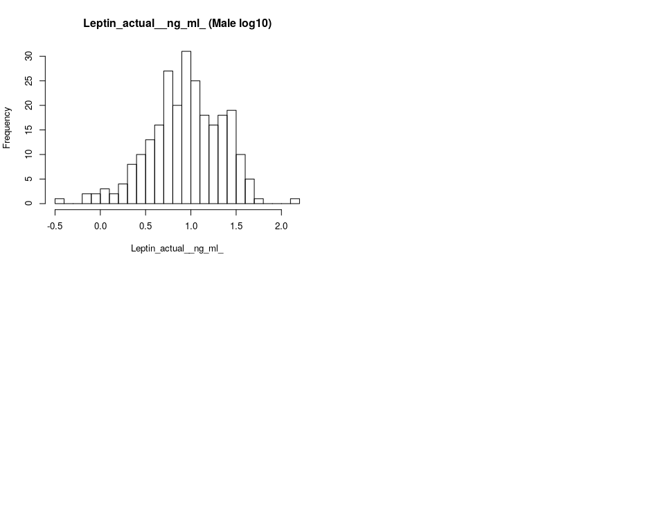

lapply(cellnames, function(x) {  
 hist(pfas_male[, x], freq = TRUE, breaks = 30, main = paste(x,   
 " Cell (Male)", sep = ""), xlab = x)  
})

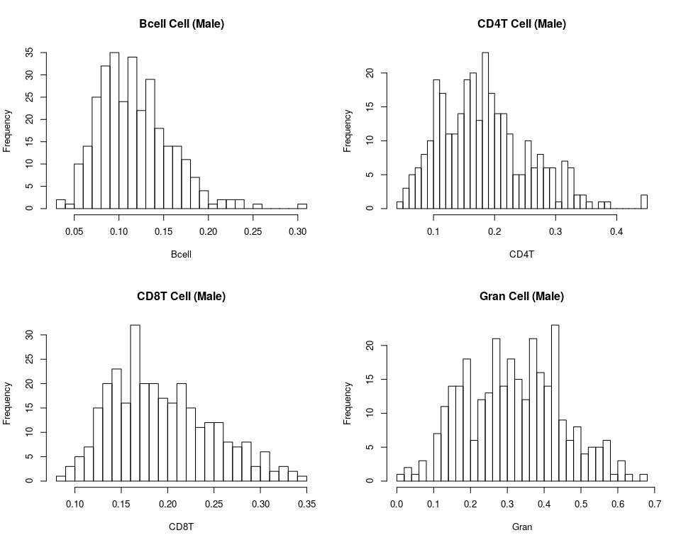[[1]] $breaks [1] 0.03 0.04 0.05 0.06 0.07 0.08 0.09 0.10 0.11 0.12 0.13 0.14 0.15 0.16 [15] 0.17 0.18 0.19 0.20 0.21 0.22 0.23 0.24 0.25 0.26 0.27 0.28 0.29 0.30 [29] 0.31

$counts [1] 2 1 10 14 25 32 35 24 34 22 29 18 14 14 11 7 4 1 2 2 2 0 1 [24] 0 0 0 0 1

$density [1] 0.6557377 0.3278689 3.2786885 4.5901639 8.1967213 10.4918033 [7] 11.4754098 7.8688525 11.1475410 7.2131148 9.5081967 5.9016393 [13] 4.5901639 4.5901639 3.6065574 2.2950820 1.3114754 0.3278689 [19] 0.6557377 0.6557377 0.6557377 0.0000000 0.3278689 0.0000000 [25] 0.0000000 0.0000000 0.0000000 0.3278689

$mids [1] 0.035 0.045 0.055 0.065 0.075 0.085 0.095 0.105 0.115 0.125 0.135 [12] 0.145 0.155 0.165 0.175 0.185 0.195 0.205 0.215 0.225 0.235 0.245 [23] 0.255 0.265 0.275 0.285 0.295 0.305

$xname [1] “pfas_male[, x]”

$equidist [1] TRUE

attr(,“class”) [1] “histogram”

[[2]] $breaks [1] 0.04 0.05 0.06 0.07 0.08 0.09 0.10 0.11 0.12 0.13 0.14 0.15 0.16 0.17 [15] 0.18 0.19 0.20 0.21 0.22 0.23 0.24 0.25 0.26 0.27 0.28 0.29 0.30 0.31 [29] 0.32 0.33 0.34 0.35 0.36 0.37 0.38 0.39 0.40 0.41 0.42 0.43 0.44 0.45

$counts [1] 1 3 5 6 8 10 19 17 11 11 14 19 20 13 23 17 14 14 11 5 5 10 6 [24] 8 6 6 1 7 6 2 2 1 0 1 1 0 0 0 0 0 2

$density [1] 0.3278689 0.9836066 1.6393443 1.9672131 2.6229508 3.2786885 6.2295082 [8] 5.5737705 3.6065574 3.6065574 4.5901639 6.2295082 6.5573770 4.2622951 [15] 7.5409836 5.5737705 4.5901639 4.5901639 3.6065574 1.6393443 1.6393443 [22] 3.2786885 1.9672131 2.6229508 1.9672131 1.9672131 0.3278689 2.2950820 [29] 1.9672131 0.6557377 0.6557377 0.3278689 0.0000000 0.3278689 0.3278689 [36] 0.0000000 0.0000000 0.0000000 0.0000000 0.0000000 0.6557377

$mids [1] 0.045 0.055 0.065 0.075 0.085 0.095 0.105 0.115 0.125 0.135 0.145 [12] 0.155 0.165 0.175 0.185 0.195 0.205 0.215 0.225 0.235 0.245 0.255 [23] 0.265 0.275 0.285 0.295 0.305 0.315 0.325 0.335 0.345 0.355 0.365 [34] 0.375 0.385 0.395 0.405 0.415 0.425 0.435 0.445

$xname [1] “pfas_male[, x]”

$equidist [1] TRUE

attr(,“class”) [1] “histogram”

[[3]] $breaks [1] 0.08 0.09 0.10 0.11 0.12 0.13 0.14 0.15 0.16 0.17 0.18 0.19 0.20 0.21 [15] 0.22 0.23 0.24 0.25 0.26 0.27 0.28 0.29 0.30 0.31 0.32 0.33 0.34 0.35

$counts [1] 1 3 5 7 15 20 23 16 32 20 20 17 16 20 15 11 12 12 8 7 8 3 6 [24] 2 3 2 1

$density [1] 0.3278689 0.9836066 1.6393443 2.2950820 4.9180328 6.5573770 [7] 7.5409836 5.2459016 10.4918033 6.5573770 6.5573770 5.5737705 [13] 5.2459016 6.5573770 4.9180328 3.6065574 3.9344262 3.9344262 [19] 2.6229508 2.2950820 2.6229508 0.9836066 1.9672131 0.6557377 [25] 0.9836066 0.6557377 0.3278689

$mids [1] 0.085 0.095 0.105 0.115 0.125 0.135 0.145 0.155 0.165 0.175 0.185 [12] 0.195 0.205 0.215 0.225 0.235 0.245 0.255 0.265 0.275 0.285 0.295 [23] 0.305 0.315 0.325 0.335 0.345

$xname [1] “pfas_male[, x]”

$equidist [1] TRUE

attr(,“class”) [1] “histogram”

[[4]] $breaks [1] 0.00 0.02 0.04 0.06 0.08 0.10 0.12 0.14 0.16 0.18 0.20 0.22 0.24 0.26 [15] 0.28 0.30 0.32 0.34 0.36 0.38 0.40 0.42 0.44 0.46 0.48 0.50 0.52 0.54 [29] 0.56 0.58 0.60 0.62 0.64 0.66 0.68

$counts [1] 1 2 1 3 0 7 11 14 14 18 6 12 13 21 14 18 15 12 21 16 14 23 9 [24] 6 8 4 5 5 6 1 3 1 0 1

$density [1] 0.1639344 0.3278689 0.1639344 0.4918033 0.0000000 1.1475410 1.8032787 [8] 2.2950820 2.2950820 2.9508197 0.9836066 1.9672131 2.1311475 3.4426230 [15] 2.2950820 2.9508197 2.4590164 1.9672131 3.4426230 2.6229508 2.2950820 [22] 3.7704918 1.4754098 0.9836066 1.3114754 0.6557377 0.8196721 0.8196721 [29] 0.9836066 0.1639344 0.4918033 0.1639344 0.0000000 0.1639344

$mids [1] 0.01 0.03 0.05 0.07 0.09 0.11 0.13 0.15 0.17 0.19 0.21 0.23 0.25 0.27 [15] 0.29 0.31 0.33 0.35 0.37 0.39 0.41 0.43 0.45 0.47 0.49 0.51 0.53 0.55 [29] 0.57 0.59 0.61 0.63 0.65 0.67

$xname [1] “pfas_male[, x]”

$equidist [1] TRUE

attr(,“class”) [1] “histogram”

[[5]] $breaks [1] 0.00 0.01 0.02 0.03 0.04 0.05 0.06 0.07 0.08 0.09 0.10 0.11 0.12 0.13 [15] 0.14 0.15 0.16 0.17 0.18 0.19 0.20 0.21 0.22

$counts [1] 1 1 1 1 8 16 25 36 50 32 46 25 14 12 6 16 2 6 3 2 1 1

$density [1] 0.3278689 0.3278689 0.3278689 0.3278689 2.6229508 5.2459016 [7] 8.1967213 11.8032787 16.3934426 10.4918033 15.0819672 8.1967213 [13] 4.5901639 3.9344262 1.9672131 5.2459016 0.6557377 1.9672131 [19] 0.9836066 0.6557377 0.3278689 0.3278689

$mids [1] 0.005 0.015 0.025 0.035 0.045 0.055 0.065 0.075 0.085 0.095 0.105 [12] 0.115 0.125 0.135 0.145 0.155 0.165 0.175 0.185 0.195 0.205 0.215

$xname [1] “pfas_male[, x]”

$equidist [1] TRUE

attr(,“class”) [1] “histogram”

[[6]] $breaks [1] 0.000 0.005 0.010 0.015 0.020 0.025 0.030 0.035 0.040 0.045 0.050 [12] 0.055 0.060 0.065 0.070 0.075 0.080 0.085 0.090 0.095 0.100 0.105 [23] 0.110 0.115 0.120 0.125 0.130 0.135 0.140 0.145 0.150 0.155 0.160 [34] 0.165 0.170 0.175 0.180 0.185 0.190

$counts [1] 174 12 15 11 19 8 6 10 4 5 4 4 2 3 1 5 0 [18] 1 6 1 1 2 0 0 3 0 1 0 0 1 2 0 1 0 [35] 1 0 0 2

$density [1] 114.0983607 7.8688525 9.8360656 7.2131148 12.4590164 [6] 5.2459016 3.9344262 6.5573770 2.6229508 3.2786885 [11] 2.6229508 2.6229508 1.3114754 1.9672131 0.6557377 [16] 3.2786885 0.0000000 0.6557377 3.9344262 0.6557377 [21] 0.6557377 1.3114754 0.0000000 0.0000000 1.9672131 [26] 0.0000000 0.6557377 0.0000000 0.0000000 0.6557377 [31] 1.3114754 0.0000000 0.6557377 0.0000000 0.6557377 [36] 0.0000000 0.0000000 1.3114754

$mids [1] 0.0025 0.0075 0.0125 0.0175 0.0225 0.0275 0.0325 0.0375 0.0425 0.0475 [11] 0.0525 0.0575 0.0625 0.0675 0.0725 0.0775 0.0825 0.0875 0.0925 0.0975 [21] 0.1025 0.1075 0.1125 0.1175 0.1225 0.1275 0.1325 0.1375 0.1425 0.1475 [31] 0.1525 0.1575 0.1625 0.1675 0.1725 0.1775 0.1825 0.1875

$xname [1] “pfas_male[, x]”

$equidist [1] TRUE

attr(,“class”) [1] “histogram”

[[7]] $breaks [1] 0.02 0.04 0.06 0.08 0.10 0.12 0.14 0.16 0.18 0.20 0.22 0.24 0.26 0.28 [15] 0.30 0.32 0.34 0.36 0.38 0.40 0.42 0.44 0.46

$counts [1] 10 64 68 45 25 18 11 21 9 14 5 2 4 2 1 4 0 1 0 0 0 1

$density [1] 1.6393443 10.4918033 11.1475410 7.3770492 4.0983607 2.9508197 [7] 1.8032787 3.4426230 1.4754098 2.2950820 0.8196721 0.3278689 [13] 0.6557377 0.3278689 0.1639344 0.6557377 0.0000000 0.1639344 [19] 0.0000000 0.0000000 0.0000000 0.1639344

$mids [1] 0.03 0.05 0.07 0.09 0.11 0.13 0.15 0.17 0.19 0.21 0.23 0.25 0.27 0.29 [15] 0.31 0.33 0.35 0.37 0.39 0.41 0.43 0.45

$xname [1] “pfas_male[, x]”

$equidist [1] TRUE

attr(,“class”) [1] “histogram”

## check the NK vs outcome, whether there is a dichotomous  
## pattern  
plot(pfas_male$NK, pfas_male$Leptin_actual__ng_ml_)

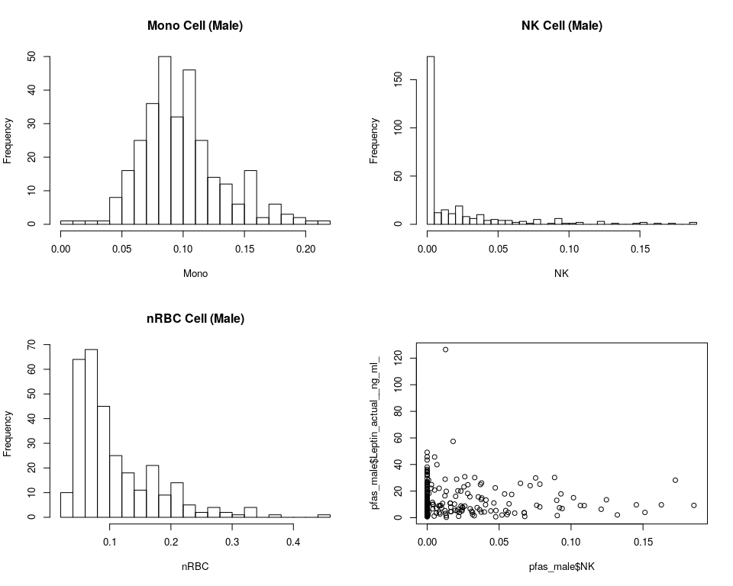

paste("It seems like the slope of this outcome vs NK is 0")

[1] “It seems like the slope of this outcome vs NK is 0”

## Based on histograms  
paste(Outcomes[-c(1, 2)], " should be log10 transformed. ", sep = "")

[1] “Chol_IPV3 should be log10 transformed.”  
[2] “FFA_IPV3 should be log10 transformed.”  
[3] “Gluc_IPV3 should be log10 transformed.”  
[4] “HDL_IPV3 should be log10 transformed.”  
[5] “Insu_IPV3 should be log10 transformed.”  
[6] “Trig_IPV3 should be log10 transformed.”  
[7] “Leptin_actual_*ng_ml* should be log10 transformed.”

## # the regression summary table for log10 outcomes  
lapply(Outcomes[1:9], function(x) {  
 cpg_reg(log10(pfas_male[, x]), pfas_male, x, 10, "Male log10",   
 300)  
})

[[1]]

Top10 CpGs from 300 for birth_weight of Male log10 by p.value (Sample Size = 305)

|  |  |  |  |  |  |  |
| --- | --- | --- | --- | --- | --- | --- |
|  | names | Estimate | Std.Error | t.statistic | p.value | FDR |
| 49 | cg16725984 | -0.0300 | 0.0081 | -3.6868 | 0.0003 | 0.0900000 |
| 67 | cg25195288 | 0.0795 | 0.0234 | 3.3957 | 0.0008 | 0.1200000 |
| 167 | cg16495448 | -0.0418 | 0.0150 | -2.7791 | 0.0058 | 0.5800000 |
| 184 | cg25137968 | 0.0424 | 0.0159 | 2.6660 | 0.0081 | 0.6000000 |
| 71 | cg16672637 | 0.0882 | 0.0340 | 2.5920 | 0.0100 | 0.6000000 |
| 204 | cg15045292 | 0.0191 | 0.0077 | 2.4795 | 0.0137 | 0.6085714 |
| 115 | cg10436026 | -0.0427 | 0.0173 | -2.4677 | 0.0142 | 0.6085714 |
| 22 | cg00784263 | 0.0410 | 0.0170 | 2.4058 | 0.0168 | 0.6300000 |
| 160 | cg07338658 | 0.0288 | 0.0124 | 2.3225 | 0.0209 | 0.6966667 |
| 103 | cg04029532 | 0.0524 | 0.0230 | 2.2728 | 0.0238 | 0.7140000 |

[[2]]

Top10 CpGs from 300 for ipv3_pp_fm_pct of Male log10 by p.value (Sample Size = 292)

|  |  |  |  |  |  |  |
| --- | --- | --- | --- | --- | --- | --- |
|  | names | Estimate | Std.Error | t.statistic | p.value | FDR |
| 203 | cg15066197 | -0.1946 | 0.0694 | -2.8039 | 0.0054 | 0.8733333 |
| 190 | cg10832304 | -0.0821 | 0.0308 | -2.6661 | 0.0081 | 0.8733333 |
| 112 | cg24366087 | -0.1595 | 0.0649 | -2.4588 | 0.0145 | 0.8733333 |
| 282 | cg08732300 | 0.1111 | 0.0485 | 2.2906 | 0.0227 | 0.8733333 |
| 292 | cg04804814 | 0.1906 | 0.0861 | 2.2145 | 0.0276 | 0.8733333 |
| 4 | cg21853587 | 0.2174 | 0.0995 | 2.1856 | 0.0297 | 0.8733333 |
| 255 | cg00634984 | -0.0695 | 0.0320 | -2.1740 | 0.0305 | 0.8733333 |
| 184 | cg25137968 | 0.1391 | 0.0645 | 2.1548 | 0.0320 | 0.8733333 |
| 139 | cg08743751 | 0.1227 | 0.0572 | 2.1452 | 0.0328 | 0.8733333 |
| 23 | cg22305268 | -0.2074 | 0.0973 | -2.1315 | 0.0339 | 0.8733333 |

[[3]]

Top10 CpGs from 300 for Chol_IPV3 of Male log10 by p.value (Sample Size = 287)

|  |  |  |  |  |  |  |
| --- | --- | --- | --- | --- | --- | --- |
|  | names | Estimate | Std.Error | t.statistic | p.value | FDR |
| 254 | cg22692511 | 0.0529 | 0.0174 | 3.0363 | 0.0026 | 0.6500000 |
| 266 | cg12857407 | 0.0930 | 0.0325 | 2.8605 | 0.0046 | 0.6500000 |
| 112 | cg24366087 | -0.0968 | 0.0353 | -2.7448 | 0.0065 | 0.6500000 |
| 95 | cg17850055 | -0.1943 | 0.0742 | -2.6196 | 0.0093 | 0.6540000 |
| 271 | cg08162803 | 0.1011 | 0.0394 | 2.5642 | 0.0109 | 0.6540000 |
| 69 | cg04168590 | 0.1527 | 0.0682 | 2.2407 | 0.0258 | 0.9564062 |
| 28 | cg12872489 | -0.0518 | 0.0233 | -2.2281 | 0.0267 | 0.9564062 |
| 170 | cg19554564 | -0.0951 | 0.0433 | -2.1995 | 0.0287 | 0.9564062 |
| 188 | cg17500055 | -0.0571 | 0.0259 | -2.1994 | 0.0287 | 0.9564062 |
| 49 | cg16725984 | 0.0371 | 0.0175 | 2.1206 | 0.0349 | 0.9564062 |

[[4]]

Top10 CpGs from 300 for FFA_IPV3 of Male log10 by p.value (Sample Size = 265)

|  |  |  |  |  |  |  |
| --- | --- | --- | --- | --- | --- | --- |
|  | names | Estimate | Std.Error | t.statistic | p.value | FDR |
| 96 | cg21215576 | 0.1513 | 0.0501 | 3.0225 | 0.0028 | 0.730 |
| 166 | cg26275850 | 0.1908 | 0.0731 | 2.6088 | 0.0096 | 0.730 |
| 156 | cg13858106 | 0.1918 | 0.0758 | 2.5289 | 0.0121 | 0.730 |
| 163 | cg26074111 | -0.2042 | 0.0841 | -2.4289 | 0.0158 | 0.730 |
| 4 | cg21853587 | -0.2415 | 0.1018 | -2.3717 | 0.0185 | 0.730 |
| 162 | cg18602114 | -0.1153 | 0.0494 | -2.3333 | 0.0204 | 0.730 |
| 126 | cg05390685 | -0.1193 | 0.0513 | -2.3260 | 0.0208 | 0.730 |
| 148 | cg13598480 | 0.1529 | 0.0661 | 2.3133 | 0.0215 | 0.730 |
| 257 | cg16529483 | 0.0589 | 0.0255 | 2.3067 | 0.0219 | 0.730 |
| 240 | cg16375541 | 0.2600 | 0.1176 | 2.2101 | 0.0280 | 0.732 |

[[5]]

Top10 CpGs from 300 for Gluc_IPV3 of Male log10 by p.value (Sample Size = 295)

|  |  |  |  |  |  |  |
| --- | --- | --- | --- | --- | --- | --- |
|  | names | Estimate | Std.Error | t.statistic | p.value | FDR |
| 145 | cg06404838 | 0.1505 | 0.0404 | 3.7236 | 0.0002 | 0.0600000 |
| 27 | cg17519749 | 0.0559 | 0.0217 | 2.5816 | 0.0103 | 0.8066667 |
| 16 | cg06873590 | -0.1788 | 0.0694 | -2.5762 | 0.0105 | 0.8066667 |
| 248 | cg11196848 | -0.0679 | 0.0266 | -2.5506 | 0.0113 | 0.8066667 |
| 217 | cg01816336 | -0.0981 | 0.0396 | -2.4761 | 0.0139 | 0.8066667 |
| 150 | cg14163408 | 0.0543 | 0.0233 | 2.3368 | 0.0202 | 0.8066667 |
| 283 | cg11144990 | 0.0734 | 0.0318 | 2.3086 | 0.0217 | 0.8066667 |
| 153 | cg01060409 | 0.1314 | 0.0575 | 2.2864 | 0.0230 | 0.8066667 |
| 278 | cg15565231 | -0.1014 | 0.0448 | -2.2654 | 0.0242 | 0.8066667 |
| 189 | cg13382072 | 0.0545 | 0.0247 | 2.2110 | 0.0278 | 0.8300000 |

[[6]]

Top10 CpGs from 300 for HDL_IPV3 of Male log10 by p.value (Sample Size = 261)

|  |  |  |  |  |  |  |
| --- | --- | --- | --- | --- | --- | --- |
|  | names | Estimate | Std.Error | t.statistic | p.value | FDR |
| 42 | cg15355952 | -0.1054 | 0.0333 | -3.1646 | 0.0017 | 0.3750000 |
| 49 | cg16725984 | 0.0517 | 0.0170 | 3.0489 | 0.0025 | 0.3750000 |
| 236 | cg04061372 | 0.0308 | 0.0110 | 2.8043 | 0.0054 | 0.5345455 |
| 271 | cg08162803 | 0.0993 | 0.0385 | 2.5761 | 0.0106 | 0.5345455 |
| 52 | cg19549232 | 0.0924 | 0.0367 | 2.5191 | 0.0124 | 0.5345455 |
| 281 | cg22946159 | -0.1367 | 0.0548 | -2.4925 | 0.0133 | 0.5345455 |
| 290 | cg00798281 | -0.0643 | 0.0263 | -2.4463 | 0.0151 | 0.5345455 |
| 230 | cg22950210 | 0.0676 | 0.0276 | 2.4450 | 0.0152 | 0.5345455 |
| 145 | cg06404838 | -0.1133 | 0.0475 | -2.3822 | 0.0180 | 0.5345455 |
| 120 | cg22700790 | 0.0501 | 0.0211 | 2.3702 | 0.0185 | 0.5345455 |

[[7]]

Top10 CpGs from 300 for Insu_IPV3 of Male log10 by p.value (Sample Size = 282)

|  |  |  |  |  |  |  |
| --- | --- | --- | --- | --- | --- | --- |
|  | names | Estimate | Std.Error | t.statistic | p.value | FDR |
| 195 | cg23785275 | -0.0578 | 0.0195 | -2.9582 | 0.0034 | 0.7200000 |
| 36 | cg11302884 | -0.2738 | 0.1018 | -2.6903 | 0.0076 | 0.7200000 |
| 169 | cg17501712 | 0.2143 | 0.0822 | 2.6085 | 0.0096 | 0.7200000 |
| 278 | cg15565231 | -0.3015 | 0.1172 | -2.5734 | 0.0106 | 0.7200000 |
| 86 | cg02648057 | -0.1231 | 0.0495 | -2.4850 | 0.0136 | 0.7200000 |
| 191 | cg25138412 | -0.1090 | 0.0442 | -2.4637 | 0.0144 | 0.7200000 |
| 19 | cg00128386 | -0.2743 | 0.1196 | -2.2927 | 0.0226 | 0.8850000 |
| 291 | cg09630142 | 0.1295 | 0.0569 | 2.2766 | 0.0236 | 0.8850000 |
| 223 | cg03786743 | -0.1304 | 0.0642 | -2.0308 | 0.0433 | 0.9904068 |
| 61 | cg04569429 | 0.1227 | 0.0605 | 2.0289 | 0.0434 | 0.9904068 |

[[8]]

Top10 CpGs from 300 for Trig_IPV3 of Male log10 by p.value (Sample Size = 284)

|  |  |  |  |  |  |  |
| --- | --- | --- | --- | --- | --- | --- |
|  | names | Estimate | Std.Error | t.statistic | p.value | FDR |
| 291 | cg09630142 | -0.1431 | 0.0443 | -3.2318 | 0.0014 | 0.4200 |
| 237 | cg21380181 | -0.1309 | 0.0481 | -2.7230 | 0.0069 | 0.5800 |
| 190 | cg10832304 | 0.0798 | 0.0295 | 2.7086 | 0.0072 | 0.5800 |
| 121 | cg23241335 | 0.1614 | 0.0627 | 2.5735 | 0.0106 | 0.5800 |
| 82 | cg18373158 | 0.1295 | 0.0509 | 2.5434 | 0.0115 | 0.5800 |
| 197 | cg14349977 | -0.0827 | 0.0326 | -2.5413 | 0.0116 | 0.5800 |
| 15 | cg05564760 | 0.0927 | 0.0401 | 2.3141 | 0.0214 | 0.6075 |
| 77 | cg23478547 | 0.0836 | 0.0364 | 2.2993 | 0.0222 | 0.6075 |
| 240 | cg16375541 | 0.2456 | 0.1068 | 2.3001 | 0.0222 | 0.6075 |
| 16 | cg06873590 | -0.3326 | 0.1448 | -2.2978 | 0.0223 | 0.6075 |

[[9]]

Top10 CpGs from 300 for Leptin_actual_*ng_ml* of Male log10 by p.value (Sample Size = 252)

|  |  |  |  |  |  |  |
| --- | --- | --- | --- | --- | --- | --- |
|  | names | Estimate | Std.Error | t.statistic | p.value | FDR |
| 49 | cg16725984 | -0.2989 | 0.0619 | -4.8256 | 0.0000 | 0.0000000 |
| 209 | cg24280832 | 0.4147 | 0.1136 | 3.6493 | 0.0003 | 0.0450000 |
| 84 | cg05524354 | 0.2988 | 0.1007 | 2.9680 | 0.0033 | 0.2940000 |
| 42 | cg15355952 | 0.3546 | 0.1246 | 2.8472 | 0.0048 | 0.2940000 |
| 116 | cg21183455 | 0.1943 | 0.0685 | 2.8374 | 0.0049 | 0.2940000 |
| 19 | cg00128386 | -0.5139 | 0.2008 | -2.5594 | 0.0111 | 0.5550000 |
| 158 | cg13973086 | 0.1845 | 0.0780 | 2.3656 | 0.0188 | 0.8057143 |
| 104 | cg10119082 | -0.1602 | 0.0709 | -2.2598 | 0.0247 | 0.8142857 |
| 214 | cg20505445 | -0.1772 | 0.0821 | -2.1582 | 0.0319 | 0.8142857 |
| 143 | cg15486454 | 0.2045 | 0.0958 | 2.1338 | 0.0339 | 0.8142857 |

## raw outcomes  
par(mfrow = c(2, 2))  
lapply(Outcomes, function(x) {  
 hist(pfas_female[, x], freq = TRUE, breaks = 30, main = paste(x,   
 " (feMale)", sep = ""), xlab = x)  
})

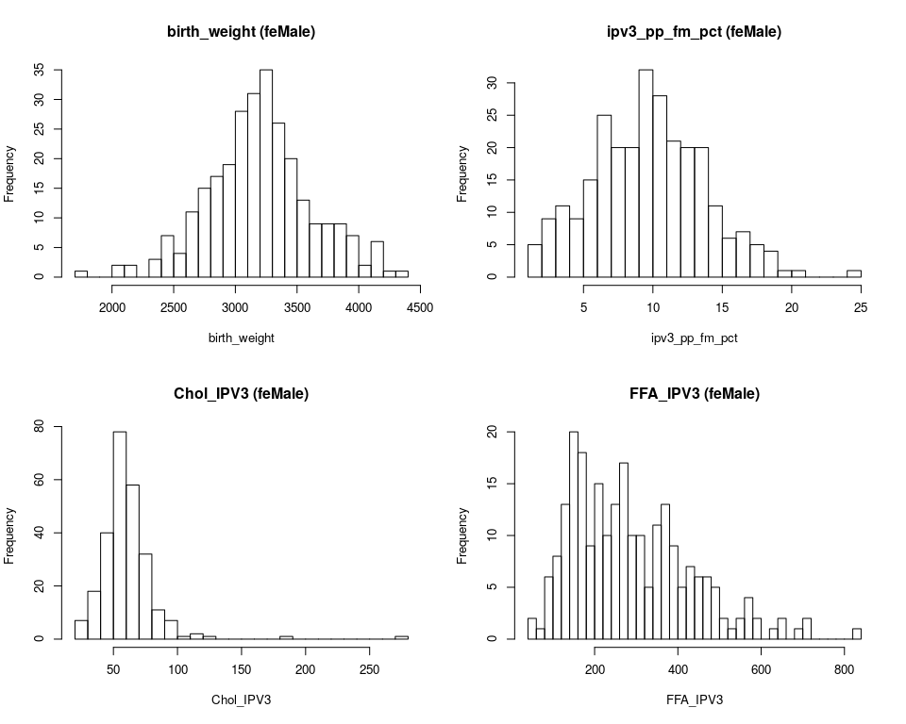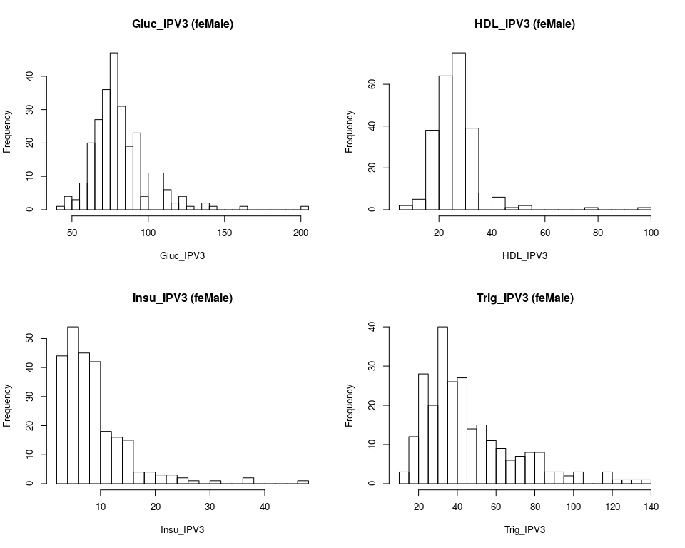[[1]] $breaks [1] 1700 1800 1900 2000 2100 2200 2300 2400 2500 2600 2700 2800 2900 3000 [15] 3100 3200 3300 3400 3500 3600 3700 3800 3900 4000 4100 4200 4300 4400

$counts [1] 1 0 0 2 2 0 3 7 4 11 15 17 19 28 31 35 26 20 13 9 9 9 7 [24] 2 6 1 1

$density [1] 3.597122e-05 0.000000e+00 0.000000e+00 7.194245e-05 7.194245e-05 [6] 0.000000e+00 1.079137e-04 2.517986e-04 1.438849e-04 3.956835e-04 [11] 5.395683e-04 6.115108e-04 6.834532e-04 1.007194e-03 1.115108e-03 [16] 1.258993e-03 9.352518e-04 7.194245e-04 4.676259e-04 3.237410e-04 [21] 3.237410e-04 3.237410e-04 2.517986e-04 7.194245e-05 2.158273e-04 [26] 3.597122e-05 3.597122e-05

$mids [1] 1750 1850 1950 2050 2150 2250 2350 2450 2550 2650 2750 2850 2950 3050 [15] 3150 3250 3350 3450 3550 3650 3750 3850 3950 4050 4150 4250 4350

$xname [1] “pfas_female[, x]”

$equidist [1] TRUE

attr(,“class”) [1] “histogram”

[[2]] $breaks [1] 1 2 3 4 5 6 7 8 9 10 11 12 13 14 15 16 17 18 19 20 21 22 23 [24] 24 25

$counts [1] 5 9 11 9 15 25 20 20 32 28 21 20 20 11 6 7 5 4 1 1 0 0 0 [24] 1

$density [1] 0.018450185 0.033210332 0.040590406 0.033210332 0.055350554 [6] 0.092250923 0.073800738 0.073800738 0.118081181 0.103321033 [11] 0.077490775 0.073800738 0.073800738 0.040590406 0.022140221 [16] 0.025830258 0.018450185 0.014760148 0.003690037 0.003690037 [21] 0.000000000 0.000000000 0.000000000 0.003690037

$mids [1] 1.5 2.5 3.5 4.5 5.5 6.5 7.5 8.5 9.5 10.5 11.5 12.5 13.5 14.5 [15] 15.5 16.5 17.5 18.5 19.5 20.5 21.5 22.5 23.5 24.5

$xname [1] “pfas_female[, x]”

$equidist [1] TRUE

attr(,“class”) [1] “histogram”

[[3]] $breaks [1] 20 30 40 50 60 70 80 90 100 110 120 130 140 150 160 170 180 [18] 190 200 210 220 230 240 250 260 270 280

$counts [1] 7 18 40 78 58 32 11 7 1 2 1 0 0 0 0 0 1 0 0 0 0 0 0 [24] 0 0 1

$density [1] 0.0027237354 0.0070038911 0.0155642023 0.0303501946 0.0225680934 [6] 0.0124513619 0.0042801556 0.0027237354 0.0003891051 0.0007782101 [11] 0.0003891051 0.0000000000 0.0000000000 0.0000000000 0.0000000000 [16] 0.0000000000 0.0003891051 0.0000000000 0.0000000000 0.0000000000 [21] 0.0000000000 0.0000000000 0.0000000000 0.0000000000 0.0000000000 [26] 0.0003891051

$mids [1] 25 35 45 55 65 75 85 95 105 115 125 135 145 155 165 175 185 [18] 195 205 215 225 235 245 255 265 275

$xname [1] “pfas_female[, x]”

$equidist [1] TRUE

attr(,“class”) [1] “histogram”

[[4]] $breaks [1] 40 60 80 100 120 140 160 180 200 220 240 260 280 300 320 340 360 [18] 380 400 420 440 460 480 500 520 540 560 580 600 620 640 660 680 700 [35] 720 740 760 780 800 820 840

$counts [1] 2 1 6 8 13 20 18 9 15 10 13 17 10 10 5 11 13 9 5 7 6 6 5 [24] 2 1 2 4 2 0 1 2 0 1 2 0 0 0 0 0 1

$density [1] 0.0004219409 0.0002109705 0.0012658228 0.0016877637 0.0027426160 [6] 0.0042194093 0.0037974684 0.0018987342 0.0031645570 0.0021097046 [11] 0.0027426160 0.0035864979 0.0021097046 0.0021097046 0.0010548523 [16] 0.0023206751 0.0027426160 0.0018987342 0.0010548523 0.0014767932 [21] 0.0012658228 0.0012658228 0.0010548523 0.0004219409 0.0002109705 [26] 0.0004219409 0.0008438819 0.0004219409 0.0000000000 0.0002109705 [31] 0.0004219409 0.0000000000 0.0002109705 0.0004219409 0.0000000000 [36] 0.0000000000 0.0000000000 0.0000000000 0.0000000000 0.0002109705

$mids [1] 50 70 90 110 130 150 170 190 210 230 250 270 290 310 330 350 370 [18] 390 410 430 450 470 490 510 530 550 570 590 610 630 650 670 690 710 [35] 730 750 770 790 810 830

$xname [1] “pfas_female[, x]”

$equidist [1] TRUE

attr(,“class”) [1] “histogram”

[[5]] $breaks [1] 40 45 50 55 60 65 70 75 80 85 90 95 100 105 110 115 120 [18] 125 130 135 140 145 150 155 160 165 170 175 180 185 190 195 200 205

$counts [1] 1 4 3 8 20 27 36 47 31 19 23 4 11 11 6 2 4 1 0 2 1 0 0 [24] 0 1 0 0 0 0 0 0 0 1

$density [1] 0.0007604563 0.0030418251 0.0022813688 0.0060836502 0.0152091255 [6] 0.0205323194 0.0273764259 0.0357414449 0.0235741445 0.0144486692 [11] 0.0174904943 0.0030418251 0.0083650190 0.0083650190 0.0045627376 [16] 0.0015209125 0.0030418251 0.0007604563 0.0000000000 0.0015209125 [21] 0.0007604563 0.0000000000 0.0000000000 0.0000000000 0.0007604563 [26] 0.0000000000 0.0000000000 0.0000000000 0.0000000000 0.0000000000 [31] 0.0000000000 0.0000000000 0.0007604563

$mids [1] 42.5 47.5 52.5 57.5 62.5 67.5 72.5 77.5 82.5 87.5 92.5 [12] 97.5 102.5 107.5 112.5 117.5 122.5 127.5 132.5 137.5 142.5 147.5 [23] 152.5 157.5 162.5 167.5 172.5 177.5 182.5 187.5 192.5 197.5 202.5

$xname [1] “pfas_female[, x]”

$equidist [1] TRUE

attr(,“class”) [1] “histogram”

[[6]] $breaks [1] 5 10 15 20 25 30 35 40 45 50 55 60 65 70 75 80 85 [18] 90 95 100

$counts [1] 2 5 38 64 75 39 8 6 1 2 0 0 0 0 1 0 0 0 1

$density [1] 0.0016528926 0.0041322314 0.0314049587 0.0528925620 0.0619834711 [6] 0.0322314050 0.0066115702 0.0049586777 0.0008264463 0.0016528926 [11] 0.0000000000 0.0000000000 0.0000000000 0.0000000000 0.0008264463 [16] 0.0000000000 0.0000000000 0.0000000000 0.0008264463

$mids [1] 7.5 12.5 17.5 22.5 27.5 32.5 37.5 42.5 47.5 52.5 57.5 62.5 67.5 72.5 [15] 77.5 82.5 87.5 92.5 97.5

$xname [1] “pfas_female[, x]”

$equidist [1] TRUE

attr(,“class”) [1] “histogram”

[[7]] $breaks [1] 2 4 6 8 10 12 14 16 18 20 22 24 26 28 30 32 34 36 38 40 42 44 46 [24] 48

$counts [1] 44 54 45 42 18 16 15 4 4 3 3 2 1 0 1 0 0 2 0 0 0 0 1

$density [1] 0.086274510 0.105882353 0.088235294 0.082352941 0.035294118 [6] 0.031372549 0.029411765 0.007843137 0.007843137 0.005882353 [11] 0.005882353 0.003921569 0.001960784 0.000000000 0.001960784 [16] 0.000000000 0.000000000 0.003921569 0.000000000 0.000000000 [21] 0.000000000 0.000000000 0.001960784

$mids [1] 3 5 7 9 11 13 15 17 19 21 23 25 27 29 31 33 35 37 39 41 43 45 47

$xname [1] “pfas_female[, x]”

$equidist [1] TRUE

attr(,“class”) [1] “histogram”

[[8]] $breaks [1] 10 15 20 25 30 35 40 45 50 55 60 65 70 75 80 85 90 [18] 95 100 105 110 115 120 125 130 135 140

$counts [1] 3 12 28 20 40 26 27 14 15 11 9 6 7 8 8 3 3 2 3 0 0 3 1 [24] 1 1 1

$density [1] 0.0023809524 0.0095238095 0.0222222222 0.0158730159 0.0317460317 [6] 0.0206349206 0.0214285714 0.0111111111 0.0119047619 0.0087301587 [11] 0.0071428571 0.0047619048 0.0055555556 0.0063492063 0.0063492063 [16] 0.0023809524 0.0023809524 0.0015873016 0.0023809524 0.0000000000 [21] 0.0000000000 0.0023809524 0.0007936508 0.0007936508 0.0007936508 [26] 0.0007936508

$mids [1] 12.5 17.5 22.5 27.5 32.5 37.5 42.5 47.5 52.5 57.5 62.5 [12] 67.5 72.5 77.5 82.5 87.5 92.5 97.5 102.5 107.5 112.5 117.5 [23] 122.5 127.5 132.5 137.5

$xname [1] “pfas_female[, x]”

$equidist [1] TRUE

attr(,“class”) [1] “histogram”

[[9]] $breaks [1] 0 5 10 15 20 25 30 35 40 45 50 55 60 65 70 75 80 [18] 85 90 95 100 105 110 115 120 125 130

$counts [1] 25 49 39 31 20 19 7 14 2 4 5 2 2 0 1 0 2 0 0 1 1 0 1 [24] 0 0 1

$density [1] 0.0221238938 0.0433628319 0.0345132743 0.0274336283 0.0176991150 [6] 0.0168141593 0.0061946903 0.0123893805 0.0017699115 0.0035398230 [11] 0.0044247788 0.0017699115 0.0017699115 0.0000000000 0.0008849558 [16] 0.0000000000 0.0017699115 0.0000000000 0.0000000000 0.0008849558 [21] 0.0008849558 0.0000000000 0.0008849558 0.0000000000 0.0000000000 [26] 0.0008849558

$mids [1] 2.5 7.5 12.5 17.5 22.5 27.5 32.5 37.5 42.5 47.5 52.5 [12] 57.5 62.5 67.5 72.5 77.5 82.5 87.5 92.5 97.5 102.5 107.5 [23] 112.5 117.5 122.5 127.5

$xname [1] “pfas_female[, x]”

$equidist [1] TRUE

attr(,“class”) [1] “histogram”

## log10 of feMale  
lapply(Outcomes, function(x) {  
 cpg_reg(log10(pfas_female[, x]), pfas_female, x, 10, "Female log10",   
 300)  
})

[[1]]

Top10 CpGs from 300 for birth_weight of Female log10 by p.value (Sample Size = 278)

|  |  |  |  |  |  |  |
| --- | --- | --- | --- | --- | --- | --- |
|  | names | Estimate | Std.Error | t.statistic | p.value | FDR |
| 49 | cg16725984 | -0.0367 | 0.0081 | -4.5194 | 0.0000 | 0.0000000 |
| 27 | cg17519749 | 0.0420 | 0.0121 | 3.4601 | 0.0006 | 0.0900000 |
| 248 | cg11196848 | 0.0444 | 0.0141 | 3.1445 | 0.0019 | 0.1900000 |
| 71 | cg16672637 | 0.0990 | 0.0342 | 2.8983 | 0.0041 | 0.3075000 |
| 297 | cg01607625 | 0.0606 | 0.0218 | 2.7815 | 0.0058 | 0.3480000 |
| 222 | cg27258399 | 0.0274 | 0.0101 | 2.7108 | 0.0071 | 0.3550000 |
| 185 | cg07716131 | -0.0547 | 0.0216 | -2.5380 | 0.0117 | 0.4745455 |
| 113 | cg22685502 | 0.0504 | 0.0202 | 2.4903 | 0.0134 | 0.4745455 |
| 240 | cg16375541 | 0.0659 | 0.0272 | 2.4200 | 0.0162 | 0.4745455 |
| 87 | cg10397322 | 0.0529 | 0.0219 | 2.4146 | 0.0164 | 0.4745455 |

[[2]]

Top10 CpGs from 300 for ipv3_pp_fm_pct of Female log10 by p.value (Sample Size = 271)

|  |  |  |  |  |  |  |
| --- | --- | --- | --- | --- | --- | --- |
|  | names | Estimate | Std.Error | t.statistic | p.value | FDR |
| 189 | cg13382072 | -0.1423 | 0.0490 | -2.9033 | 0.0040 | 0.9863415 |
| 203 | cg15066197 | -0.1936 | 0.0750 | -2.5808 | 0.0104 | 0.9863415 |
| 33 | cg05431942 | 0.0802 | 0.0334 | 2.4037 | 0.0169 | 0.9863415 |
| 28 | cg12872489 | 0.1035 | 0.0441 | 2.3500 | 0.0195 | 0.9863415 |
| 20 | cg00210042 | -0.2069 | 0.0885 | -2.3380 | 0.0202 | 0.9863415 |
| 51 | cg15642854 | -0.0514 | 0.0222 | -2.3163 | 0.0213 | 0.9863415 |
| 5 | cg12657739 | -0.1407 | 0.0638 | -2.2053 | 0.0283 | 0.9863415 |
| 54 | cg19529074 | 0.1854 | 0.0866 | 2.1398 | 0.0333 | 0.9863415 |
| 151 | cg10996327 | -0.1580 | 0.0775 | -2.0371 | 0.0427 | 0.9863415 |
| 292 | cg04804814 | 0.1641 | 0.0819 | 2.0041 | 0.0461 | 0.9863415 |

[[3]]

Top10 CpGs from 300 for Chol_IPV3 of Female log10 by p.value (Sample Size = 257)

|  |  |  |  |  |  |  |
| --- | --- | --- | --- | --- | --- | --- |
|  | names | Estimate | Std.Error | t.statistic | p.value | FDR |
| 64 | cg24469114 | 0.1554 | 0.0524 | 2.9647 | 0.0033 | 0.3375000 |
| 49 | cg16725984 | 0.0576 | 0.0198 | 2.9107 | 0.0039 | 0.3375000 |
| 72 | cg16659510 | -0.1442 | 0.0501 | -2.8788 | 0.0043 | 0.3375000 |
| 60 | cg26381452 | 0.0502 | 0.0175 | 2.8655 | 0.0045 | 0.3375000 |
| 142 | cg21501241 | -0.1370 | 0.0495 | -2.7677 | 0.0061 | 0.3514286 |
| 235 | cg25017403 | 0.0629 | 0.0232 | 2.7141 | 0.0071 | 0.3514286 |
| 11 | cg02233835 | -0.1200 | 0.0450 | -2.6644 | 0.0082 | 0.3514286 |
| 267 | cg22138002 | -0.0931 | 0.0368 | -2.5340 | 0.0119 | 0.4100000 |
| 193 | cg01541565 | -0.0894 | 0.0354 | -2.5225 | 0.0123 | 0.4100000 |
| 45 | cg16422816 | 0.1515 | 0.0627 | 2.4169 | 0.0164 | 0.4450000 |

[[4]]

Top10 CpGs from 300 for FFA_IPV3 of Female log10 by p.value (Sample Size = 237)

|  |  |  |  |  |  |  |
| --- | --- | --- | --- | --- | --- | --- |
|  | names | Estimate | Std.Error | t.statistic | p.value | FDR |
| 167 | cg16495448 | -0.1639 | 0.0669 | -2.4498 | 0.0151 | 0.9170642 |
| 14 | cg09473264 | -0.1372 | 0.0565 | -2.4274 | 0.0160 | 0.9170642 |
| 171 | cg09461851 | 0.1977 | 0.0860 | 2.2975 | 0.0225 | 0.9170642 |
| 290 | cg00798281 | -0.1250 | 0.0555 | -2.2531 | 0.0252 | 0.9170642 |
| 281 | cg22946159 | 0.2346 | 0.1050 | 2.2341 | 0.0265 | 0.9170642 |
| 20 | cg00210042 | 0.2069 | 0.0948 | 2.1816 | 0.0302 | 0.9170642 |
| 268 | cg05119480 | 0.1364 | 0.0628 | 2.1711 | 0.0310 | 0.9170642 |
| 272 | cg17269633 | -0.1239 | 0.0576 | -2.1514 | 0.0325 | 0.9170642 |
| 230 | cg22950210 | -0.1085 | 0.0528 | -2.0534 | 0.0412 | 0.9170642 |
| 215 | cg11417025 | -0.0954 | 0.0469 | -2.0353 | 0.0430 | 0.9170642 |

[[5]]

Top10 CpGs from 300 for Gluc_IPV3 of Female log10 by p.value (Sample Size = 263)

|  |  |  |  |  |  |  |
| --- | --- | --- | --- | --- | --- | --- |
|  | names | Estimate | Std.Error | t.statistic | p.value | FDR |
| 168 | cg12680424 | -0.1812 | 0.0631 | -2.8701 | 0.0045 | 0.74375 |
| 260 | cg17284440 | 0.1544 | 0.0576 | 2.6823 | 0.0078 | 0.74375 |
| 262 | cg05888037 | -0.1581 | 0.0617 | -2.5634 | 0.0110 | 0.74375 |
| 6 | cg26724375 | -0.0689 | 0.0300 | -2.2927 | 0.0227 | 0.74375 |
| 288 | cg10848522 | 0.0451 | 0.0198 | 2.2795 | 0.0235 | 0.74375 |
| 216 | cg06230206 | -0.0553 | 0.0245 | -2.2586 | 0.0248 | 0.74375 |
| 285 | cg27535677 | 0.0459 | 0.0204 | 2.2495 | 0.0254 | 0.74375 |
| 173 | cg23506842 | -0.0582 | 0.0259 | -2.2458 | 0.0256 | 0.74375 |
| 167 | cg16495448 | -0.0593 | 0.0267 | -2.2251 | 0.0270 | 0.74375 |
| 3 | cg07551200 | -0.1361 | 0.0619 | -2.2002 | 0.0287 | 0.74375 |

[[6]]

Top10 CpGs from 300 for HDL_IPV3 of Female log10 by p.value (Sample Size = 242)

|  |  |  |  |  |  |  |
| --- | --- | --- | --- | --- | --- | --- |
|  | names | Estimate | Std.Error | t.statistic | p.value | FDR |
| 113 | cg22685502 | -0.1310 | 0.0476 | -2.7522 | 0.0064 | 0.6054545 |
| 291 | cg09630142 | -0.0839 | 0.0316 | -2.6515 | 0.0086 | 0.6054545 |
| 11 | cg02233835 | -0.1171 | 0.0448 | -2.6148 | 0.0095 | 0.6054545 |
| 185 | cg07716131 | -0.1327 | 0.0507 | -2.6149 | 0.0095 | 0.6054545 |
| 222 | cg27258399 | -0.0604 | 0.0237 | -2.5461 | 0.0116 | 0.6054545 |
| 277 | cg05227616 | -0.0942 | 0.0374 | -2.5210 | 0.0124 | 0.6054545 |
| 147 | cg03604367 | 0.0913 | 0.0378 | 2.4148 | 0.0165 | 0.6054545 |
| 50 | cg27124293 | 0.0560 | 0.0241 | 2.3272 | 0.0208 | 0.6054545 |
| 60 | cg26381452 | 0.0400 | 0.0172 | 2.3239 | 0.0210 | 0.6054545 |
| 72 | cg16659510 | -0.1130 | 0.0488 | -2.3147 | 0.0215 | 0.6054545 |

[[7]]

Top10 CpGs from 300 for Insu_IPV3 of Female log10 by p.value (Sample Size = 255)

|  |  |  |  |  |  |  |
| --- | --- | --- | --- | --- | --- | --- |
|  | names | Estimate | Std.Error | t.statistic | p.value | FDR |
| 139 | cg08743751 | 0.2928 | 0.0706 | 4.1470 | 0.0000 | 0.0000000 |
| 254 | cg22692511 | 0.1893 | 0.0389 | 4.8637 | 0.0000 | 0.0000000 |
| 88 | cg19667731 | -0.2844 | 0.0893 | -3.1842 | 0.0016 | 0.1600000 |
| 237 | cg21380181 | -0.1887 | 0.0624 | -3.0266 | 0.0027 | 0.2025000 |
| 236 | cg04061372 | -0.0684 | 0.0251 | -2.7190 | 0.0070 | 0.4200000 |
| 295 | cg09114153 | 0.1922 | 0.0744 | 2.5843 | 0.0103 | 0.5150000 |
| 299 | cg17217478 | -0.0537 | 0.0219 | -2.4560 | 0.0148 | 0.5366667 |
| 77 | cg23478547 | -0.1117 | 0.0461 | -2.4244 | 0.0161 | 0.5366667 |
| 239 | cg01969701 | 0.1360 | 0.0561 | 2.4246 | 0.0161 | 0.5366667 |
| 28 | cg12872489 | 0.1170 | 0.0495 | 2.3613 | 0.0190 | 0.5700000 |

[[8]]

Top10 CpGs from 300 for Trig_IPV3 of Female log10 by p.value (Sample Size = 252)

|  |  |  |  |  |  |  |
| --- | --- | --- | --- | --- | --- | --- |
|  | names | Estimate | Std.Error | t.statistic | p.value | FDR |
| 109 | cg22120094 | -0.1019 | 0.0415 | -2.4572 | 0.0147 | 0.876087 |
| 13 | cg21451869 | -0.1961 | 0.0802 | -2.4448 | 0.0152 | 0.876087 |
| 297 | cg01607625 | -0.2053 | 0.0865 | -2.3747 | 0.0184 | 0.876087 |
| 172 | cg07812715 | -0.2047 | 0.0881 | -2.3233 | 0.0210 | 0.876087 |
| 58 | cg09887862 | 0.0701 | 0.0305 | 2.2991 | 0.0224 | 0.876087 |
| 155 | cg15727287 | 0.0822 | 0.0368 | 2.2318 | 0.0266 | 0.876087 |
| 38 | cg10533331 | 0.2260 | 0.1013 | 2.2300 | 0.0267 | 0.876087 |
| 17 | cg13699963 | -0.2083 | 0.0939 | -2.2175 | 0.0275 | 0.876087 |
| 298 | cg14801692 | 0.0655 | 0.0308 | 2.1289 | 0.0343 | 0.876087 |
| 113 | cg22685502 | 0.1607 | 0.0778 | 2.0645 | 0.0400 | 0.876087 |

[[9]]

Top10 CpGs from 300 for Leptin_actual_*ng_ml* of Female log10 by p.value (Sample Size = 226)

|  |  |  |  |  |  |  |
| --- | --- | --- | --- | --- | --- | --- |
|  | names | Estimate | Std.Error | t.statistic | p.value | FDR |
| 62 | cg04523661 | -0.4288 | 0.1297 | -3.3065 | 0.0011 | 0.3300000 |
| 204 | cg15045292 | 0.1756 | 0.0585 | 3.0045 | 0.0030 | 0.3800000 |
| 126 | cg05390685 | -0.2360 | 0.0805 | -2.9301 | 0.0038 | 0.3800000 |
| 45 | cg16422816 | -0.4788 | 0.1695 | -2.8248 | 0.0052 | 0.3900000 |
| 232 | cg03991871 | -0.2149 | 0.0803 | -2.6745 | 0.0081 | 0.3900000 |
| 49 | cg16725984 | -0.1600 | 0.0607 | -2.6351 | 0.0090 | 0.3900000 |
| 237 | cg21380181 | -0.2534 | 0.0963 | -2.6321 | 0.0091 | 0.3900000 |
| 199 | cg21261158 | 0.4504 | 0.1865 | 2.4144 | 0.0166 | 0.5716667 |
| 82 | cg18373158 | 0.2249 | 0.0943 | 2.3833 | 0.0180 | 0.5716667 |
| 44 | cg09420412 | -0.2234 | 0.0998 | -2.2390 | 0.0262 | 0.5716667 |

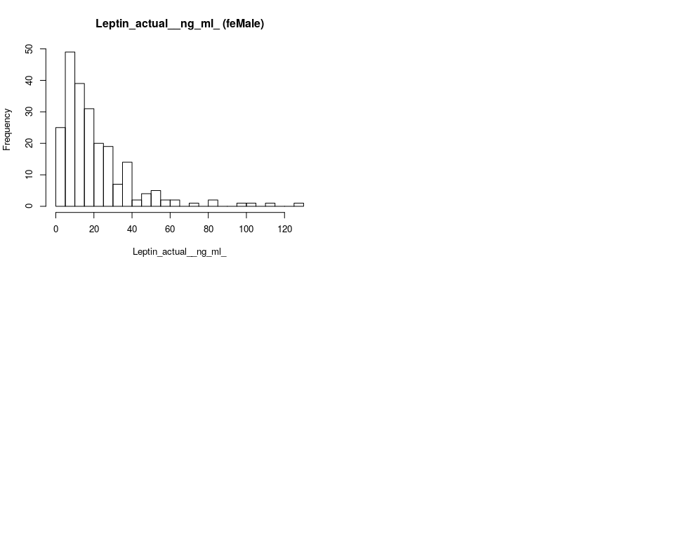

####################################### using pfas_male_FDRcpg pfas_female_FDRcpg  
lapply(Outcomes[1:9], function(x) {  
 cpg_reg(log10(pfas_male_FDRcpg[, x]), pfas_male_FDRcpg, x,   
 10, "Male log10", 120)  
})

[[1]]

Top10 CpGs from 120 for birth_weight of Male log10 by p.value (Sample Size = 305)

|  |  |  |  |  |  |  |
| --- | --- | --- | --- | --- | --- | --- |
|  | names | Estimate | Std.Error | t.statistic | p.value | FDR |
| 8 | cg25195288 | 0.0795 | 0.0234 | 3.3957 | 0.0008 | 0.0960000 |
| 70 | cg25137968 | 0.0424 | 0.0159 | 2.6660 | 0.0081 | 0.4860000 |
| 49 | cg04029532 | 0.0524 | 0.0230 | 2.2728 | 0.0238 | 0.6257143 |
| 69 | cg07105947 | 0.0165 | 0.0074 | 2.2346 | 0.0262 | 0.6257143 |
| 37 | cg05524354 | 0.0273 | 0.0129 | 2.1183 | 0.0350 | 0.6257143 |
| 108 | cg07011961 | 0.0290 | 0.0144 | 2.0125 | 0.0451 | 0.6257143 |
| 48 | cg19708901 | 0.0366 | 0.0184 | 1.9864 | 0.0479 | 0.6257143 |
| 74 | cg03015672 | 0.0277 | 0.0143 | 1.9432 | 0.0530 | 0.6257143 |
| 21 | cg04591709 | 0.0466 | 0.0242 | 1.9280 | 0.0548 | 0.6257143 |
| 119 | cg09114153 | 0.0280 | 0.0146 | 1.9194 | 0.0559 | 0.6257143 |

[[2]]

Top10 CpGs from 120 for ipv3_pp_fm_pct of Male log10 by p.value (Sample Size = 292)

|  |  |  |  |  |  |  |
| --- | --- | --- | --- | --- | --- | --- |
|  | names | Estimate | Std.Error | t.statistic | p.value | FDR |
| 68 | cg15066197 | -0.1946 | 0.0694 | -2.8039 | 0.0054 | 0.6480000 |
| 109 | cg04804814 | 0.1906 | 0.0861 | 2.2145 | 0.0276 | 0.7872000 |
| 4 | cg21853587 | 0.2174 | 0.0995 | 2.1856 | 0.0297 | 0.7872000 |
| 70 | cg25137968 | 0.1391 | 0.0645 | 2.1548 | 0.0320 | 0.7872000 |
| 35 | cg08743751 | 0.1227 | 0.0572 | 2.1452 | 0.0328 | 0.7872000 |
| 86 | cg01969701 | 0.0834 | 0.0428 | 1.9485 | 0.0524 | 0.9520588 |
| 80 | cg16489689 | 0.1055 | 0.0576 | 1.8296 | 0.0684 | 0.9520588 |
| 65 | cg09461851 | 0.1377 | 0.0798 | 1.7247 | 0.0857 | 0.9520588 |
| 37 | cg05524354 | 0.0871 | 0.0524 | 1.6624 | 0.0975 | 0.9520588 |
| 88 | cg20732198 | 0.0848 | 0.0515 | 1.6447 | 0.1011 | 0.9520588 |

[[3]]

Top10 CpGs from 120 for Chol_IPV3 of Male log10 by p.value (Sample Size = 287)

|  |  |  |  |  |  |  |
| --- | --- | --- | --- | --- | --- | --- |
|  | names | Estimate | Std.Error | t.statistic | p.value | FDR |
| 102 | cg08162803 | 0.1011 | 0.0394 | 2.5642 | 0.0109 | 0.874 |
| 69 | cg07105947 | -0.0341 | 0.0162 | -2.1106 | 0.0357 | 0.874 |
| 108 | cg07011961 | 0.0586 | 0.0309 | 1.8965 | 0.0590 | 0.874 |
| 104 | cg17132124 | 0.0510 | 0.0271 | 1.8835 | 0.0607 | 0.874 |
| 72 | cg09825146 | -0.0384 | 0.0214 | -1.7976 | 0.0733 | 0.874 |
| 84 | cg04061372 | 0.0198 | 0.0110 | 1.7973 | 0.0734 | 0.874 |
| 10 | cg13699963 | 0.0851 | 0.0476 | 1.7869 | 0.0751 | 0.874 |
| 47 | cg15486454 | -0.0477 | 0.0271 | -1.7597 | 0.0796 | 0.874 |
| 97 | cg11618577 | 0.0434 | 0.0250 | 1.7396 | 0.0831 | 0.874 |
| 52 | cg03225444 | 0.0864 | 0.0505 | 1.7101 | 0.0884 | 0.874 |

[[4]]

Top10 CpGs from 120 for FFA_IPV3 of Male log10 by p.value (Sample Size = 265)

|  |  |  |  |  |  |  |
| --- | --- | --- | --- | --- | --- | --- |
|  | names | Estimate | Std.Error | t.statistic | p.value | FDR |
| 46 | cg21215576 | 0.1513 | 0.0501 | 3.0225 | 0.0028 | 0.336 |
| 4 | cg21853587 | -0.2415 | 0.1018 | -2.3717 | 0.0185 | 0.846 |
| 89 | cg16375541 | 0.2600 | 0.1176 | 2.2101 | 0.0280 | 0.846 |
| 88 | cg20732198 | -0.1148 | 0.0531 | -2.1609 | 0.0316 | 0.846 |
| 22 | cg19529074 | -0.1452 | 0.0711 | -2.0430 | 0.0421 | 0.846 |
| 43 | cg13771313 | 0.0765 | 0.0379 | 2.0214 | 0.0443 | 0.846 |
| 64 | cg15404665 | 0.0649 | 0.0356 | 1.8222 | 0.0696 | 0.846 |
| 120 | cg14801692 | 0.0542 | 0.0310 | 1.7465 | 0.0819 | 0.846 |
| 94 | cg05888037 | -0.2177 | 0.1256 | -1.7339 | 0.0842 | 0.846 |
| 107 | cg15115757 | -0.0412 | 0.0242 | -1.7044 | 0.0895 | 0.846 |

[[5]]

Top10 CpGs from 120 for Gluc_IPV3 of Male log10 by p.value (Sample Size = 295)

|  |  |  |  |  |  |  |
| --- | --- | --- | --- | --- | --- | --- |
|  | names | Estimate | Std.Error | t.statistic | p.value | FDR |
| 17 | cg01816336 | -0.0981 | 0.0396 | -2.4761 | 0.0139 | 0.9797 |
| 59 | cg01060409 | 0.1314 | 0.0575 | 2.2864 | 0.0230 | 0.9797 |
| 30 | cg23478547 | 0.0360 | 0.0177 | 2.0375 | 0.0425 | 0.9797 |
| 88 | cg20732198 | 0.0478 | 0.0235 | 2.0291 | 0.0434 | 0.9797 |
| 32 | cg23629795 | 0.0412 | 0.0208 | 1.9808 | 0.0486 | 0.9797 |
| 15 | cg15355952 | 0.0573 | 0.0290 | 1.9767 | 0.0491 | 0.9797 |
| 92 | cg26781129 | 0.0452 | 0.0244 | 1.8477 | 0.0657 | 0.9797 |
| 22 | cg19529074 | -0.0552 | 0.0309 | -1.7885 | 0.0748 | 0.9797 |
| 49 | cg04029532 | 0.0754 | 0.0426 | 1.7682 | 0.0781 | 0.9797 |
| 73 | cg25138412 | -0.0285 | 0.0168 | -1.7010 | 0.0901 | 0.9797 |

[[6]]

Top10 CpGs from 120 for HDL_IPV3 of Male log10 by p.value (Sample Size = 261)

|  |  |  |  |  |  |  |
| --- | --- | --- | --- | --- | --- | --- |
|  | names | Estimate | Std.Error | t.statistic | p.value | FDR |
| 15 | cg15355952 | -0.1054 | 0.0333 | -3.1646 | 0.0017 | 0.2040000 |
| 84 | cg04061372 | 0.0308 | 0.0110 | 2.8043 | 0.0054 | 0.3020000 |
| 102 | cg08162803 | 0.0993 | 0.0385 | 2.5761 | 0.0106 | 0.3020000 |
| 20 | cg19549232 | 0.0924 | 0.0367 | 2.5191 | 0.0124 | 0.3020000 |
| 101 | cg22946159 | -0.1367 | 0.0548 | -2.4925 | 0.0133 | 0.3020000 |
| 93 | cg00798281 | -0.0643 | 0.0263 | -2.4463 | 0.0151 | 0.3020000 |
| 90 | cg03989507 | 0.0708 | 0.0311 | 2.2785 | 0.0235 | 0.4028571 |
| 82 | cg06230206 | -0.0629 | 0.0292 | -2.1575 | 0.0319 | 0.4785000 |
| 51 | cg21209948 | -0.0319 | 0.0154 | -2.0630 | 0.0402 | 0.4920000 |
| 117 | cg19059839 | -0.0293 | 0.0143 | -2.0539 | 0.0410 | 0.4920000 |

[[7]]

Top10 CpGs from 120 for Insu_IPV3 of Male log10 by p.value (Sample Size = 282)

|  |  |  |  |  |  |  |
| --- | --- | --- | --- | --- | --- | --- |
|  | names | Estimate | Std.Error | t.statistic | p.value | FDR |
| 73 | cg25138412 | -0.1090 | 0.0442 | -2.4637 | 0.0144 | 0.9533793 |
| 111 | cg09630142 | 0.1295 | 0.0569 | 2.2766 | 0.0236 | 0.9533793 |
| 24 | cg21261158 | -0.2247 | 0.1141 | -1.9699 | 0.0499 | 0.9533793 |
| 91 | cg20276750 | -0.1754 | 0.0999 | -1.7556 | 0.0803 | 0.9533793 |
| 82 | cg06230206 | 0.1143 | 0.0660 | 1.7318 | 0.0845 | 0.9533793 |
| 48 | cg19708901 | -0.1525 | 0.0904 | -1.6869 | 0.0928 | 0.9533793 |
| 18 | cg01541565 | 0.1209 | 0.0720 | 1.6786 | 0.0944 | 0.9533793 |
| 65 | cg09461851 | 0.1610 | 0.0988 | 1.6295 | 0.1044 | 0.9533793 |
| 57 | cg17578309 | -0.1901 | 0.1180 | -1.6114 | 0.1083 | 0.9533793 |
| 107 | cg15115757 | 0.0421 | 0.0277 | 1.5209 | 0.1295 | 0.9533793 |

[[8]]

Top10 CpGs from 120 for Trig_IPV3 of Male log10 by p.value (Sample Size = 284)

|  |  |  |  |  |  |  |
| --- | --- | --- | --- | --- | --- | --- |
|  | names | Estimate | Std.Error | t.statistic | p.value | FDR |
| 111 | cg09630142 | -0.1431 | 0.0443 | -3.2318 | 0.0014 | 0.168 |
| 36 | cg18373158 | 0.1295 | 0.0509 | 2.5434 | 0.0115 | 0.464 |
| 44 | cg14349977 | -0.0827 | 0.0326 | -2.5413 | 0.0116 | 0.464 |
| 30 | cg23478547 | 0.0836 | 0.0364 | 2.2993 | 0.0222 | 0.480 |
| 89 | cg16375541 | 0.2456 | 0.1068 | 2.3001 | 0.0222 | 0.480 |
| 49 | cg04029532 | -0.2009 | 0.0885 | -2.2703 | 0.0240 | 0.480 |
| 72 | cg09825146 | -0.0813 | 0.0382 | -2.1276 | 0.0343 | 0.588 |
| 61 | cg06243084 | 0.1372 | 0.0717 | 1.9148 | 0.0566 | 0.768 |
| 71 | cg19711268 | -0.0808 | 0.0426 | -1.8948 | 0.0592 | 0.768 |
| 110 | cg27535677 | -0.0812 | 0.0446 | -1.8212 | 0.0697 | 0.768 |

[[9]]

Top10 CpGs from 120 for Leptin_actual_*ng_ml* of Male log10 by p.value (Sample Size = 252)

|  |  |  |  |  |  |  |
| --- | --- | --- | --- | --- | --- | --- |
|  | names | Estimate | Std.Error | t.statistic | p.value | FDR |
| 78 | cg24280832 | 0.4147 | 0.1136 | 3.6493 | 0.0003 | 0.0360000 |
| 37 | cg05524354 | 0.2988 | 0.1007 | 2.9680 | 0.0033 | 0.1920000 |
| 15 | cg15355952 | 0.3546 | 0.1246 | 2.8472 | 0.0048 | 0.1920000 |
| 55 | cg20505445 | -0.1772 | 0.0821 | -2.1582 | 0.0319 | 0.7306667 |
| 47 | cg15486454 | 0.2045 | 0.0958 | 2.1338 | 0.0339 | 0.7306667 |
| 38 | cg07716131 | 0.3561 | 0.1715 | 2.0761 | 0.0390 | 0.7306667 |
| 97 | cg11618577 | -0.1649 | 0.0893 | -1.8472 | 0.0660 | 0.7306667 |
| 118 | cg01607625 | 0.2999 | 0.1625 | 1.8450 | 0.0663 | 0.7306667 |
| 45 | cg07694864 | 0.1770 | 0.0960 | 1.8433 | 0.0665 | 0.7306667 |
| 50 | cg24833819 | 0.1527 | 0.0866 | 1.7635 | 0.0791 | 0.7306667 |

lapply(Outcomes[1:9], function(x) {  
 cpg_reg(log10(pfas_female_FDRcpg[, x]), pfas_female_FDRcpg,   
 x, 10, "Male log10", 120)  
})

[[1]]

Top10 CpGs from 120 for birth_weight of Male log10 by p.value (Sample Size = 278)

|  |  |  |  |  |  |  |
| --- | --- | --- | --- | --- | --- | --- |
|  | names | Estimate | Std.Error | t.statistic | p.value | FDR |
| 118 | cg01607625 | 0.0606 | 0.0218 | 2.7815 | 0.0058 | 0.4176 |
| 16 | cg27258399 | 0.0274 | 0.0101 | 2.7108 | 0.0071 | 0.4176 |
| 38 | cg07716131 | -0.0547 | 0.0216 | -2.5380 | 0.0117 | 0.4176 |
| 89 | cg16375541 | 0.0659 | 0.0272 | 2.4200 | 0.0162 | 0.4176 |
| 48 | cg19708901 | 0.0517 | 0.0216 | 2.3927 | 0.0174 | 0.4176 |
| 91 | cg20276750 | -0.0462 | 0.0215 | -2.1458 | 0.0328 | 0.5508 |
| 78 | cg24280832 | 0.0276 | 0.0130 | 2.1152 | 0.0353 | 0.5508 |
| 21 | cg04591709 | 0.0537 | 0.0263 | 2.0429 | 0.0421 | 0.5508 |
| 70 | cg25137968 | 0.0338 | 0.0168 | 2.0157 | 0.0448 | 0.5508 |
| 50 | cg24833819 | 0.0297 | 0.0148 | 2.0059 | 0.0459 | 0.5508 |

[[2]]

Top10 CpGs from 120 for ipv3_pp_fm_pct of Male log10 by p.value (Sample Size = 271)

|  |  |  |  |  |  |  |
| --- | --- | --- | --- | --- | --- | --- |
|  | names | Estimate | Std.Error | t.statistic | p.value | FDR |
| 68 | cg15066197 | -0.1936 | 0.0750 | -2.5808 | 0.0104 | 0.9803077 |
| 19 | cg15642854 | -0.0514 | 0.0222 | -2.3163 | 0.0213 | 0.9803077 |
| 22 | cg19529074 | 0.1854 | 0.0866 | 2.1398 | 0.0333 | 0.9803077 |
| 109 | cg04804814 | 0.1641 | 0.0819 | 2.0041 | 0.0461 | 0.9803077 |
| 1 | cg09331106 | -0.2992 | 0.1609 | -1.8595 | 0.0641 | 0.9803077 |
| 110 | cg27535677 | 0.0865 | 0.0480 | 1.8033 | 0.0725 | 0.9803077 |
| 85 | cg02333352 | 0.2072 | 0.1156 | 1.7927 | 0.0742 | 0.9803077 |
| 16 | cg27258399 | 0.0709 | 0.0403 | 1.7572 | 0.0801 | 0.9803077 |
| 13 | cg03991871 | -0.0790 | 0.0457 | -1.7272 | 0.0853 | 0.9803077 |
| 44 | cg14349977 | 0.0595 | 0.0351 | 1.6973 | 0.0909 | 0.9803077 |

[[3]]

Top10 CpGs from 120 for Chol_IPV3 of Male log10 by p.value (Sample Size = 257)

|  |  |  |  |  |  |  |
| --- | --- | --- | --- | --- | --- | --- |
|  | names | Estimate | Std.Error | t.statistic | p.value | FDR |
| 27 | cg16659510 | -0.1442 | 0.0501 | -2.8788 | 0.0043 | 0.2700000 |
| 25 | cg26381452 | 0.0502 | 0.0175 | 2.8655 | 0.0045 | 0.2700000 |
| 105 | cg22138002 | -0.0931 | 0.0368 | -2.5340 | 0.0119 | 0.3560000 |
| 18 | cg01541565 | -0.0894 | 0.0354 | -2.5225 | 0.0123 | 0.3560000 |
| 118 | cg01607625 | -0.1293 | 0.0540 | -2.3941 | 0.0174 | 0.3560000 |
| 113 | cg27166921 | -0.1089 | 0.0457 | -2.3855 | 0.0178 | 0.3560000 |
| 78 | cg24280832 | -0.0719 | 0.0310 | -2.3204 | 0.0211 | 0.3617143 |
| 100 | cg05227616 | -0.0811 | 0.0383 | -2.1149 | 0.0355 | 0.5325000 |
| 9 | cg09473264 | -0.0639 | 0.0319 | -1.9996 | 0.0467 | 0.5378182 |
| 81 | cg07226718 | -0.1033 | 0.0519 | -1.9920 | 0.0475 | 0.5378182 |

[[4]]

Top10 CpGs from 120 for FFA_IPV3 of Male log10 by p.value (Sample Size = 237)

|  |  |  |  |  |  |  |
| --- | --- | --- | --- | --- | --- | --- |
|  | names | Estimate | Std.Error | t.statistic | p.value | FDR |
| 9 | cg09473264 | -0.1372 | 0.0565 | -2.4274 | 0.0160 | 0.7950000 |
| 65 | cg09461851 | 0.1977 | 0.0860 | 2.2975 | 0.0225 | 0.7950000 |
| 93 | cg00798281 | -0.1250 | 0.0555 | -2.2531 | 0.0252 | 0.7950000 |
| 101 | cg22946159 | 0.2346 | 0.1050 | 2.2341 | 0.0265 | 0.7950000 |
| 114 | cg17217478 | 0.0405 | 0.0207 | 1.9588 | 0.0514 | 0.8885333 |
| 107 | cg15115757 | 0.0451 | 0.0238 | 1.8919 | 0.0598 | 0.8885333 |
| 79 | cg06407657 | 0.1096 | 0.0607 | 1.8071 | 0.0721 | 0.8885333 |
| 120 | cg14801692 | -0.0624 | 0.0349 | -1.7882 | 0.0751 | 0.8885333 |
| 17 | cg01816336 | 0.1655 | 0.0938 | 1.7648 | 0.0790 | 0.8885333 |
| 61 | cg06243084 | 0.1687 | 0.0975 | 1.7311 | 0.0848 | 0.8885333 |

[[5]]

Top10 CpGs from 120 for Gluc_IPV3 of Male log10 by p.value (Sample Size = 263)

|  |  |  |  |  |  |  |
| --- | --- | --- | --- | --- | --- | --- |
|  | names | Estimate | Std.Error | t.statistic | p.value | FDR |
| 94 | cg05888037 | -0.1581 | 0.0617 | -2.5634 | 0.0110 | 0.7620000 |
| 5 | cg26724375 | -0.0689 | 0.0300 | -2.2927 | 0.0227 | 0.7620000 |
| 82 | cg06230206 | -0.0553 | 0.0245 | -2.2586 | 0.0248 | 0.7620000 |
| 110 | cg27535677 | 0.0459 | 0.0204 | 2.2495 | 0.0254 | 0.7620000 |
| 10 | cg13699963 | -0.0851 | 0.0416 | -2.0464 | 0.0418 | 0.7905000 |
| 51 | cg21209948 | 0.0483 | 0.0244 | 1.9752 | 0.0493 | 0.7905000 |
| 75 | cg13652281 | 0.0968 | 0.0493 | 1.9644 | 0.0506 | 0.7905000 |
| 48 | cg19708901 | 0.0715 | 0.0367 | 1.9470 | 0.0527 | 0.7905000 |
| 13 | cg03991871 | -0.0372 | 0.0199 | -1.8658 | 0.0632 | 0.8426667 |
| 78 | cg24280832 | 0.0382 | 0.0222 | 1.7192 | 0.0868 | 0.9585882 |

[[6]]

Top10 CpGs from 120 for HDL_IPV3 of Male log10 by p.value (Sample Size = 242)

|  |  |  |  |  |  |  |
| --- | --- | --- | --- | --- | --- | --- |
|  | names | Estimate | Std.Error | t.statistic | p.value | FDR |
| 111 | cg09630142 | -0.0839 | 0.0316 | -2.6515 | 0.0086 | 0.3685714 |
| 38 | cg07716131 | -0.1327 | 0.0507 | -2.6149 | 0.0095 | 0.3685714 |
| 16 | cg27258399 | -0.0604 | 0.0237 | -2.5461 | 0.0116 | 0.3685714 |
| 100 | cg05227616 | -0.0942 | 0.0374 | -2.5210 | 0.0124 | 0.3685714 |
| 41 | cg03604367 | 0.0913 | 0.0378 | 2.4148 | 0.0165 | 0.3685714 |
| 25 | cg26381452 | 0.0400 | 0.0172 | 2.3239 | 0.0210 | 0.3685714 |
| 27 | cg16659510 | -0.1130 | 0.0488 | -2.3147 | 0.0215 | 0.3685714 |
| 18 | cg01541565 | -0.0783 | 0.0347 | -2.2555 | 0.0250 | 0.3750000 |
| 43 | cg13771313 | -0.0442 | 0.0203 | -2.1842 | 0.0300 | 0.4000000 |
| 95 | cg07638935 | 0.1370 | 0.0647 | 2.1186 | 0.0352 | 0.4224000 |

[[7]]

Top10 CpGs from 120 for Insu_IPV3 of Male log10 by p.value (Sample Size = 255)

|  |  |  |  |  |  |  |
| --- | --- | --- | --- | --- | --- | --- |
|  | names | Estimate | Std.Error | t.statistic | p.value | FDR |
| 35 | cg08743751 | 0.2928 | 0.0706 | 4.1470 | 0.0000 | 0.0000 |
| 40 | cg19667731 | -0.2844 | 0.0893 | -3.1842 | 0.0016 | 0.0960 |
| 84 | cg04061372 | -0.0684 | 0.0251 | -2.7190 | 0.0070 | 0.2760 |
| 119 | cg09114153 | 0.1922 | 0.0744 | 2.5843 | 0.0103 | 0.2760 |
| 114 | cg17217478 | -0.0537 | 0.0219 | -2.4560 | 0.0148 | 0.2760 |
| 30 | cg23478547 | -0.1117 | 0.0461 | -2.4244 | 0.0161 | 0.2760 |
| 86 | cg01969701 | 0.1360 | 0.0561 | 2.4246 | 0.0161 | 0.2760 |
| 94 | cg05888037 | -0.3696 | 0.1662 | -2.2240 | 0.0271 | 0.4065 |
| 36 | cg18373158 | 0.1232 | 0.0618 | 1.9945 | 0.0472 | 0.5760 |
| 16 | cg27258399 | 0.0921 | 0.0463 | 1.9876 | 0.0480 | 0.5760 |

[[8]]

Top10 CpGs from 120 for Trig_IPV3 of Male log10 by p.value (Sample Size = 252)

|  |  |  |  |  |  |  |
| --- | --- | --- | --- | --- | --- | --- |
|  | names | Estimate | Std.Error | t.statistic | p.value | FDR |
| 118 | cg01607625 | -0.2053 | 0.0865 | -2.3747 | 0.0184 | 0.8023529 |
| 10 | cg13699963 | -0.2083 | 0.0939 | -2.2175 | 0.0275 | 0.8023529 |
| 120 | cg14801692 | 0.0655 | 0.0308 | 2.1289 | 0.0343 | 0.8023529 |
| 9 | cg09473264 | -0.1036 | 0.0511 | -2.0277 | 0.0437 | 0.8023529 |
| 84 | cg04061372 | 0.0423 | 0.0212 | 1.9952 | 0.0472 | 0.8023529 |
| 61 | cg06243084 | 0.1681 | 0.0855 | 1.9667 | 0.0504 | 0.8023529 |
| 71 | cg19711268 | -0.0979 | 0.0512 | -1.9135 | 0.0569 | 0.8023529 |
| 69 | cg07105947 | -0.0473 | 0.0258 | -1.8342 | 0.0679 | 0.8023529 |
| 90 | cg03989507 | 0.0976 | 0.0544 | 1.7944 | 0.0740 | 0.8023529 |
| 7 | cg04523661 | 0.1275 | 0.0713 | 1.7871 | 0.0752 | 0.8023529 |

[[9]]

Top10 CpGs from 120 for Leptin_actual_*ng_ml* of Male log10 by p.value (Sample Size = 226)

|  |  |  |  |  |  |  |
| --- | --- | --- | --- | --- | --- | --- |
|  | names | Estimate | Std.Error | t.statistic | p.value | FDR |
| 7 | cg04523661 | -0.4288 | 0.1297 | -3.3065 | 0.0011 | 0.1320000 |
| 13 | cg03991871 | -0.2149 | 0.0803 | -2.6745 | 0.0081 | 0.4860000 |
| 24 | cg21261158 | 0.4504 | 0.1865 | 2.4144 | 0.0166 | 0.5400000 |
| 36 | cg18373158 | 0.2249 | 0.0943 | 2.3833 | 0.0180 | 0.5400000 |
| 78 | cg24280832 | 0.2090 | 0.0940 | 2.2224 | 0.0273 | 0.6411429 |
| 90 | cg03989507 | -0.2162 | 0.1015 | -2.1299 | 0.0343 | 0.6411429 |
| 22 | cg19529074 | 0.2851 | 0.1361 | 2.0946 | 0.0374 | 0.6411429 |
| 25 | cg26381452 | 0.1038 | 0.0512 | 2.0275 | 0.0439 | 0.6585000 |
| 47 | cg15486454 | 0.1817 | 0.0950 | 1.9135 | 0.0570 | 0.6924000 |
| 113 | cg27166921 | 0.2592 | 0.1358 | 1.9082 | 0.0577 | 0.6924000 |