1. Global temperature data.

Here I used the piece-wise cubic regression to fit the data, with one knot at year = 1944. The model was fit by PROC GLM in SAS with i.i.d error structure, and it is a two-pieces polynomial linear regression. The residual plot and residuals Q-Q plot suggest this model has a good fit to the data. Particularly, the residuals are evenly distributed around 0 and the quantiles also shows an approximate normal distribution of residuals. Thus, the AR(1) error structure is not necessary here.

 

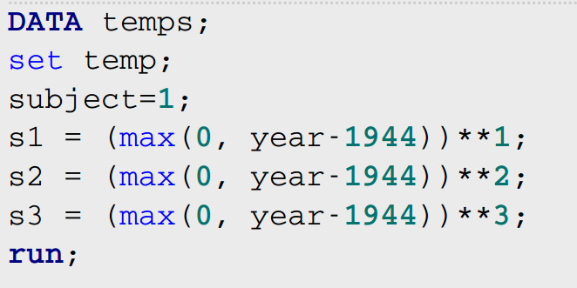

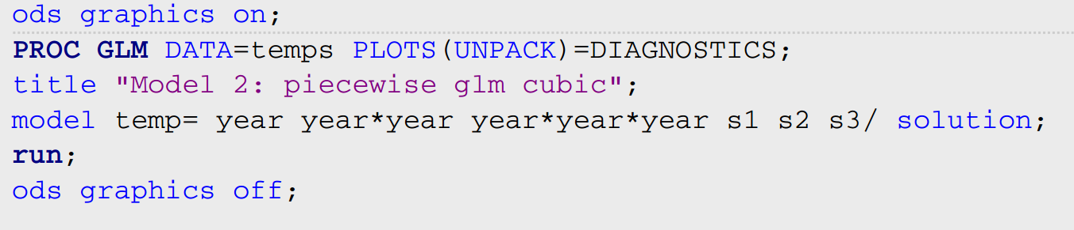

1. **LMM (ML and REML estimation)**

ML is the maximum likelihood estimation approach. The L function is maximized wrt fixed-effects (beta) first, then covariance parameters (alpha). A ridge-stabilized Newton-Raphson algorithm can solve alpha, then plugin alpha to get the ML estimates of beta.

REML is restricted (or residual) maximum likelihood estimation. In this L function, the fixed-effect parameters (beta) are eliminated from the model. By this approach, unbiased estimators of covariance parameters (alpha) are obtained. By the approach, the variance of Y is estimated by maximizing the the likelihood of the error contrasts matrix. Similarly, The restricted likelihood (no betas) can be maximized to yield α. The ML method is used to get the estimates of beta.

Under the marginal model, the Var(beta) = (XtV-1X)-, beta hat is normal distributed. The numerical estimates of α in V-1 come from profile likelihood by ML or restricted ML by REML, then yielding the variance of beta. Thus, miss-specifying the covariance structure may lead to biased estimates of the Var(beta).

1. **GzLM/GEE (quasilikelihood estimation)**

Initially, assuming data are independent and getting estimates by the usual GzLM. Then, GEE are applied iteratively to obtain estimates of beta for the correlated data by using a working covariance matrix. After the GEE process is complete, model-based and empirical forms of Var(β) can be obtained. The variance of Y is a function of the mean. The estimation of Var(beta) comes from the variance of Y. The estimation of Y based on the working correlation.

1. **GzLMM, quadrature (maximum likelihood estimation)**

Approximation of the objective function

For non-normal outcomes, the likelihood function cannot even be written in closed form. Adaptive quadrature or Laplace method (integral approximation) can be used to approximate the likelihood. The approximated likelihood can then be maximized using numerical approach. The estimation process is singly iterative. Similarly, the Var(beta) is the function of the variance of Y and predictors. The mean and the variance are functionally related for most distributions in the exponential family. Thus the variance of Y is estimated during the process of the maximum likelihood approach.

1. **GzLMM, linearization (pseudo-likelihood estimation)**

Approximation of the model.

This method is to create pseudo data (P) using the framework of the GzLMM, and then original responses (Y) that can be modeled with a standard LMM. Particularly, the first-order Taylor expansion of current beta and mean are used to transform the outcome to approximately normal distributed P. The pseudo-ML or pseudo-REML is used subsequently to get the estimation of beta and mean. This process is repeated iteratively until the convergence and doubly iterative. The variance of the pseudo-response P is estimated by the linear mixed pseudo-model. The Var(beta) can be estimated by the Var(P) via the linearization model.