SIMULATION STUDIES

The treatment effects is measured as the difference between 𝑦 1 it and the predicted 𝑦 0 it . Since the true DGP is unknown, the only way to consider which method is more likely to yield more accurate 𝑦 0 it in a wide array of situations is to conduct computer simulations. In the DGPs below, we assume that the common factors , , and are ; the factor loadings , and are also , unless they are specified otherwise. The coefficients are set at and . The DGPs are designed as follows:

**DGP1.** Model with exogenous variables and common factors:

The covariates are (positively) correlated with the factors as follows:

，

where , and *.*

**DGP2.** Model with exogenous variables and common factors:

The covariates follow an autoregressive moving average (ARMA) process as

，

where and .

**DGP3.** Non-linearmodel with exogenous variables and common factors:

The covariates follow an autoregressive moving average (ARMA) process as

，

where and .

**DGP4.** DGP1 with heteroscedasticity:

where and .

**DGP5.** DGP1 with autocorrelation:

where and

**DGP6.** DGP1 with heteroscedasticity and autocorrelation:

where and

**DGP7.** Pure factor model:

where not depended on . The covariates are (positively) correlated with factors as follows:

，

where , and *.*

The treatment and control groups consist of 1 and units, respectively. The treatment for unit 1 starts at time .The other units are not subject to treatment. We let and the pretreatment time as well. The posttreatment periods are set at ; that is, . The number of replications is set at .

We consider four criteria for comparison: the coverage probability of confidence interval for treatment effect (CP) at each post-treatment period, the width of confidence interval for treatment effect (WCI) at each post-treatment period, the mean of the sum of squared error for the actual outcomes and the counterfactuals at each post-treatment period (MSE), the median absolute deviation for the actual outcomes and the counterfactuals at each post-treatment period(MAD). We consider the performances obtained by constructing the counterfactuals of via QCM and QCMX. The simulation results are summarized in Tables 1 –7. We also plot simulation results for DGPs 1–7 when N = 40 and T = 60 in Figures 1– 7. In general, we find that

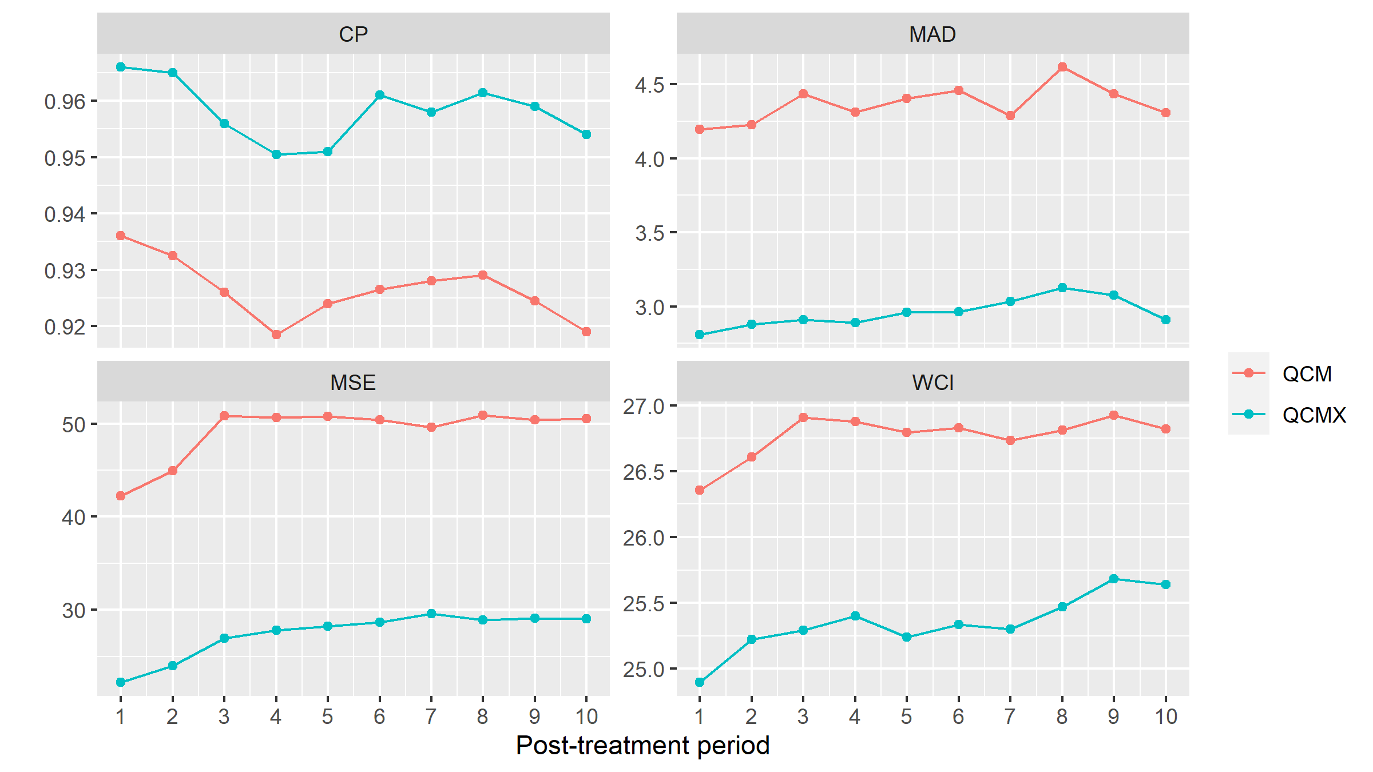

FIGURE 1 Plot of simulation result for DGP1 when N = 40 and T = 70

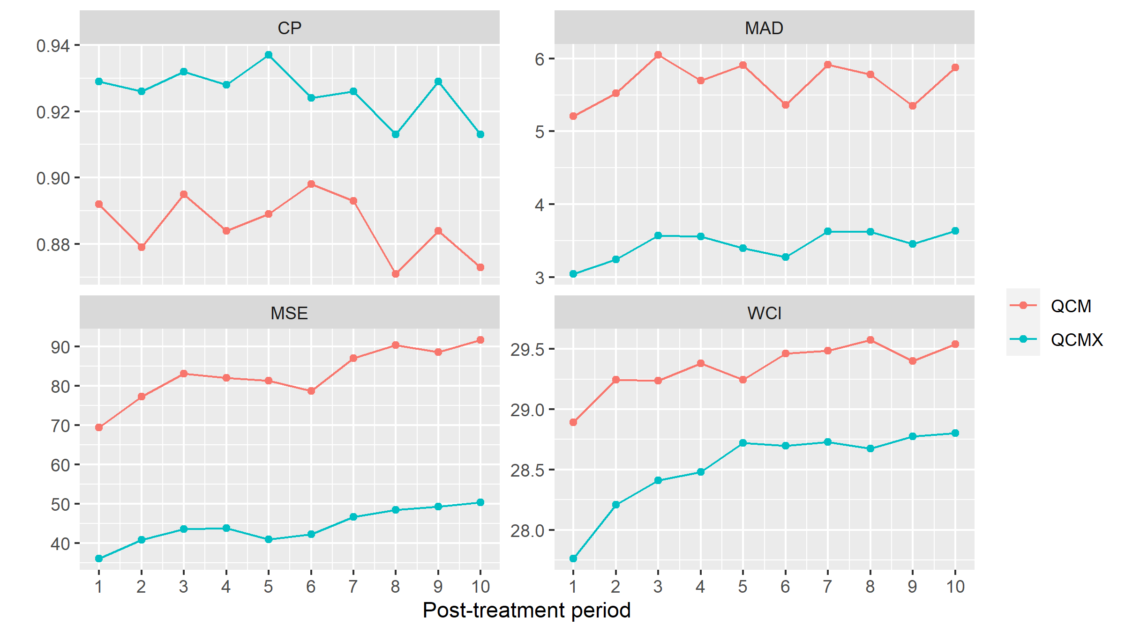

FIGURE 2 Plot of simulation result for DGP2 when N = 40 and T = 70

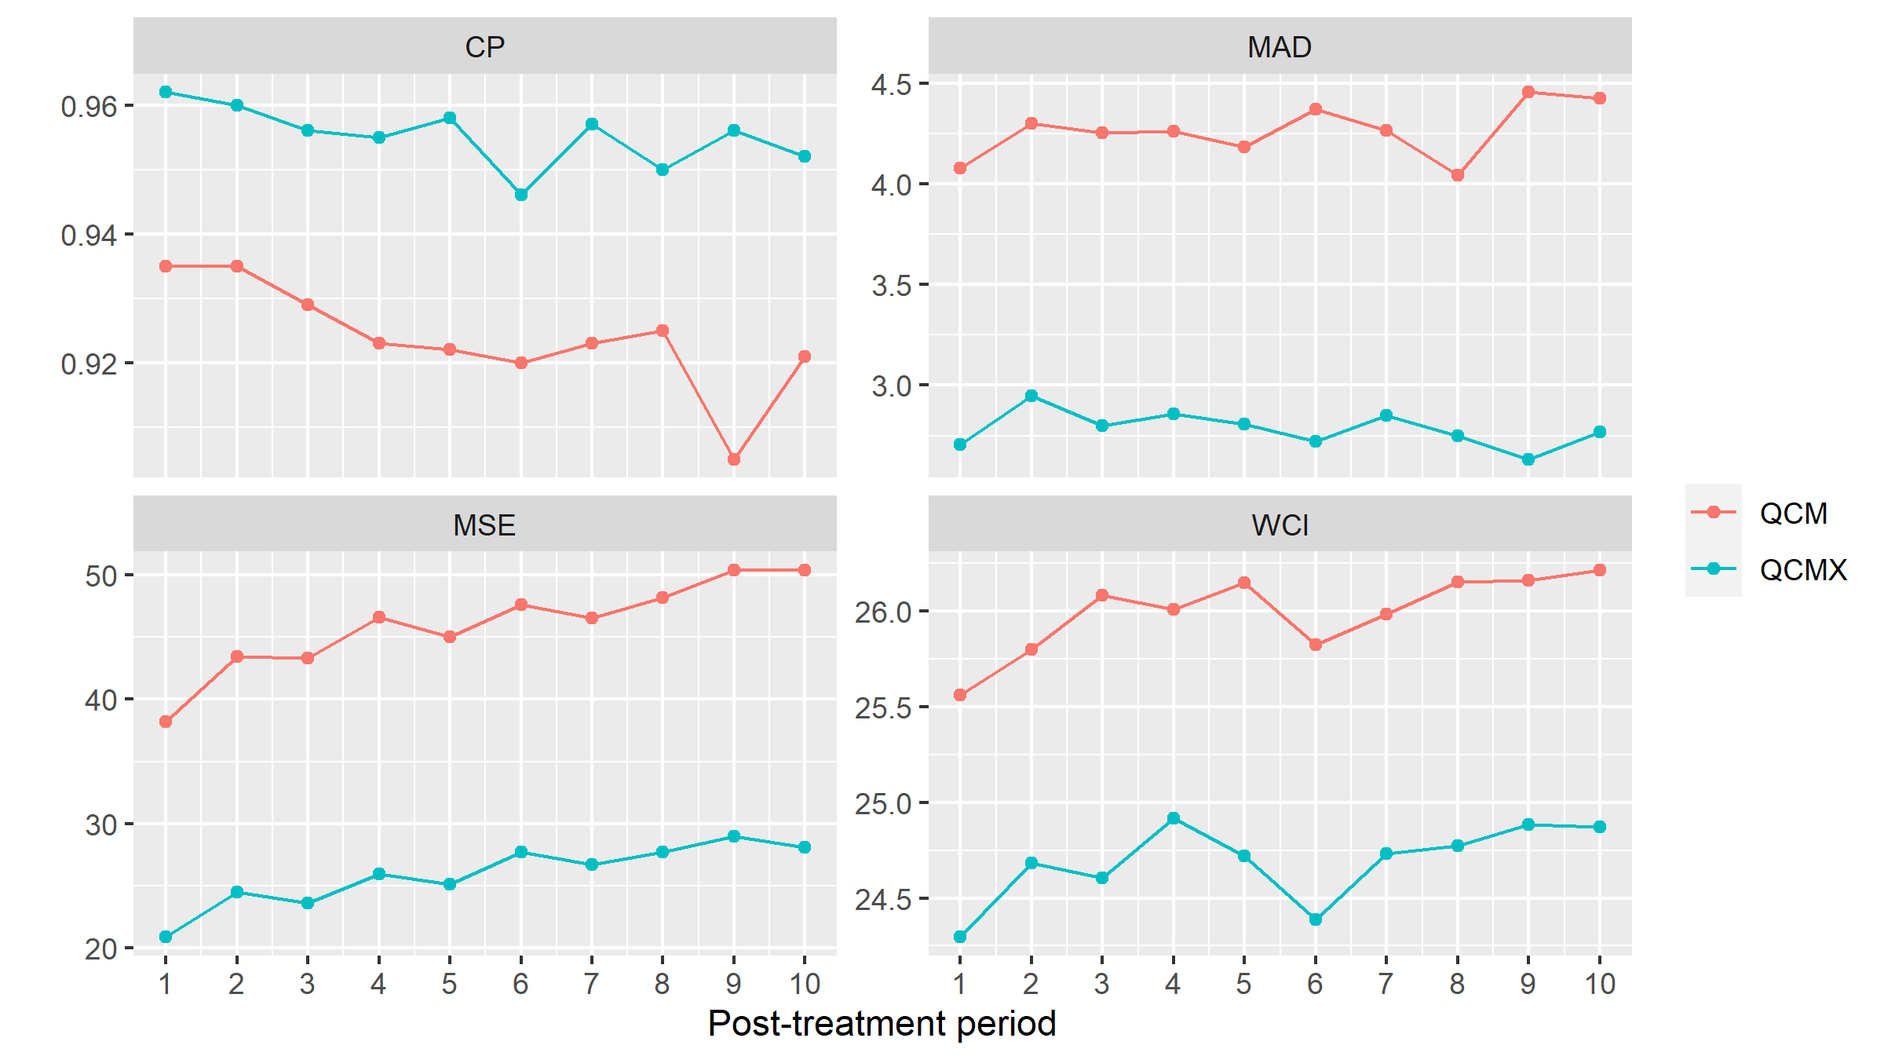

FIGURE 5 Plot of simulation result for DGP5 when N = 40 and T = 70

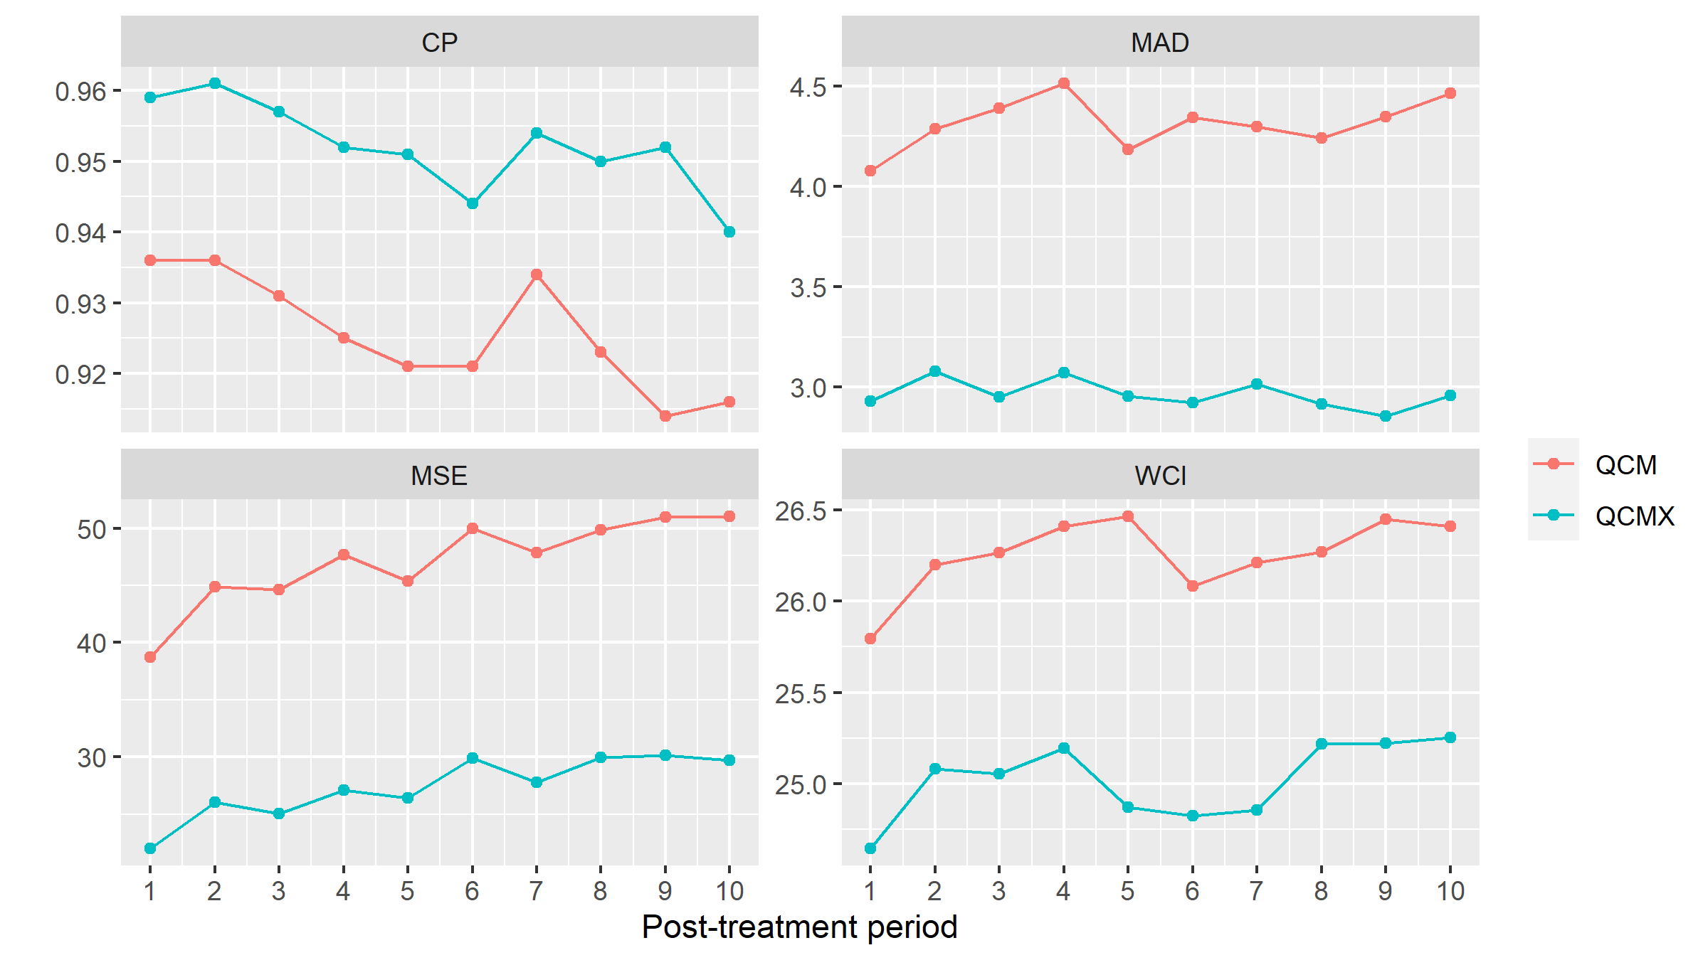

FIGURE 6 Plot of simulation result for DGP6 when N = 40 and T = 70

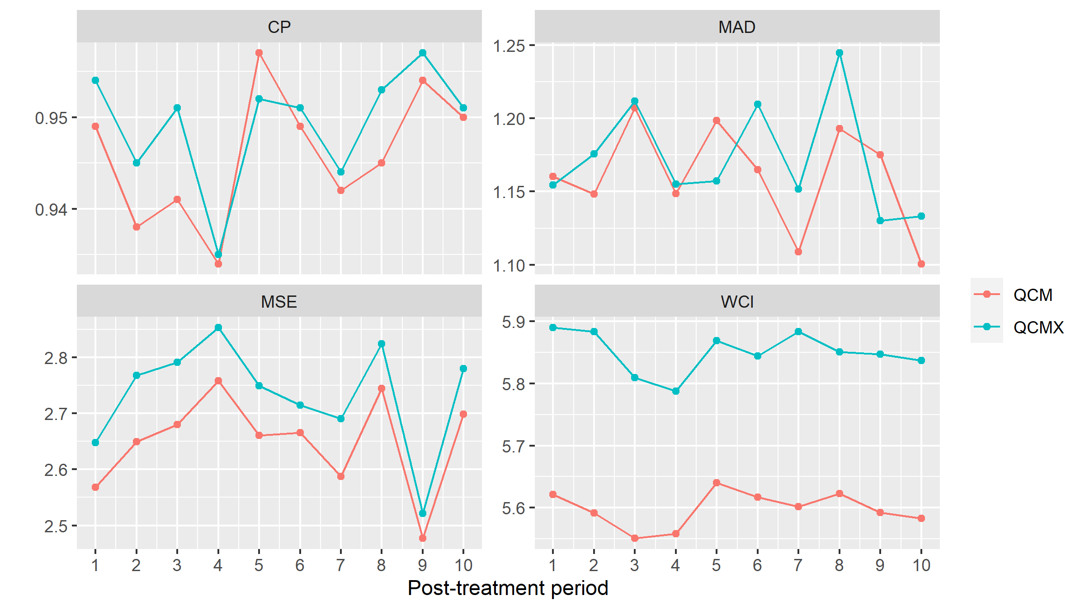

FIGURE 7 Plot of simulation result for DGP6 when N = 40 and T = 70