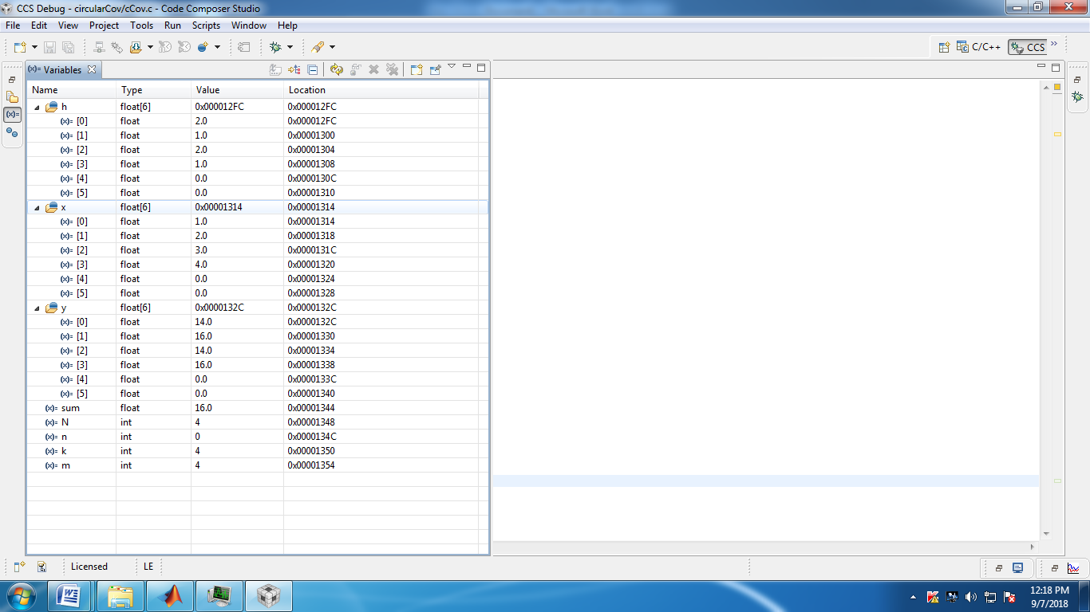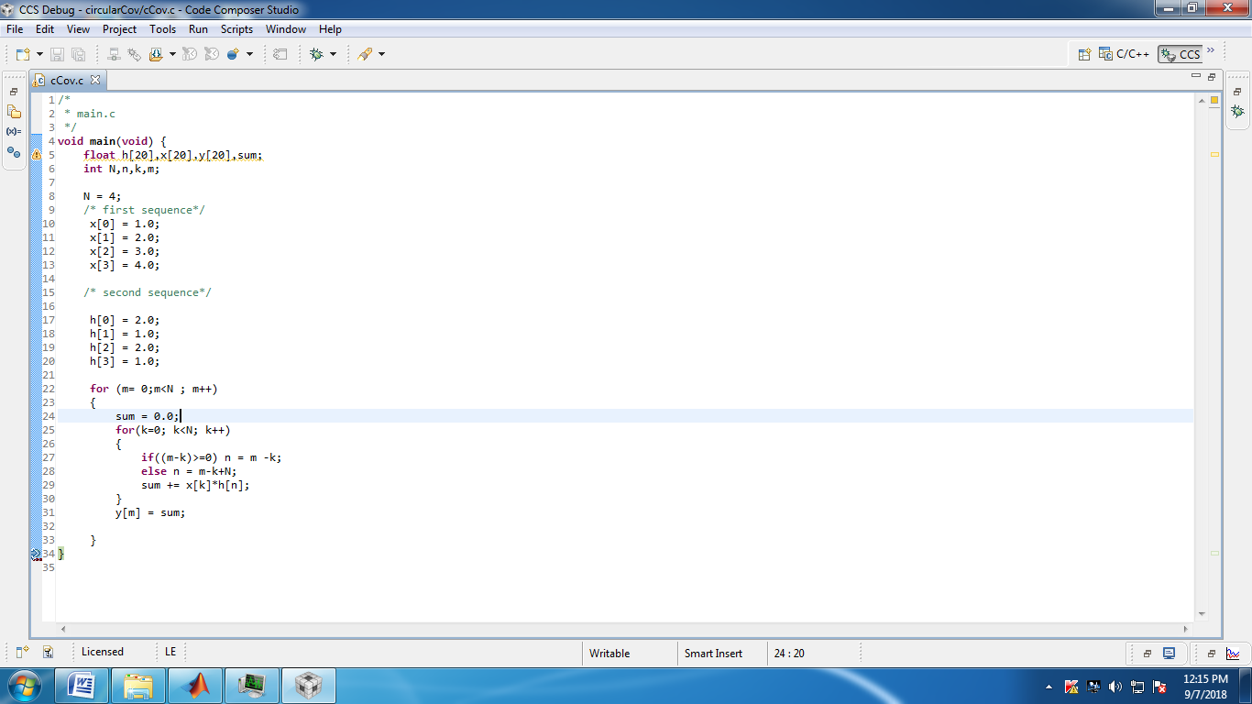

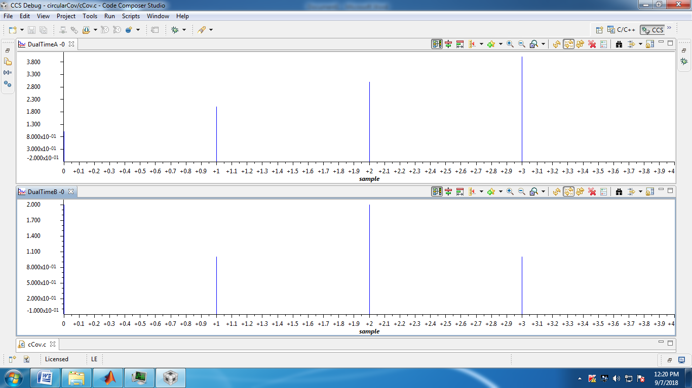

/*

* main.c

*/

**void** **main**(**void**) {

**float** h[6],x[6],y[6],sum;

**int** N,n,k,m;

N = 4;

/* first sequence*/

x[0] = 1.0;

x[1] = 2.0;

x[2] = 3.0;

x[3] = 4.0;

/* second sequence*/

h[0] = 2.0;

h[1] = 1.0;

h[2] = 2.0;

h[3] = 1.0;

**for** (m= 0;m<N ; m++)

{

sum = 0.0;

**for**(k=0; k<N; k++)

{

**if**((m-k)>=0) n = m -k;

**else** n = m-k+N;

sum += x[k]*h[n];

}

y[m] = sum;

}

}

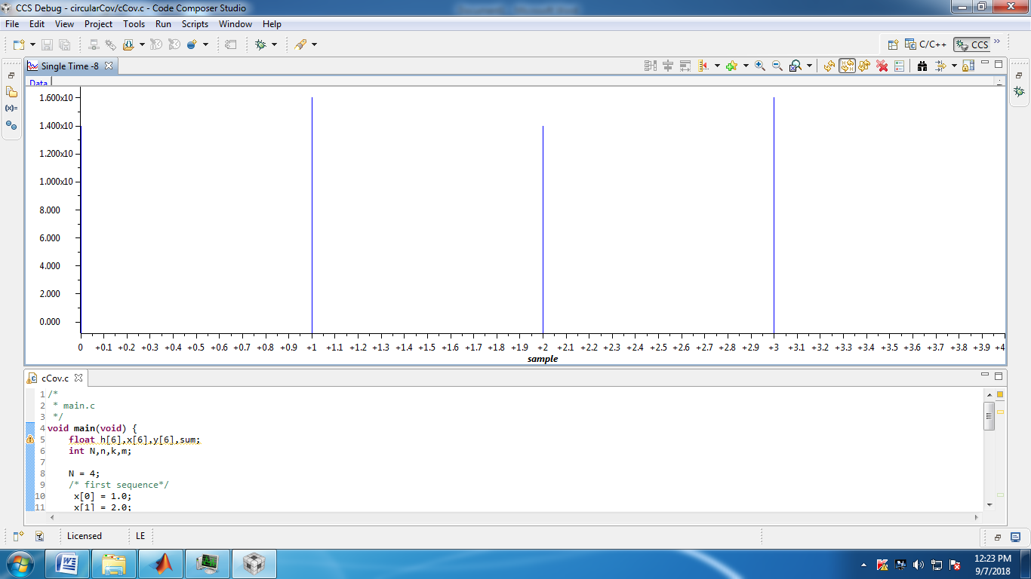

x=[1 2 3 4]

h=[2 1 2 1]

cconv(x,h,4)

circonvu

x =

1 2 3 4

h =

2 1 2 1

ans =

14 16 14 16

