An automated intelligent assistant to present day farmers to maximize yield and streamline the process of buying and selling using IoT

Name: Vignesh Anantharamakrishnan, USN: 1MS16EC130, Phone No: 9886841921, Email: [vigneshkrishnan14@gmail.com](mailto:vigneshkrishnan14@gmail.com)

Name: Simhadri Govindappa, USN: 1MS16EC107, Phone No: 8548040290, Email: simhadri064@gmail.com

Name: Koushik Phani A, USN: 1MS12EC024 Phone No: 9537690106, Email: koushik94a@gmail.com

Abstract:

Mistimed cultivation leads to massive loss of resources and this quite common in India. Basic awareness regarding changing composition of soil before every crop, overview of expected rains and climate for coming months would avoid this and increase yield significantly. They even fall prey for greedy pesticide and fertilizers dealers who scare them into using more than required medicines for the expected diseases which will reduce the standard of the crop. It is also quite common that farmers find it difficult to make a good business model out of their cultivation. Addressing these issues we want to propose a solution which would be the front end for an IoT system which acquires the necessary soil and weather data from the fields and this data is analysed by a machine learning model and predicts which crops grows best for given soil and weather conditions, then we also provide detailed guide for growing the predicted crop and a list of buyers who the accept the grown crop at reasonable price. Thus, ensuring the farmer is benefited to the maximum.

Introduction:

With more than 50% of the population into agriculture, the farmers are the back-bone of our nation. Despite large areas under agriculture, India's agricultural sector has **very low productivity**. This is due to several factors such as the limited use of mechanized farming techniques, a lack of adequate equipment and infrastructure and many other challenges. As a result the farmers do not earn the profits they deserve for the efforts they put in to cultivate the crops all throughout the year.

One of such challenges that we aim to address in this report is that this mistimed cultivation leads to massive loss of resources and this quite common in India. Basic awareness regarding changing composition of soil before every crop, overview of expected rains and climate for coming months would avoid this and increase yield significantly. They even fall prey for greedy pesticide dealers who scare them into using more than required medicines for the expected diseases which will reduce the standard of the crop. It is also quite common that farmers find it difficult to make a good business model out of their cultivation. We address this issue in our proposed model.

##### Our proposed model is a simple looking three-point solution based on **Internet of things(IoT)** which could be very effective when it is genuinely implemented:

1. Know what grows best.

2. Grow what you can sell.

3. Sell what you have grown.

###### Know what grows best

To achieve this we use the data we’ve been given on soil nature, crops, climate and weather and train a machine learning model based on decision tree to predict which crops need to be grown on a given soil for maximum yield. To enable IoT functionality we will use NODE MCU to collect various data on soil nature, soil humidity is measured by sensors such as soil sensors, the local weather conditions in the fields measured by weather sensors, relayed in real-time and supply the details to a machine learning model to get accurate results, thus automating the entire process. It also has an option to manually enter the data from soil test thus giving the user more flexibility . This weather data, combined with the particular soil parameters can give us a good estimate on what would work best in the favor of the farmers.

###### Grow what you can sell:

It's always better to know the standard your client expects before making the product. This platform can provide information of step by step procedure for cultivating a particular crop, possible diseases and setbacks with the appropriate diagnosis based on soil, season and locality. By doing so, we make the farmer aware for scientific methods available to grow a crop to ensure he gets the best yield.

###### Sell what you have grown:

Here, we have a list of authenticated buyers in the market such as big basket (who buy produce at reasonable price)whom the farmer can contact to sell his produce. We also display the present market prices of each crop the farmer grows taken from an authentic source and allow farmers to make their bargain and send quotation. If they are going for low prices it will be by their choice to beat the competition but never because of ignorance again. Sending quotations should be easier than ever.

Farmers would be able to maintain this cycle of three points within a mobile application supported by an array of IoT sensors.

Related work :

<https://www.cesga.es/images/noticias/novas/articulos/paper_13.pdf> \

<https://ieeexplore.ieee.org/stamp/stamp.jsp?arnumber=7225403>

<https://www.researchgate.net/publication/317696446_Crop_recommendation_system_for_precision_agriculture>

The above papers cite parts of the issues but none of them address the issues we solve in this report completely.

Proposed Model:

The model is designed to have cross platform support. Initially, the client or user interacts with the app to access information about the crops and send information to the server over the internet.

Know what you grow:

Here we either, gather vital soil information such as rainfall content, moisture content, biomass and soil nutrition using the required soil and rainfall sensors or ask the user to manually enter data obtained from soil test through the app or user interface. This data is sent over to the server .The collected data is then sent to a mongoDB database where is it analysed by a machine learning model to predict a crop the gives maximum yield. This result is then displayed in the app to requested client along with detailed guide on how to grow the predicted crop and a page with the list of verified sellers.

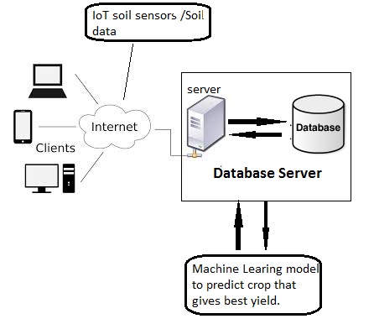

IMPLEMENTATION:

To implement the above model we have used **react-native** with JavaScript to build the front end for the client. The backend server runs on **Meteor.JS** with **MongoDB** as database. This server then sends the soil data as a get request to the machine learning model written in **python**, the results are then sent to the server by the means of an api written in python with **flask**.

The App - Part 1: Know what grows best.

* Here we used the data on soil nature, crops, climate and weather and trained a machine learning model to predict which crops need to be grown on a given soil for maximum yield and minimize cost.
* We have implemented this using Soil moisture, N-P-K ratio, Dry matter (manure) already present in soil as parameter to ML model.
* The model uses a decision tree based learning algorithm.

Validation of result:

For a particular case of growing Bananas, the NPK ratio need by the crop is 10:2:22 N:P:K for the 1st stage. So when we enter the NPK details in the app in such a ratio the result was Bananas.

Advantages of such approach:

* Fertilizers are added to get the soil nutrient levels to the ratio required by crop the farmer plans to grow leading to lots of expensive base work of cultivating soil.
* But as our model already predicts which crop grows best given present condition, we are eliminating a major step of cultivating the soil to get it up to the required level.

*The App- part2: Grow what you can sell :*

* This platform provides detailed information of step by step procedure for cultivating a particular crop, possible diseases, and setbacks with the appropriate diagnosis based on soil and season.
* Adding crop data to data base:

A web page is used to add or correct data about the crops on the server. The access to this web page is given to only authorized / verified experts who can give accurate information about the crops. Thus our model is easily scalable.

*The App-part 3: Sell what you have grown:*

Here, we have a list of authenticated buyers in the market such as big basket (who buy produce at reasonable price)whom the farmer can contact to sell his produce. We also display the present market prices of each crop the farmer grows taken from an authentic source and allow farmers to make their bargain and send quotation.

SCREEN SHOTS:

Authentication and login:

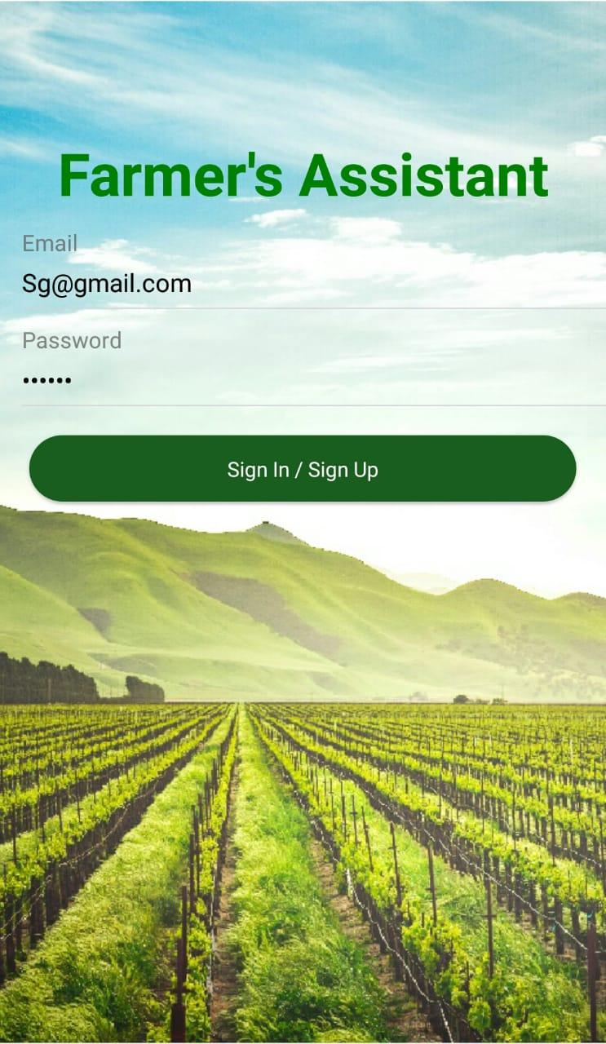

The App - Part 1: Know what grows best.

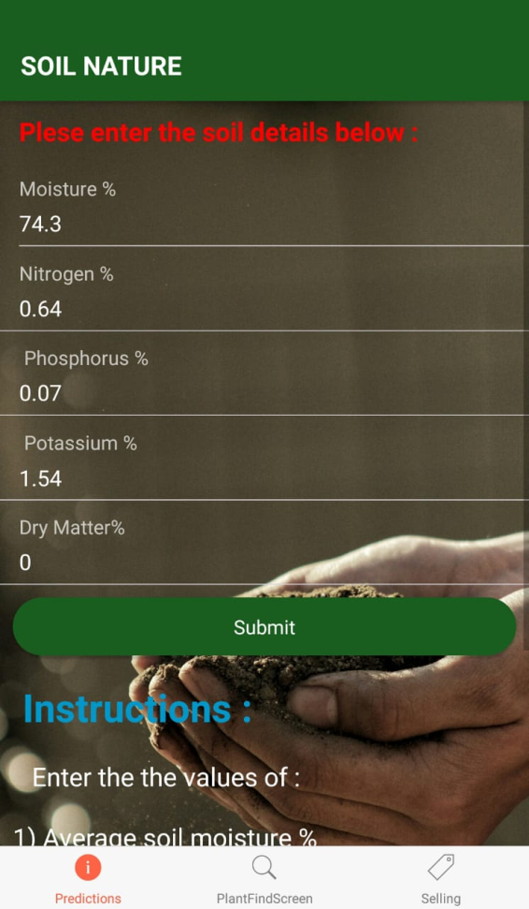 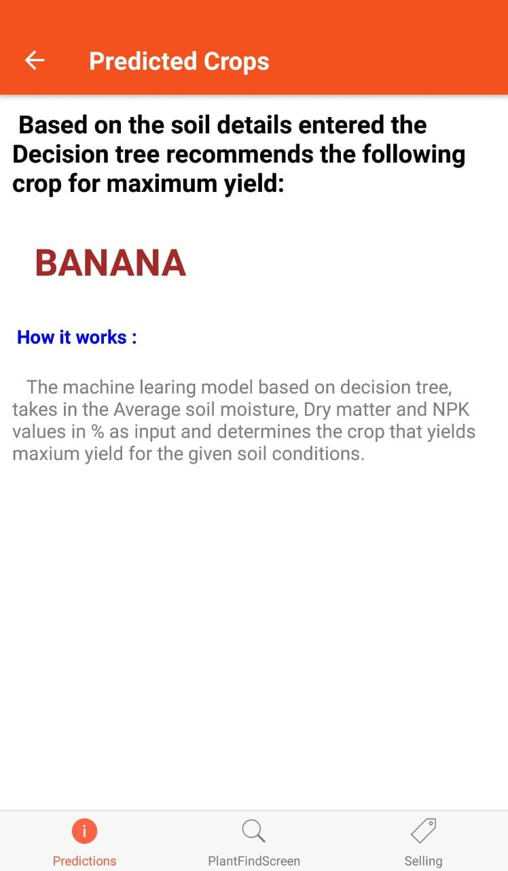

*The App- part2: Grow what you can sell:*

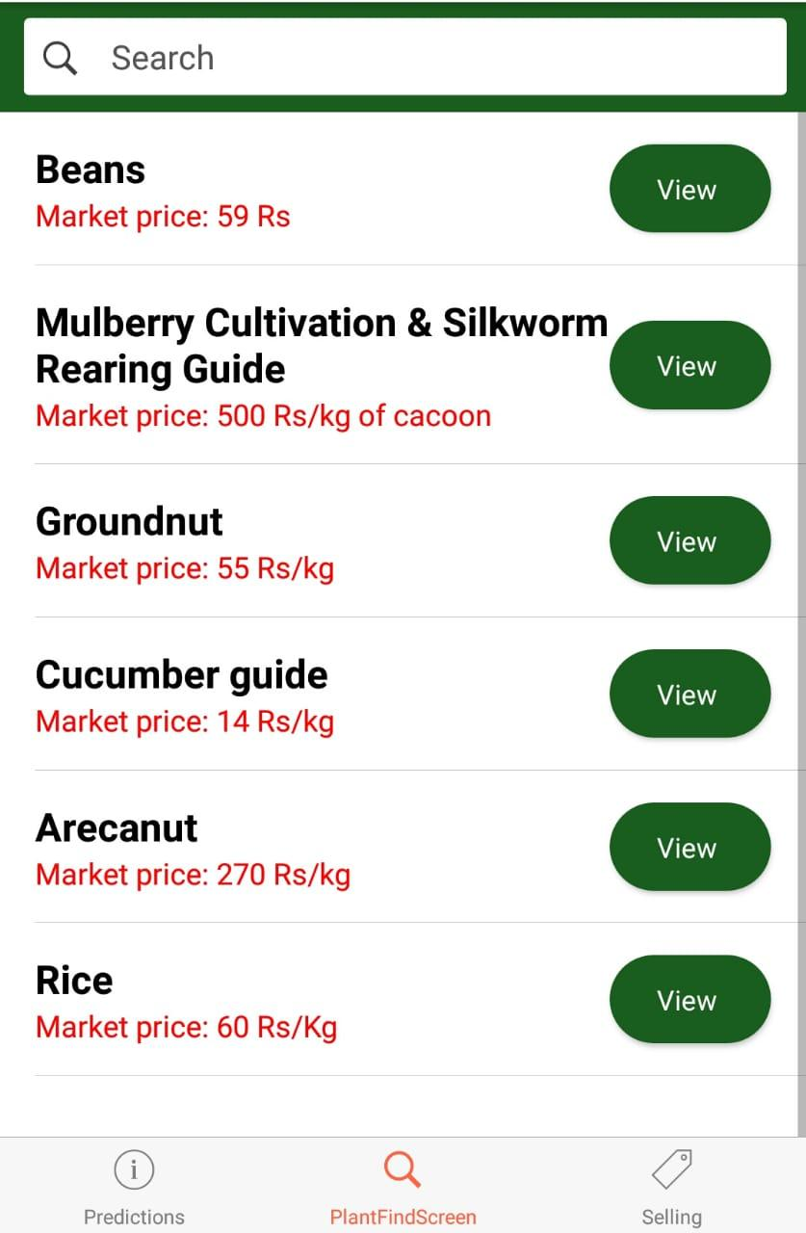 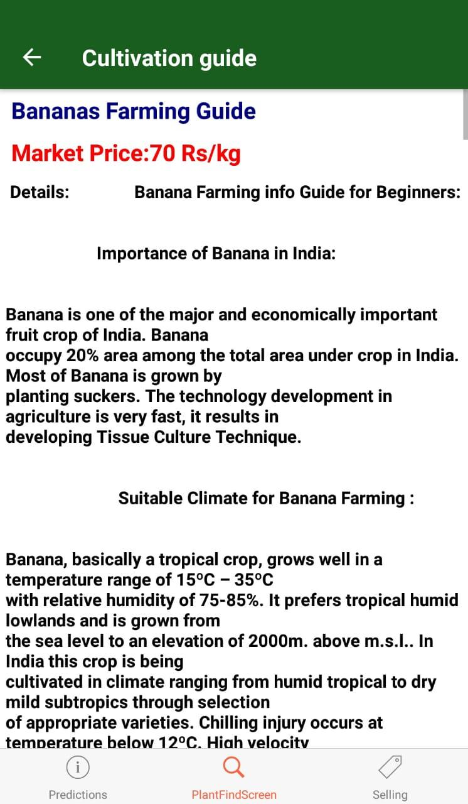

###### Sell what you have grown and webpage to add data:

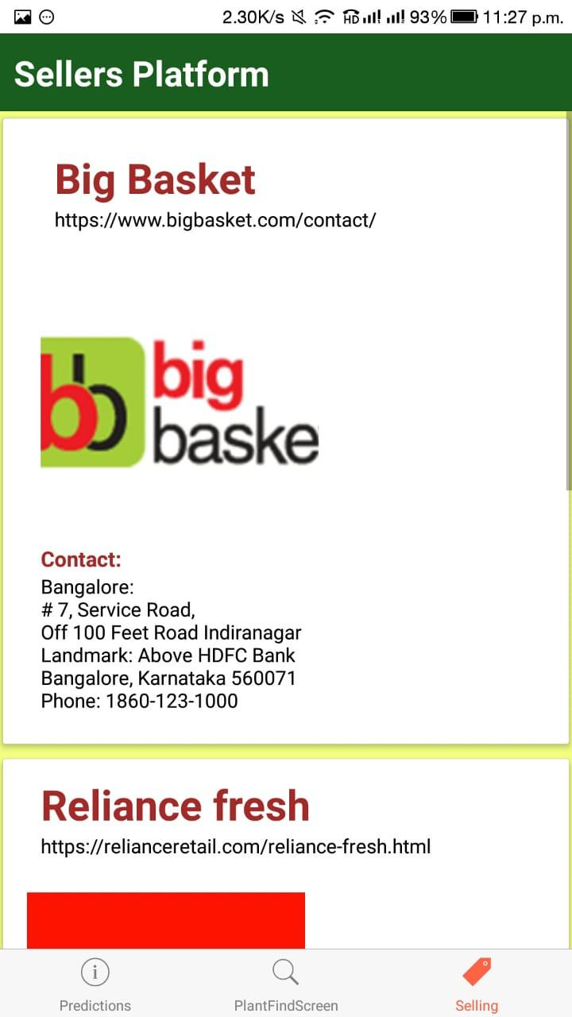 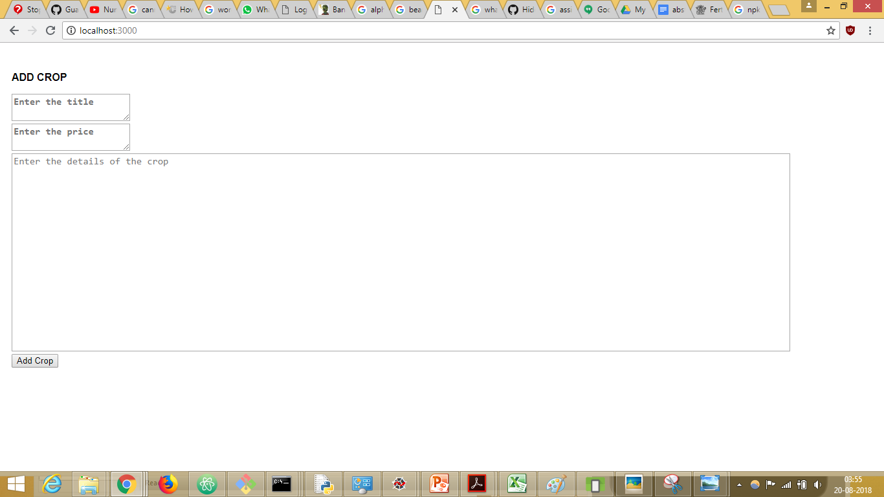

Conclusion:

The above solution provides farmers an efficient way to maximise quantity while ensuring the highest quality. Our solution also has made it extremely feasible for everyone as it is supported on all platforms. This ensures that farmers are rewarded for their hard work in growing various crops and also sustains farming in India for the forthcoming years.