CSE-528 Project Plan

Bhavik 2018385

Hardik 2018391

Ritvik 2018407

# Project Motivation

Modern Societies collect **Cooperative funds** from members, which are then later used to maintain and organize events in societies, So the organization looks something like

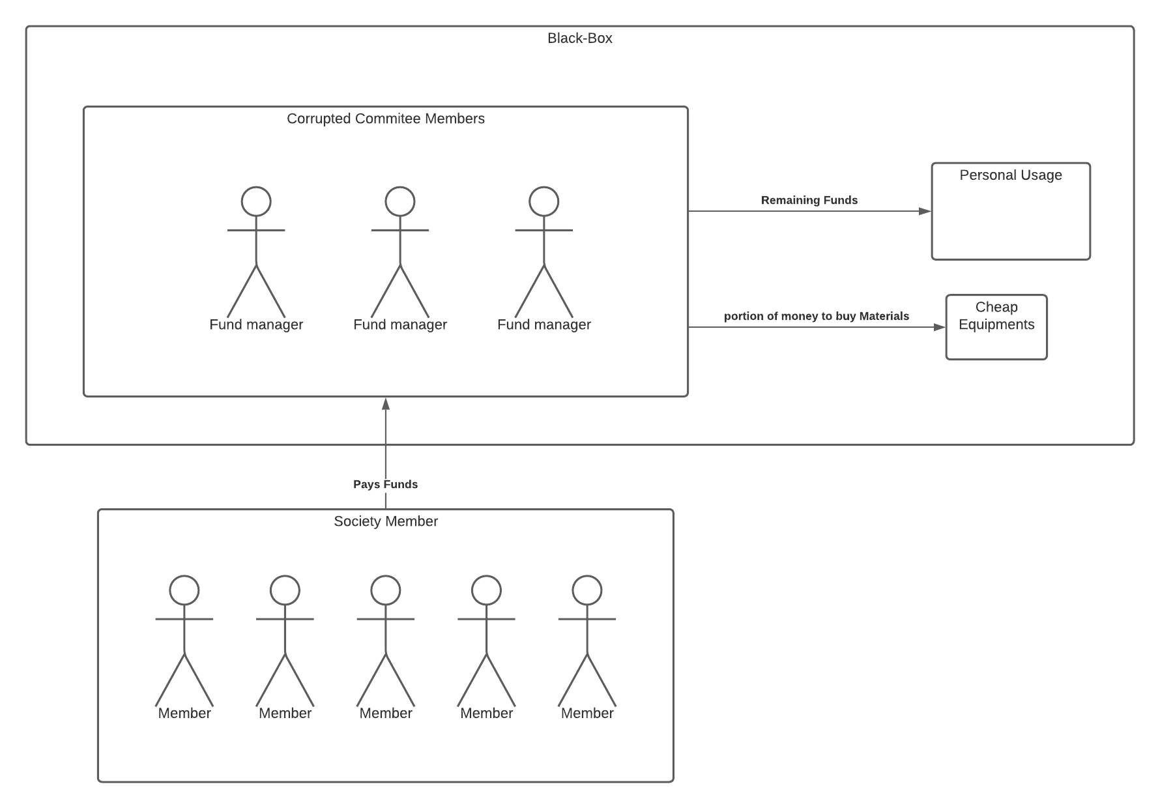

For example, Most of the people in urban cities live in societies. In a housing society, a small group of people who are generally the members of the society, are elected as the welfare committee, who have the following responsibilities:

1. Collect monthly maintenance from all members of the society and storing it as society funds.
2. Making decisions on where this fund would be used i.e. using the society funds for expenses related to regular maintenance-related works and giving salaries to all the employees like electricians, plumbers, cleaners, etc.
3. Managing various monthly/festival/cultural events, and all the expenses done by the committee would be funded by the contributions of the society members and a new fund would be created by the committee for every new event.

Now every member of society would like to have an assurance that all the money they are contributing is being spent in a fair manner, free of corruption. Hence there is a need for a robust and transparent system where all the expenditure done by the committee is visible to all the contributors of the fund.

# Project Description (Tentative)

We have thought of implementing a DAPP application for the above problem in which the funds could only be approved after it has been verified by the majority of the society members. Basically, each and every time transaction would only take place, after the majority of the members give permission. So in this way, every society member would be aware where their money is being used and frauds could be avoided.

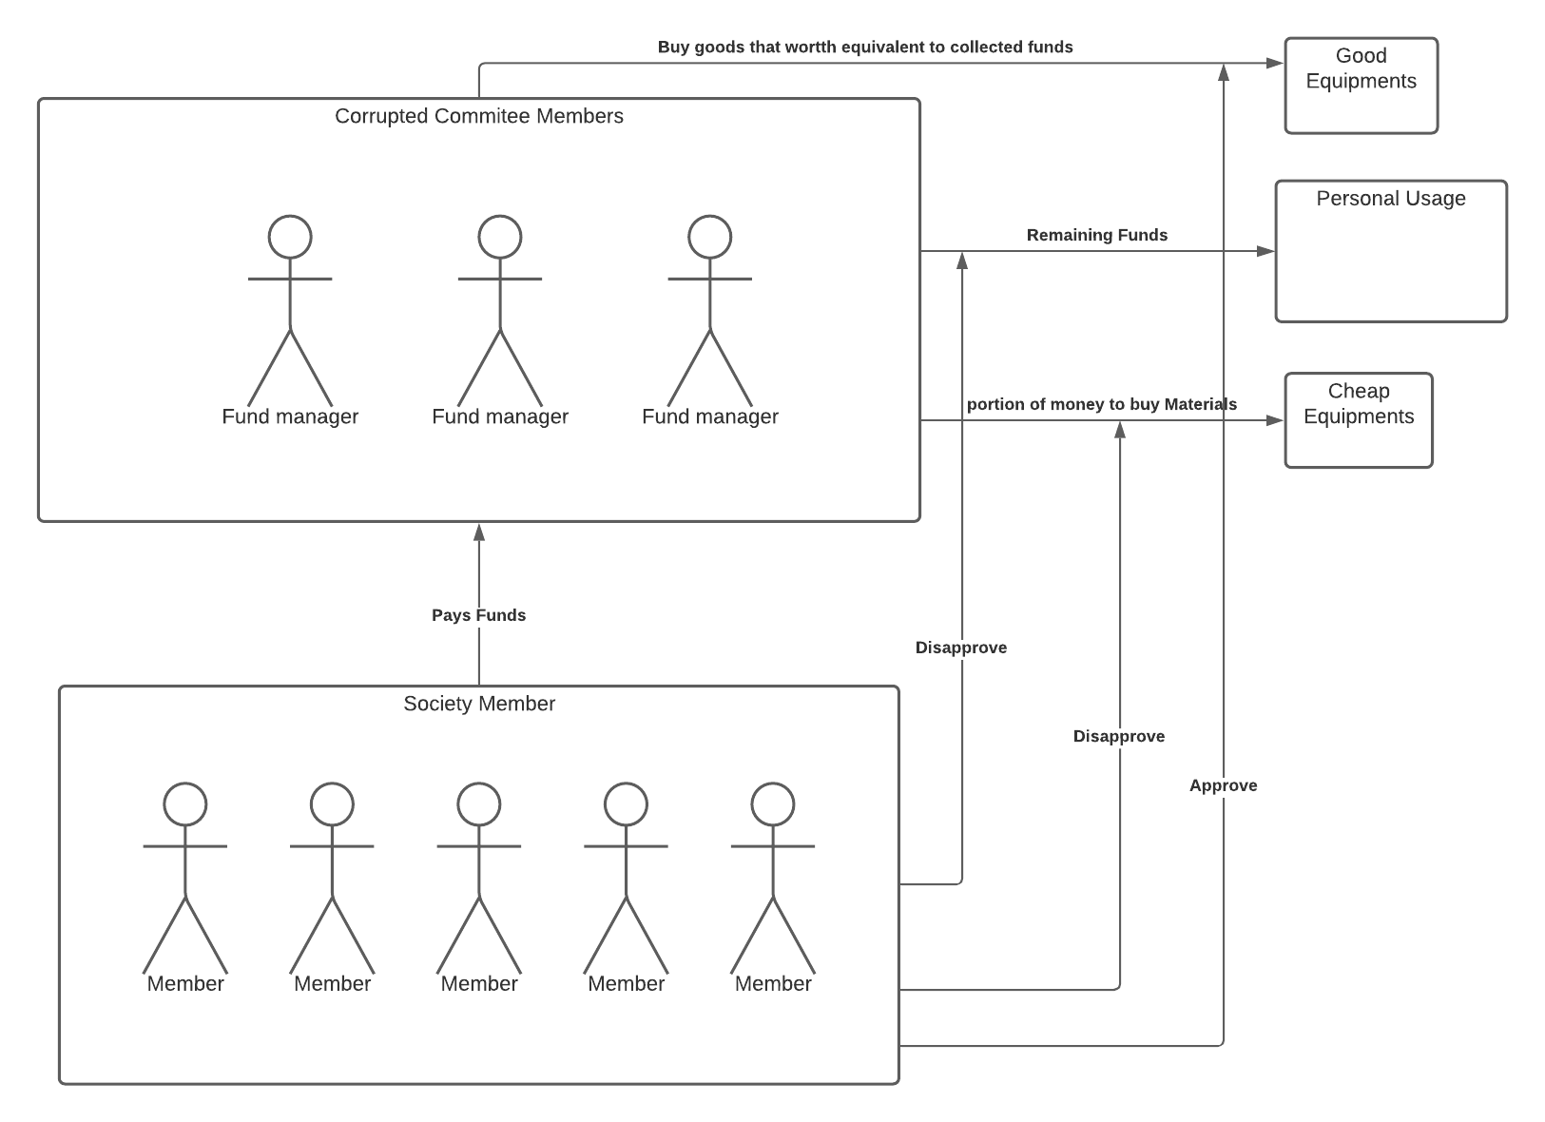

# Project Workflow:

1. Selecting the problem we are going to solve using our application
2. Finding out who all will be the stakeholders.
3. Figuring how blockchain can help overcome specific challenges in the application.
4. Deciding what all languages and technologies we are going to use.
5. Research about the use of similar fund management systems using blockchain.
6. Learn various technologies that will be used during the project like solidity, smart contracts, etc.
7. Designing the whole application
8. Coding the application using good coding practices- includes creating smart contracts, building the frontend and backend of the application, and connecting to the database.
9. Testing the application and asking the users for feedback, and improving the app based on feedback.

# Project Schedule (Tentative)

**Project Schedule:**

| **#** | **Description** | **Time Period (Tentative)** |
| --- | --- | --- |
| 1 | Learning Solidity, Smart Contracts, Blockchain Applications | 2 Weeks |
| 2 | Software Specification Requirements, Policies & Design | 3 Weeks |
| 3 | Coding Period | 4 Weeks |
| 4 | Testing & Feedback | 2 Weeks |

**Work/Responsibilities Distribution:**

| **#** | **Responsibilities** | **Person** |
| --- | --- | --- |
| 1 | Understanding Basics of Blockchain, React Frontend, Software requirement specification, Blockchain Development, Creating database, Testing Blockchain Code | Hardik |
| 2 | Understanding Basics of Ethereum, Front-End event Handling, deciding Application policies/Rules, Smart Contract development, configuring the database, Testing Smart Contract Code | Bhavik |
| 3 | Understanding Basics of smart-contracts, Connection with Backend, Designing, Smart Contract & Blockchain Integration with Application, Maintaining Database (Across Iteration), Testing Whole Application | Ritvik |

**Resources:**

[Solidity](https://youtu.be/YjbIrNRqiYU), [Smart Contracts](https://youtu.be/ipwxYa-F1uY), [React](https://youtu.be/4UZrsTqkcW4), [Knowledge of database](https://youtu.be/oSIv-E60NiU), [StackOverflow](https://stackoverflow.com/questions), [GeeksforGeeks](https://www.geeksforgeeks.org/)