Report

Course Code: CSE202

Course Name: Fundamentals of Database Management System

Work in progress Document

Team Name: db45

Team Members

* Dhruv Diwan: 2018031
* Hardik Saini: 2018391
* Ishan Sharma: 2018043
* Nikhil Yadav: 2018298
* Sonali Supriya: 2018318

**Idea**

We have built an app to facilitate purchase of books that publishers bring to us for further retail.

The app caters to 5 stakeholders :

* Book Purchasers / Readers
* Publication Houses
* Books Authors
* Company manager / Auditor
* Book Stock/Warehouse maintainer

**Schema**

<https://drive.google.com/file/d/1k09HXmjKZrS7lT4e1AmWkFEfusr6NI7b/view?usp=sharing>

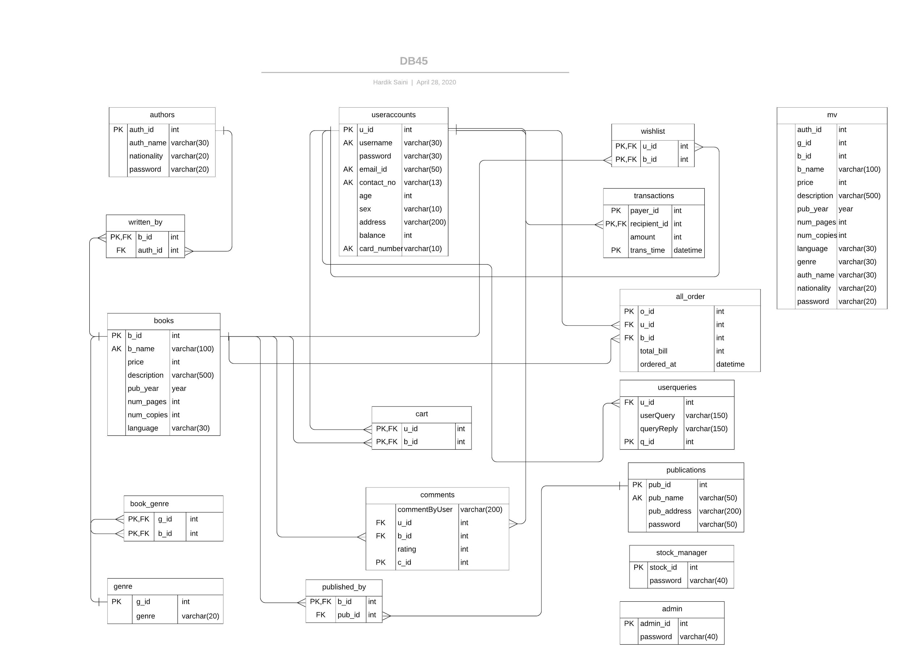

**Software Requirements** to run the program on your system

* Java
* JavaFX
* Java-MailX
* IDE
* Font-Awesome
* JFoenix
* JDBC-Driver

**Study of previous work**

We took ideas from existing platforms similar to ours, in order to finalize the functionality and interface of our app. Some of them were:

Good Reads

Flipkart

Paytm

**The user functionality**

1. Providing separate views for different stakeholders treating them as different types of “users” of the system
2. Enabling the publisher to upload and put up for sale new books.
3. Providing a bookwise, informative track of the warehouse to the stock manager
4. Providing a week wise sorted report/summary in a presentable manner to the platform company owner.
5. Allowing the end-user to buy books via the platform and search our depository using an “advanced search” option which shall allow search on basis of:

* Name
* Author’s name
* Language
* Year of Publication
* Price
* Nationality of Author

Also, these parameters support partial substring search, i.e.

User can search in for some parameter even if they don’t remember

whole word.

Example: if there exists a book name Alchemist, Allen And if the user searches for “al”, then both of these books will pop up in results.

1. Providing users an easy way to purchase, by putting an amount into their store wallet. They can also make transfers to other accounts safely by entering their (store provided) card number.

**Data Curation**

We used a few data generation websites to gather data relevant to our purpose in CSV form.

Then we used these CSV’s to populate the databases using scripts to generate SQL commands.

Specifically, we used [www.generatedata.com](http://www.generatedata.com) and [www.mockaroo.com](http://www.mockaroo.com) .

|  |
| --- |
| **Bonus Attempt**   * **Interface**: A GUI Interface allowing easy navigation to the user * **Search**:   + Dynamic Search: The search result are displayed dynamically while the user enters his query, like in the google search bar   + Advance search option allowing user to perform complex queries * **User login session**, so that the user does not have to enter his username and password every time he uses the app. * **Password Retrieval** via mail: In case a user forgets their password, they get a mail for the same from [**books.paradise45@gmail.com**](mailto:books.paradise45@gmail.com) **.** * Pie **Chart based representation** of store’s weekly financial and warehouse data for an intuitive view. * **Password encryption:** Password of higher privilege users viz. admin and stock manager are sha encrypted, as in the case of actual stores. |
|  |

**Snapshots of GUI and future scope.**

