Nama : Soni Andika Gutama

NIM : 1301200419

Kelas : IF-44-06

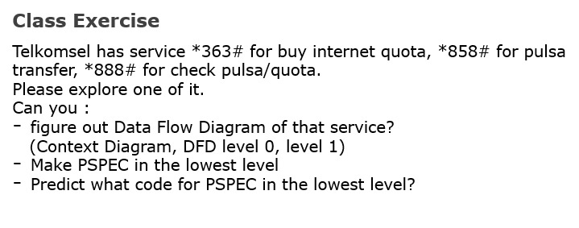

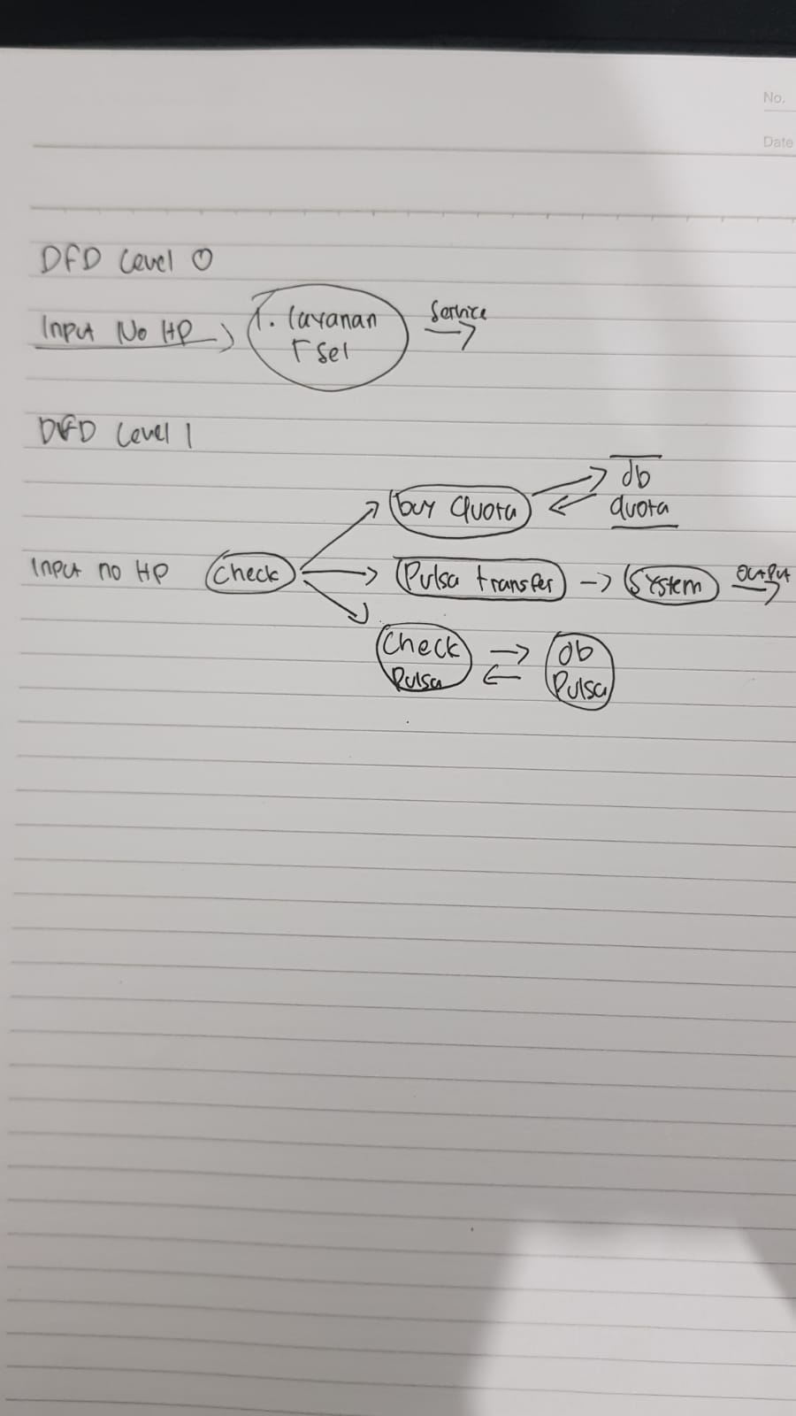

1. PSPEC in Java

public void TSelServ(String input){

if(input=="*363#") buyQuota();

else if(input=="*858#") pulsaTransfer();

else if(input=="*888#") checkPulsa();

}

1. public void CountFee(int computer_amount){

float base_fee, additional_fee;

if(computer_amount == 1 || computer_amount == 2)

base_fee = 100;

additional_fee = 0;

break;

else if(computer_amount >=3 && computer_amount <=10)

base_fee = 100;

additional_fee = 10;

break;

else if(computer_amount>10)

base_fee = 500;

additional_fee = 10;

break;

}

if (!contains(service_time, business_hour)) base_fee *= base_fee;

if (willDropOff(customer) && willPickUp(customer)) base_fee = base_fee - (base_fee*0.5);

}