Starting from the modified GLV:

$$\frac{dx_{i}}{dt}=ax_{i}+(\sum_{j=1}{c_{0}x_{j})x_{i}+\sum_{j=1}{\sum_{k=1, not i, j}{c_{k}x_{k}}x_{j}x_{i}}}$$

Where $c_{0}x_{j}$ describes how each species and its concentration affect the growth of $x_{i}$; and $c_{k}x_{k}$ describes how each species and its concentration modifies $c_{0}$, the unit density (of $x_{j}$) pairwise ( $x_{i}$ and $x_{j}$) interaction matrix.

~~This equation relates the density changing rate and density of individual species:~~

~~If we take summation on both sides, on the left hand side, the summation of individual density changing rate would be the whole microbiome density change rate. On the right hand side, there would be a quantity that has to do with total density of the microbiome, which is the product of average density across species and the number of species in the microbiome.~~

~~Before the whole communities reaches a steady state, the faster the whole community grows, the sooner $\frac{dM}{dt}$ becomes 0.~~

From our preliminary studies, we noticed the presence of higher order interaction (HOI) helps to stabilize the community (Fig. 1). The effect becomes more apparent when more species participated in the community. This forms our first hypothesis.

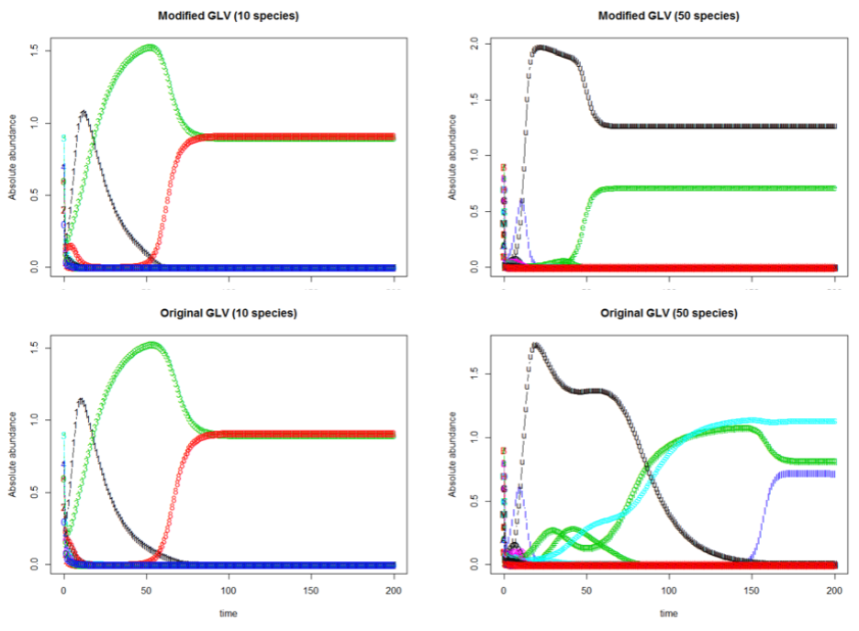

Fig. 1 HOI helps to stabilize a community, particularly for larger community

To test the hypothesis, one thousand simulations of a community of size N are run using GLV model and HOI model, given the same initial condition. The community steady state time for each simulation is defined as the time when all species have reached steady state (i.e. the time when the last species in the community plateaus). When some species are not able to reach steady state within our investigation time frame (500), the community steady state time is set to NA. We then subtract the community steady state time for each GLV model and HOI model pair and study if the difference is significant.

DensityMediated_varyingCoefficientLinear.R is used to generate intial condition, interaction score matrix and to integrate the model (HOI and GLV). Its input is the community size N. Its output are species-wise density over integration time (500).

FindSS.R find time when a species reaches SS. It input is a species density over time (1D vector). Its output it the time when SS is reached. If no SS is found, NA is returned.

SpeciesSSTimeMultipleSimulation.R calls functions in DensityMediated_varyingCoefficientLinear.R and FindSS.R and run over 1000 simulation (nrow = 1000) for N = 10, 20, 30, 40, 50. It returns a matrix where each row is a simulation and each column is time for a species to reach SS. 5 matrices (for each N) for each model are generated and stored as csv file (10 files in total).

HOIStabilizesCommunity.R draws csv files from working directory and find for each simulation the largest time (i.e. find max over each row) and store as the community steady state time. This is repeated over both GLV and HOI model on a specific N and the difference is calculated and plotted as below.

