Problem Solving

A Cat, a Parrot, and a Bag of Seed:

A man finds himself on a riverbank with a cat, a parrot and a bag of seed. He needs to transport all three to the other side of the river in his boat. However, the boat has room for only the man himself and one other item (either the cat, parrot or seed). In his absence, the cat could eat the goat, and the goat would eat the cabbage. Show how he can get all the passengers to the other side, without leaving the wrong ones alone together.

1. **Define the problem**:
   * The man’s problem is having enough space to transport his cat, parrot, and bag of seeds along with himself in the boat. We don’t know his intended use for the seeds, or animals. His over all goal is to get himself and his belongings to the other side.
2. **Break the problem apart**:
   * The boat only has room for himself and one of the three items. He must transport himself and all of his items to the other side.
3. **Identify potential solutions:**
   * He could feed the seeds to the bird, feed the bird to the cat, and carry the cat with him on the boat.
   * He could try to put the bid and cat inside the bag of seeds. This will allow him to carry only the bag on the boat.
   * Another option he has is to take each item over one at a time. He could have someone on each side watch the items as he makes the separate trips across the water.
4. **Evaluate each potential solution**:
   * The 1st option is destructive to both the seeds and bird.
   * The 2nd option has the same potential of being destructive to the bird and seeds. Once in the bag, the bird may be tempted to eat the seeds, just as the cat may be tempted to eat the bird.
   * Although the 3rd option requires multiple steps, it has the greatest chance for success. This can be done with the assistance of a helper on each side to watch his items.
5. **Choose a solution and develop a plan to implement it:**
   * For option 3 I would have the man call up two friends, one to meet him on each side of the river. Once he meets up with the friend on the same side of the riverbed he is on, he should call the other fried to confirm they are waiting on the other side. He would make the first trip over with his first item he confirms everyone is in place. Then he will return back to the first riverbed and repeat this steps until all items have made the trip across the river. Upon completing this to until process, the man will thank his friends and go on his way.

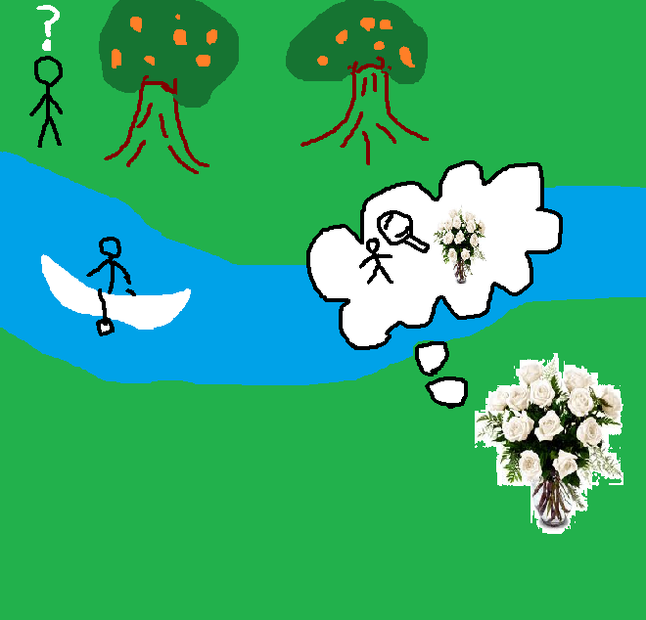

Socks in the Dark:

There are 20 socks in a drawer: 5 pairs of black socks, 3 pairs of brown and 2 pairs of white. You select the socks in the dark and can check them only after a selection has been made. What is the smallest number of socks you need to select to guarantee getting the following?

a) At least one matching pair

b) At least one matching pair of each color.

1. **Define the problem**:

* Predict the number of time one would need to pull socks out of a drawer in the dark to get 1 matching pair.
* Predict the number of time one would need to pull socks out of a drawer in the dark to get 1 matching pair of each of the 3 colors.

1. **Break the problem apart**:
   * The room is dark.
   * We can only check the pairs after we make a selection.
   * The drawer has 20 socks in it. We do not know if the socks are packaged, pined, folded or rolled together as pairs.
   * Do the different color socks have a different feel?
2. **Identify potential solutions:**

* Math – Do a percentage equation to see the number of pulls required to come out with 1 of each colored pair of socks. Once this is determined, adjust the equation to reflect getting a single pair.
* Fell – If the fell is different, allow you fingers to detect the differences between the socks.
* Pre Packaged – Simply reach in and pull one out.

1. **Evaluate each potential solution**:

* A mathematical equation will always work if time is allotted and if the person knows the correct equation to use.
* The fell method would only work if each color had its own texture.
* If the socks were not prepackaged, the reach in pull method would truly be a shot in the dark.

1. **Choose a solution and develop a plan to implement it:**

* Math – First I would determine what % of the 20 socks are black. (10/20 = 50%) Next I would determine what % of the 20 socks are brown. (6/20 = 30%) Then I would determine what % of the 20 socks are white. (4/20 = 20%)

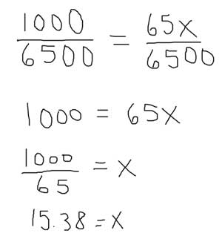

Predicting Fingers:

A little girl counts using the fingers of her left hand as follows:

She starts by calling her thumb 1, the first finger 2, middle finder 3, ring finger 4, and little finger 5. Then she reverses direction, calling the ring finger 6, middle finger 7, first finger 8 and thumb 9, after which she calls her first finger 10 and so on. If she continues to count in this manner, on which finger will she stop?

a) What if the girl counts from 1 to 10

b) What if the girl counts from 1 to 100

c) What if the girl counts from 1 to 1000

1. **Define the problem**:

* Figure out the finger she would land on using her counting method.

1. **Break the problem apart**:

* Understand her counting method.
* Check for a mathematical pattern.

1. **Identify potential solutions:**

* Count on your fingers to 10, 100, and 1000.
* Count 1 time in both directions to discover the pattern

1. **Evaluate each potential solution**:
2. **Choose a solution and develop a plan to implement it:**