WONUKWUBE, OWHONDAH OGUCH

Abstract

This BI project transforms raw sales data from the US Superstore into actionable insights that reveal profit drivers, underperforming markets, and growth opportunities. By leveraging analytics to guide strategy—such as boosting top-selling products, replicating winning tactics in high-performing states, and refining marketing efforts—it empowers decision-makers to optimise performance and maximise ROI.

SUPERSTORE SALES BUSINESS INTELLIGENCE REPORT

**EXECUTIVE BI REPORT FOR STAKEHOLDERS**

Contents

2 INTRODUCTION 2

2.1 Background 2

2.2 Data Source 2

2.3 Data Description 2

3 BI SOLUTION OVERVIEW 4

3.1 Summary of BI KPI Requirement and Question for each Dashboard 4

3.2 Methodology 4

4 KEY FINDINGS 6

4.1 DATA VISUALIZATION (DASHBOARD) 6

4.1.1 Visualization for Marketing Analysis 6

4.1.2 Visualization for Product Analysis 7

4.1.3 Visualization for Geographical Location Analysis 8

4.1.4 Visualization for Budget Analysis 8

4.1.5 Visualization for Profit Analysis 9

4.1.6 Visualization for Sales Analysis 10

5 LIMITATION and RECOMMENDATION 15

5.1 Limitation 15

5.2 Recommendations 15

# INTRODUCTION

## Background

In the current dynamic and competitive corporate environment, data has emerged as an essential tool for making well-informed decisions. Business Intelligence (BI) technologies are essential for deriving valuable insights from large datasets, which enable organisations to take strategic decisions that propel expansion and productivity. The use of BI in the context of the US superstore dataset is based on its capacity to find patterns, trends, and correlations in the data. BI allows for a more in-depth insight of product performance, market dynamics, and other crucial data. Organisations can transform raw data into actionable insights with the right BI tools, improving their capacity to adapt to market changes and optimise operational operations.

## Data Source

The dataset pertains to a US store’s sale for January 2010 and January 2011. It is made up of 4249 rows and 20 columns in one table. The store trades in different locations, within the small and major market segment and operates in the retail sector, where it offers a diverse range of products. The dataset was gotten from Kaggle via this link: <https://www.kaggle.com/datasets/dsfelix/us-stores-sales>.

## Data Description

|  |  |  |
| --- | --- | --- |
| S/N | COLUMN NAME | DESCRIPTION |
| 1 | Area Code | A unique identity of the US states where the business activities are carried out |
| 2 | State | The US states where the business activities are carried out |
| 3 | Market | Sheds light on the geographical location of the market |
| 4 | Market Size | Provides information on the scale of the market |
| 5 | Profit | The gains made from the business |
| 6 | Margin | The proportion of profit that shows how profitable the company is. |
| 7 | Sales | The amount of money made through sales |
| 8 | COGS | Exact expenses incurred in the purchasing of goods |
| 9 | Total Expenses | Sum of all costs incurred by the business while carrying out its operations |
| 10 | Marketing | The spend on marketing each product |
| 11 | Inventory | The stock level of the products |
| 12 | Budget Profit | The budgeted gains to be made from the business |
| 13 | Budget COGS | Budgeted expenses for purchasing of goods |
| 14 | Budget Margin | The budgeted proportion of profit that shows how profitable the company is. |
| 15 | Budget Sales | The budgeted total amount of money from sales |
| 16 | ProductId | A unique identification for the products |
| 17 | Date | The period when all the transactions were made |
| 18 | Product Type | A sub-category of the products |
| 19 | Product | The names of the items sold by the store |
| 20 | Type | A major classification of the products |

# BI SOLUTION OVERVIEW

## Summary of BI KPI Requirement and Question for each Dashboard

|  |  |  |
| --- | --- | --- |
| S/N | KPI | BI QUESTION |
| 1 | Monitor the Return on Investment (ROI) | What is the correlation between customer acquisition cost and net profit in each state and which state and product are top on ROI. |
| 2 | Identify the Best-Selling product | What is the overall best-selling product for the period and how much is the sales for the best-selling product**?** |
| 3 | Monitor the sales in each location | What is the overall sales performance across the states and which state recorded the highest sales amount? |
| 4 | Monitor budget performance | What is the difference between actual cumulative sales and the budget cumulative sales per day for each location? |
| 5 | Increase the profit ratio | What is the sales amount for each product that will yield the highest profit ratio?  Identify the top-performing and underperforming product sub-categories? |
| 6 | Monitor sales trend | Are there discernible pattern or trends in the daily sales and what date did we recorded the highest and the lowest sales |

This report is aimed at providing key insights to stakeholders like the CEO’s, Sales manager, Finance manager, the sales and finance team.

## Methodology

In summary, the approach and technique used in implementing this BI solution involves:

1.Data Sourcing: Identify and collect data from relevant sources. In this case my dataset was gotten from Kaggle.

2. Cleaning and Transformation of Data: This was carried out to assure data quality, identify and rectify inconsistencies, mistakes, or missing values in the dataset.

3. Modelling Data: I design a suitable data model, outlining relationships between distinct tables and entities inside the dataset using star schemas, to aid in querying and reporting.

4. Dashboard and Report Development: I Created an interactive dashboards and reports that allow users to gain insights at a glance and also implement features that enable users to interact with data, such as filters, and drill down into specific details.

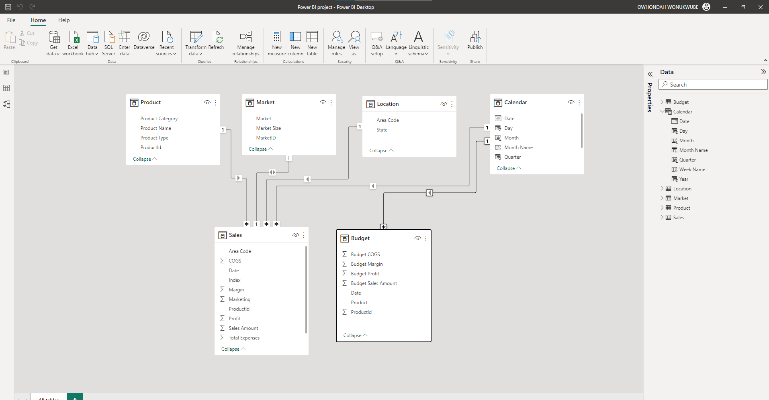

Data Model – Star Schema

Power BI was chosen to carry out these BI analytics because it has an easy-to-use interface and powerful analytical features. It allows users to develop interactive dashboards, reports, and visualisations that provide a complete and easy-to-understand perspective of critical information. Because of the tool's interaction with numerous data sources, such as databases and spreadsheets, it is especially useful for organisations with diverse datasets.

# KEY FINDINGS

## DATA VISUALIZATION (DASHBOARD)

### Visualization for Marketing Analysis

BI Question:

* What is the total cost of marketing, customer acquisition cost and percentage return on investment over the period?
* What is the marketing spent across each location?
* How do customer acquisition costs (CAC) differ by location and what state has the highest CAC
* What is the correlation between customer acquisition cost and net profit for the top 6 states and which state has the highest ROI.
* What is the correlation between customer acquisition cost and net profit for per region for the top 6 states.
* What is the distribution of net profit margin across states for each product and identify the state where we recorded losses?

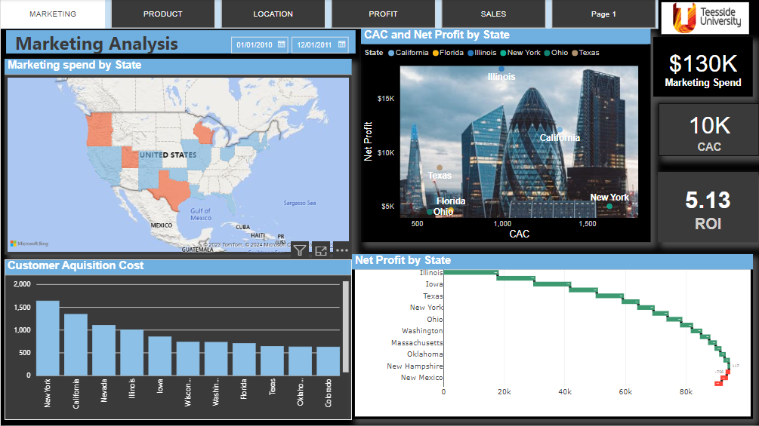

**Figure 1: Marketing Analysis Dashboard**

The dashboard above was used to answer the BI question. It provides the following insights:

* The scatter plot shows that marketing spends which translated to customer acquisition cost (CAC) for each state did not correlate with the net profit (New York was highest in CAC but the highest net profit came from Illinois)
* The return on investment for the period under analysis is 5.13 which implies that the business generated high profit which is 5.13 times the investment for the period.
* Illinois was top on ROI while the sub-product category with the highest ROI is Tea
* Total cost of marketing, customer acquisition cost and percentage return on investment over the period?
* The distribution of net profit margin across states for each product. The states that recorded losses were Missouri, New Mexico and Nevada
* The filled map distribution of the marketing spends across the regions.
* The stacked column chart shows the amount for the CAC across the states.

### Visualization for Product Analysis

BI Question:

* Which product recorded the lowest sales for the period and for each location?
* What is the overall best-selling product for the period and how much is the sales for the best-selling product**?**
* What is the best-selling product for each state and how much is the sales for the best-selling product for each state**?**
* What influences sales amount to increase?
* What is the product performance with regards to the net profit?

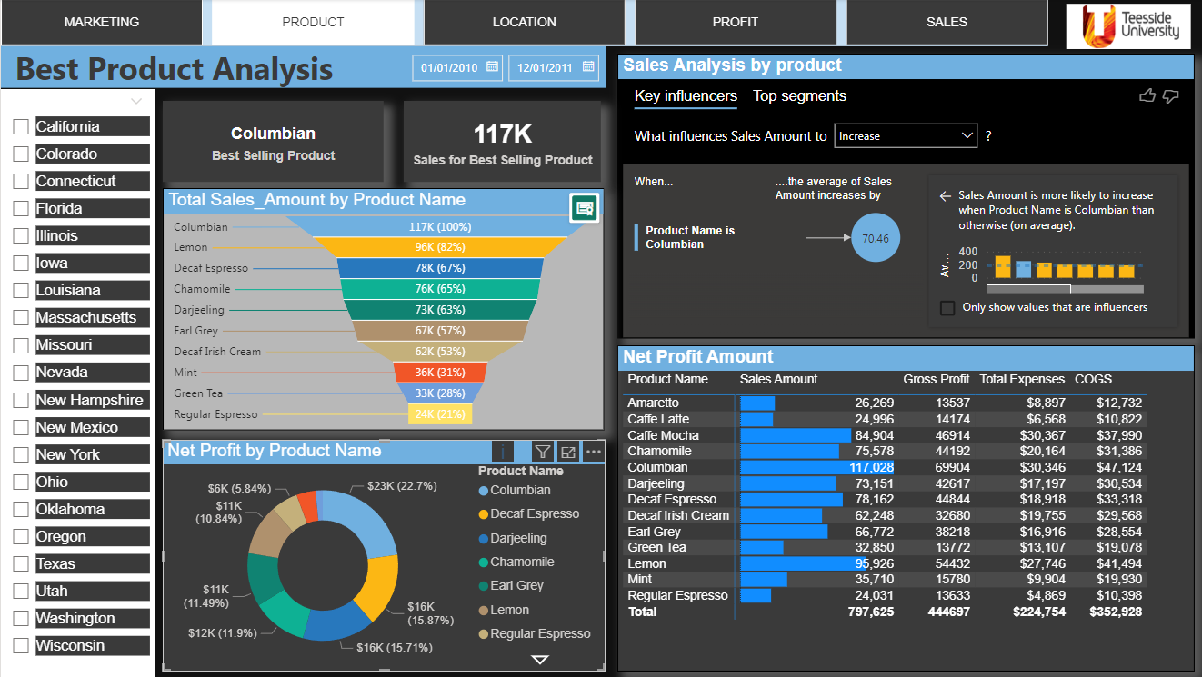

**Figure 2: Best Product Analysis Dashboard**

The dashboard above provides a combination of charts and slicers for **Date** and **State** to give insights to the BI question. The following insights can be drawn from the dashboard:

* The overall best-selling product and sales amount for the best-selling product is Columbian, and the corresponding sales amount is 117K.
* The sales for each product and the product with the lowest sales is Regular Espresso.
* The product that influenced sales is Columbian when the average sales amount is increased by 70.46 dollars.
* The best-selling product for each state or period and the corresponding sales amount for the best-selling product can be gotten by selecting the **State or Date** slicer.

### Visualization for Geographical Location Analysis

BI Questions:

* Which state exhibit the highest and lowest customer retention rate?
* Identify the leading states in cumulative sales and gross profit.
* How does gross profit vary across all states?
* Which states are the top and bottom performers in terms of sales?

**Figure 3: Geographical Analysis Dashboard**

The dashboard above provides following key insights to the BI questions.

* California and Utah have the highest customer retention rate of 92.31% while Massachusetts has the lowest customer retention rate of 46.51%
* The top 6 states with the highest cumulative sales amount
* Gross profit across all states
* California, New York and Illinois were top in cumulative sales and gross profit.
* California is leading in all the metric checked for geographical locations, which is customer retention rate, cumulative sales, gross profit and total sales.
* New Mexico is least performing state.

### Visualization for Budget Analysis

BI Question:

* What is the total budget sales amount over the period?
* What is the total sales amount over the period?
* What is the total sales amount over the period?
* What is the total sales amount over the period?
* How does the actual COGS compare to the budget COGS per day for each location?
* What days did the actual cumulative sales exceed the budget cumulative sales?
* Can you identify any trends in the variances between budgeted cumulative sales and actual cumulative sales per day in each location?
* What is the difference between actual cumulative sales and the budget cumulative sales per day for each location?

**Figure 4: Budget Performance Analysis Dashboard**

The dashboard above provides following key insights to the BI questions.

* The comparison between budget sales amount and actual sales amount
* The comparison between budget COGS and actual COGS
* Comparison between actual COGS and budget COGS per day for each location
* The area chart shows the trends in the variances between budgeted cumulative sales and actual cumulative sales per day in each location.
* The line chart shows the exact difference between actual cumulative sales and the budget cumulative sales per day. With the aid of location slicer, we can check the metrics for any location of interest.

### Visualization for Profit Analysis

BI Question:

* What is the total profit amount, Maximum profit, Average profit and net profit margin over the period.
* What is the trend of net profit margin for each product within the period?
* Identify the top-performing and underperforming product sub-categories?
* What is the distribution of net profit margin across states for each product and identify the state where we recorded losses?
* What is the distribution of net profit margin across states for each product?
* What is the sales amount for each product that will yield the highest profit ratio?
* Which product sub-category is driving the highest ROI and are there sub-categories where marketing efforts need to be adjusted for better results

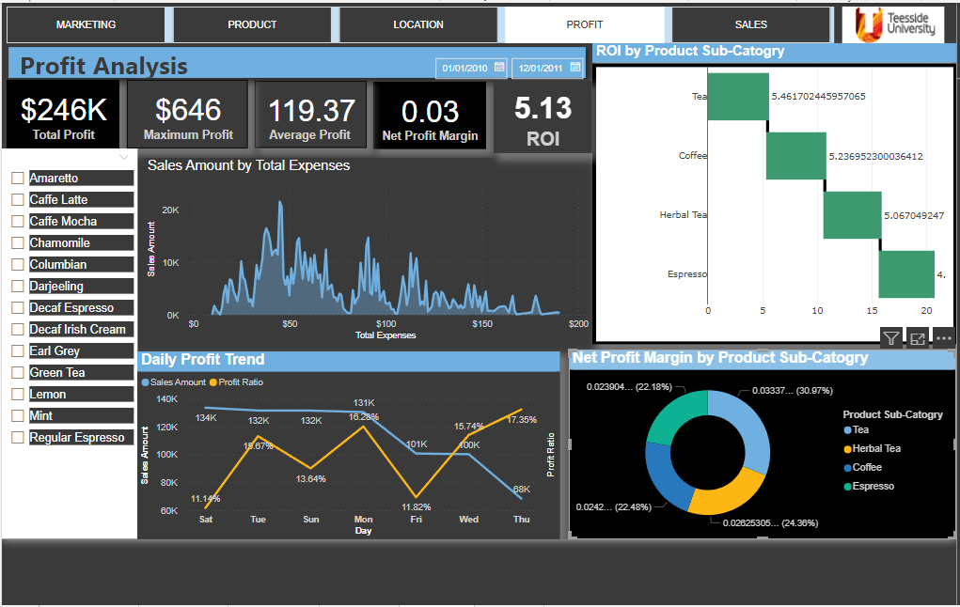

**Figure 5: Sales Analysis Dashboard**

The dashboard above provides following key insights to the BI questions.

* The total profit amount, Maximum profit, Average profit and net profit margin over the period
* What is the trend of net profit margin for each product within the period.
* The top-performing and underperforming product sub-categories are Tea and Espresso respectively.
* All the product sub-category performed very well in terms of their ROI with Tea sub-category as highest.
* The line chart for profit ratio and sales amount provides sales amount with the corresponding profit ratio for each product with the aid of the slicer.

### Visualization for Sales Analysis

**Figure 6: Total Sales Amount**

Type of Visual: Card

BI Question: What is the total sales amount over the period?

KPI: Total Sales

Field: Sales Amount  
DAX: Total Sales_Amount = SUM('Sales'[Sales Amount])

**Figure 7: Average Sales per Day**

Type of Visual: KPI

BI Question: What is the average sales amount for the period?

KPI: Average Sales

Field: Sales Amount

**Figure 8: Sales Trend per Day**

Type of Visual: Sparkline

* BI Question: Are there discernible pattern or trends in the daily sales and what date did we recorded the highest and the lowest sales?

KPI: Total Sales per day

Field: Sales amount, Date

**Figure 9: Sales Count by Product**

BI Question: What are the total sales for each product sorted by product category?

KPI: Total Sales for each product by their category

Field: Sales amount, Product and product category

**Figure 10: Sales Distribution by market**

Type of Visual: Walkers Animated Pictogram

BI Question: What is the market share of each market category to the total revenue?

KPI: Total Sales by product

Field: Sales amount, Cumulative Sales and Market size

DAX Formula: Cumulative Sales =

IF( ISBLANK([Total Sales_Amount]),

BLANK(),

CALCULATE(

    SUM('Sales'[Sales Amount]),

    FILTER(

        ALL('Sales'[Date]),

        'Sales'[Date] <= MAX('Sales'[Date])

    )

)

)

**Figure 11: Daily Customer Acquisition Cost by Product**

Type of Visual: Animated Bar Chart Race (from Get more visuals)

BI Question: What is the cost of acquiring new customers for each product within the period and which product has the highest CAC

Field: Sales amount, Cumulative Sales and Market size

DAX Formula:CAC = DIVIDE(SUM('Sales'[Marketing]), COUNTROWS(VALUES('Sales'[ProductId])))

BI Question:

* What is the total sales amount for the period and the average sales recorded per day.
* Are there discernible pattern or trends in the daily sales and what date did we recorded the highest and the lowest sales.
* What are the total sales for each product sorted by product category.
* What is the market share of each market to the total revenue.

What is the cost of acquiring new customers for each product within the period and which product has the highest CAC**.**

**Figure 12: Sales Analysis Dashboard**

The dashboard above provides following key insights to the BI questions.

* The total sales amount for the period and the average sales per day.
* Daily sales trend for the period. The highest and the lowest sales were recorded on the January 1, 2011, and January 11, 2010, respectively.
* Total sales for each product according to the product category.
* Market that contributes most to the market share. The analysis shows that the small markets have larger contribution to the market share.
* Cost of acquiring new customers for each product within the period and Caffe Mocha has the highest CAC of 830 dollars.

# LIMITATION and RECOMMENDATION

## Limitation

* Data Quality: The dataset had some inconsistent and poor-quality data that could result to inaccurate visuals and misinterpretation. This was handled during the pre-processing stage.
* The dataset contained dates for only January 2010 and part of January 2011. This limited my ability to do some analytics with respect to dates, such as forecasting and visualization with respect to months. Hence, my time related analytics was done as per days.

## Recommendations

* Review the marketing strategies to yield a corresponding net profit amount.
* Improve the marketing strategies in states like Missouri, New Mexico and Nevada that recorded losses.
* Promote the best-selling product ‘Columbian’ to increase the total sales amount.
* Expand the scope of the business in the top 6 states like California, New York, and Illinois, that recorded the highest gross profit and cumulative sales amount.
* Replicate the business strategies used in California to improve other locations.
* Follow the profit trend to increase profit ratio for each product.
* Increase the count of tea sub-category to increase the net profit margin and ROI.