**A Seminar Report on**

**Decoding Handwriting Development:**

**Insights from Computational Analysis of children with and without Dysgraphia**

Submitted by

Guda Tharunya varma

20251A0542



**Department of Computer Science & Engineering**

**G. NARAYANAMMA INSTITUTE OF TECHNOLOGY & SCIENCE**

**(Autonomous) (For Women)**

**Approved by AICTE, New Delhi & Affiliated to JNTUH, Hyderabad**

**Accredited by NBA & NAAC, an ISO 9001:2015 certified Institution**

**Shaikpet, HYDERABAD – 500 104, T.S., INDIA**

**March 2023**

**­Department of Computer Science & Engineering**

**G. NARAYANAMMA INSTITUTE OF TECHNOLOGY & SCIENCE**

**(Autonomous) (For Women)**

**Approved by AICTE, New Delhi & Affiliated to JNTUH, Hyderabad**

**Accredited by NBA & NAAC, an ISO 9001:2015 certified Institution**

**Shaikpet, HYDERABAD – 500 104, T.S., INDIA**

**March 2023**



**CERTIFICATE**

This is to certify that the seminar report on “Decoding Handwriting Development : Insights from computational Analysis of children with and without Dysgraphia” that is being submitted by **Guda Tharunya varma (20251A0542)** in partial fulfilment for the award of B.Tech in Computer Science & Engineering to the Jawaharlal Nehru Technological University is a record of bonafide work carried out by her in our guidance and supervision.

The work done in the seminar have not been submitted to any other University or Institution for the award of any degree or diploma.

**Seminar Coordinators Head of the Department**

1. Mr. N. Venkateswarlu, Assistant Professor Dr. M. Seetha

2. Mrs. D.R Nandadevi, Assistant Professor Professor & Head

Department of CSE

**ACKNOWLEDGEMENTS**

It gives me immense pleasure to acknowledge with gratitude, the help and guidance rendered to me by a host of people, to whom I owe a substantial for the successful completion of this seminar work.

I express my sincere thanks to **Dr. K. Ramesh Reddy**, **Principal,** GNITS, for providing the working facilities to pursue my studies in this college.

I would like to express gratitude to **Dr. M. Seetha, Professor & Head,** Department of CSE, GNITS for all the timely support and valuable suggestions during the period of my seminar.

I am extremely thankful to **Mr. N. Venkateswarlu, Assistant Professor**, Department of CSE, GNITS and **Mrs. D.R Nandadevi, Assistant Professor**, Department of CSE, GNITS for their valuable suggestions and constant support throughout the seminar.

Finally, thanks to the entire faculty and staff of the Computer Science & Engineering department who helped me directly or indirectly, parents and friends for their cooperation in completion of the seminar.

## GUDA THARUNYA VARMA

## (20251A0542)

**ABSTRACT**

Handwriting is a complex skill to acquire and it requires years of training to mastered. Children presenting dysgraphia exhibit difficulties automatizing their handwriting. This can bring anxiety and can negatively impact education. The researchers recruited 280 children and used digital tablets to evaluate their handwriting using the Concise Evaluation Scale for Children's Handwriting (Brave Handwriting Kinder- BHK). They extracted 12 digital features related to handwriting, including static, kinematic, pressure, and tilt aspects, and used linear models to predict changes in handwriting quality over time. K-means clustering was used to classify dysgraphia into three clusters (Ci), with C1 indicating mild dysgraphia and C2 and C3 indicating severe dysgraphia. The study found that children with dysgraphia had different development patterns in static, kinematic, pressure, and tilt features than those without dysgraphia, suggesting the potential for automatic detection and therapeutic opportunities through serious games.

**CONTENTS**

|  |  |  |
| --- | --- | --- |
| **Sl. No.** | **Topic** | **Page No.** |
|  | Abstract | iii |
| 1 | Introduction | 1 |
| 2 | Materials and methods | 3 |
|  | 2.1 Participants | 3 |
|  | 2.2 Procedure | 3 |
|  | 2.2.1 Static features | 5 |
|  | 2.2.2 Kinematic features | 5 |
|  | 2.2.3 Pressure features | 6 |
|  | 2.2.4 Tilt features | 6 |
|  | 2.2.5 Statistical models | 6 |
|  | 2.2.6 Clustering | 7 |
| 3 | Results | 8 |
|  | 3.1 Participant’s demographics | 8 |
|  | 3.2 Handwriting acquisition | 9 |
|  | 3.3 A new clustering of dysgraphia | 14 |
| 4 | Discussion | 17 |
| 5 | Conclusion and future enhancements | 18 |
| 6 | References | 19 |

**LIST OF FIGURES**

|  |  |  |  |  |
| --- | --- | --- | --- | --- |
| **Sl. No.** | **Title of the figure** | | | **Page No.** |
| Fig 1.1 | | Psychopathological model of dysgraphia | | 1 |
| Fig 3.1 | | Annotation of the database with the BHK test defining children with dysgraphia and children without dysgraphia | | 9 |
| Fig 3.2 | | BHK handwriting quality and speed scores according to grade in children with typical development and in children with dysgraphia | 9 | |
| Fig 3.3 | | The impact of the 12 digital features on the BHK raw handwriting quality score for children without dysgraphia (TD dataset) and for all grades | | 10 |
| Fig 3.4 | | Elbow method to characterize the optimal number of clusters | | 15 |
| Fig 3.5 | | Comparisons of the SD of speed of pressure change and Bandwidth of Speed of Tilt-x Change Frequencies for the children without dysgraphia from the 3 different clusters | | 16 |

**LIST OF TABLES**

|  |  |  |
| --- | --- | --- |
| **Sl. No.** | **Title of the table** | **Page No.** |
| Table 2.1 | Diagnosis of children in the specialized clinic | 3 |
| Table 2.2 | Clinical-Gold Standard (BHK scores) and digital features on handwriting | 4 |
| Table 3.1 | Descriptive statistics of the participants (TD and D). | 8 |
| Table 3.2 | Multivariate models to predict the BHK handwriting quality raw score | 11 |
| Table 3.3 | Multivariate models to predict the BHK speed raw score for typically developing children (TD dataset), and all children together (TD + D dataset) | 12 |
| Table 3.4 | Multivariate models with interaction to predict the BHK quality raw score | 13 |
| Table 3.5 | Multivariate models with interaction to predict the BHK speed raw score for typically developing children (TD dataset) and all children together (TD + D dataset) | 14 |
| Table 3.6 | Mean digital features value of each features according to their clustering | 15 |

**1.Introduction**

Children spend a significant amount of time in school writing, making handwriting a crucial skill [2]. Handwriting is a complex perceptual–motor task, as it involves attention, perceptual, linguistic and fine motor skills [1]. Formal handwriting training begins around age five and takes about ten years to master. During this time, handwriting improves in quality and speed, with girls generally exhibiting higher scores than boys. Handedness does not appear to have an effect on handwriting ability.

Dysgraphia, affecting legibility and/or speed, can hinder a child's academic and behavioral development, leading to increased school-performance anxiety and avoidance of written tasks. The **Fig 1.1** describes a cause a vicious cycle of fewer writing opportunities, increased anxiety, and low self-esteem, ultimately resulting in school refusal.

Dysgraphia is not recognized as a disorder on its own by DSM-5 or ICD-11, but can be a specifier of neurodevelopmental disorders. There are three sub-groups of dysgraphia proposed based on comorbidities: dyslexic dysgraphia, spatial dysgraphia, and motor dysgraphia [3].

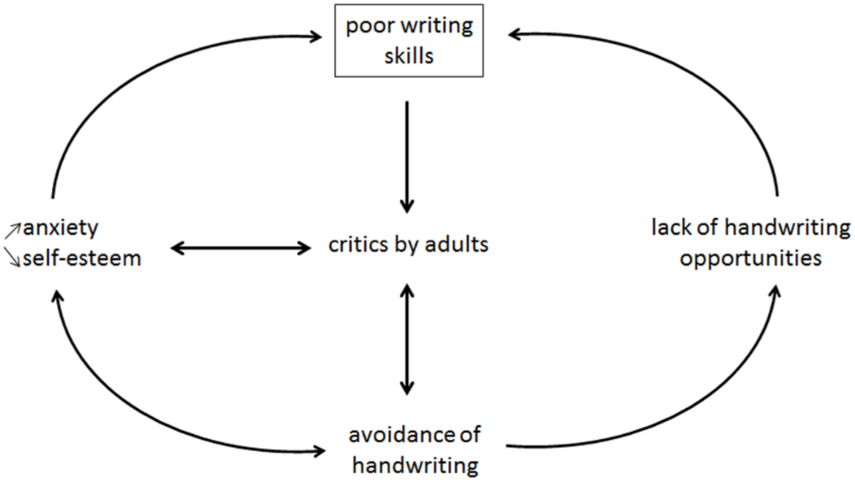

**Fig 1.1**. Psychopathological model of dysgraphia.Vicious circles can appear due to anxiety and lack of practice that can worsen handwriting.

Various tests can be used to assess dysgraphia in different alphabets [4], such as DASH, E scale, and BHK. However, these tests only analyze the final handwriting product and do not consider the movement dynamics. The use of digital tablets enables the analysis of new aspects of handwriting, and studies have used this technology to classify children with dysgraphia with excellent accuracy. A recent study developed a new test based on the analysis of 53 digital handwriting features extracted from BHKs written on a digital tablet, which showed high sensitivity and specificity. However, no study using digital features has taken into account age and developmental changes in typically developing children.

In the current study, aimed to extend our work[4] addressing the effect of age, and the heterogeneity of dysgraphia. The **objectives** were the following:

1. Study the developmental approach of handwriting in typically developing children(TD dataset only) and those with dysgraphia(TD dataset).

2. Determine effective features for diagnosing dysgraphia in children of different ages, using traditional clinical methods and digital features.

3. Conduct unsupervised clustering of children with dysgraphia to identify distinct groups and their unique characteristics, using K-means clustering.

**2 Materials and methods**

**2.1Participants**

The present study was conducted in accordance with the Declaration of Helsinki and approved by the Grenoble University Ethics Committee. In total, 280 children were recruited, excluding those with known disabilities or neurodevelopmental disorders and non-French natives. No specific neurological and cognitive assessments were conducted, and disorder absence was assumed based on teachers' academic achievement judgments. Among the children recruited, 231 were from different schools in the Grenoble area, and 49 were recruited based on a clinical diagnosis of dysgraphia from the Reference Center for Language and Learning Disorders at Grenoble University Hospital. Children with dysgraphia from this specialized center were excluded if they were in 1st grade, as diagnosis is not recommended at this stage. The **Table 2.1** shows the report of diagnosis of children from the specialized clinics are reported in

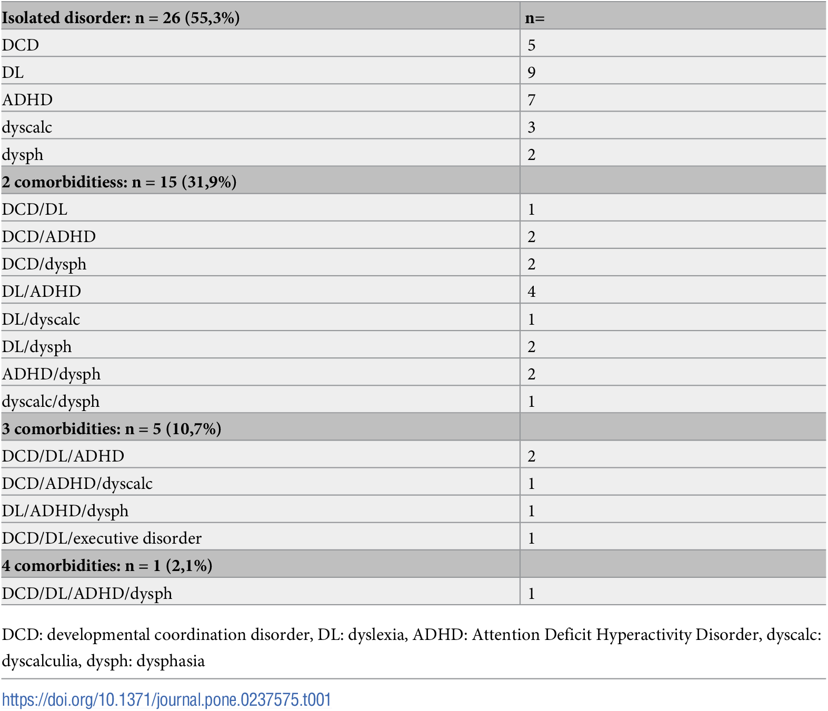

**Table 2.1.** Diagnosis of children in the specialized clinic.

**2.2 Procedure**

The BHK test consists of copying a text beginning with simple monosyllabic words and evolving towards more complex words for five minutes onto a blank paper. Different features reflecting handwriting quality (e.g., letter form, size, alignment, spacing. etc) are scored to generate a final handwriting quality score. The final handwriting quality score is a degradation score. Here the **Table 2.2** shows the BHK scores and digital features on handwriting. Higher scores correspond to more errors and a worse quality. A speed score is also provided (i.e., the number of characters written in five minutes)

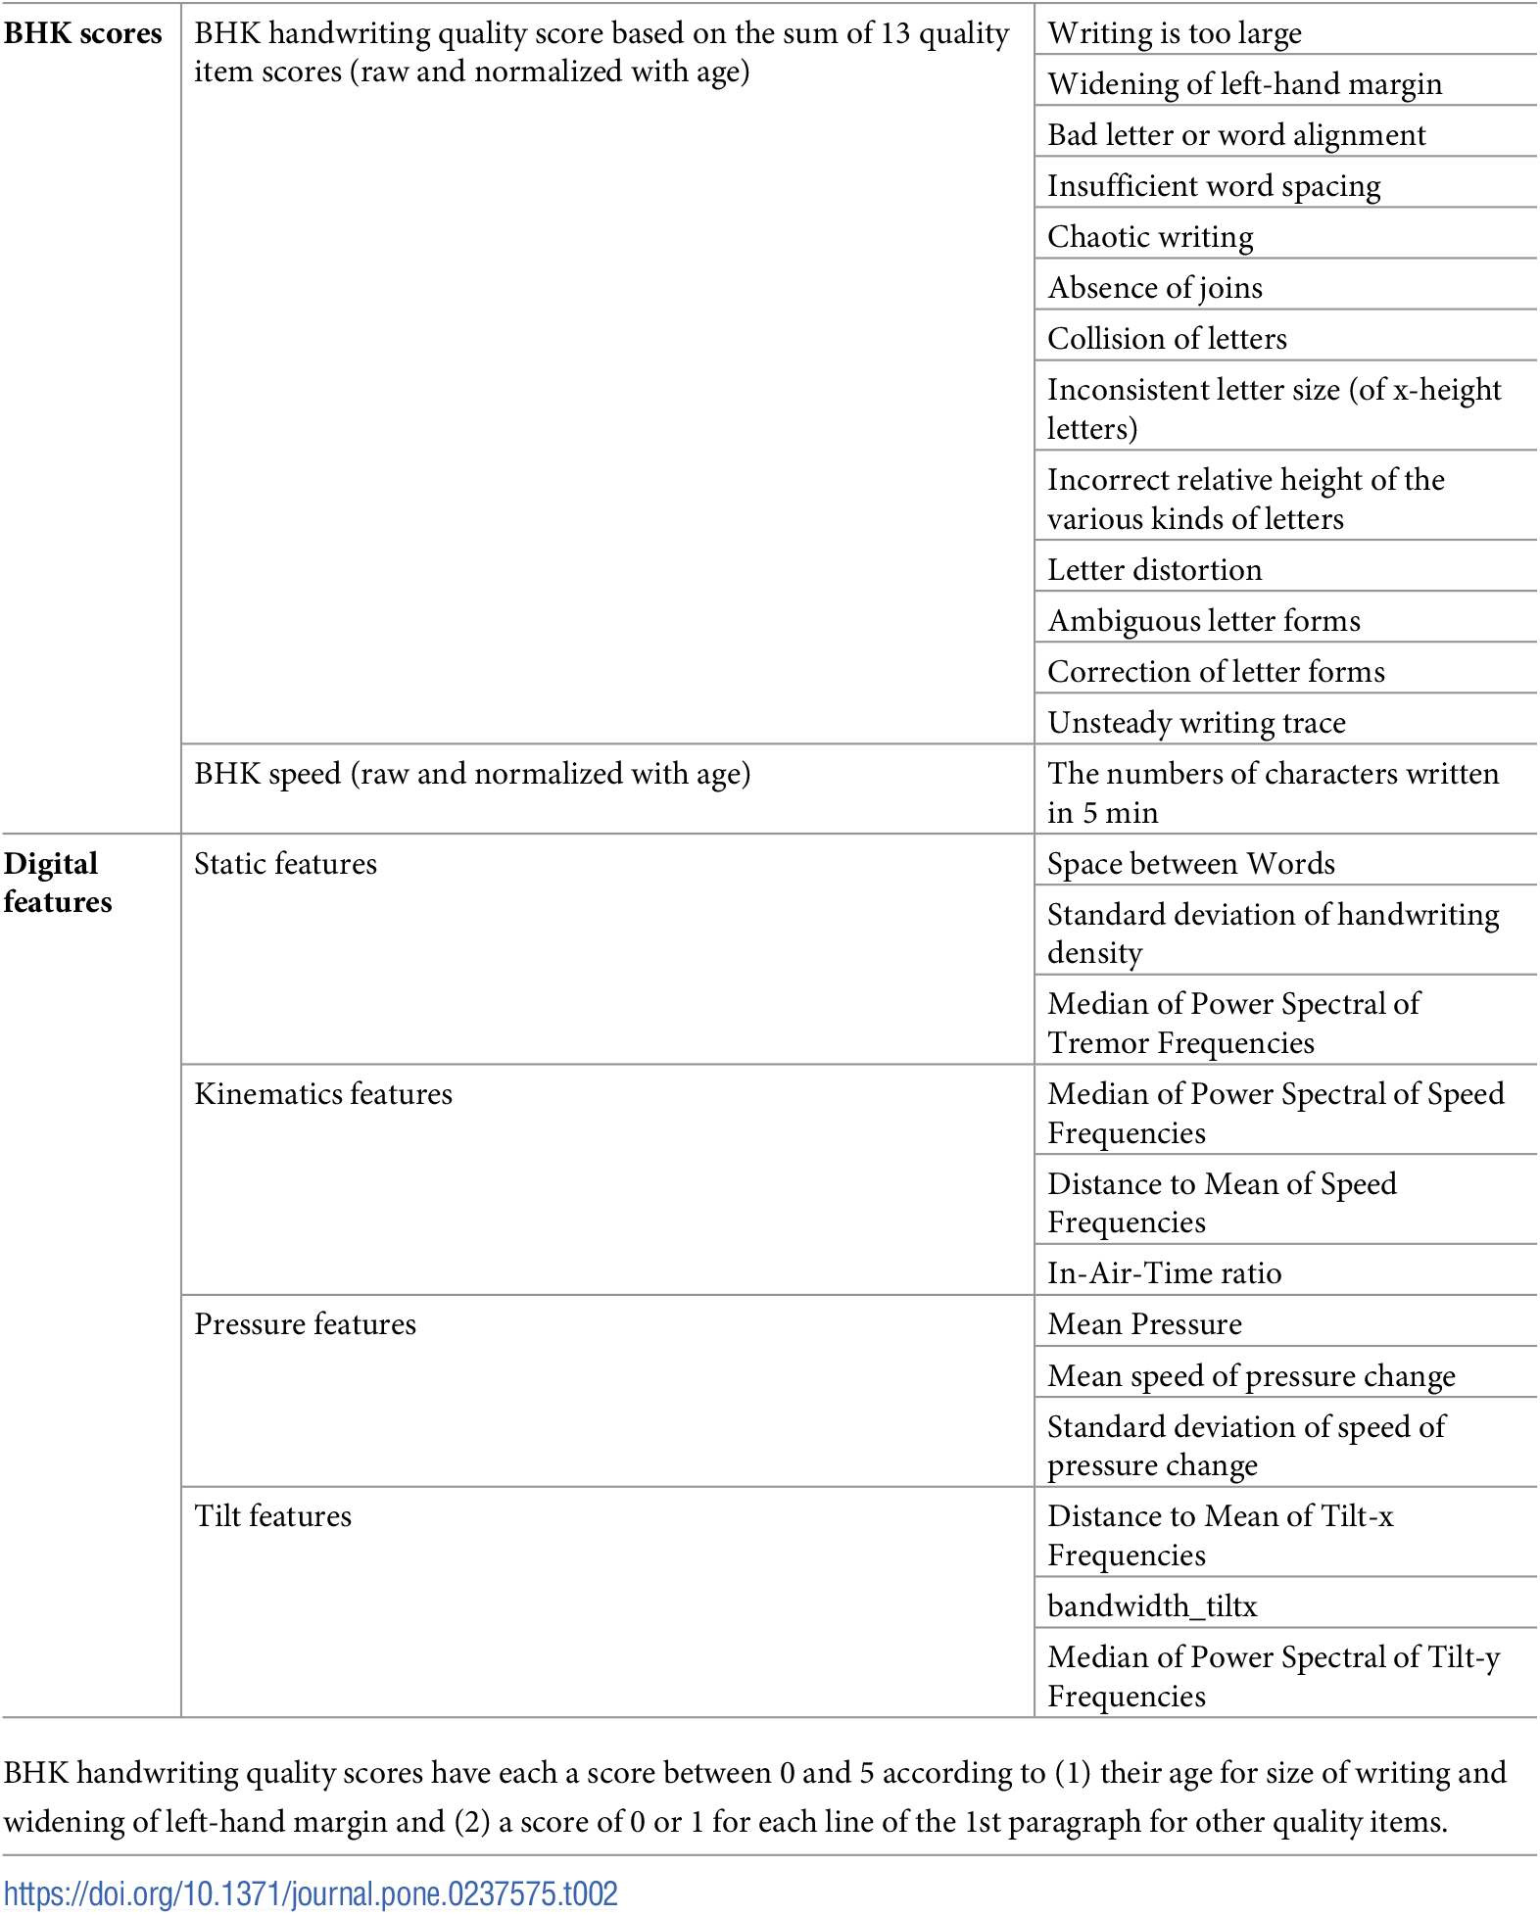

**Table 2.2.** Clinical-Gold Standard (BHK scores) and digital features on handwriting.

In the study, 280 children performed the BHK test by writing on a Wacom graphic tablet. Two different types of tablets were used, and pressure data were carefully calibrated to explore the full range of tablet outputs. A 4th degree polynomial fit was created to model the function describing the X/Y relation of the first tablet and used to correct the output of the second tablet. Two junior psychomotor therapists were trained to score the BHK test and annotated independently. For the 30 least consistent scores, the senior therapist scored the BHK. The correlation between the weight input and the tablet output was found to be very similar for the two tablets, with a high correlation and low mean squared error after correction.

The professionals who scored the BHK test were blinded to the demographics and clinical characteristics of the children. Scoring was based on handwriting velocity (number of characters written in five minutes) and handwriting quality, which was assessed using a semiquantitative method with 13 items. The inter-rater reliability was calculated using intra-class correlation and found to be high (ICC = 0.97, 95% CI: 0.96-0.98). The BHK handwriting quality scores were used to calculate a qualitative score and a quantitative score, based on normal scores by age measured during a previous validation of the scale.

**2.2.1 Static features:** They are purely geometric characteristics. The selected static features in the study are:

(1) **Space Between Words**, which is the average distance between words in the text;

(2) **SD of handwriting density**, which measures the variability in the number of points recorded by the tablet in a 300-pixel grid covering the handwriting trace.

(3) **Median of Power Spectral of Tremor Frequencies**, which uses time series analysis and Fourier transform to calculate the median of the spectral distribution of tremors present in the handwriting. Children with handwriting difficulties show abnormal movements that translate into high frequencies in the Fourier transform, resulting in a shift of the median towards higher frequencies.

**2.2.2 Kinematic features:** They regroup features describing the dynamics of the handwriting process. The selected features in the study are:

(1)**Median of Power Spectral of Speed Frequencies**, which uses Fourier transform to calculate the median of the spectral distribution of changes in handwriting speed, showing fast changes in children with dysgraphia.

(2) **Distance to Mean of Speed Frequencies,** which measures the distance between the spectral distribution of the child's writing and that of a typical child of the same age, indicating how eclectic the child's handwriting is.

(3) **In-Air-Time ratio**, which represents the proportion of time the writer spends without touching the surface of the tablet.

**2.2.3 Pressure features**: They regroup features using the notion of pressure measured between the pen tip and the tablet surface. The selected features in the study are:

(1) **Mean Pressure**, which is the average pressure during the test.

(2) **Mean Speed of Pressure Change**, which is the average time spent between two averaged buckets of 10 pressure record points.

(3) SD of Speed of Pressure Change, which is the standard deviation of the time spent between two averaged buckets of 10 pressure record points.

**2.2.4 Tilt features:** They regroup features using the notion of tilt between the pen and the

surface of the tablet. The selected features in the study are:

(1) **Distance to Mean of Tilt-x Frequencies**, which measures the distance between the spectral distribution of a child's handwriting and that of a typical child of the same age, indicating how eclectic the child's handwriting is.

(2**) The Bandwidth of Speed of Tilt-x Frequencies**, which measures the spread of tilt-x frequencies, indicating handwriting difficulties.

(3) **Median of Power Spectral of Tilt-y Frequencies**, which measures the median of the spectral distribution of tilt-y frequencies, indicating lower tilt-y frequencies in children with handwriting difficulties.

**2.2.5 Statistical models**: Since selected the 12 digital features through machine learning classifying BHK scores as threshold (binary classification). Since group comparisons were considered inappropriate, linear regression models were used instead to assess the effect of each feature on BHK handwriting quality and speed as continuous variables

To understand how a given digital feature is explaining or not BHK handwriting quality taking into account grade and gender, a linear regression model per feature was created to predict the continuous BHK handwriting quality score. This model was adjusted for grade and gender. In the same way, a model was created to predict the BHK speed score. The formulas can be described as follows:

*BHK Score ~ Normalized(feature)+ grade +gender + ε*

To understand how a given digital feature explaining continuous BHK changes according to a child’s grade, a similar model with interaction [grade*Normalized(feature)] was also created. In other words, the model can show the relative importance of a given digital feature to diagnose dysgraphia according to age. As recommended in the BHK manual, we selected the grade rather than the age to assess the effect on education, since the writing process is learned at school and not spontaneously. The formulas can be described as follows:

*BHK Score ~ Normalized(feature)+grade + gender+ grade *Normalized(feature) +ε*

The models were adjusted for grade and gender, and interaction terms were included to assess the effect of each feature on BHK scores across different grades. The models were run on both TD and TD+D datasets, and a bootstrap analysis was performed to assess the 95% confidence intervals and p-values.

**2.2.6 Clustering:** Finally, we tested the theoretical classification of Deuel[3] by a K-means clustering of our digital features, to assess how many clusters of patients had a similar profile and to identify their main characteristics. We used the elbow method to explore the best number of clusters.

**3 Results**

**3.1 Participant’s demographics**

Our first aim to characterize children recruited from schools and assess the prevalence of dysgraphia. Clinical assessment of BHK tests confirmed dysgraphia in all children recruited from special clinics and detected 13 (5.63%) children with dysgraphia among those recruited from regular schools. Speed dysgraphia was observed in 12 children, all of whom showed poor handwriting quality, leading to the definition of dysgraphia based on the BHK handwriting quality score. The resulting dataset included 218 children without dysgraphia (TD group) and 62 children with dysgraphia (D group). The **Fig 3.1** results that the two groups had similar average ages, and most children were right-handed. However, girls were underrepresented in the D group.

**Table 3.1** summarizes the main characteristics of the two groups. The TD and D children had similar ages of around nine years on average despite a tendency of older age in the group with dysgraphia. Most children were right-handed. There was a gender bias (girls were underrepresented in the D group).

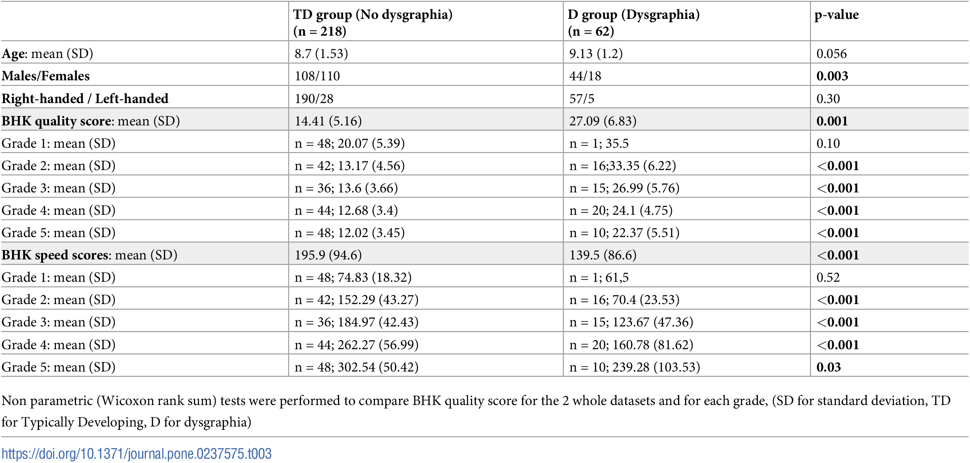

**Table 3.1.** Descriptive statistics of the participants (TD and D).

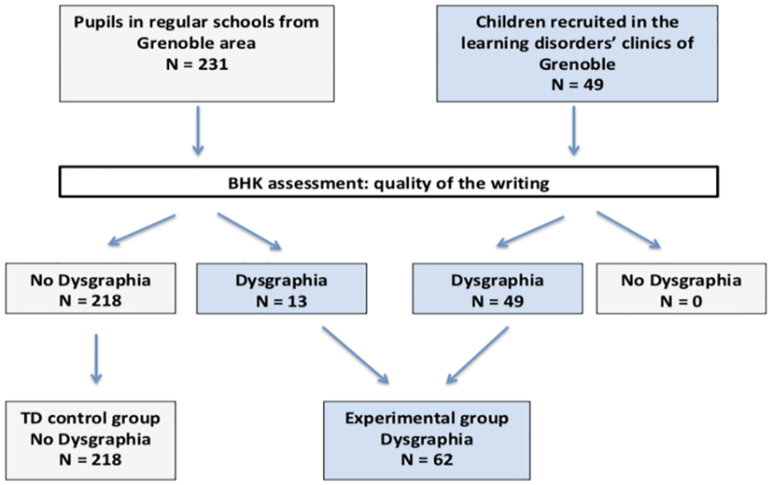

**Fig 3.1.** Annotation of the database with the BHK test defining children with dysgraphia (writing quality too bad, BHK handwriting quality score too high) and children without dysgraphia.

**3.2 Handwriting acquisition** Our second aim was to identify the best features to diagnose children with dysgraphia both using BHK scores & relevant digital features, and to explore how the relevant digital features had statistical interaction with age.

**Handwriting explained from the BHK features.** **Fig 3.2** summarizes the handwriting

quality and speed BHK scores for both the TD and D datasets. As expected, the

improvement of the handwriting quality (decrease of the BHK quality score) together with an

increase of the writing speed with the age of children. Normalized score allow comparisons between grades. The cut-off for a diagnostic of qualitative and quantitative dysgraphia is -2.

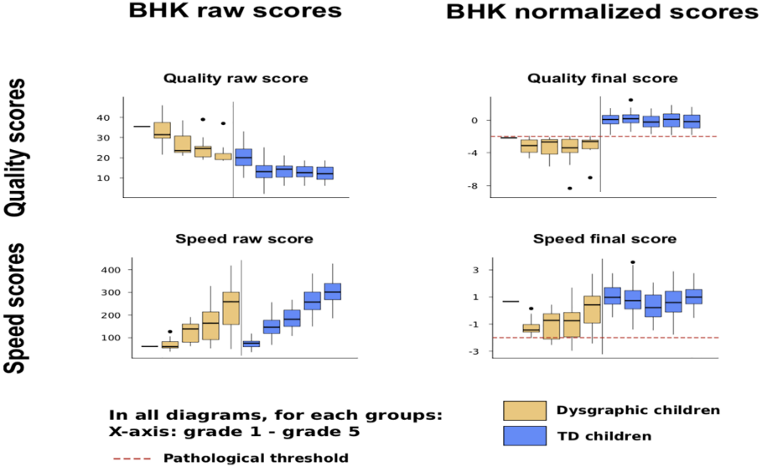

**Fig 3.2.** BHK handwriting quality and speed scores according to grade in children with typical development and in children with dysgraphia. Raw score (left) and normalized score (right).

**Handwriting explained from the digital features.** Twelve digital features expressing handwriting on different aspects (static, kinematics, pressure, and tilt) were selected from the work of Asselborn et al [4]. In **Fig 3.3**, the link between the digital features and the BHK raw handwriting quality score in terms of function of the grade is presented (children without dysgraphia, TD dataset).

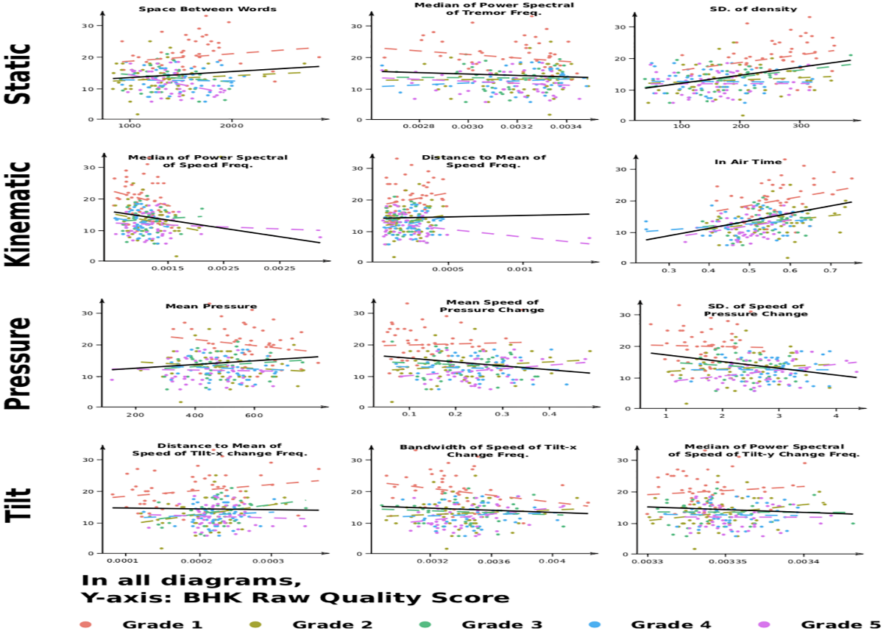

**Fig 3.3**. The impact of the 12 digital features on the BHK raw handwriting quality score (opposite of handwriting quality) for children without dysgraphia (TD dataset) and for all grades.

**Handwriting Quality Score association**. the **Table 3.2** shows the association between digital features and handwriting quality in children with and without dysgraphia. All digital features were significantly associated with handwriting quality in both groups, but only three features were significantly associated with the handwriting quality of children without dysgraphia. These features were two kinematic features and one static feature, which were positively correlated with handwriting quality. The study suggests that some digital features become important predictors of handwriting quality only when the score is above a certain threshold. The study also notes that the interpretation of digital features in children with dysgraphia may be difficult due to the variability of handwriting caused by different potential causes and severity levels of dysgraphia.

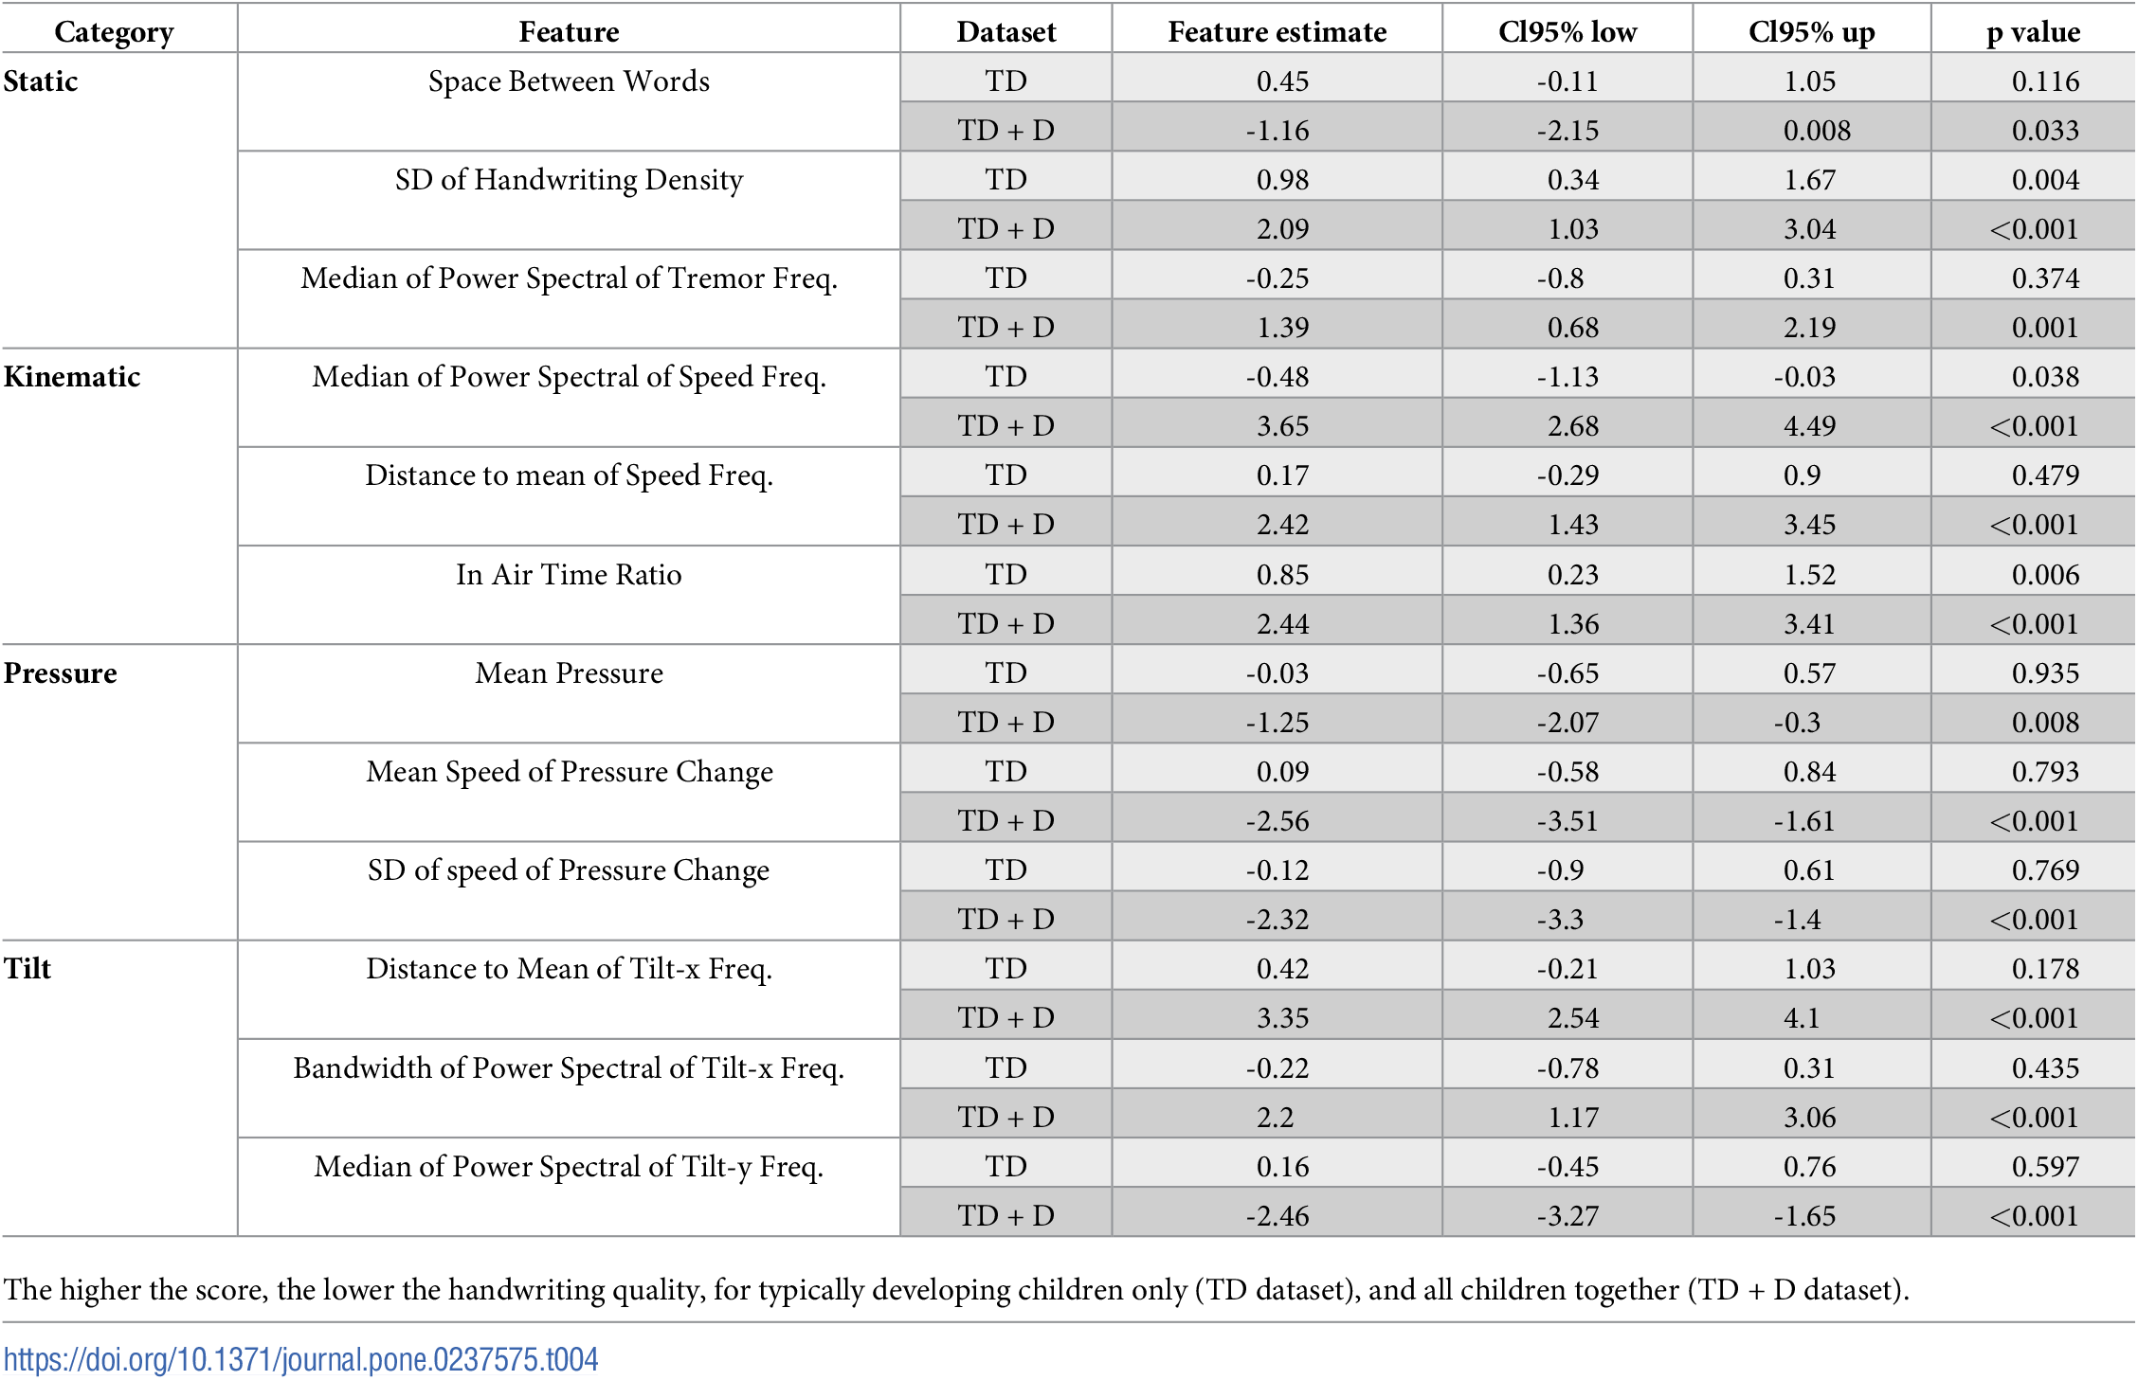

**Table 3.2**. Multivariate models to predict the BHK handwriting quality raw score.

**Handwriting speed association**. The **Table 3.3** shows the association between digital features and handwriting speed in children without dysgraphia. The same three features that were significantly correlated with handwriting quality were also significantly correlated with handwriting speed, along with a fourth feature, the SD of Speed of Pressure Change. The Median of Power Spectral of Speed Frequencies was negatively correlated with the BHK speed score, while the In Air Time Ratio and the SD of Handwriting density were negatively correlated with the handwriting speed. On the other hand, the SD of Speed of Pressure Change was positively correlated with handwriting speed, and it was clinically linked with the automation of the pen movement.

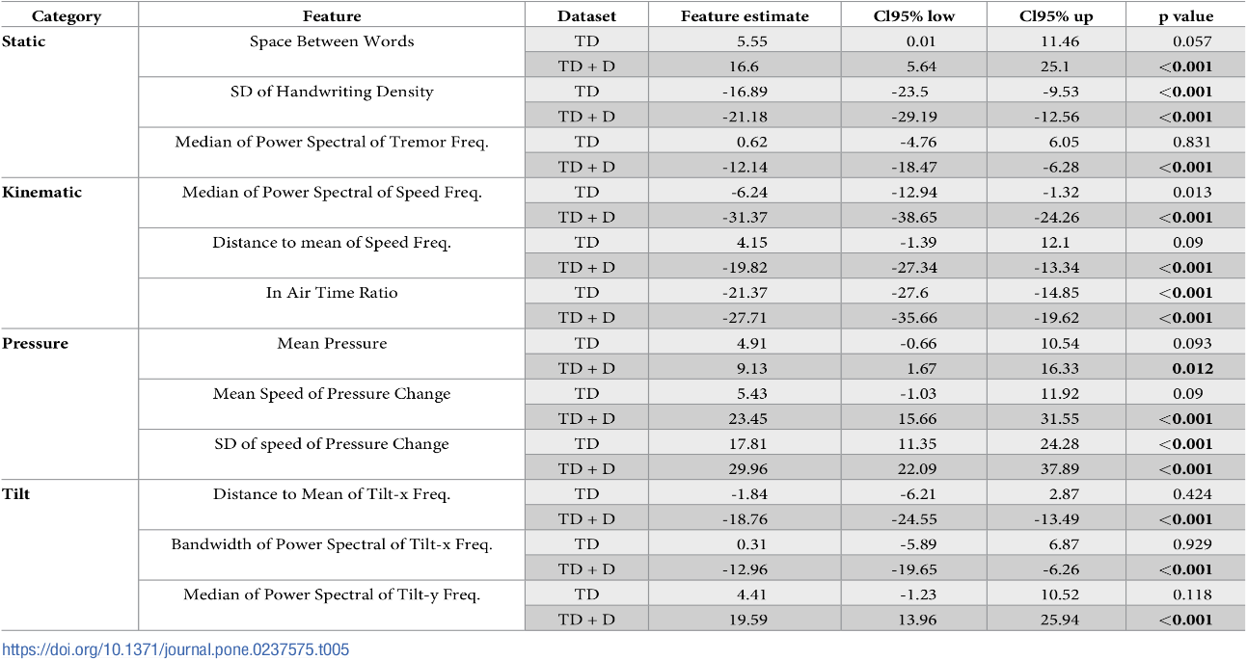

**Table 3.3**. Multivariate models to predict the BHK speed raw score for typically developing children (TD dataset), and all children together (TD + D dataset).

**Interaction of the digital features with grade**. The **Table 3.4** and **Table 3.5** shows the interaction between digital features, grade, and gender in predicting children's BHK handwriting quality and speed scores.

**Quality interaction**: The interaction between handwriting digital features and grade differs between children with dysgraphia and typically developing (TD) children. TD children show significant interactions between most digital features and grade to predict handwriting quality. However, adding children with dysgraphia adds noise to the model and makes it difficult to find significant interactions. Most digital features are useful for detecting handwriting quality for either younger or older children, and their predictive value changes with grade. The Space Between Words feature is positively associated with BHK score in first grade and becomes negatively associated by fifth grade from the **Table 3.4**, indicating its importance in predicting handwriting quality as children progress in school.

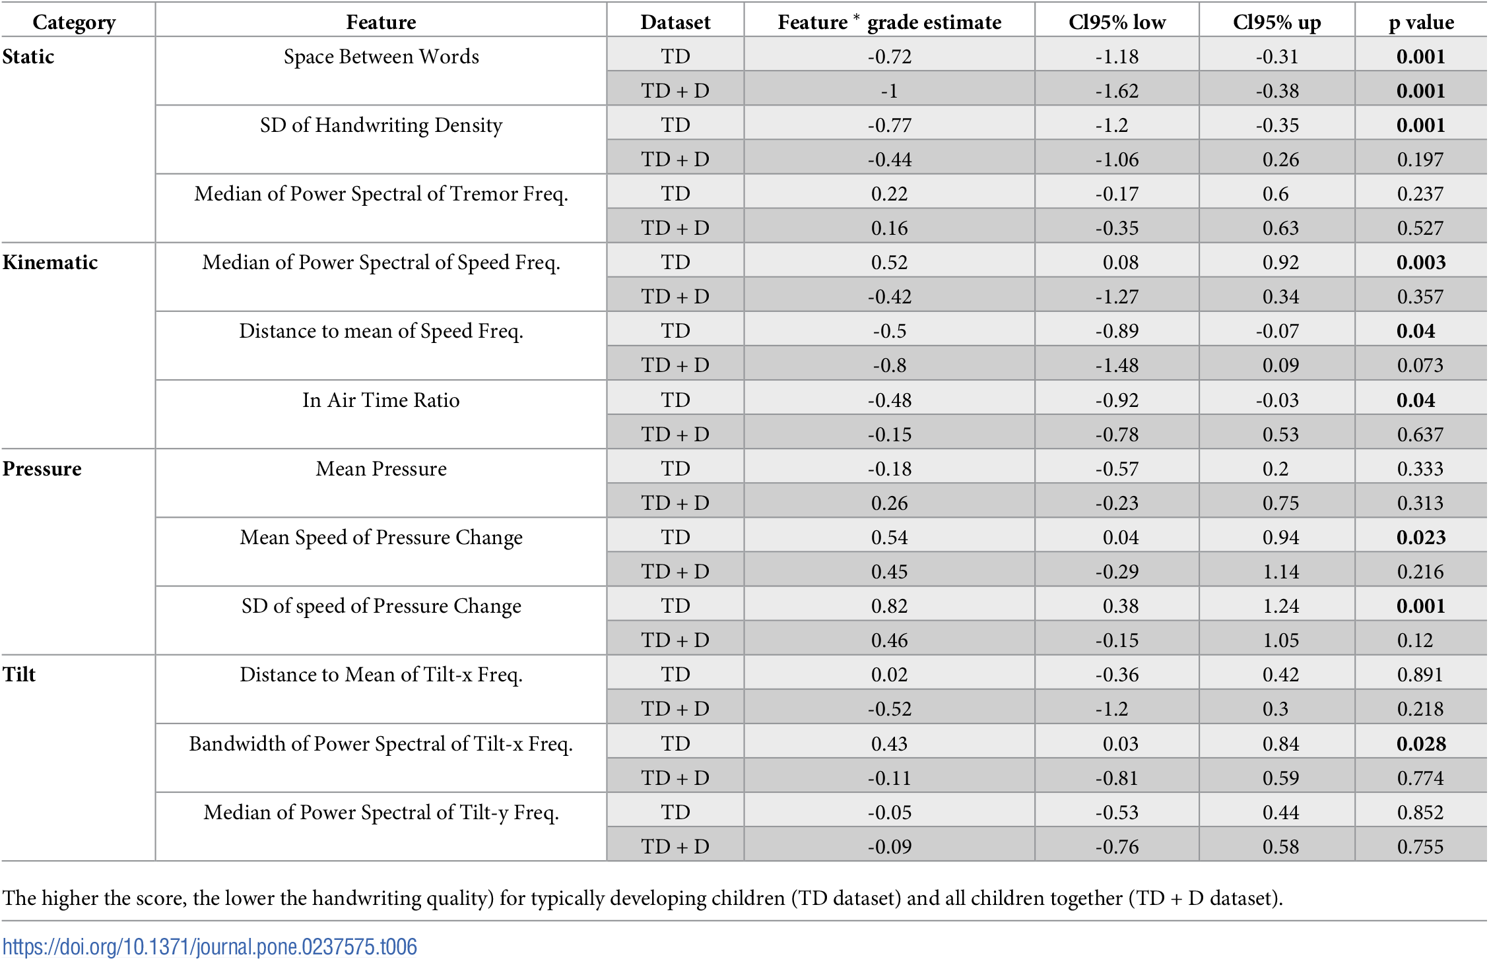

**Table 3.4.** Multivariate models with interaction to predict the BHK quality raw score.

**Speed interaction:** The interaction between handwriting features and grade to predict BHK speed differs between TD and TD+D datasets. In the TD dataset, two kinematic features and one pressure feature showed a significant interaction. However, in the TD+D dataset of the **Table 3.5**, two kinematic features, one static feature, and one pressure feature showed a significant interaction with grade to predict speed.

Interestingly, Space Between Words is the only feature that interacts with grade to predict both BHK quality and speed in the TD+D dataset.

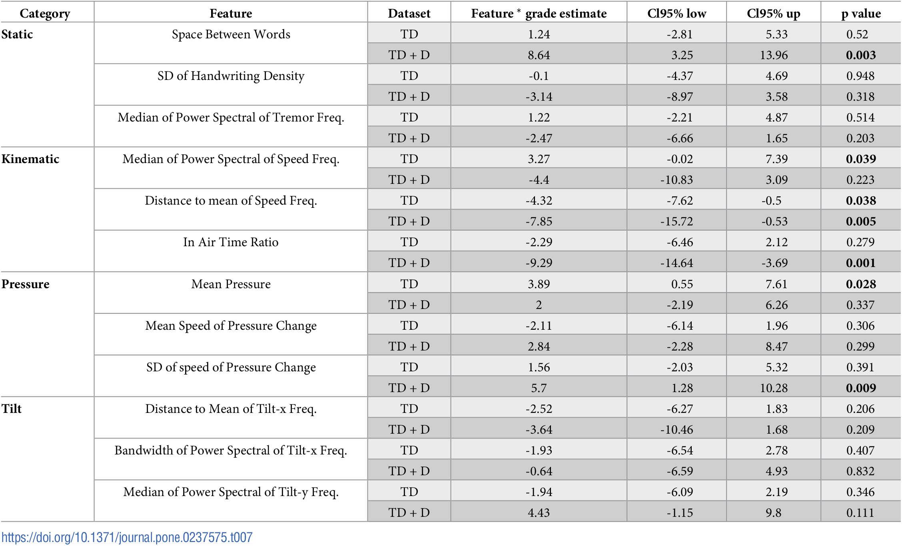

**Table 3.5**. Multivariate models with interaction to predict the BHK speed raw score for typically developing children (TD dataset) and all children together (TD + D dataset).

**3.3 A new clustering of dysgraphia**

The third aim is to create a new classification of dysgraphia based on objective handwriting features. Here used a K-means clustering algorithm with their 12 digital features as input and found that three clusters was the optimal number. The clusters' stability was satisfactory, and individuals from each cluster had different attributes. Using the elbow method to explore the best number of clusters, from the **Fig 3.4** found that three clusters was an optimal number according to the majority rule .

Regarding the final model, the Table 3.6 provides information about the Hopkins statistic was 0.35 and the clusters’ stability were satisfactory (cluster 1: 0.87, cluster 2: 0.89 and cluster 3: 0.84).

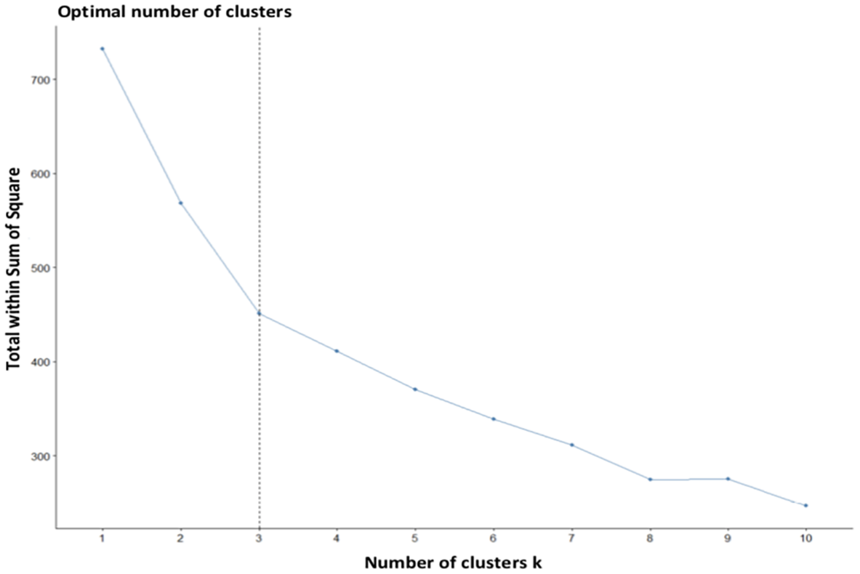

**Fig 3.4**. Elbow method to characterize the optimal number of clusters.

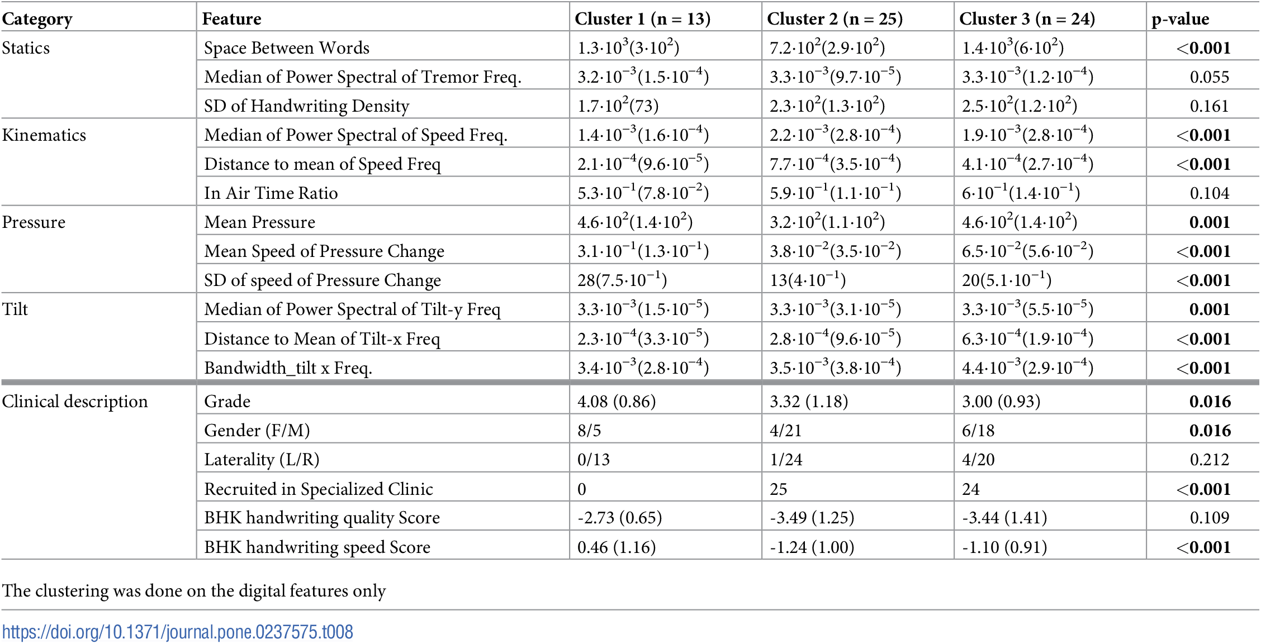

**Table 3.6**. Mean digital features value of each features according to their clustering**.** Demographic characteristics and BHK scores of children with dysgraphia corresponding to the 3 clusters.

The three clusters of children with dysgraphia based on the severity of their condition. Cluster 1 had the least severe form of dysgraphia, with higher handwriting speed and better handwriting quality. Cluster 2 and 3 had more severe dysgraphia and were predominantly boys. Cluster 2 had more abnormalities in speed and pressure features, while cluster 3 had issues with tilt features. These differences were reflected in the digital features analyzed. Examples of the differences between the clusters were provided in the **Fig 3.5** through handwriting examples and digital feature visualizations.

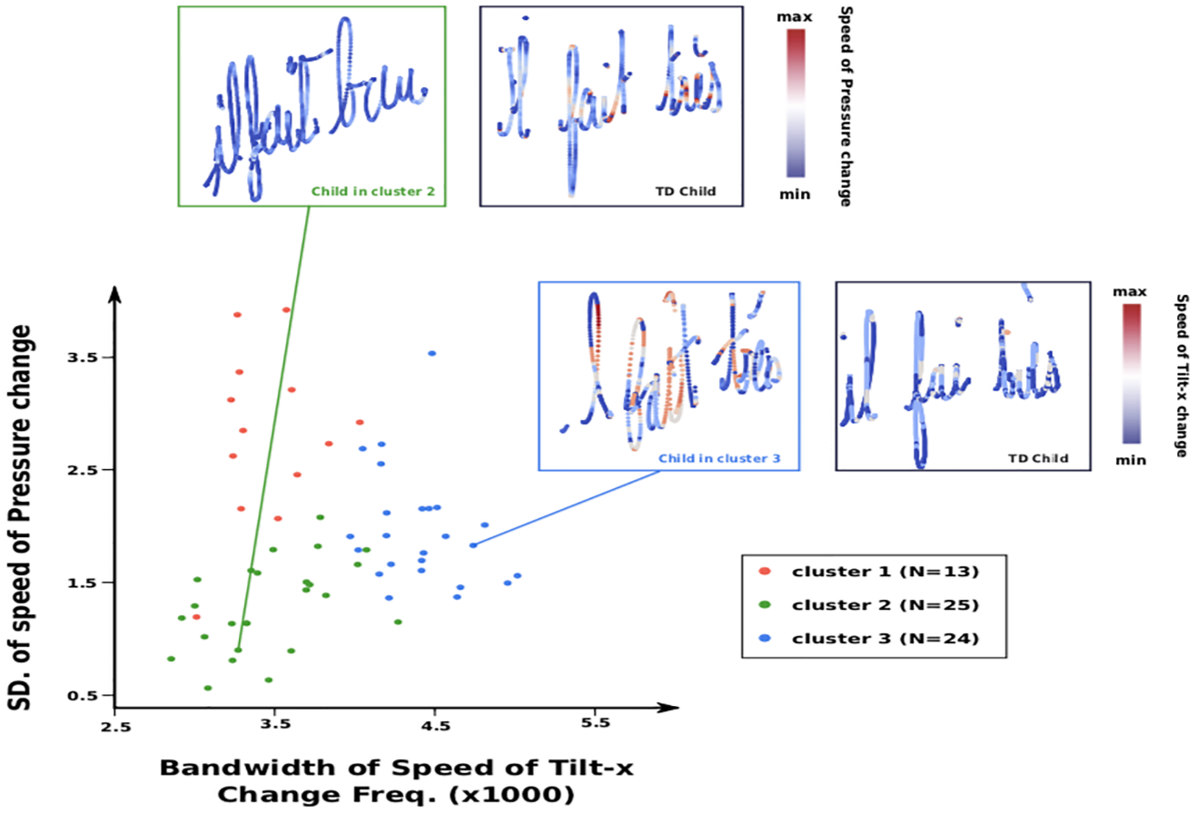

**Fig 3.5**. Comparisons of the SD of speed of pressure change and Bandwidth of Speed of Tilt-x Change Frequencies for the children without dysgraphia from the 3 different clusters. Examples of writing from a child with the most severe difficulties from cluster 2 and cluster 3 are shown.

**4. Discussion**

study that investigates children's handwriting acquisition in a group of children with and without dysgraphia using a set of digital features. The study shows that some of the digital features are not useful in explaining the handwriting quality of typically developing children, while they are associated with handwriting quality in children with dysgraphia. The pressure and tilt aspects of handwriting appear to be particularly central aspects of dysgraphia. The study also introduces a new clustering of children with dysgraphia based on low-level motor aspects of handwriting, which yielded three different subgroups. Finally, the study notes that new handwriting tests capable of running on digital tablets may be helpful in the diagnosis of handwriting-acquisition deficit, and that additional research should be done to verify the findings with a stylus/tablet setting.

**5.Conclusion and future enhancements**

**Conclusion**:

The paper concludes that their computational approach to studying dysgraphia has allowed for a more precise classification of dysgraphia based on objective characteristics of handwriting. The study identified three clusters of dysgraphia, each with distinct digital features and attributes.

Cluster 1 presented the least severe type of dysgraphia, with better handwriting quality and a smoother transition between low and high speeds of handwriting. Cluster 2 and 3 presented more severe cases of dysgraphia, with abnormalities in space between words, speed frequencies, pressure features, and tilt features. This approach could be used in future studies to develop a more detailed understanding of dysgraphia and to design more targeted interventions to help children with dysgraphia.

**Future enhancements**:

Future enhancements could include expanding the study to a larger sample size and exploring additional digital features that may be relevant to dysgraphia. And also this approach could be applied to other areas of motor control research, such as speech or gait analysis.

The current results open new opportunities for the automatic detection of children with dysgraphia in classroom. To believe that the training of pressure and tilt may open new therapeutic opportunities through serious games able to manipulate these features.

**6.REFERENCES**

1. Asselborn T, Cohen D, Gargot T, Johal W, Jolly C and Kidziński Ł, et al, Automated human-level diagnosis of dysgraphia using a consumer tablet, npj Digital Medicine, vol.1(1), pp.42,2018.

2. Cermak SA and McHale K, Fine motor activities in elementary school: preliminary findings and provisional implications for children with fine motor problems, American Journal of Occupational Therapy, vol.46 (10), pp.898–903,1992.

3. Deuel RK, Developmental Dysgraphia and Motor Skills Disorders, Journal of Child Neurology, vol.10, pp. S6–S8, 1995.

4. McCutchen D, From novice to expert: implications of language skills and writing relevant knowledge for memory during the development of writing skill, Journal of Writing Research, vol.3, pp.51–68, 2011.