1. Rina is 150 cm  
    Vini is 165 cm  
    Anisa is 170 cm  
    Vini is ... than Rina.  
    A. tall  
    B. taller  
    C. tallest  
    D. as tall as  
  
2. Rindi .... the floor everyday.  
    A. sweeps  
    B. is sweeps  
    C. sweeping  
    D. has sweep  
  
3. This book cost is fifteen thousand rupiahs.  
    A. Rp. 50.000,00  
    B. Rp. 15.000,00  
    C. Rp. 75.000,00  
    D. Rp. 85.000,00  
  
4. The opposite of big is ....  
    A. clever  
    B. dilligent  
    C. long  
    D. small  
  
5. Sandi is a hunter. He likes ....  
    A. hunting  
    B. climbing  
    C. writing  
    D. reading  
  
6. We buy stamps in the ....  
    A. post office  
    B. airport  
    C. hospital  
    D. railway station  
  
7. Cindy is 90 kg and Rida is 90 kg. Cindy is .... Rida.  
    A. fatter  
    B. fattest  
    C. fat  
    D. as fat as  
  
8. Ant is small but elephant is ....  
    A. long  
    B. big  
    C. slim  
    D. small  
  
9. Indonesia is in ....  
    A. America  
    B. Europe  
    C. Australia  
    D. Asia  
  
10. I need a cup of .... for breakfast.  
      A. fried rice  
      B. tea  
      C. potato  
      D. bread  
  
11. It is ....

[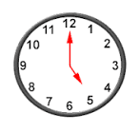](https://3.bp.blogspot.com/-5ucx-NA_KeM/WL97eynF_nI/AAAAAAAADjI/qR70OxevBX0Yp3xhftlzFw_b2ddRFORtwCEw/s1600/jam.png)

A. two o'clock

B. three o'clock

C. four o'clock

D. five o'clock

12. It is ....

[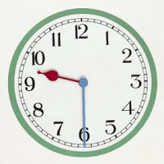](https://1.bp.blogspot.com/-VMNcaEc55dA/WL98mslnw4I/AAAAAAAADjM/sP7ZBtxs9PgMER3QS1daISBW3xWJzCa9wCLcB/s1600/930.jpg)

  A. nine o'clock

  B. a quarter past nine

  C. a half past nine

  D. a half past ten

13. It is ....

[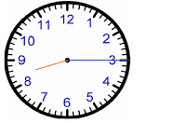](https://2.bp.blogspot.com/-mrnUpzit1zs/WL-D1WwmjII/AAAAAAAADjc/nf3sJO-1PygUbk7K5wGCjZhtzXLc4pP0QCLcB/s1600/815.jpg)

 A. eight o'clock

 B. nine o'clock

 C. a quarter past eight

 D. a quarter past nine

14. I .... a glass of milk every morning.

      A. drink

      B. eat

      C. sweep

      D. sing

15. I like to eat ..... for breakfast.

[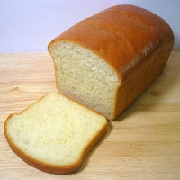](https://3.bp.blogspot.com/-mN1w-GJBapc/WL-F7oMlHiI/AAAAAAAADjk/jJmshknZwn0BA5Xg9dbnTGpJeFfl72uOACLcB/s1600/rot.jpg)

A. bread  
B. fried rice  
C. poridge  
D. potato  
  
  
  
  
  
  
  
  
  
16. I like to play ....

[](https://4.bp.blogspot.com/-SA0SSaMdWnM/WL-Gl6UfBmI/AAAAAAAADjs/flUfehxZVU4L7PY7uVimRCnqRoCg2tEzwCLcB/s1600/basket.jpg)

A. basket ball  
B. volley ball  
C. table tennis  
D. golf