Standard Operating Procedure
M365 Tenant User Onboarding via Microsoft Graph PowerShell
Tenant: InnovaticT Technologies | Document Owner: Aguddati@InnovaticT.onmicrosoft.com | Version 1.0

1. Purpose & Scope
This SOP documents the procedure for onboarding new user accounts into the InnovaticT Technologies Microsoft 365 tenant using the M365_User_Onboarding.ps1 PowerShell script. It covers prerequisites, execution steps, verification, manager assignment, troubleshooting, and cleanup. This procedure creates real, licensable user accounts visible in Microsoft 365 admin center → Active users.
Audience: engineers or IT administrators with User Administrator (or higher) privileges in the tenant.

2. Prerequisites
- An account with the User Administrator or Global Administrator role active in the InnovaticT tenant (e.g. Aguddati@InnovaticT.onmicrosoft.com).
- Windows PowerShell 5.1+ or PowerShell 7, with internet access.
- The Microsoft Graph PowerShell SDK modules: Microsoft.Graph.Users, Microsoft.Graph.Identity.DirectoryManagement.
- A prepared onboarding CSV file with user details, using the InnovaticT.onmicrosoft.com domain.
- One-time tenant admin consent granted for the User.ReadWrite.All and Organization.Read.All Graph scopes (see Section 7).

3. Files Used
File | Purpose
M365_User_Onboarding.ps1 | Main script - reads the CSV, creates accounts, assigns manager/license, verifies and logs results.
Onboarding CSV (e.g. InnovaticT_Test_Onboarding.csv) | Input list of users to create. Columns: FirstName, LastName, DisplayName, UserPrincipalName, MailNickname, JobTitle, Department, UsageLocation, LicenseSkuPartNumber, ManagerUPN.
Onboarding_Results_<timestamp>.csv | Auto-generated output - one row per user with Success / Skipped / Failed status.
Onboarding_Credentials_<timestamp>.csv | Auto-generated output - temporary passwords. SENSITIVE - handle and delete securely.

4. Step-by-Step Procedure

4.1 Environment Setup (one-time)
Install the required Microsoft Graph modules:
Install-Module Microsoft.Graph.Users, Microsoft.Graph.Identity.DirectoryManagement -Scope CurrentUser -Force
If PowerShell blocks script execution, allow it for the current session only:
Set-ExecutionPolicy -Scope Process -ExecutionPolicy Bypass

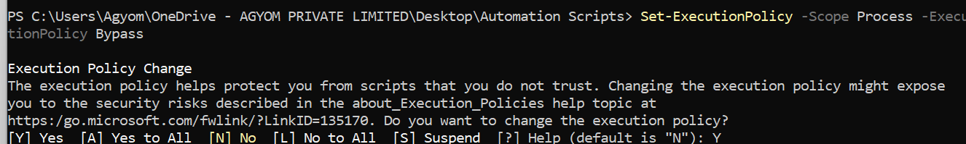
4.2 Navigate to the Script Folder
Use quotes around the path if it contains spaces (e.g. OneDrive folder names):
cd "C:\Users\<username>\OneDrive - AGYOM PRIVATE LIMITED\Desktop\Automation Scripts"
dir *.ps1, *.csv

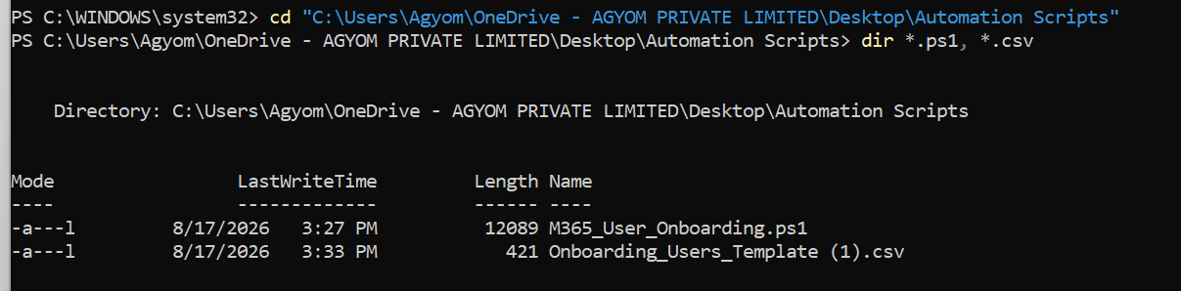

4.3 Prepare the CSV
Confirm every UserPrincipalName and ManagerUPN uses the correct tenant domain: @InnovaticT.onmicrosoft.com. A mismatched domain (e.g. a leftover @nttdata.onmicrosoft.com from a template) will cause account creation to fail.
FirstName,LastName,DisplayName,UserPrincipalName,MailNickname,JobTitle,Department,UsageLocation,LicenseSkuPartNumber,ManagerUPN
Nick,Doe,Nick Doe,nick.doe@InnovaticT.onmicrosoft.com,nick.doe,QA Tester,IT,IN,,Aguddati@InnovaticT.onmicrosoft.com

4.4 Dry Run (validate without creating anything)
.\M365_User_Onboarding.ps1 -CsvPath ".\InnovaticT_Test_Onboarding.csv" -WhatIf
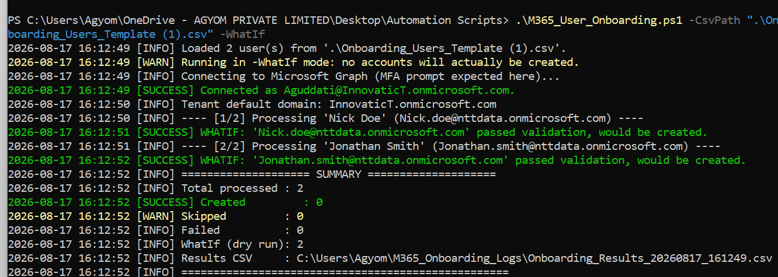
Sign in as Aguddati@InnovaticT.onmicrosoft.com and complete MFA when prompted. Confirm the summary shows no red ERROR lines and a WhatIf count matching the number of CSV rows.

4.5 Real Run (creates accounts)
.\M365_User_Onboarding.ps1 -CsvPath ".\InnovaticT_Test_Onboarding.csv"
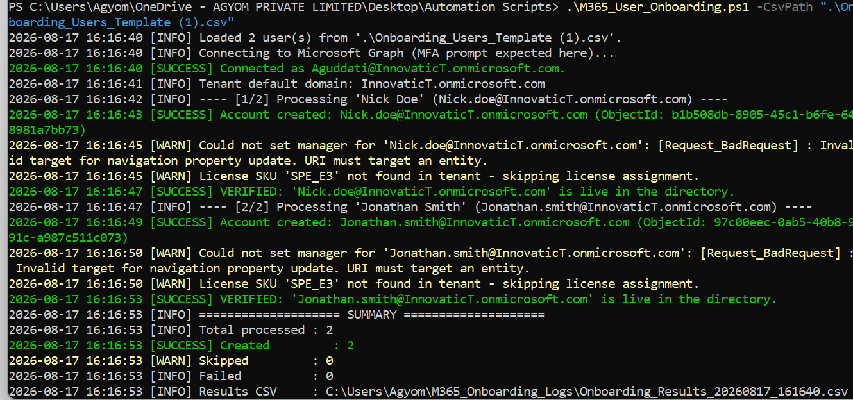
Confirm the console shows “Account created” and “VERIFIED” for each user, and the summary reports the expected Created count.

5. Post-Creation: Manager Assignment
If a manager was not set via the CSV's ManagerUPN column, assign it manually after creation:
Connect-MgGraph -Scopes "User.ReadWrite.All"
$manager = Get-MgUser -Filter "userPrincipalName eq 'Aguddati@InnovaticT.onmicrosoft.com'"
$refBody = @{ "@odata.id" = "https://graph.microsoft.com/v1.0/users/$($manager.Id)" }
Set-MgUserManagerByRef -UserId "nick.doe@InnovaticT.onmicrosoft.com" -BodyParameter $refBody
Set-MgUserManagerByRef -UserId "jonathan.smith@InnovaticT.onmicrosoft.com" -BodyParameter $refBody

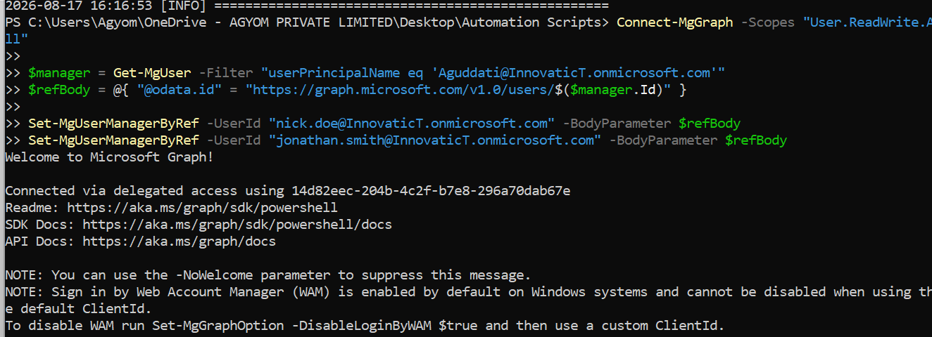
6. Verification

6.1 Verify Account Creation
Portal: admin.microsoft.com → Users → Active users → search by display name. Allow a few minutes for propagation.
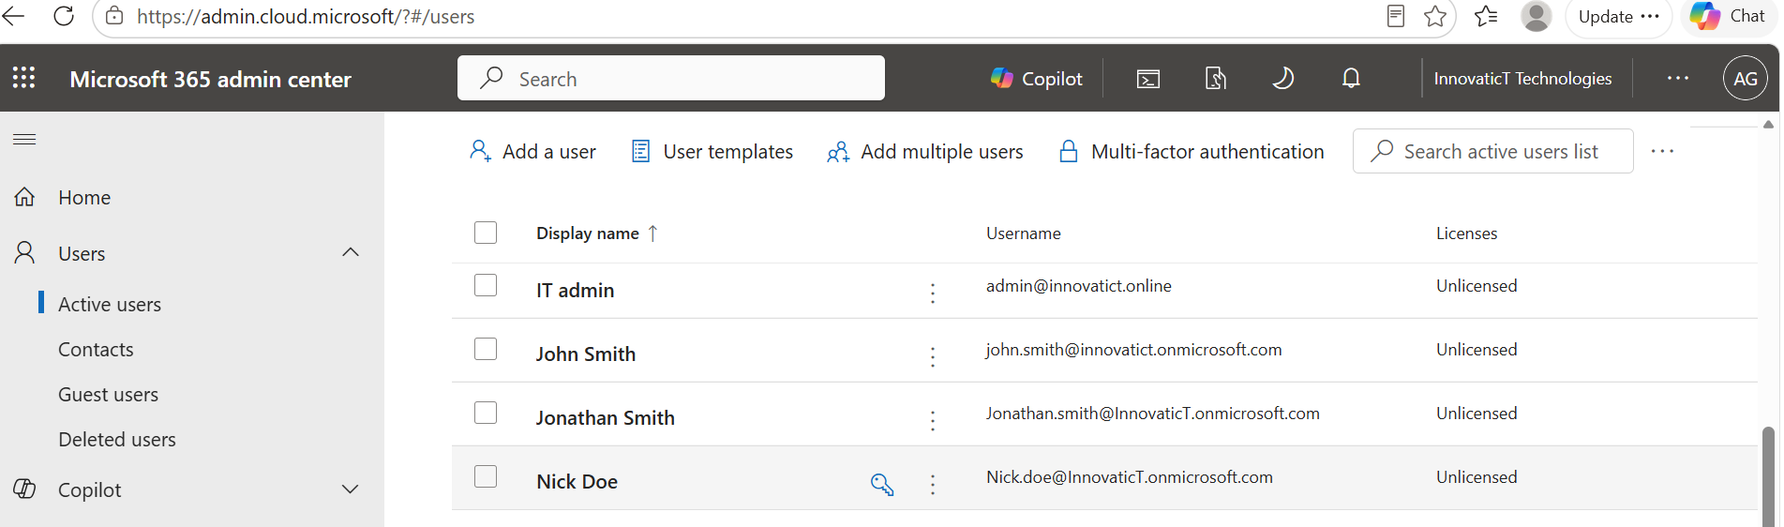

6.2 Verify Manager Assignment
Get-MgUserManager -UserId "nick.doe@InnovaticT.onmicrosoft.com" | Select-Object DisplayName, Id
Get-MgUser -UserId "<returned Id>" | Select-Object DisplayName, UserPrincipalName
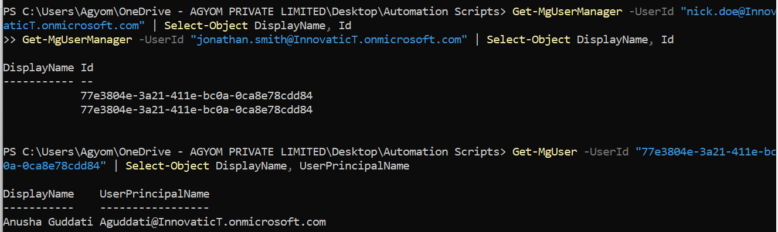
A matching manager DisplayName / UserPrincipalName confirms success.

7. Known Issues & Troubleshooting
Symptom | Cause / Resolution
“Access blocked to AAD Graph API… Forbidden” | Tenant has retired the legacy AzureAD/AzureADPreview module path (Microsoft-wide retirement, Oct 2025). Not fixable by re-authenticating with a different account - use the Microsoft Graph SDK path instead.
“Approval required” / AADSTS90097 on sign-in | The Graph scopes (User.ReadWrite.All, RoleManagement.*) require one-time tenant admin consent. A non-admin cannot self-grant this - have a Global/User Administrator approve it once via Entra admin center → Enterprise applications → Permissions.
“Running scripts is disabled on this system” | PowerShell execution policy is blocking the script. Run: Set-ExecutionPolicy -Scope Process -ExecutionPolicy Bypass
“That Microsoft account doesn’t exist” at sign-in | Typo, stray space, or incorrect domain in the UPN. Verify the exact UPN in the admin center and retype it cleanly.
Set-Location: positional parameter cannot be found ('-') | Folder path has spaces and wasn’t quoted. Always wrap paths in double quotes.
User created but not visible in Active Users | Script was run with -WhatIf (simulation only, creates nothing), or the CSV domain doesn’t match the tenant. Re-run without -WhatIf using a CSV with the correct @InnovaticT.onmicrosoft.com domain.
