Name: Vijay Patil 125B2F003
Sahil Dhumal 125B2F006
Mahadev Jundale 125B2F007

Assignment 5

1. Introduction to UML
Unified Modeling Language (UML) is a standardized modeling language used to visualize, specify, design, and document software systems. UML provides different types of diagrams to represent both the structural and behavioral aspects of a system.
UML diagrams help developers and system designers understand how a software system is organized and how its different components interact with each other.

2. UML Sequence Diagram
A Sequence Diagram is a behavioral UML diagram used to represent the interaction between different actors and objects in a system in a particular sequence of time.
It focuses mainly on:
- The participants involved in an interaction.
- The messages exchanged between participants.
- The order in which messages are exchanged.
- The responses returned by different objects.
- The conditions and repetitions involved in a process.
In a sequence diagram, time progresses from top to bottom. Participants are normally placed horizontally, while their interactions are represented using arrows between their lifelines.

3. Purpose of Sequence Diagrams
The main purpose of a sequence diagram is to describe the dynamic behavior of a system.
Sequence diagrams are useful for:
- Understanding the flow of a particular system operation.
- Identifying communication between system components.
- Showing the order of events.
- Identifying alternative and exceptional flows.
- Understanding the responsibilities of different objects.
- Supporting software design and implementation.
- Communicating system behavior to developers and stakeholders.

4. Basic Elements of a Sequence Diagram

4.1 Actor
An actor is an external entity that interacts with the system. It may be a user, another system, or an external service.
For an Online Examination System, a Student can be represented as an actor.

4.2 Lifeline
A lifeline represents a participant involved in the interaction. It is shown as a vertical dashed line extending below the participant's name.

4.3 Message
A message represents communication between two participants. It is shown using an arrow and describes an operation or request.
Examples include:
- Login request
- Validate credentials
- Start examination
- Submit answer
- Generate result

4.4 Activation Bar
An activation bar represents the period during which a participant is actively performing an operation.

4.5 Return Message
A return message represents the response from one participant to another after processing a request.

4.6 Guard Condition
A guard condition specifies a condition that must be satisfied before an interaction takes place.
For example:
[credentials valid]
or
[exam time expired]

5. Advanced Interaction Notations in UML 2.0
UML 2.0 provides Combined Fragments to represent complex interaction behavior within sequence diagrams.
The major interaction notations include:

5.1 alt – Alternative
The alt fragment represents alternative paths in an interaction. Only one of the alternatives is executed depending on the specified condition.
For example, a system may follow one flow when login credentials are valid and another flow when they are invalid.
Purpose: Used for conditional or decision-based behavior.

5.2 opt – Optional
The opt fragment represents an optional interaction. The interaction occurs only when its condition is satisfied.
For example, an additional authentication step may be performed only when two-factor authentication is enabled.
Purpose: Used when an interaction may or may not occur.

5.3 loop – Loop
The loop fragment represents a repeated interaction. The interaction continues while a specified condition is satisfied or for a specified number of iterations.
For example, a sequence of operations may be repeated for every question in an examination.
Purpose: Used for repetitive behavior.

5.4 break – Break
The break fragment represents an exceptional condition that terminates the current interaction.
For example, if an examination reaches its time limit, the normal interaction can be terminated and the examination can be automatically submitted.
Purpose: Used for exception handling and early termination.

5.5 par – Parallel
The par fragment represents interactions that can occur concurrently or in parallel.
For example, in an examination system, the examination timer may continue running while the system saves the student's answers.
Purpose: Used to represent concurrent activities.

5.6 ref – Interaction Reference
The ref fragment is used to refer to another sequence diagram or interaction.
For example, a Login sequence diagram can be reused or referenced from another process instead of drawing the complete login interaction again.
Purpose: Used to reuse an already defined interaction.
Notations:
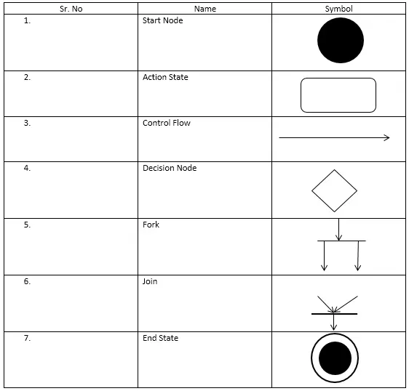

6. Online Examination System
An Online Examination System is a software system that enables examinations to be conducted electronically through a computer or web-based interface.
The system generally supports activities such as:
- User authentication
- Examination selection
- Examination instructions
- Question presentation
- Answer submission
- Time management
- Automatic submission
- Answer evaluation
- Result generation
The system involves several interacting components, including the student, user interface, authentication service, examination service, question database, answer database, and result processing service.

7. Major Scenarios
For modeling an Online Examination System, several important scenarios can be identified.

Scenario 1: User Login
The student provides authentication information to access the system. The system verifies the information and either grants access or rejects the login attempt.

Scenario 2: Starting an Examination
After successful authentication, the student selects an examination. The system verifies eligibility, retrieves the required examination information, creates an examination session, and displays the examination.

Scenario 3: Submitting Answers
During the examination, the student provides answers to questions. The system records the responses and allows the student to continue answering until the examination is submitted.

8. Importance of Advanced Interaction Notations
Advanced interaction notations make sequence diagrams more realistic and detailed than simple message-flow diagrams.
For an Online Examination System:
- alt can represent valid and invalid conditions.
- opt can represent optional authentication or instructions.
- loop can represent answering multiple examination questions.
- break can represent examination termination due to time expiration.
- par can represent concurrent operations such as maintaining the timer and saving responses.
- ref can represent reuse of an existing interaction such as the login process.
These notations help represent the actual behavior of a software system, including normal, alternative, optional, repeated, concurrent, and exceptional flows.

9. Advantages of Using Sequence Diagrams
Sequence diagrams provide several advantages in software development:
- Visual representation – Complex interactions can be understood easily through diagrams.
- Clear execution order – The sequence of operations is clearly represented.
- Better system analysis – Developers can identify how different components communicate.
- Exception handling – Alternative and exceptional scenarios can be represented.
- Improved design – The diagrams help identify system components and their responsibilities.
- Easy communication – Technical and non-technical stakeholders can understand system behavior.
- Support for implementation – The interaction flow can guide developers during coding.

10. Conclusion
UML 2.0 Sequence Diagrams are an important tool for modeling the dynamic behavior of software systems. They represent how actors and system components communicate with each other and show the order in which operations occur.
For an Online Examination System, sequence diagrams can effectively represent major scenarios such as user login, starting an examination, answering questions, submitting answers, and generating results.
The use of advanced UML 2.0 interaction notations such as alt, opt, loop, break, par, and ref allows both normal and exceptional system behavior to be modeled clearly. Therefore, sequence diagrams provide a structured and visual method for analyzing, designing, and documenting the behavior of an Online Examination System.

