SIMATS ENGINEERING (SAVEETHA SCHOOL OF ENGINEERING)

Department of Computer Science and Engineering

ASSESSMENT TOOL 2 – CONCEPT MAPPING

Course Code: | CSA0614 | Course Title: | Design and Analysis of Algorithms
CO Assessed: | CO1 – Precision (BL1, BL2, BL3) | Assessment: | Assessment Tool 2 – Concept Mapping
Weightage: | 20% of CIA | Total Marks: | 100 (2 Questions × 50 Marks)
CO1 Statement: | Determine algorithm efficiency using asymptotic notations and mathematical techniques including Master Theorem and substitution method. (BL1, BL2, BL3)
Student Name: | Gudi Rama Krishna | Reg. No.: | 192565028
Section / Batch: |  | Date:
Instructions to Students
- Answer BOTH questions. Each question carries 50 Marks. Total: 100 Marks.
- Draw a clear and neat concept map for each question.
- Identify all key concepts and arrange them in a logical hierarchy.
- Show meaningful linkages between concepts using arrows and connecting words.
- Compare related concepts wherever required and justify the relationships clearly.
- Ensure the concept map is well-organized, readable, and properly labelled.

Question Type | Focus Area | Questions | Marks
Concept Mapping | Map algorithm efficiency concepts using asymptotic analysis, search techniques, recurrence relations, and recursion tree method | Q1 – Q2 | Q1 –50  Q2 –50
GRAND TOTAL: |  | 100 Marks

SECTION A – CONCEPT MAPPING

Q1. Consider the concept map: Algorithm → Growth Function → Big-Omega → Lower Bound → Best-case Explain how lower bound represents minimum execution time. Extend the map with performance guarantee node. Justify why best-case analysis is useful. Interpret how this contributes to overall performance understanding.

Explain how Merge Sort follows divide-and-conquer strategy. Extend the map by linking recurrence relation to Master
Theorem. Justify how recurrence leads to O(n log n) complexity. Interpret how this mapping explains efficiency compared
to quadratic sorting algorithms.
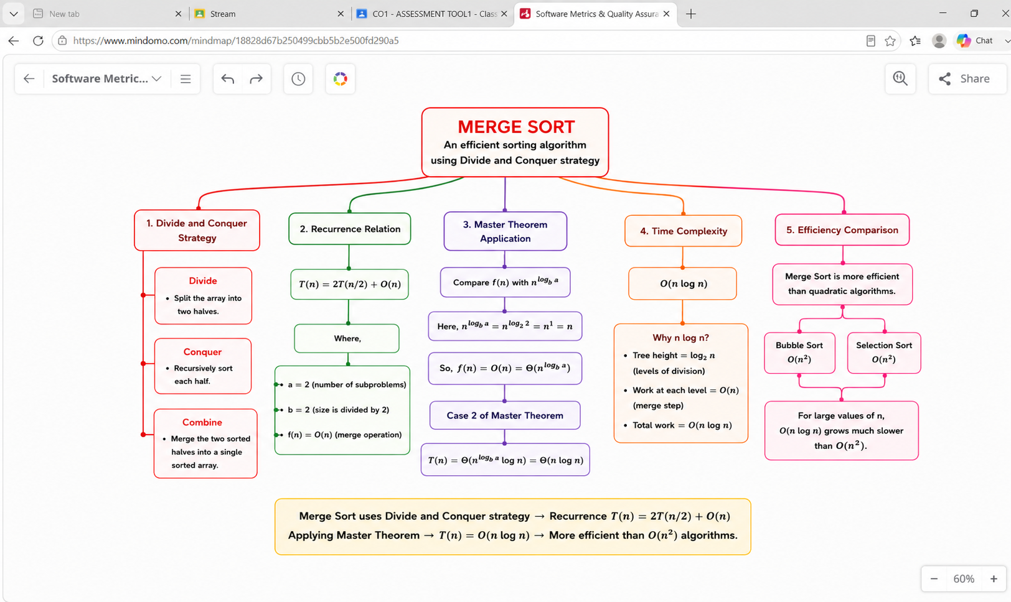

Q2. Consider the concept map: Recurrence Relation → Substitution Method → Expansion → Simplification → Final Complexity Trace the step-by-step transformation of recurrence into a closed form. Extend the map with Guess and Verification nodes. Justify how substitution helps solve non-standard recurrences. Interpret how this structured approach improves understanding.

Map how counting operations leads to asymptotic upper bounds. Extend the map with Worst-case Analysis. Justify why
Big-O represents worst-case behavior. Interpret how this supports algorithm comparison.
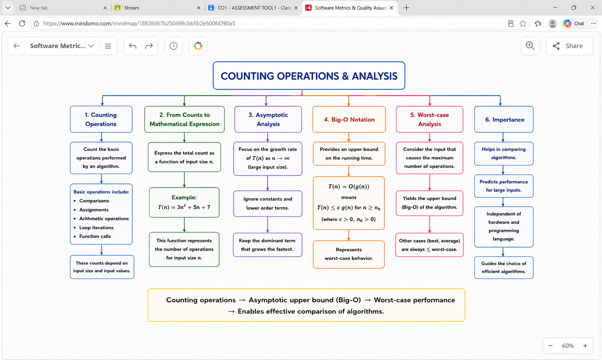

Code of Conduct
I (Name / Reg No) certify that this submission is my original work and that I have adhered to the guidelines specified for this assessment. I understand that any violation of academic integrity rules will result in disciplinary action.
Signature of the Student: G . Rama Krishna

RUBRICS FOR CALCULATION

Criteria | Weighta ge | Level 4 – Exemplary | Level 3 – Proficient | Level 2 – Developing | Level 1 – Beginning
Concept Identification | 25% | Identifies all key concepts from literature accurately and comprehensively | Identifies most key concepts with minor omissions | Identifies limited concepts; some are irrelevant or missing | Fails to identify essential  concepts
Linkages | 25% | Establishes clear, meaningful, and accurate relationships between concepts | Shows correct relationships with minor gaps | Relationships are weak, unclear, or partially incorrect | No  meaningful relationships established
Organization | 20% | Concepts are well-structured hierarchically with logical flow and grouping | Mostly organized with minor  structural issues | Some organization but lacks clear hierarchy | No logical organization or structure
Integration of Literature | 20% | Integrates multiple studies effectively to show connections and comparisons | Shows some integration of literature | Limited integration; mostly isolated concepts | No integration of literature evidence
Clarity | 10% | Concept map is clear, neat, visually structured, and easy to interpret | Generally clear with minor readability issues | Clarity is reduced; difficult to interpret in parts | Poorly presented and hard to understand

Marks Evaluation:
Questio n No. | Concept Identification (25%) | Linkages (25%) | Organizatio n (20%) | Integratio n of Literature (20%) | Clarity (10%) | Total Marks (Each – 50)
Q1
Q2
Overall Total (100)

Faculty In-charge | Course Coordinator | Head of Department
Signature: | Signature: | Signature:
Date: | Date: | Date:

