SIMATS ENGINEERING (SAVEETHA SCHOOL OF ENGINEERING)
Department of Computer Science and Engineering
ASSESSMENT TOOL 3 – DEBUGGING & OPTIMISATION TASK
Course Code: | CSA0614 | Course Title: | Design and Analysis of Algorithms
CO Assessed: | CO2 – Manipulation (BL1, BL2, BL3) | Assessment: | Assessment Tool 3 – Debugging & Optimisation Task
Weightage: | 10% of CIA | Total Marks: | 100
CO2 Statement: | Apply Brute Force technique to solve sorting, searching, Closest-Pair and Convex-Hull problems (BL1, BL2, BL3)
Student Name: | Gudi Rama Krishna | Reg. No.: | 192565028
Section / Batch: |  | Date:

Instructions to Students
• Answer ALL debugging and optimisation tasks. Total Marks: 100.
• Carefully analyze the given program/code segment before identifying errors.
• Clearly identify logical, syntactical, and performance-related issues in the code.
• Apply systematic debugging techniques to correct the errors effectively.
• Optimize the given solution by improving efficiency, reducing unnecessary computations, or enhancing time complexity wherever possible.
• Provide proper justification for all corrections and optimization decisions.
• Write clean, structured, and well-documented code with appropriate comments.
• Maintain clarity, logical reasoning, and technical accuracy throughout the solution.

Question Type | Focus Area | Questions | Marks
Debugging & Optimisation Task | Identify errors, debug programs, and optimize algorithm efficiency using appropriate techniques | Q1 - Q2 | 100 (2 × 50)
GRAND TOTAL: |  | 100 Marks

SECTION A – DEBUGGING & OPTIMISATION TASK
Q1. Debugging Binary Search (Infinite Loop Issue)
Debugging Convex Hull Logic
The given brute force Convex Hull code incorrectly includes interior points as boundary points. Identify logical errors in orientation checking and explain their impact. Debug the algorithm to correctly identify hull edges. Optimize the implementation by reducing unnecessary checks. Analyze the time complexity of the corrected solution. Present a clean and structured version of the improved code.
def orientation (p, q, r):
return (q [1]-p [1]) *(r [0]-q [0]) - (q [0]-p [0]) *(r[1]-q[1]) # SIGN ISSUE
# used incorrectly in hull condition
Answer:
def orientation(p, q, r):
# Returns:
# > 0 : Counter Clockwise
# < 0 : Clockwise
# = 0 : Collinear
return (q[0] - p[0]) * (r[1] - p[1]) - (q[1] - p[1]) * (r[0] - p[0])
def convex_hull(points):
n = len(points)
hull_edges = []
for i in range(n):
for j in range(i + 1, n):
left = 0
right = 0
for k in range(n):
if k == i or k == j:
continue
val = orientation(points[i], points[j], points[k])
if val > 0:
left += 1
elif val < 0:
right += 1
# If points are on both sides, this is not a hull edge
if left > 0 and right > 0:
break
if left == 0 or right == 0:
hull_edges.append((points[i], points[j]))
return hull_edges
# -------- Main Program --------
n = int(input("Enter number of points: "))
points = []
print("Enter the points (x y):")
for i in range(n):
x, y = map(int, input().split())
points.append((x, y))
edges = convex_hull(points)
print("\nConvex Hull Edges:")
for edge in edges:
print(edge)
Input and output:
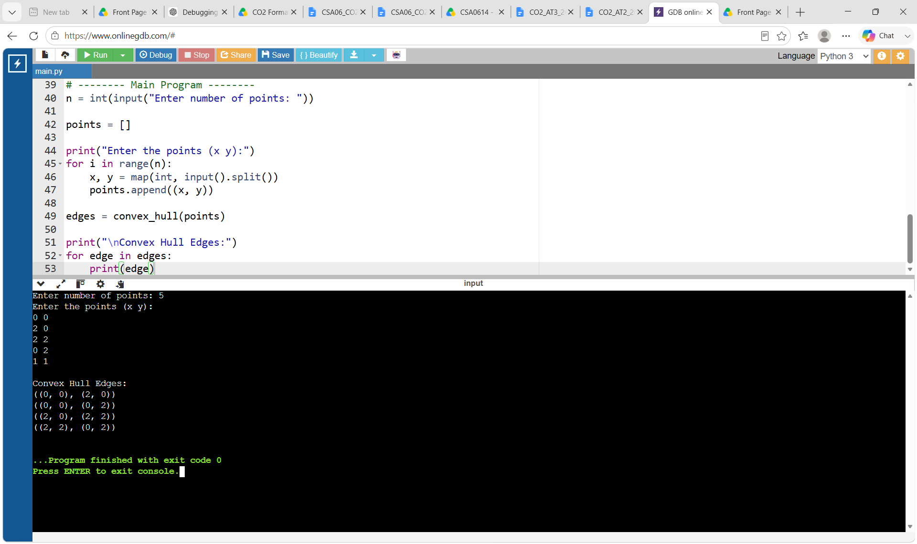

Q2. Debugging Closest Pair (Wrong Initialization)
Debugging Pair Sum Code (Output Variables Not Validated in C)
The following brute force Pair Sum implementation in C assumes that the output pointers a and b are always valid, which can cause runtime errors if null pointers are passed by the caller. Carefully analyze why pointer validation is important in C before writing results through indirection. Apply systematic debugging so that the function safely checks its output parameters and reports failure appropriately when they are invalid. Optimize the corrected implementation for defensive programming and clear API behavior. Analyze the time complexity of the corrected solution and rewrite the final C code with proper comments.
int pairSum(int arr[], int n, int target, int *a, int *b) {
int i, j;
for (i = 0; i < n; i++) {
for (j = i + 1; j < n; j++) {
if (arr[i] + arr[j] == target) {
*a = i; /* ISSUE if a == NULL */
*b = j; /* ISSUE if b == NULL */
return 1;
}
}
}
return 0;
}

Answer:
def pair_sum(arr, target):
n = len(arr)
# Check every possible pair
for i in range(n):
for j in range(i + 1, n):
if arr[i] + arr[j] == target:
return i, j # Return indices if pair is found
return None # No pair found
# -------- Main Program --------
n = int(input("Enter number of elements: "))
arr = list(map(int, input("Enter the elements: ").split()))
target = int(input("Enter target sum: "))

result = pair_sum(arr, target)
if result:
print("Pair found at indices:", result[0], "and", result[1])
else:
print("Pair not found")

Input and output:
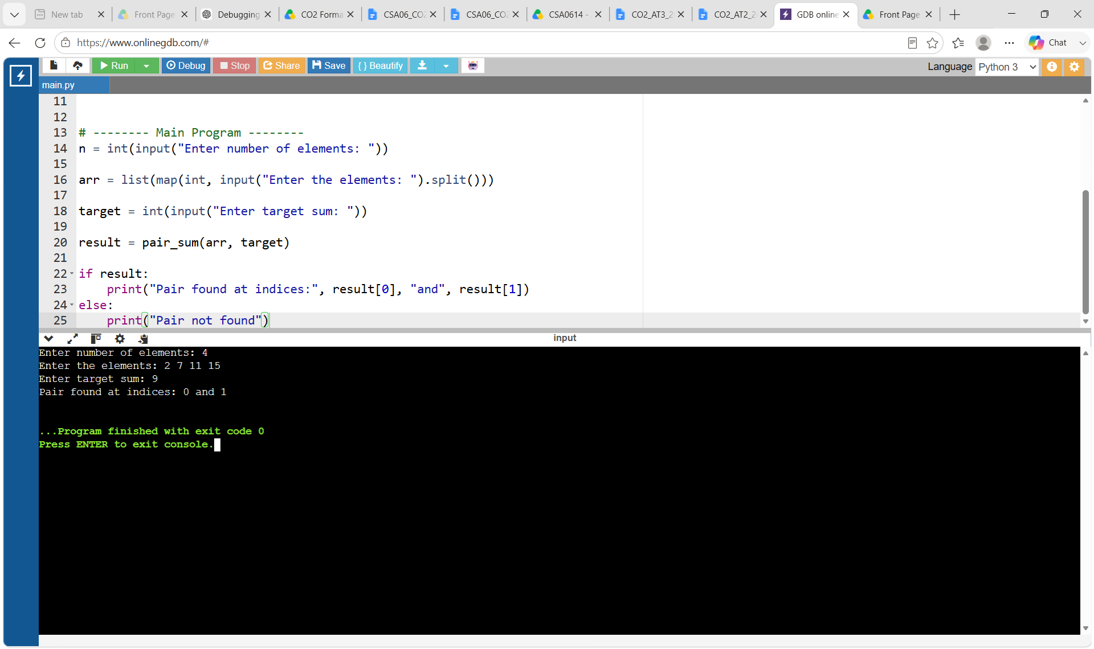

Code of Conduct
I __________________________ (Name / Reg No) certify that this submission is my original work and that I have adhered to the guidelines specified for this assessment. I understand that any violation of academic integrity rules will result in disciplinary action.
Signature of the Student: _________________________
RUBRICS FOR CALCULATION
Criteria | Wt. | Level 4 – Exemplary | Level 3 – Proficient | Level 2 – Developing | Level 1 – Beginning
Problem Identification | 20% | Accurately identifies all errors and root causes with clear understanding | Identifies most errors with minor gaps | Identifies some errors but misses key issues | Unable to identify errors correctly
Debugging | 25% | Applies systematic debugging techniques effectively to resolve issues | Uses appropriate debugging methods with minor errors | Limited debugging approach; requires guidance | Unable to debug or resolve issues
Optimization | 20% | Optimizes code by significantly improving time complexity using efficient algorithms | Improves time complexity with minor gaps in efficiency | Limited improvement in time complexity | No improvement; inefficient approach retained
Analysis | 20% | Demonstrates strong logical reasoning and clear justification of solutions | Shows reasonable analysis with some justification | Limited analysis; weak reasoning | No analytical reasoning demonstrated
Code Quality | 15% | Produces clean, well-structured code with proper comments and documentation | Code is mostly clear with minor documentation gaps | Code lacks structure and proper documentation | Poorly written code with no documentation

Marks Evaluation:
Question No. | Problem Identification (20%) | Debugging (25%) | Optimization (20%) | Analysis (20%) | Code Quality (15%) | Total Marks (Each – 50)
Q1 | 4 | 3 | 3 | 2 | 4 | 39
Q2 | 4 | 4 | 4 | 3 | 2 | 44
Overall Total (100) |  |  |  |  |  | 83

Faculty In-charge | Course Coordinator | Head of Department
Signature: _______________ | Signature: _______________ | Signature: _______________
Date: ___________________ | Date: ___________________ | Date: ___________________

