

**CSE3003 : Computer Networks**

**Name :** Gudi Varaprasad

**Reg. No. :** 19BCE7048

School of Computer Science and Engineering

**Lab Slot :** L39 + L40

**Date :** 27 – 01 – 2021

**Submitted to :** . Dr. R. Nandha Kumar sir

**Ex No : 1 Basic Networking Commands**

**Date : 27-01-2021**

**1. ipconfig :**

Displays **current TCP/IP** network configuration values.

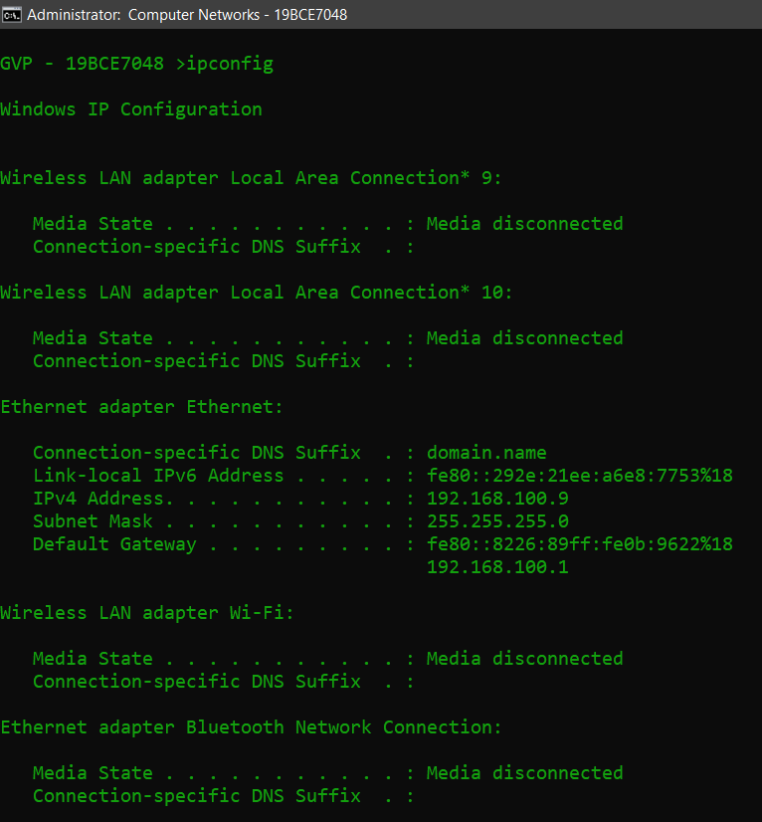

**2. ipconfig /all :**

Display the **full TCP/IP** configuration information for all network adapters.

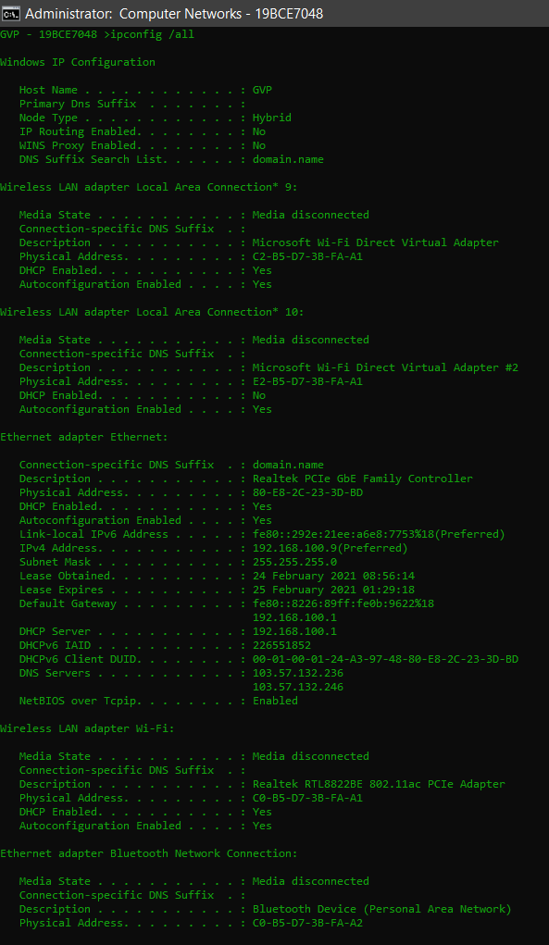

**3. ping** [**www.youtube.com**](http://www.youtube.com) **:**

Ping is a basic Internet program that allows a user to verify that a particular IP address exists and can accept requests. Ping can be used for troubleshooting to test connectivity and determine response time.

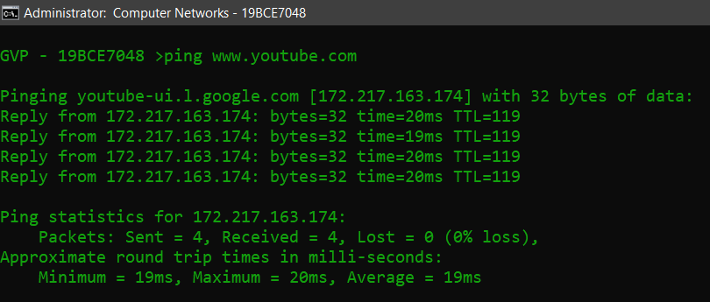

**4. ping 192.168.100.9 :**

A quick **ping by IP address** will confirm that the system is on, that there is a connection, and that the two machines can talk to each other.

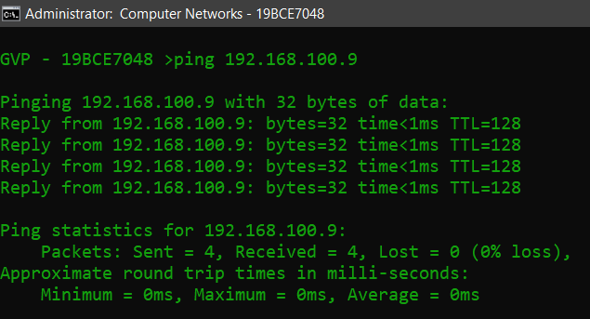

**5. ping** [**www.19bce7048computer.com**](http://www.19bce7048computer.com) **:**

pinging an unknown website results in failure of ping request.

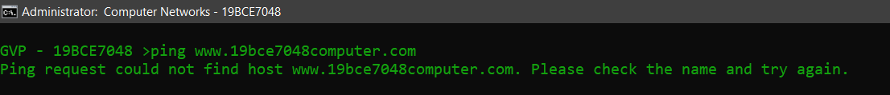

**6. tracert** [**www.vitap.ac.in**](http://www.vitap.ac.in) **:**

It determines the route to a destination by sending ICMP packets to the destination. The command will return output indicating the hops discovered and time (in milliseconds) for each hop. Each entry, or hop, is a location that the packet passes through to reach its final destination.

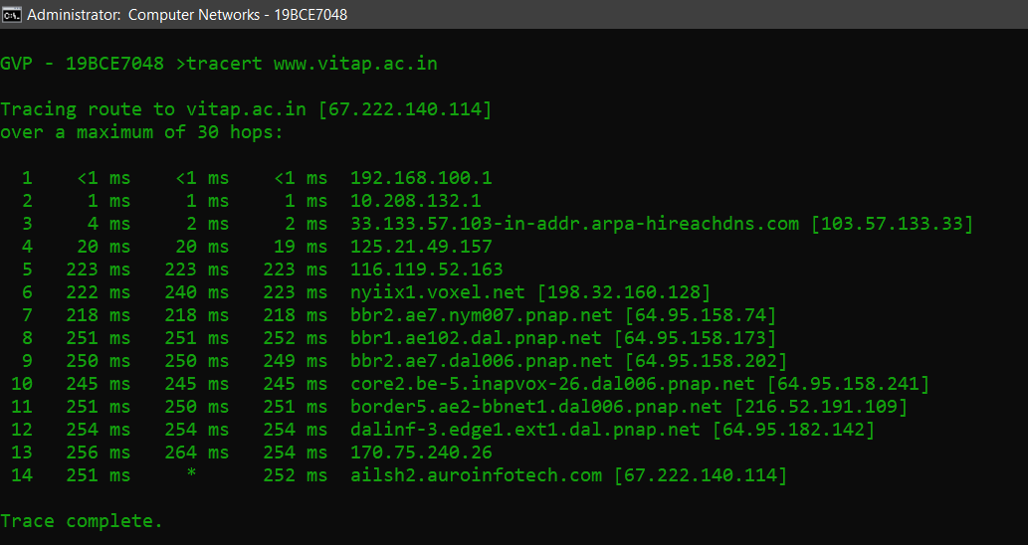

**7. tracert 192.168.100.9 :**

Traceroute is a network diagnostic tool used to track in real-time the pathway taken by a packet on an IP network from source to destination.

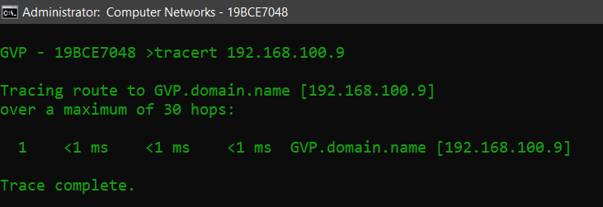

**8. nslookup :**

**nslookup** (stands for “**Name Server Lookup**”) is a useful command for getting information from DNS server. It is a network administration tool for querying the Domain Name System (DNS) to obtain domain name or IP address mapping or any other specific DNS record. It is also used to troubleshoot DNS related problems.

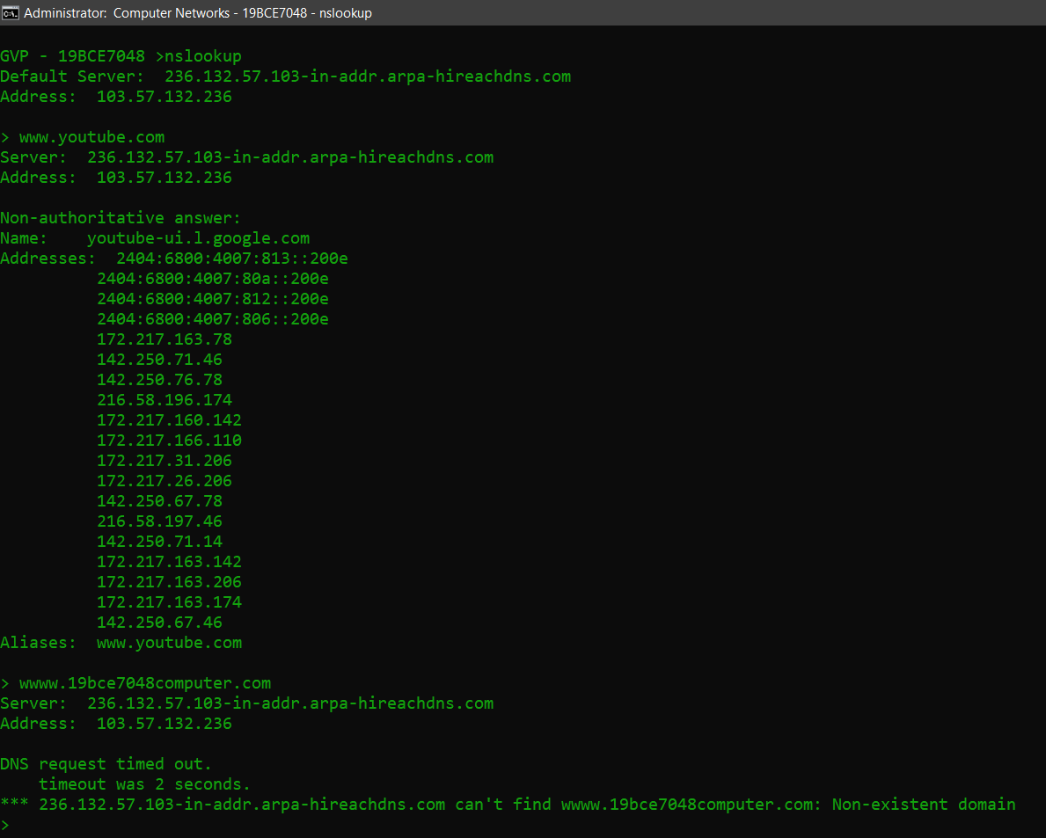

**9. netstat -a :**

**netstat** command is used to show network status. Displays all connections and listening ports.

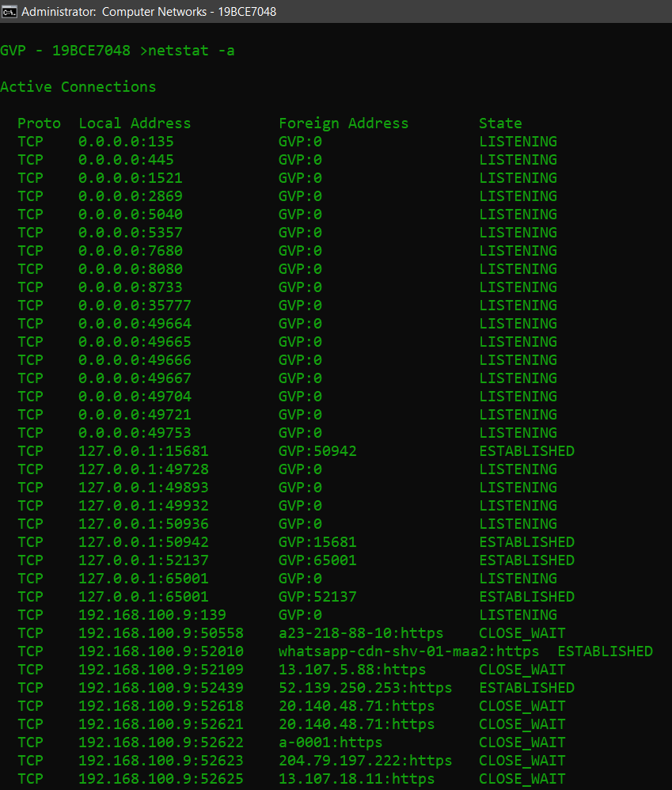

**10. netstat -r :**

Displays the routing table.

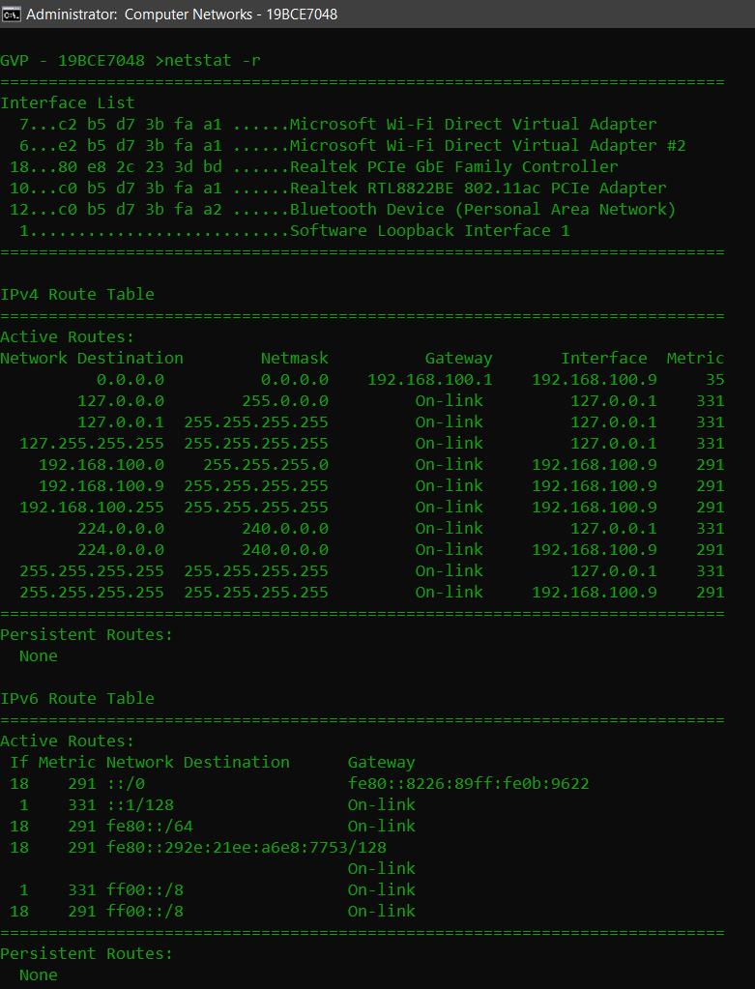

**11. hostname :**

**hostname** command is used to view or change a system's domain and hostname

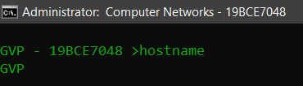

**12. arp :**

**arp** displays and modifies entries in the Address Resolution Protocol (ARP) cache. Displays current ARP entries by interrogating the current protocol data.

