

**CSE3003 : Computer Networks**

**Name :** Gudi Varaprasad

**Reg. No. :** 19BCE7048

School of Computer Science and Engineering

**Lab Slot :** L39 + L40

**Date :** 26-04-2021

**Submitted to :** . Dr. R. Nandha Kumar sir

**Ex.No : 10 - SUBNETTING THROUGH IPV4 ADDRESSING**

**Date : 26-04-2021**

Subnetting is the process of taking a network and splitting it into smaller networks, known as subnets. It's used to free up more public IPv4 addresses and segment networks for security and easier management. IPv4 allows for a variation of the network and host segments of an IP address, known as subnetting, can be used to physically and logically design a network. Subnetwork addresses enhance local routing capabilities, while reducing the number of network addresses required.

To illustrate this, let us consider the following :

**1. Scenario :**Our Campus VIT-AP has the following departments and we need to configure the subnetting for them. We need to assign near by range of Class less address in order to make use of things more efficiently and not wasting the IP addresses. Let us assume that,

* Department CSE has **240** systems.
* Department ECE has **90** systems.
* Department MECH has **60** systems.
* Department VSB has **25** systems.
* and VIT-AP IP address of the original network: **192.168.1.0**

**2. Calculation of required addresses :**

|  |  |  |  |  |
| --- | --- | --- | --- | --- |
| **Type \ Department** | **CSE** | **ECE** | **MECH** | **VSB** |
| **Total Systems** | 240 | 90 | 60 | 25 |
| **Subnet mask bits** | 24 | 25 | 26 | 27 |
| **Subnet representation** | 192.168.1.0/24 | 192.168.2.0/25 | 192.168.2.128/26 | 192.168.2.192/27 |
| **IP address** | 192.168.1.0 | 192.168.2.0 | 192.168.2.128 | 192.168.2.192 |
| **Subnet mask** | 255.255.255.0 | 255.255.255.128 | 255.255.255.192 | 255.255.255.224 |
| **Subnet binary** | 11111111 11111111 11111111 00000000 | 11111111 11111111 11111111 **1**0000000 | 11111111 11111111 11111111 **11**000000 | 11111111 11111111 11111111 **111**00000 |
| **First Host IP** | 192.168.1.1 | 192.168.2.1 | 192.168.2.129 | 192.168.2.193 |
| **Last Host IP** | 192.168.1.254 | 192.168.2.126 | 192.168.2.190 | 192.168.2.223 |

**CSE →** **192.168.1.0** : (**192.168.1.0** to **192.168.1.255**)

**ECE →** **192.168.2.0** : (**192.168.2.0** to **192.168.2.127**)

**MECH →** **192.168.2.128** : (**192.168.2.128** to **192.168.2.191**)

**VSB → 192.168.2.192** : (**192.168.2.192** to **192.168.2.223**)

**3. Build the network topology :**

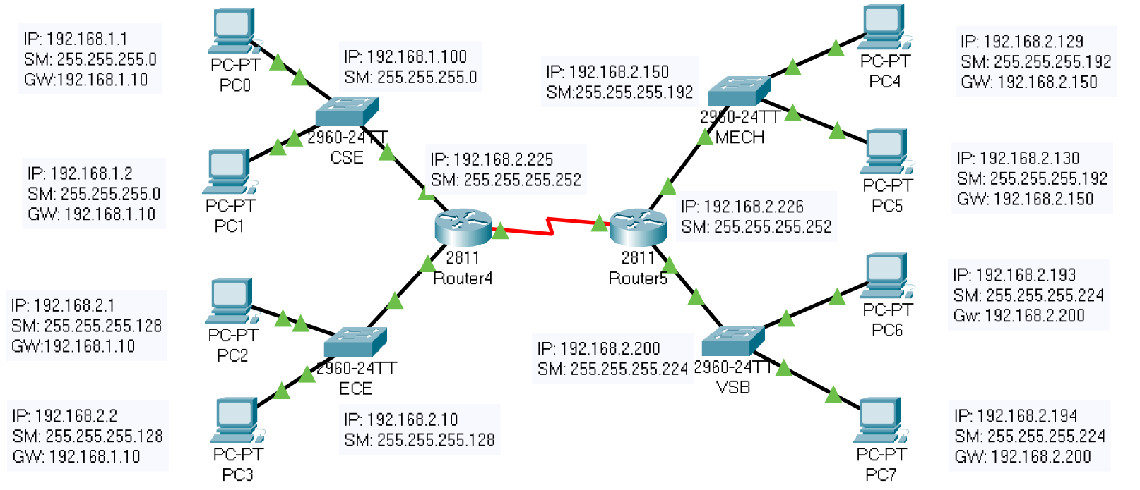

**4.** On the router4, configure **interface fa0/0** to act as the default gateway for our LAN.

Router>enable

Router#

Router#configure terminal

Enter configuration commands, one per line. End with CNTL/Z.

Router(config)#interface FastEthernet0/0

Router(config-if)#ip address

% Incomplete command.

Router(config-if)#

Router(config-if)#exit

Router(config)#interface FastEthernet0/0

Router(config-if)#no ip address

Router(config-if)#no ip address

Router(config-if)#ip address 192.168.1.10 255.255.255.0

Router(config-if)#ip address 192.168.1.10 255.255.255.0

Router(config-if)#

Router(config-if)#exit

Router(config)#interface FastEthernet0/1

Router(config-if)#ip address 192.168.2.10 255.255.255.0

Router(config-if)#no ip address

Router(config-if)#

Router(config-if)#exit

Router(config)#interface FastEthernet0/0

Router(config-if)#no shutdown

Router(config-if)#

%LINK-5-CHANGED: Interface FastEthernet0/0, changed state to up

%LINEPROTO-5-UPDOWN: Line protocol on Interface FastEthernet0/0, changed state to up

Router(config-if)#exit

Router(config)#interface FastEthernet0/1

Router(config-if)#ip address 192.168.2.10 255.255.255.0

Router(config-if)#ip address 192.168.2.10 255.255.255.128

Router(config-if)#no shutdown

Router(config-if)#

%LINK-5-CHANGED: Interface FastEthernet0/1, changed state to up

%LINEPROTO-5-UPDOWN: Line protocol on Interface FastEthernet0/1, changed state to up

%IP-4-DUPADDR: Duplicate address 192.168.1.10 on FastEthernet0/0, sourced by 000A.41A0.E150

%IP-4-DUPADDR: Duplicate address 192.168.1.10 on FastEthernet0/0, sourced by 000A.41A0.E150

Router con0 is now available

Press RETURN to get started.

Router(vlan)#

%SYS-5-CONFIG_I: Configured from console by console

Router(vlan)#exit

APPLY completed.

Exiting....

Router#vlan database

% Warning: It is recommended to configure VLAN from config mode,

as VLAN database mode is being deprecated. Please consult user

documentation for configuring VTP/VLAN in config mode.

Router(vlan)#

Router(vlan)#exit

APPLY completed.

Exiting....

Router#configure terminal

Enter configuration commands, one per line. End with CNTL/Z.

Router(config)#interface FastEthernet0/0

Router(config-if)#

Router(config-if)#exit

Router(config)#interface Serial0/3/0

Router(config-if)#ip address 192.168.2.225 255.255.255.128

Router(config-if)#ip address 192.168.2.225 255.255.255.252

Router(config-if)#no shutdown

Router(config-if)#

%LINK-5-CHANGED: Interface Serial0/3/0, changed state to up

%LINEPROTO-5-UPDOWN: Line protocol on Interface Serial0/3/0, changed state to up

Router(config-if)#exit

Router(config)#

Router(config)#ip route 192.168.2.128 255.255.255.192 192.168.2.226

Router(config)#ip route 192.168.2.128 255.255.255.224 192.168.2.226

Router(config)#

Router#

%SYS-5-CONFIG_I: Configured from console by console

Router#

**5.** On the router5, configure **interface fa0/1** to act as the default gateway for our LAN.

Router>enable

Router#

Router#configure terminal

Enter configuration commands, one per line. End with CNTL/Z.

Router(config)#interface FastEthernet0/0

Router(config-if)#ip address 192.168.2.150 255.255.255.0

Router(config-if)#ip address 192.168.2.150 255.255.255.192

Router(config-if)#no shutdown

Router(config-if)#

%LINK-5-CHANGED: Interface FastEthernet0/0, changed state to up

%LINEPROTO-5-UPDOWN: Line protocol on Interface FastEthernet0/0, changed state to up

Router(config-if)#exit

Router(config)#interface FastEthernet0/1

Router(config-if)#ip address 192.168.2.200 255.255.255.192

Router(config-if)#ip address 192.168.2.200 255.255.255.224

Router(config-if)#no shutdown

Router(config-if)#

%LINK-5-CHANGED: Interface FastEthernet0/1, changed state to up

%LINEPROTO-5-UPDOWN: Line protocol on Interface FastEthernet0/1, changed state to up

Router con0 is now available

Press RETURN to get started.

Router>enable

Router#

Router#configure terminal

Enter configuration commands, one per line. End with CNTL/Z.

Router(config)#interface Serial0/3/0

Router(config-if)#ip address 192.168.2.226 255.255.255.224

Router(config-if)#ip address 192.168.2.226 255.255.255.252

Router(config-if)#no shutdown

Router(config-if)#

%LINK-5-CHANGED: Interface Serial0/3/0, changed state to up

%LINEPROTO-5-UPDOWN: Line protocol on Interface Serial0/3/0, changed state to up

Router(config-if)#exit

Router(config)#

Router(config)#ip route 192.168.1.0 255.255.255.0 192.168.2.225

Router(config)#ip route 192.168.2.0 255.255.255.128 192.168.2.225

Router(config)#

Router con0 is now available

Press RETURN to get started.

**5.** Verifying from PC0 :

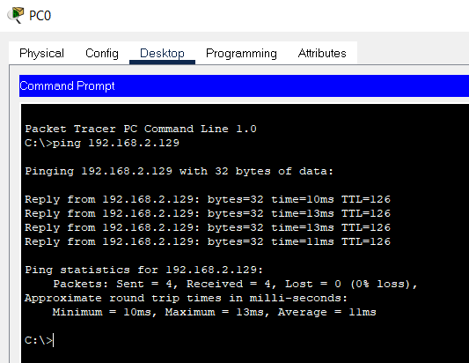

**6.** Before configuring and giving address to routers / Before Subnetting :

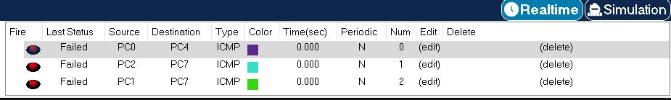

**7.** After configuring and giving address to routers / After Subnetting : **Output**

