**Name: Nikhilesh Gunnam**

**Reg. No: 19BCE7274**

**Slot: L39 + L40**

**SUBNETTING THROUGH IPV4 ADDRESSING**

|  |  |  |  |  |  |  |  |  |  |
| --- | --- | --- | --- | --- | --- | --- | --- | --- | --- |
| **512** | **256** | **128** | **64** | **32** | **16** | **8** | **4** | **2** | **1** |
| **2^9** | **2^8** | **2^7** | **2^6** | **2^5** | **2^4** | **2^3** | **2^2** | **2^1** | **2^0** |

CSE – 240

ECE – 90

MECH – 60

VSB – 25

VIT-AP IP Address of the original network: 192.168.1.0

**CSE Department required 240_IP** CSE-> 192.168.1.0-(192.168.1.0-192.168.1.255)

All the IP’s are power of 2 ECE-> 192.168.2.0-(192.168.2.0-192.168.2.127)

Near range IP are 2^8 = 256 MECH-> 192.168.2.128-(192.168.2.128-192.168.2.191)

32-8 = 24(24 ones and 8 zeros) VSB-> 192.168.2.192-(192.168.2.192-192.168.2.223)

So, Subnet mask has 24 bits represented as:

192.168.1.0/24

IP: 192.168.1.0

Subnet mask: 255.255.255.0

Subnet mask: 11111111 11111111 11111111 00000000

First HOST_IP: 192.168.1.1

Last HOST_IP: 192.168.1.254

**ECE Department required 90_IP**

All the IP’s are power of 2

Near range of IP are 2^7 = 128

32-7 = 25 (25 ones and 7 zeros)

So, Subnet mask has 25 bits represented as:

192.168.2.0/25

IP: 192.168.2.0

Subnet mask: 255.255.255.128

Subnet mask: 11111111 11111111 11111111 10000000

First HOST_IP: 192.168.2.1

Last HOST_IP: 192.168.2.126

**MECH Department required 60_IP**

All the IP’s are power of 2

Near range of IP are 2^6 = 64

32-6 = 26(26 ones and 6 zeros)

So, Subnet mask has 26 bits represented as:

192.168.2.128/26

IP: 192.168.2.128

Subnet mask: 255.255.255.192

Subnet mask: 11111111 11111111 11111111 11000000

First HOST_IP: 192.168.2.129

Last HOST_IP: 192.168.2.190

**VSB Department required 25_IP**

All the IP’s are power of 2

Near range of IP are 2^5 =32

32-5= 27(27 ones and 5 zeros)

So, Subnet mask has 27 bits represented as:

192.168.2.192/27

IP: 192.168.2.192

Subnet mask: 255.255.255.224

Subnet mask: 11111111 11111111 11111111 11100000

First HOST_IP: 192.168.2.193

Last HOST_IP: 192.168.2.223

**OUTPUT:**

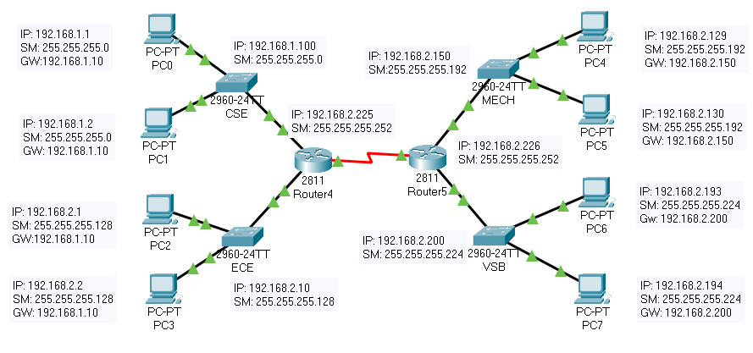

**ROUTER 1 SETUP:**

Router>enable

Router#

Router#configure terminal

Enter configuration commands, one per line. End with CNTL/Z.

Router(config)#interface FastEthernet0/0

Router(config-if)#ip address

% Incomplete command.

Router(config-if)#

Router(config-if)#exit

Router(config)#interface FastEthernet0/0

Router(config-if)#no ip address

Router(config-if)#no ip address

Router(config-if)#ip address 192.168.1.10 255.255.255.0

Router(config-if)#ip address 192.168.1.10 255.255.255.0

Router(config-if)#

Router(config-if)#exit

Router(config)#interface FastEthernet0/1

Router(config-if)#ip address 192.168.2.10 255.255.255.0

Router(config-if)#no ip address

Router(config-if)#

Router(config-if)#exit

Router(config)#interface FastEthernet0/0

Router(config-if)#no shutdown

Router(config-if)#

%LINK-5-CHANGED: Interface FastEthernet0/0, changed state to up

%LINEPROTO-5-UPDOWN: Line protocol on Interface FastEthernet0/0, changed state to up

Router(config-if)#exit

Router(config)#interface FastEthernet0/1

Router(config-if)#ip address 192.168.2.10 255.255.255.0

Router(config-if)#ip address 192.168.2.10 255.255.255.128

Router(config-if)#no shutdown

Router(config-if)#

%LINK-5-CHANGED: Interface FastEthernet0/1, changed state to up

%LINEPROTO-5-UPDOWN: Line protocol on Interface FastEthernet0/1, changed state to up

%IP-4-DUPADDR: Duplicate address 192.168.1.10 on FastEthernet0/0, sourced by 000A.41A0.E150

%IP-4-DUPADDR: Duplicate address 192.168.1.10 on FastEthernet0/0, sourced by 000A.41A0.E150

Router con0 is now available

Press RETURN to get started.

Router(vlan)#

%SYS-5-CONFIG_I: Configured from console by console

Router(vlan)#exit

APPLY completed.

Exiting....

Router#vlan database

% Warning: It is recommended to configure VLAN from config mode,

as VLAN database mode is being deprecated. Please consult user

documentation for configuring VTP/VLAN in config mode.

Router(vlan)#

Router(vlan)#exit

APPLY completed.

Exiting....

Router#configure terminal

Enter configuration commands, one per line. End with CNTL/Z.

Router(config)#interface FastEthernet0/0

Router(config-if)#

Router(config-if)#exit

Router(config)#interface Serial0/3/0

Router(config-if)#ip address 192.168.2.225 255.255.255.128

Router(config-if)#ip address 192.168.2.225 255.255.255.252

Router(config-if)#no shutdown

Router(config-if)#

%LINK-5-CHANGED: Interface Serial0/3/0, changed state to up

%LINEPROTO-5-UPDOWN: Line protocol on Interface Serial0/3/0, changed state to up

Router(config-if)#exit

Router(config)#

Router(config)#ip route 192.168.2.128 255.255.255.192 192.168.2.226

Router(config)#ip route 192.168.2.128 255.255.255.224 192.168.2.226

Router(config)#

Router#

%SYS-5-CONFIG_I: Configured from console by console

Router#

**ROUTER 2 SETUP:**

Router>enable

Router#

Router#configure terminal

Enter configuration commands, one per line. End with CNTL/Z.

Router(config)#interface FastEthernet0/0

Router(config-if)#ip address 192.168.2.150 255.255.255.0

Router(config-if)#ip address 192.168.2.150 255.255.255.192

Router(config-if)#no shutdown

Router(config-if)#

%LINK-5-CHANGED: Interface FastEthernet0/0, changed state to up

%LINEPROTO-5-UPDOWN: Line protocol on Interface FastEthernet0/0, changed state to up

Router(config-if)#exit

Router(config)#interface FastEthernet0/1

Router(config-if)#ip address 192.168.2.200 255.255.255.192

Router(config-if)#ip address 192.168.2.200 255.255.255.224

Router(config-if)#no shutdown

Router(config-if)#

%LINK-5-CHANGED: Interface FastEthernet0/1, changed state to up

%LINEPROTO-5-UPDOWN: Line protocol on Interface FastEthernet0/1, changed state to up

Router con0 is now available

Press RETURN to get started.

Router>enable

Router#

Router#configure terminal

Enter configuration commands, one per line. End with CNTL/Z.

Router(config)#interface Serial0/3/0

Router(config-if)#ip address 192.168.2.226 255.255.255.224

Router(config-if)#ip address 192.168.2.226 255.255.255.252

Router(config-if)#no shutdown

Router(config-if)#

%LINK-5-CHANGED: Interface Serial0/3/0, changed state to up

%LINEPROTO-5-UPDOWN: Line protocol on Interface Serial0/3/0, changed state to up

Router(config-if)#exit

Router(config)#

Router(config)#ip route 192.168.1.0 255.255.255.0 192.168.2.225

Router(config)#ip route 192.168.2.0 255.255.255.128 192.168.2.225

Router(config)#

Router con0 is now available

Press RETURN to get started.

**COMMAND PROMPT FOR PC0:**

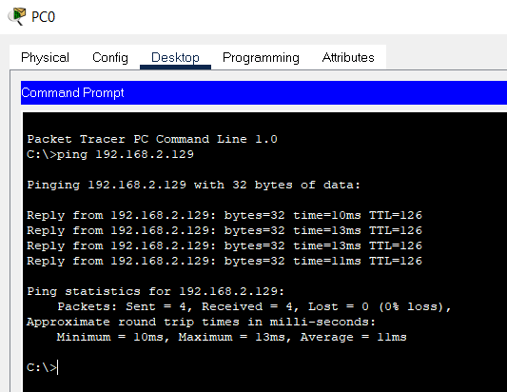

**FINAL OUTPUT:**

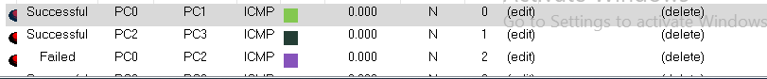 

**After giving address for routers:**

