

**CSE3003 : Computer Networks**

**Name :** Gudi Varaprasad

**Reg. No. :** 19BCE7048

School of Computer Science and Engineering

**Lab Slot :** L39 + L40

**Date :** 17 – 05 – 2021

**Submitted to :** . Dr. R. Nandha Kumar sir

**Ex.No: 11 DHCP Configuration**

**Date : 17-05-2021**

DHCP stands for Dynamic Host Configuration Protocol. When a host (DHCP client) needs an IP configuration, it connects to a DHCP server and requests for an IP configuration. A DHCP server contains several pre-configured IP configurations. When it receives a DHCP request from a DHCP client, it provides an IP configuration to the client from all available IP configurations.  
  
In this lab, I configured a DHCP server both on a router and on a generic server in Cisco Packet Tracer.

**1. Build the network topology :**

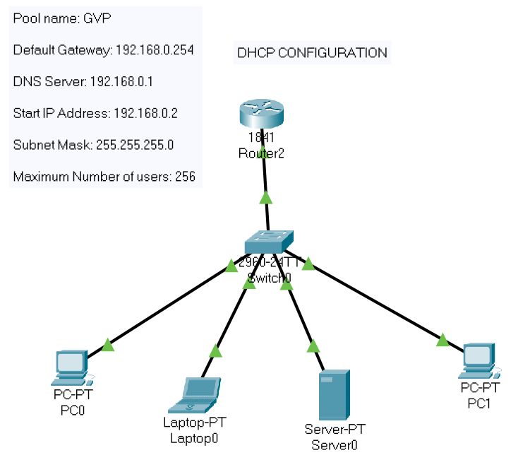

**2.** On the router, configure **interface fa0/0** to act as the default gateway for our LAN.

Router>enable

Router#config terminal

Router(config)#int fa0/0

Router(config-if)#ip add 192.168.0.1 255.255.255.0

Router(config-if)#no shutdown

Router(config-if)#exit

**3.** Configure DHCP server on the Router. In the server we will define a **DHCP pool** of IP addresses to be assigned to hosts, a **Default gateway**  for the LAN and a **DNS Server**.

Router(config)#

Router(config)#ip dhcp pool GVP

Router(dhcp-config)#network 192.168.0.0 255.255.255.0

Router(dhcp-config)#default-router 192.168.0.254

Router(dhcp-config)#dns-server 192.168.0.1

Router(dhcp-config)#exit

Router(config)#exit

Router#write memory

Building configuration…

[OK]

Router#

**4.** Now go to every PC and on their **IP configuration** tabs, enable **DHCP**. Every PC should be able to obtain an IP address, default gateway and DNS server, as defined in step 2.

For example, to enable DHCP on PC1:

Click **PC1->Desktop->IP configuration**. Then enable DHCP :

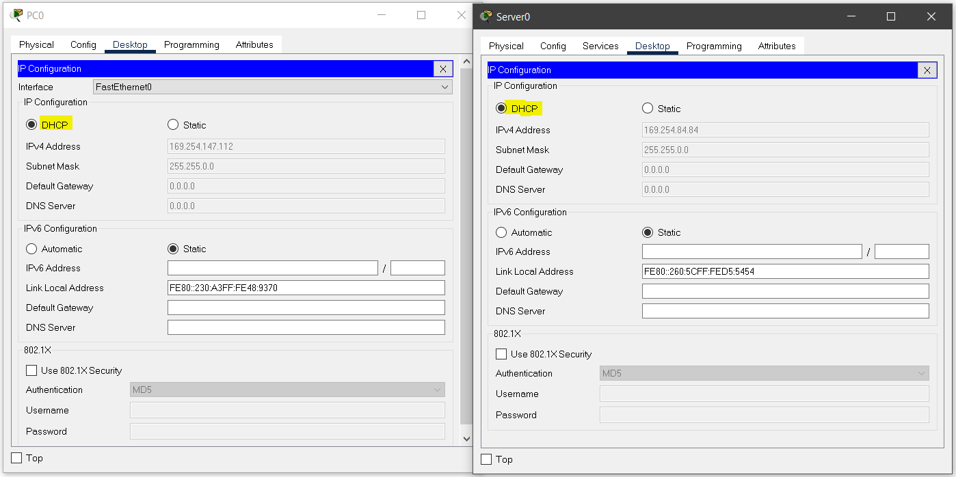

**5.** Creating and configuring **DHCP Server :**

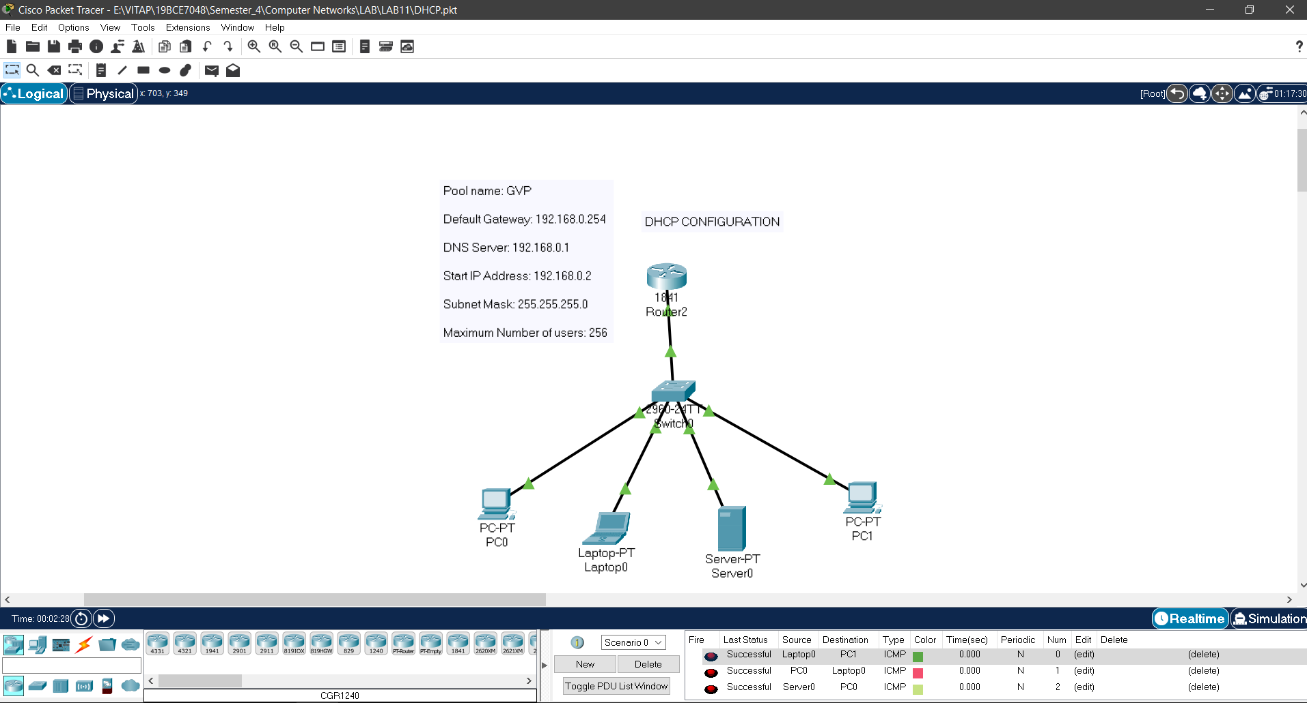

In the above picture, you can observe that the packets are sent from different desktops and status is successful. This is how to configure DHCP Server that pre-configures IP.