

**CSE3003 : Computer Networks**

**Name :** Gudi Varaprasad

**Reg. No. :** 19BCE7048

School of Computer Science and Engineering

**Lab Slot :** L39 + L40

**Date :** 17 – 05 – 2021

**Submitted to :** . Dr. R. Nandha Kumar sir

**Ex.No: 12 CONFIGURATION OF HTTP, DHCP AND DNS Server**

**Date : 17-05-2021**

**1. Build the network topology :**

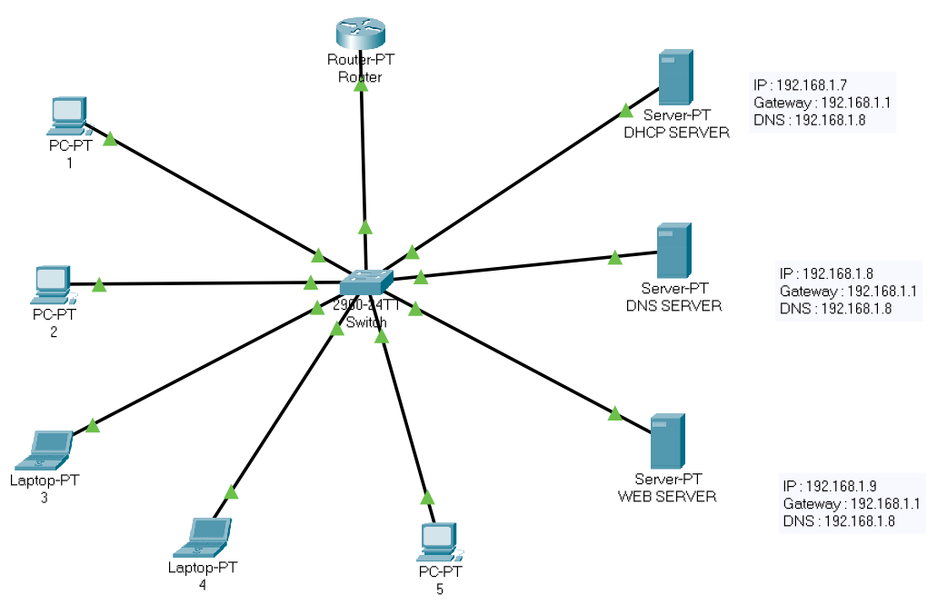

**2. Configuring Router :**

Router>enable

Router#

Router#configure terminal

Enter configuration commands, one per line. End with CNTL/Z.

Router(config)#interface FastEthernet0/0

Router(config-if)#no ip address

Router(config-if)#ip address 192.168.0.1 255.255.255.0

Router(config-if)#ip address 192.168.0.1 255.255.255.0

Router(config-if)#ip address 192.168.1.1 255.255.255.0

Router(config-if)#ip address 192.168.1.1 255.255.255.0

Router(config-if)#no shutdown

Router(config-if)#

%LINK-5-CHANGED: Interface FastEthernet0/0, changed state to up

%LINEPROTO-5-UPDOWN: Line protocol on Interface FastEthernet0/0, changed state to up

Router(config-if)#

Router(config-if)#EXIT

Router(config)#ip dhcp pool GVP-NETWORK

Router(dhcp-config)#network 192.168.1.0 255.255.255.0

Router(dhcp-config)#default-router 192.168.1.1

Router(dhcp-config)#exit

Router(config)#exit

Router#

**3. DHCP Server Configuration :**

When you deploy Dynamic Host Configuration Protocol (DHCP) servers on your network, you can automatically provide client computers and other TCP/IP-based network devices with valid IP addresses. You can also provide the additional configuration parameters these clients and devices need, called DHCP options, that allow them to connect to other network resources, such as DNS servers, and routers.

IP : 192.168.1.7 Default Gateway : 192.168.1.1 DNS : 192.168.1.8

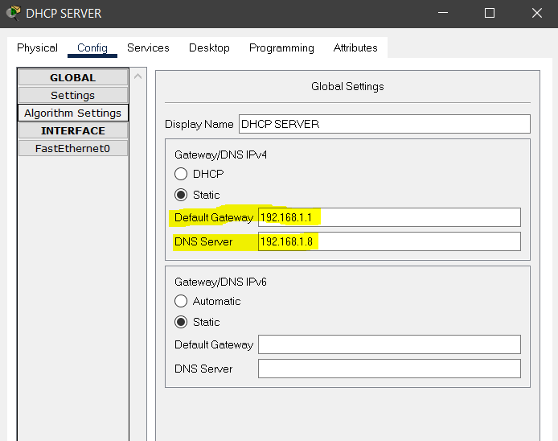 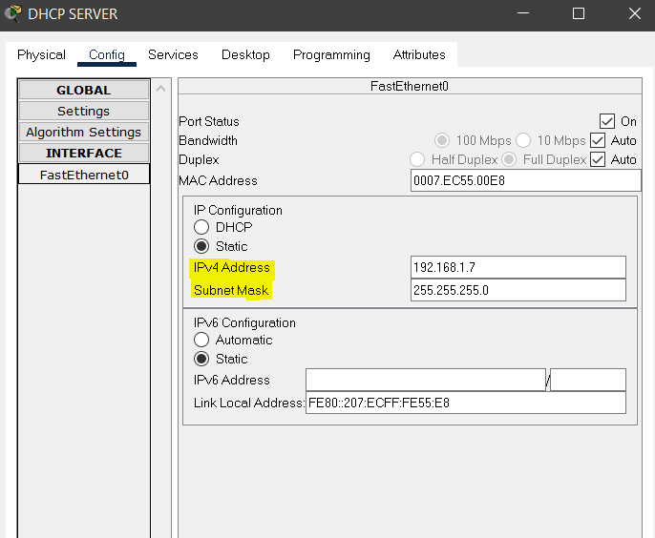

**4. DNS Server Configuration :**

Domain Name System (DNS) is the name resolution protocol for TCP/IP networks, such as the Internet. Client computers query a DNS server to resolve memorable, alphanumeric DNS names to the IP addresses that computers use to communicate with each other.

IP : 192.168.1.8 Default Gateway : 192.168.1.1 DNS : 192.168.1.8

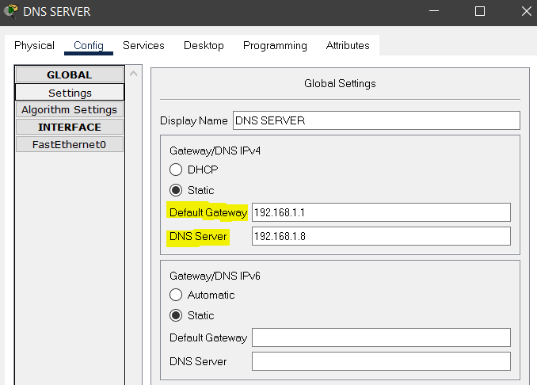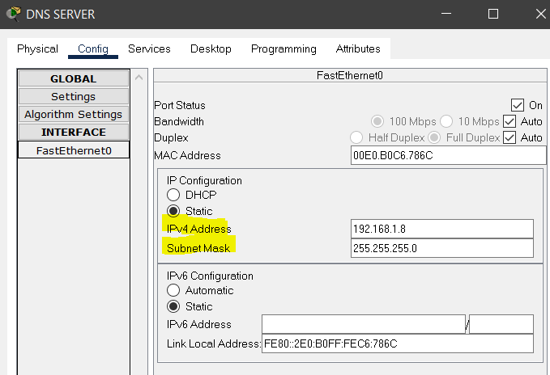

**5. Web Server Configuration :**

Short for Hyper Text Transfer Protocol, the underlying protocol used by the World Wide Web. HTTP defines how messages are formatted and transmitted, and what actions Web servers and browsers should take in response to various commands. For example, when you enter a URL in your browser, this actually sends an HTTP command to the Web server directing it to fetch and transmit the requested Web page.

IP : 192.168.1.9 Default Gateway : 192.168.1.1 DNS : 192.168.1.8

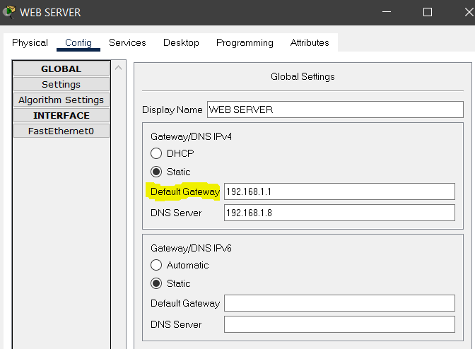 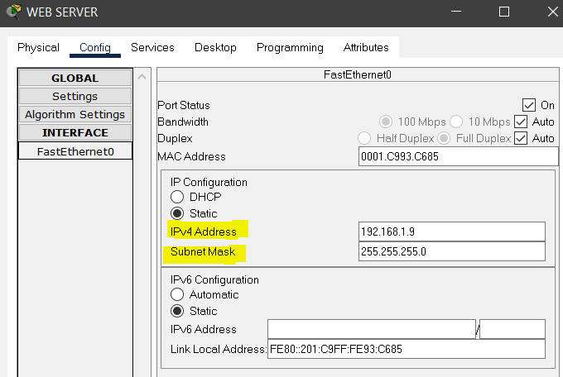

**6. Creating a new html page in Webserver and setting up in DNS :**

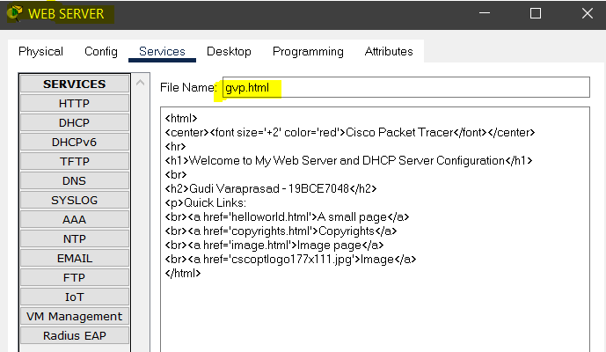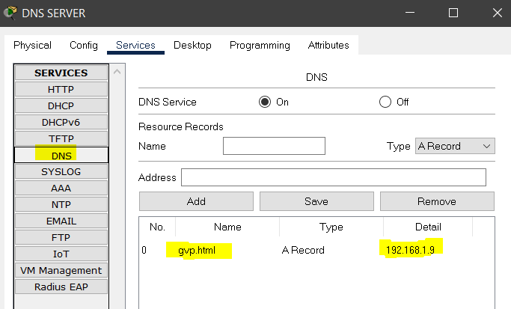

Configuring the page setting up it in DNS

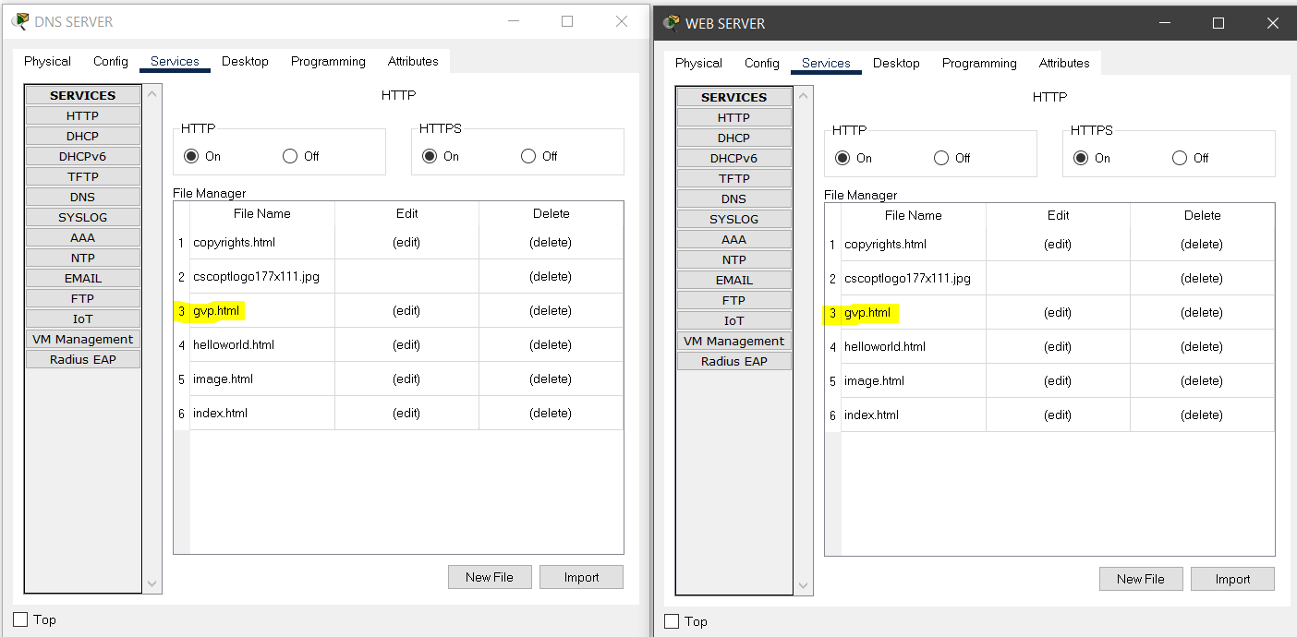

Checking the webpages configured in both DNS Server and Web Server Services tab

**7. Opening the webpage :**

Now, navigate to any of the **PC -> Desktop -> Web Browser**. In the URL bar, enter the IP address of the Web Server (192.168.1.9) or the DNS Server (192.168.1.8) to view the created web pages. Navigate to the configured files using the URLs and view them. The below picture depicts how the view looks when navigated from PC 3.

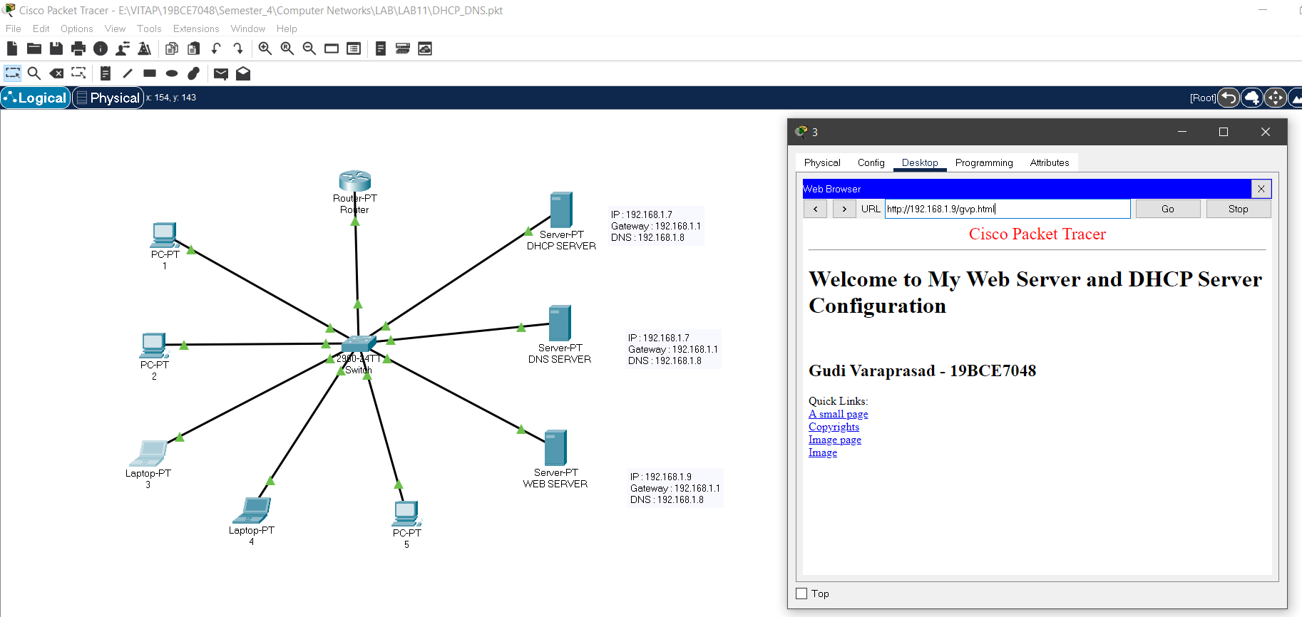

**8. Accessing gvp.html page from various computer :**

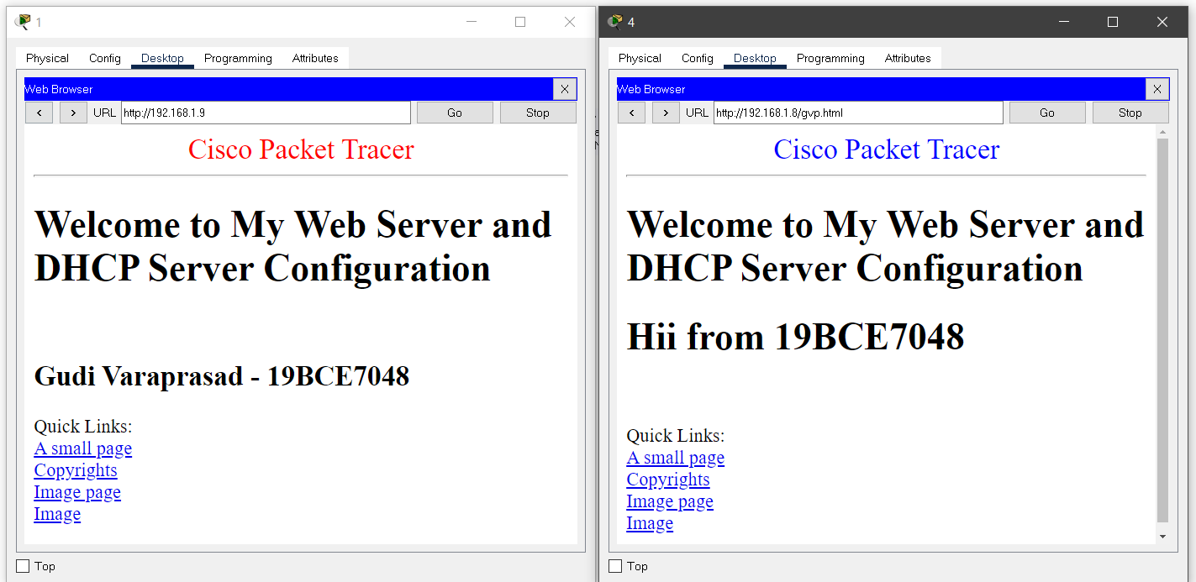

This is by requesting Web Page This is by requesting Web Page

from Web Server 192.168.1.9 in desktop 1 from DNS Server 192.168.1.8 in desktop 4