

**CSE3003 : Computer Networks**

**Name :** Gudi Varaprasad

**Reg. No. :** 19BCE7048

School of Computer Science and Engineering

**Lab Slot :** L39 + L40

**Date :** 10 – 02 – 2021

**Submitted to :** . Dr. R. Nandha Kumar sir

**LAB 2 : Answer the following Questions**

**Date : 10-02-2021**

**Q1. What are the types of address you know ? Write few words about it.**

**Answer :**

**Physical Address –** MAC Address : It is a hardware level address embedded in the network card of a device by the manufacturer. Most of the Local Area networks use a 48-bit physical address written as 12-bit hexadecimal bits. **Example :** 00:1A:C2:7B:00:47

**Logical Address –** IP Address : It is an address used to identify different computers/devices that are inter connected on internet. It is a 32-bit address in dotted decimal notation. **Example :** 192.168.100.9

**Port Address -** A port number is the logical address of each application or process that uses a network or the Internet to communicate. A port number uniquely identifies a network-based application on a computer. This number is assigned automatically by the OS, manually by the user or is set as a default for some popular applications. It is 16-bit in length. **Example :** HTTP : 80 ; FTP : 21

**The Physical address (MAC) will change from device to device but the Logical (IP) address and Port address will remain same.**

**Application specific address -** Some applications have user-friendly addresses that are designed for that specific application. **Example :** [varaprasad.19bce7048@vitap.ac.in](mailto:varaprasad.19bce7048@vitap.ac.in) ; URL : www. vitap.ac.in

**Q2. What are host names ?**

A hostname is a label that identifies a hardware device, or host, on a network. Hostnames are used in both local networks (LANs) as well as wide area networks like the Internet. The entire hostname, including the delimiting dots, has a maximum of 253 ASCII characters. The syntax to find your Host name is ***hostname.***

**Q3. What is your hostname ?**

**Answer :** My Host name is **GVP**

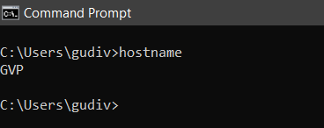

**Q4. What is your IP Address and MAC Address ?**

**Answer :** using command **ipconfig/all**

**IP Address :** 192.168.100.1

**MAC Address :** 80-E8-2C-23-3D-BD

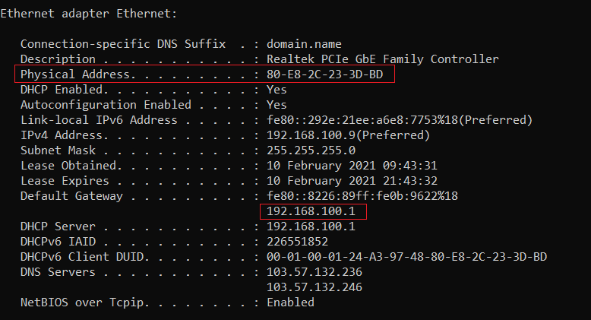

**Q5. Change your Command Prompt to your regno. (use commands)**

**Answer :** use the command **PROMPT <text>**

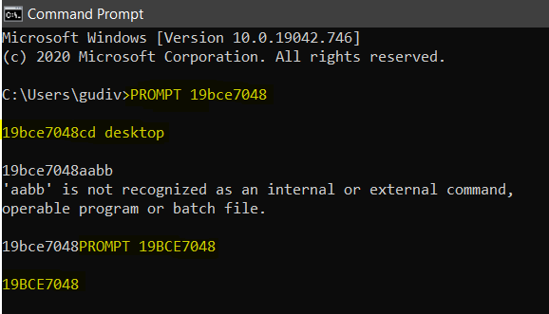

**Q6. Display your Command Prompt.**

**Answer :**

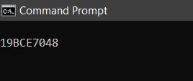

**Q7. What do you mean by Port number ?**

**Answer :**

A port is a communication endpoint. A port number is always associated with an IP address of a host and the type of transport protocol used for communication. It completes

the destination or origination network address of a message. The most common transport protocols that use port numbers are the Transmission Control Protocol (TCP) and the User Datagram Protocol (UDP).

**Q8. How many ports are there ?**

**Answer :**

A port number is a 16-bit unsigned integer, thus ranging from 0 to 65535 **( Total = 65536 ports )**.

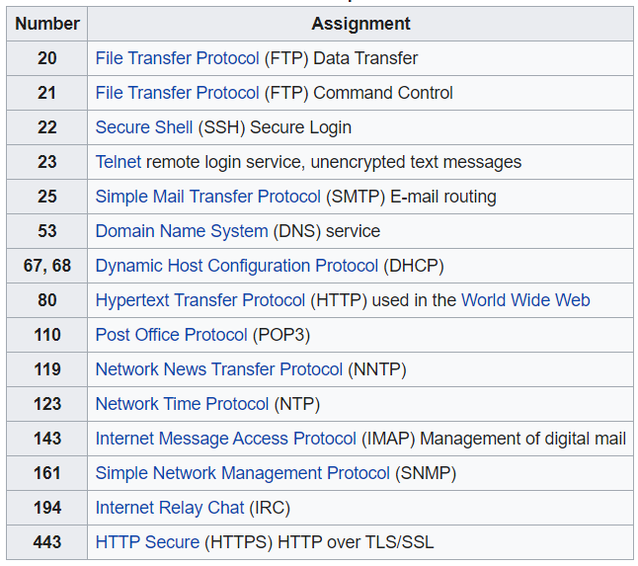

The registered ports are those from 1024 through 49151. IANA maintains the official list of well-known and registered ranges. The dynamic or private ports are those from 49152 through 65535.

**Q9. Differentiate between client and server ?**

**Answer :**

|  |  |  |
| --- | --- | --- |
| **S.No.** | **Client** | **Server** |
| **1** | A client is a device that requires services via the web/internet. | A device or program that responds to the requests of the clients. |
| **2** | A client requests the server for content or service function. | Server provides functions or services to the clients when the client request for services. |
| **3** | **Example :** Desktops, Laptops, smartphones, tablets, web browsers | **Example :** Database servers, file servers, and web servers, etc.. |

**Q10. Determine your machine address.**

**Answer :**

Type **ipconfig /all** in the CMD. The Physical address associated is your Machine Address.

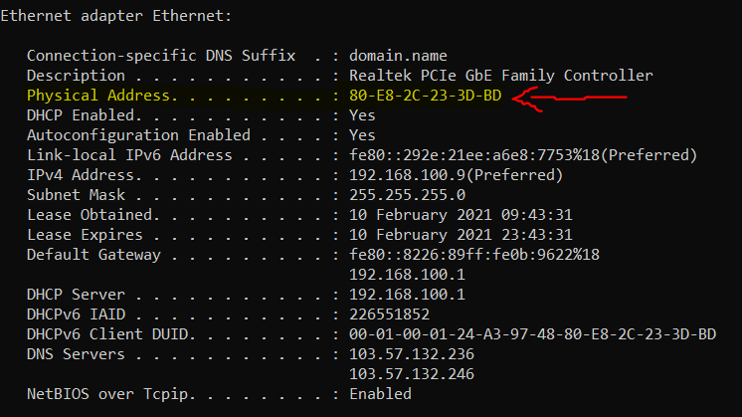

**Q11. Run *getmac* and write down what does it show.**

**Answer :**

***getmac*** is a windows command used to display the Media Access Control (MAC) addresses i.e., the Physical Address for each network adapter in the computer.

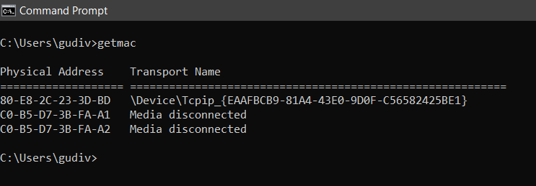

**Q12. What do you mean by socket ?**

**Answer :**

A network socket is a software structure within a network node of a computer network that serves as an endpoint for sending and receiving data across the network. The socket mechanism provides a means of inter-process communication (IPC) by establishing named contact points between which the communication take place.

**Q13. How many types of socket are there ? What are they ?**

**Answer :**

There are **four types of sockets** available to the users. The first two are most commonly used and the last two are rarely used.

Processes are presumed to communicate only between sockets of the same type but there is no restriction that prevents communication between sockets of different types.

**1. Stream Sockets –** If you send through the stream socket three items "X, Y, Z", they will arrive in the same order − "X, Y, Z". These sockets use TCP (Transmission Control Protocol) for data transmission.

**2. Datagram Sockets −** Delivery in a networked environment is not guaranteed. They're connectionless and use UDP (User Datagram Protocol) for data transmission.

**3. Raw Sockets −** These provide users access to the underlying communication protocols, which support socket abstractions. These sockets are normally datagram oriented.

**4. Sequenced Packet Sockets −** They are similar to a stream socket, with the exception that record boundaries are preserved. Sequenced-packet sockets allow the user to manipulate the Sequence Packet Protocol (SPP) or Internet Datagram Protocol (IDP) headers on a packet or a group of packets.

**Q14. Can you find out figure for socket ?**

**Answer :**

A socket is identified by: (Local IP, Local Port, Remote IP, Remote Port, IP Protocol (UDP/TCP/SCTP/etc.) And that's the information the OS uses to map the packets/data to the right handle/file descriptor of your program.  
  
**Q15. Write a small program to print your IP Address and Hostname.**

**Code :**

import java.net.*;

public class FindHostDetails {

public static void main(String[] args){

try{

InetAddress my_address = InetAddress.getLocalHost();

System.out.println("The IP address is : " + my_address.getHostAddress());

System.out.println("The host name is : " + my_address.getHostName());

}

catch (UnknownHostException e){

System.out.println( "Couldn't find the local address.");

}

}

}

**Output :**

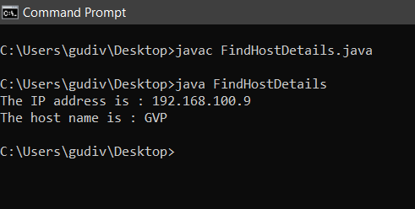

**Q16. Mention the class used to print IP Address and Hostname.**

**Answer :**A class named *FindHostDetails* contains the main function. In this main function, a ‘try’ and ‘catch’ block is defined. In the ‘try’ block, an instance of ***InetAddress***  is created and the **‘*getLocalHost’***  function is used to get the Host address and host name of the ***InetAddress*** instance. In case one of the attributes is not found, the ‘catch’ block defines catching the exception and printing the relevant message on the console.

**Q17. Write few points about the class and methods used in the class.**

**Answer :**

There are many ways to get the IP Address of a particular host. So, the method which helps to get the IP address for any Host is getHostAddress() of InetAddress class.

**Syntax :** public String getHostAddress()

**Returns :** It returns the raw IP address in a string format.

The following methods are used to get the Host Name :

**1. getHostName():** This function retrieves the standard hostname for the local computer.

**2. getHostByName():** This function retrieves host information corresponding to a hostname from a host database.  
  
**Q18. Write few classes you feel important for network programming.**

**Answer :**

The core Package **java.net** contains a number of classes that allow programmers to carry out network programming :

* **ContentHandler**
* **DatagramPacket**
* **DatagramSocket**
* **DatagramSocketImplHttpURLConnection**
* **InetAddress**
* **MulticastSocket**
* **ServerSocket**
* **Socket**
* **SocketImpl**
* **URL**
* **URLConnection**
* **URLEncoder**
* **URLStreamHandler**