

**CSE3003 : Computer Networks**

**Name :** Gudi Varaprasad

**Reg. No. :** 19BCE7048

School of Computer Science and Engineering

**Lab Slot :** L39 + L40

**Date :** 03 – 03 – 2021

**Submitted to :** . Dr. R. Nandha Kumar sir

**EX No 5 : Introduction to Packet Trace and Simple HUB**

**Date : 03 – 03 – 2021**

**Cisco Packet Tracer :**

Packet Tracer is a cross-platform visual simulation tool designed by Cisco Systems that allows users to create network topologies and imitate modern computer networks. The software allows users to simulate the configuration of Cisco routers and switches using a simulated command line interface.

**>** Download Link : [click here](https://archive.org/download/packet-tracer-800-build-212-mac-notarized/PacketTracer800_Build212_64bit_setup-signed.exe)

**Exploring Packet Tracer :**

**1. Network Devices :**

a) Routers :

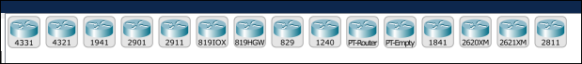

b) Switches :

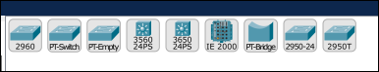

c) Hubs :



d) Wireless Devices :

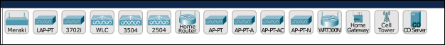

**2. End Devices :**

a) Devices :



b) Home Devices :



**3. Connections :**

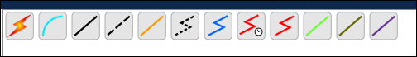

**Working with Packet Tracer :**

**1. Connecting two computers :**

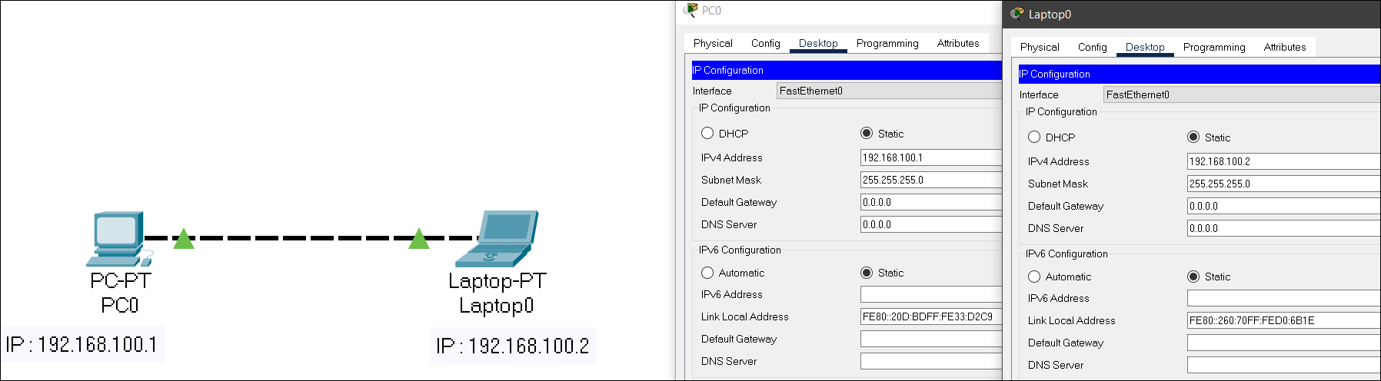

**Steps in Connecting the types :**

**1.** Open Cisco Packet Tracer and Open Networking Device Menu.

**2.** Select any two end devices of your choice.

**3.** Place them side by side in the workspace and click on connections tab.

**4.** Then select copper cross over cable since both are same type of devices and can able to understand digital communication.

**5.** Connect all the devices as shown in the above figure.

**6.** If we get a green triangular symbol, it indicates that there is no problem in the connection.

**7.** Open Device Settings 🡪 Device Settings Interface 🡪 Open Desktop Menu and Select IP Configuration.

**8.** Configure IP Address and Subnet Mask. You can use any IP address but make sure that all the IP addresses belong to the same class.

**9.** Open Device Settings 🡪 Device Settings Interface 🡪 Open Desktop Menu and Select Command Prompt.

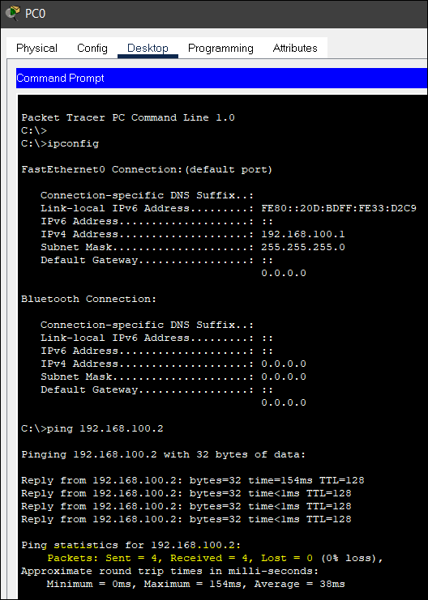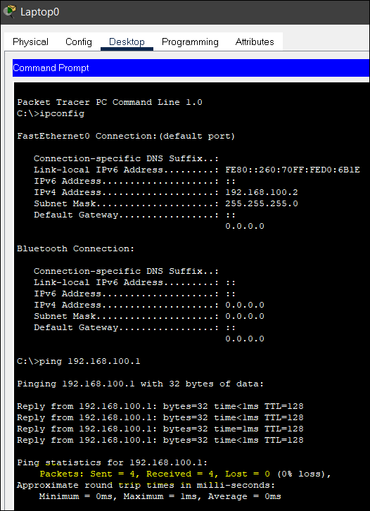

**2. Connecting the systems to a hub :**

A hub is a physical layer networking device which is used to connect multiple devices in a network. They are generally used to connect computers in a LAN. Hub is responsible to transmit the signal to port to respond wherever the signal was received.

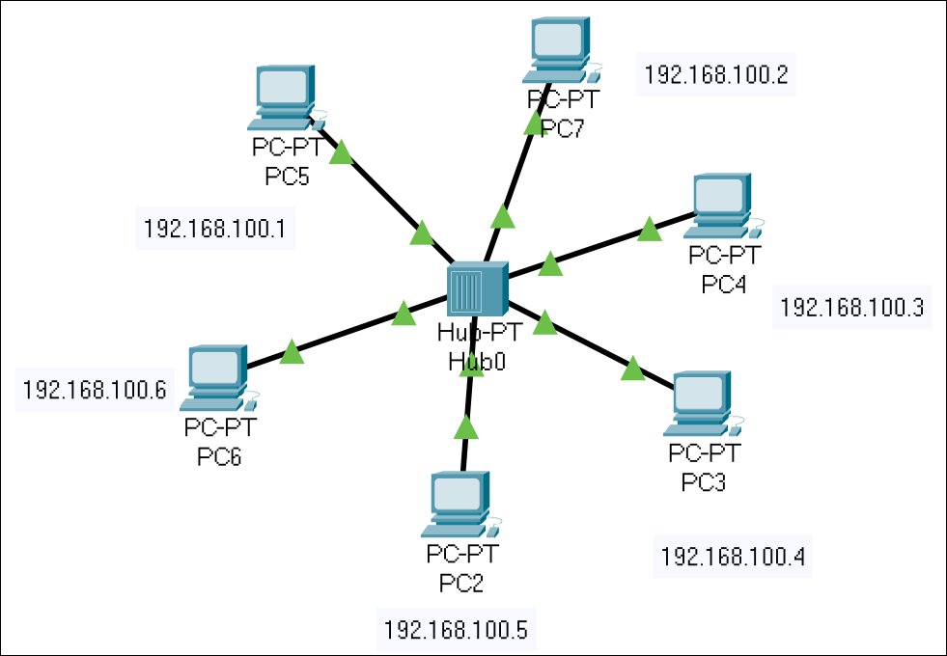

**Steps in Connecting the types :**

**1.** Open Cisco Packet Tracer and Open Networking Device Menu.

**2.** Select any 5 or 6 end devices of your choice and a hub (network devices tab)

**3.** Align them properly in the workspace and click on connections tab.

**4.** Then select copper straight-through cable since all are different type of devices and for same type of devices use copper cross over cable.

**5.** Connect all the devices in any topology and make sure that they are connected to a hub.

**6.** If we get a green triangular symbol, it indicates that there is no problem in the connection.

**7.** Open Device Settings 🡪 Device Settings Interface 🡪 Open Desktop Menu and Select IP Configuration.

**8.** Configure IP Address and Subnet Mask. You can use any IP address but make sure that all the IP addresses belong to the same class.

**9.** Open Device Settings 🡪 Device Settings Interface 🡪 Open Desktop Menu and Select Command Prompt and repeat the same process unlike previous exercise.

**10.** Now for testing the topology you built, Select Sample PDU to Initiate Testing.

**11.** Choose Message Sender and Drop Message PDU on Receiver.

**12.** Check and See Results in PDU List window and also go to simulations tab and run the simulation.

**13.** Before running the simulation, apply ACL filters and select only ICMP in order to test it once for one operation.

**14.** Similarly, all the hubs function in a network topology.

**15.** Below are the screenshots of function of a hub.

**Process how a Message works from sender to receiver : (Hub)**

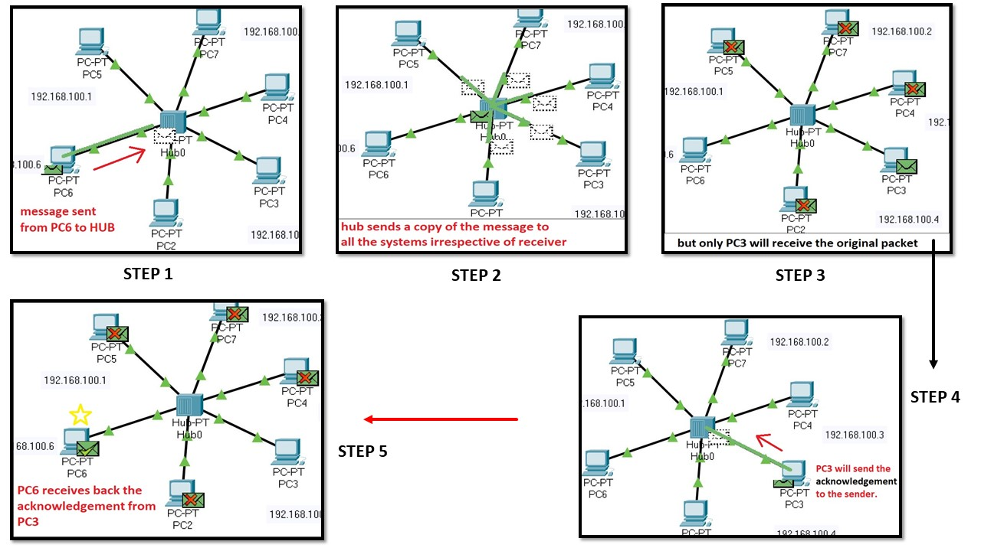

**Final Output :**

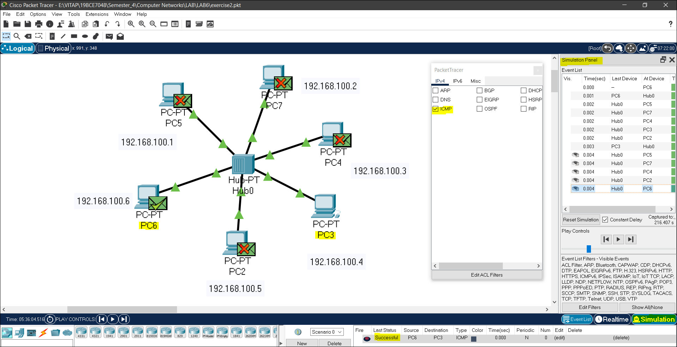

Testing on sending different packets :

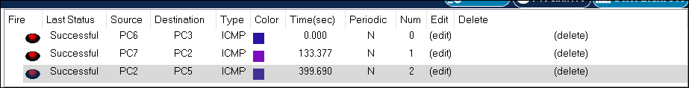

**3. Connecting the systems to a switch :**

A network switch is networking hardware that operates on datalink layer and connects devices on a computer network by using packet switching to receive and forward data to the destination device. Switch enable connection setting and terminating based on need.

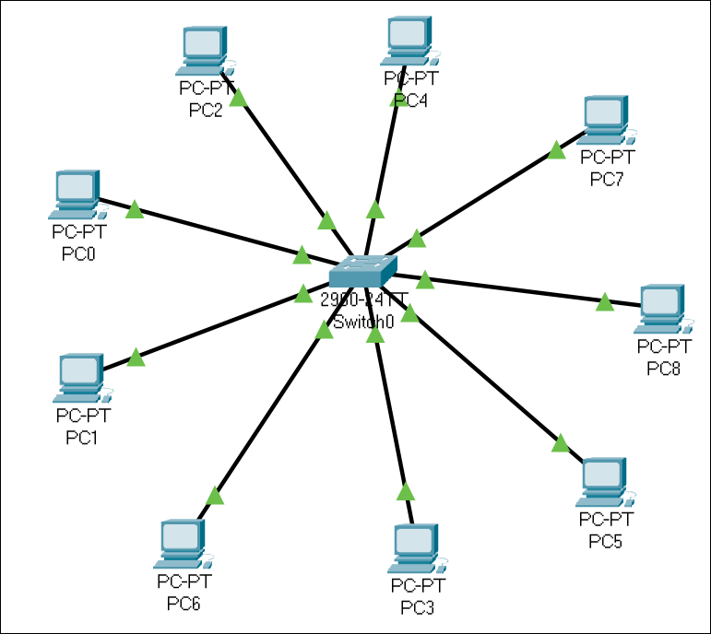

**Process how a Message works from sender to receiver : (Switch)**

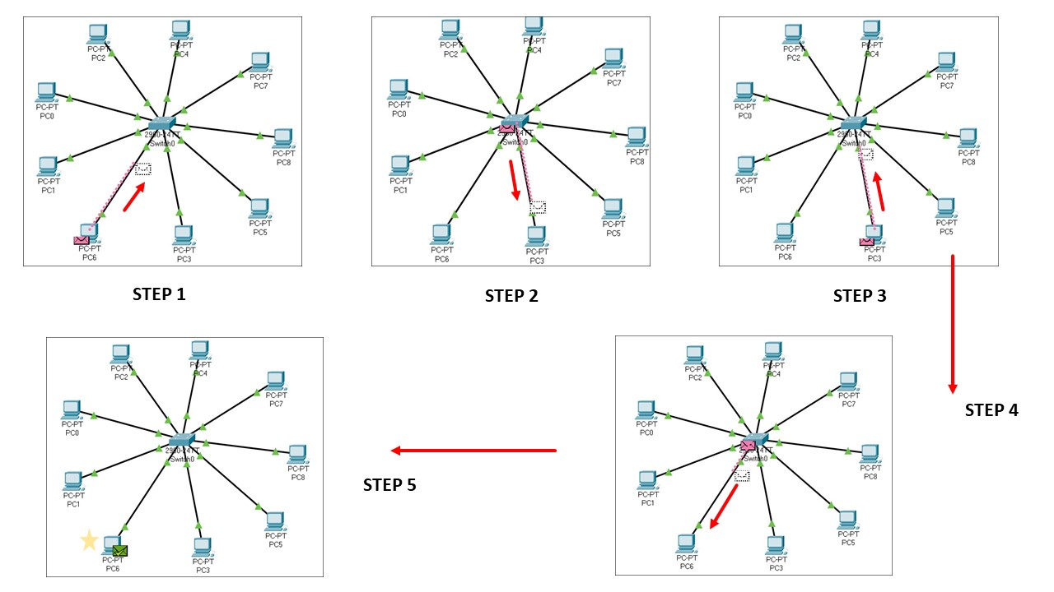

**Final Output :**

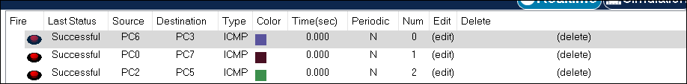

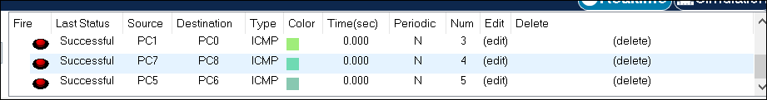

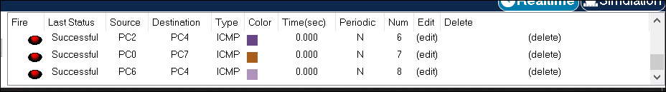

**MAC ADDRESS TABLE : (Switch 0)**

Switch>en

Switch#show mac address-table

Mac Address Table

-------------------------------------------

Vlan Mac Address Type Ports

---- ----------- -------- -----

1 0000.0c30.1227 DYNAMIC Fa0/2

1 0001.43c4.2670 DYNAMIC Fa0/6

1 0001.634e.36ce DYNAMIC Fa0/5

1 0060.3ee8.beaa DYNAMIC Fa0/8

1 0060.473e.d566 DYNAMIC Fa0/9

1 0090.2126.81dd DYNAMIC Fa0/1

1 00d0.5841.01e5 DYNAMIC Fa0/7

1 00d0.58b9.8a53 DYNAMIC Fa0/4

1 00e0.f9d6.b4a4 DYNAMIC Fa0/3

Switch#

