

**CSE3003 : Computer Networks**

**Name :** Gudi Varaprasad

**Reg. No. :** 19BCE7048

School of Computer Science and Engineering

**Lab Slot :** L39 + L40

**Date :** 10 – 03 – 2021

**Submitted to :** . Dr. R. Nandha Kumar sir

**EX No 6 : Network Topology Configuration**

**Date : 10 – 03 – 2021**

**Computer Network Topology :**

Geometric representation of how the computers is connected to each other is known as topology. There are six types of topologies – **Mesh, Star, Bus, Ring, Tree and Hybrid**.

**Configuring the Network Topology :**

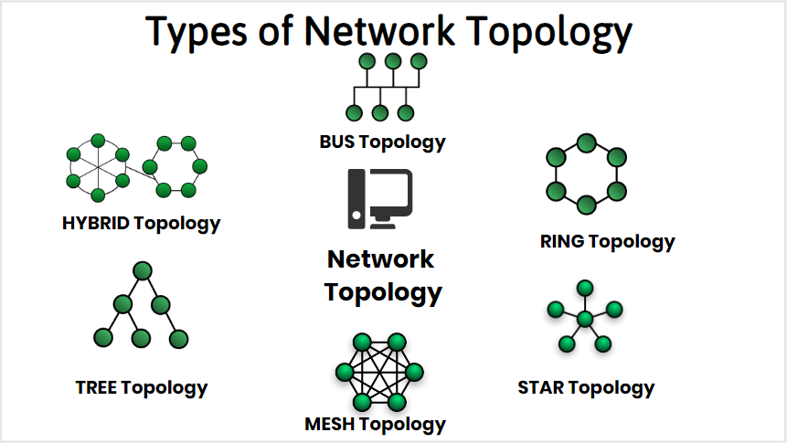

**Steps in Connecting the types :**

**1.** Open Cisco Packet Tracer and Open Networking Device Menu.

**2.** Select Desired Hub or Switch Model depending on the topology you choose.

**3.** Choose End Devices for your type of Network topology – **Mesh, Star, Bus, Ring, Tree and Hybrid.**

**4.** Choose Connecting Cable for Device Connections and Initiating Cable Connections.

**5.** Connect all the devices for respective topologies and make sure that they are connected to switches or hub.

**6.** Open Device Settings 🡪 Device Settings Interface 🡪 Open Desktop Menu and Select IP Configuration.

**7.** Configure IP Address and Subnet Mask. You can use any IP address but make sure that all the IP addresses belong to the same class.

**8.** Now for testing the topology you built, Select Sample PDU to Initiate Testing.

**9.** Choose Message Sender and Drop Message PDU on Receiver.

**10.** Check and See Results in PDU List window.

**Types of Topologies:**

**1. Mesh Topology :**

In mesh topology each device is connected to every other device on the network through a dedicated point-to-point link. When we say dedicated, it means that the link only carries data for the two connected devices only. Let’s say we have n devices in the network then each device must be connected with **(n-1)** devices of the network. Number of links in a mesh topology of n devices would be **n(n-1)/2**.

**Configuring by following the steps given above.**

**1. Build the network topology :**

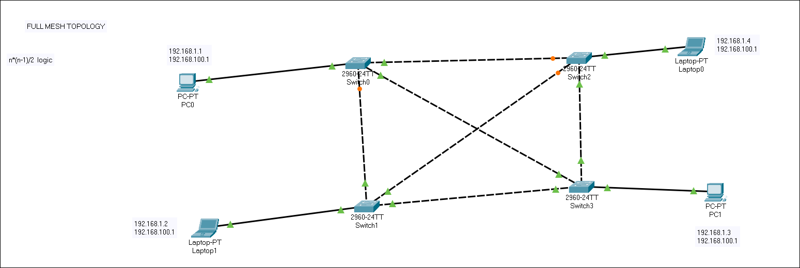

**2. Configuring IP address after connection :**

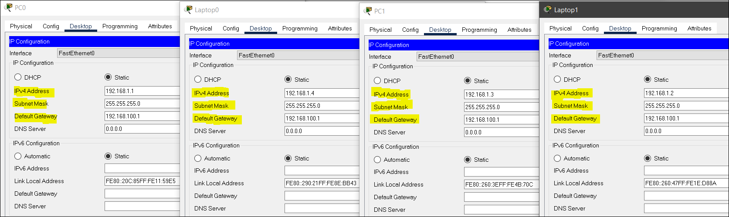

**3. Output :**

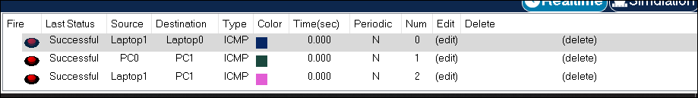

**2. Star Topology :**

In star topology each device in the network is connected to a central device called hub. Unlike Mesh topology, star topology doesn’t allow direct communication between devices, a device must have to communicate through hub. If one device wants to send data to other device, it has to first send the data to hub and then the hub transmits that data to the designated device.

**Configuring by following the steps given above.**

**1. Build the network topology :**

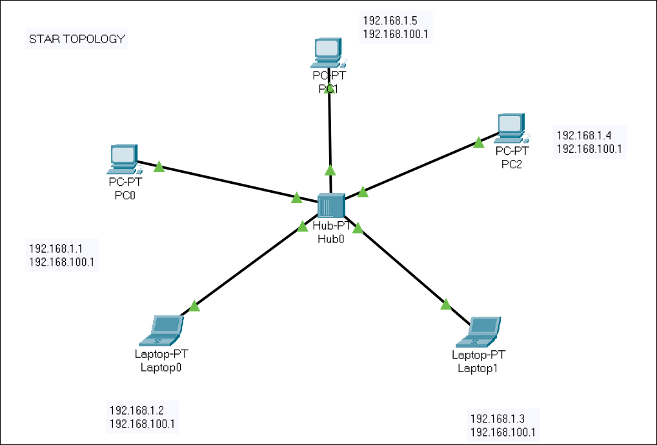

**2. Configuring IP address after connection :**

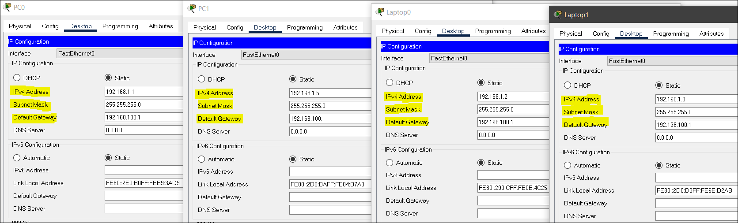

**3. Output :**

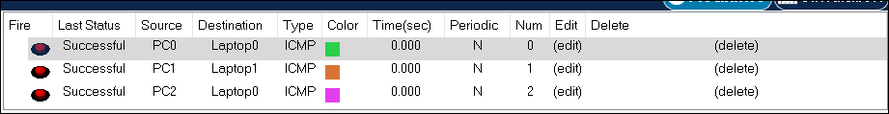

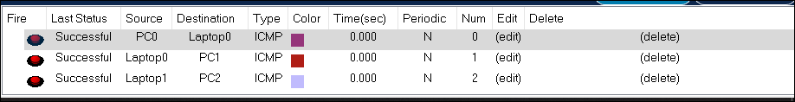

**3. Bus Topology :**

In bus topology there is a main cable and all the devices are connected to this main cable through drop lines. There is a device called tap that connects the drop line to the main cable. Since all the data is transmitted over the main cable, there is a limit of drop lines and the distance a main cable can have.

**Configuring by following the steps given above.**

**1. Build the network topology :**

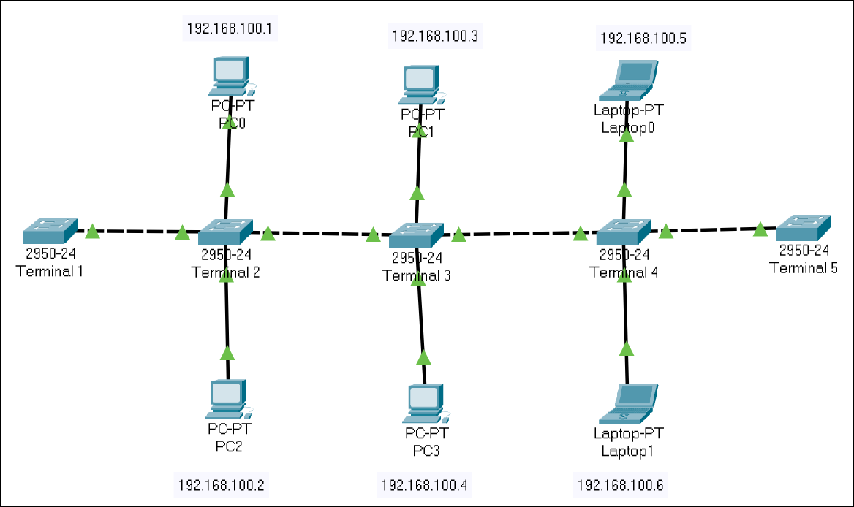

**2. Configuring IP address after connection :**

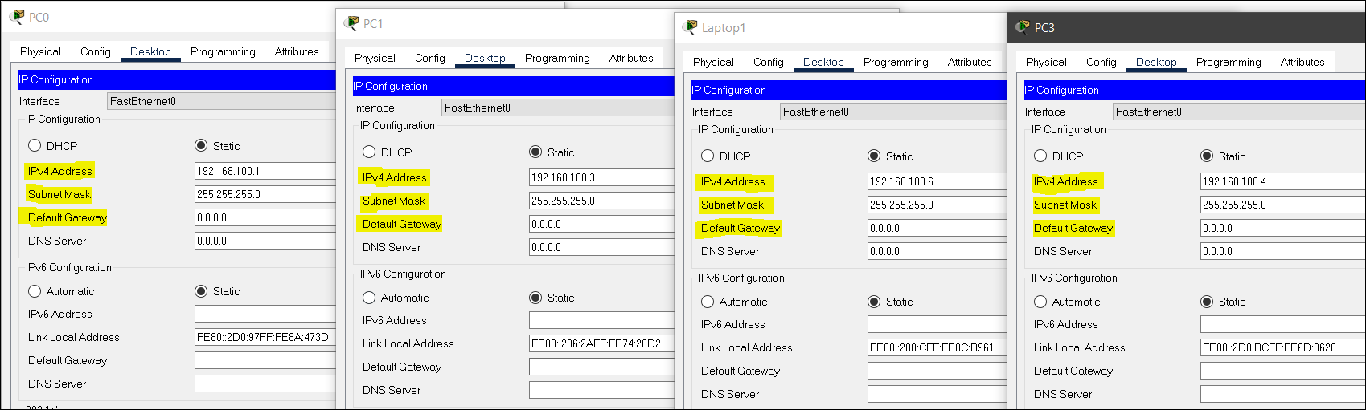

**3. Output :**

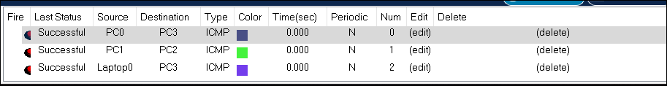

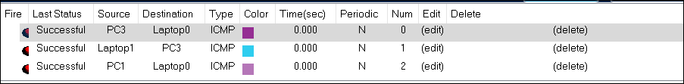

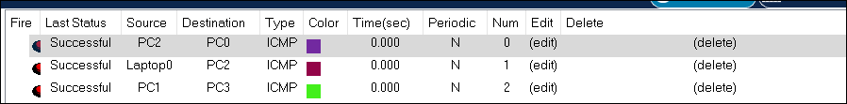

**4. Ring Topology :**

In ring topology each device is connected with the two devices on either side of it. There are two dedicated point to point links a device has with the devices on the either side of it. This structure forms a ring thus it is known as ring topology. If a device wants to send data to another device, then it sends the data in one direction, each device in ring topology has a repeater, if the received data is intended for other device, then repeater forwards this data until the intended device receives it.

**Configuring by following the steps given above.**

**1. Build the network topology :**

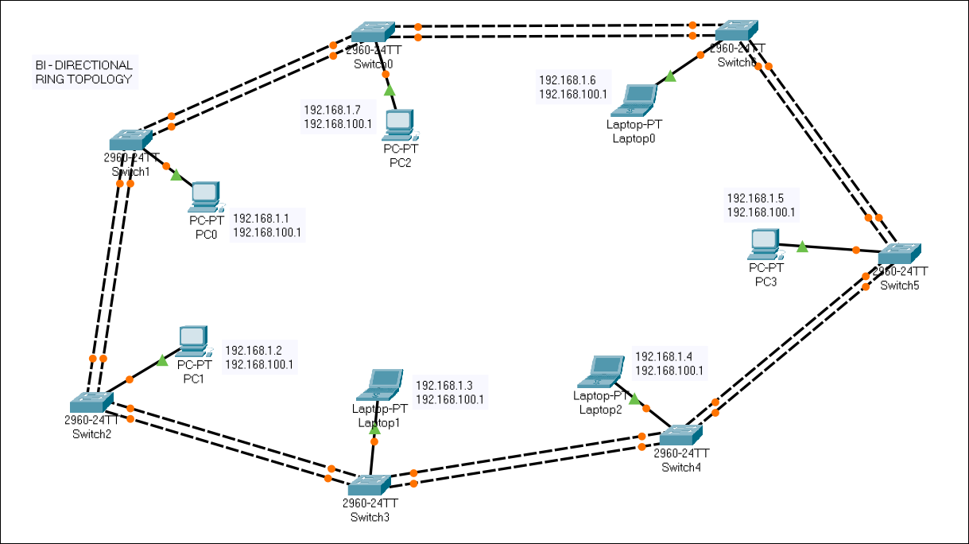

**2. Configuring IP address after connection :**

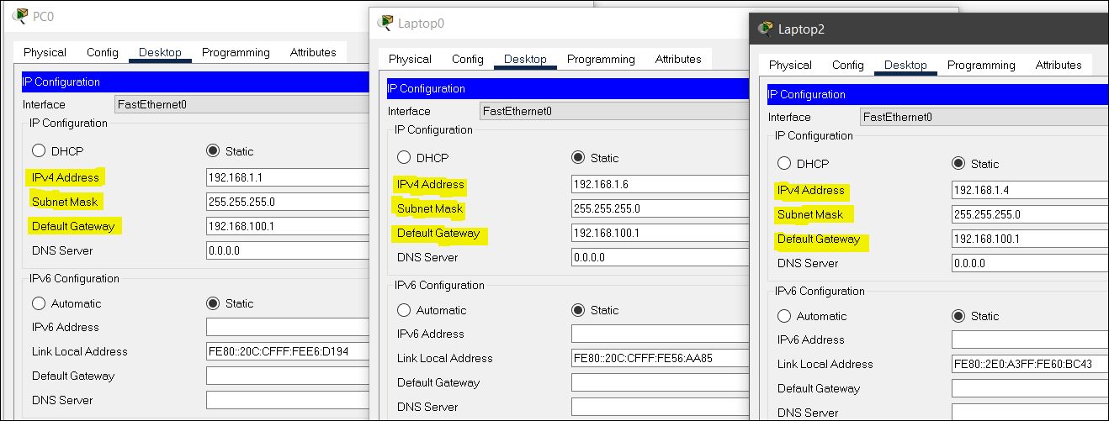

**3. Output :**

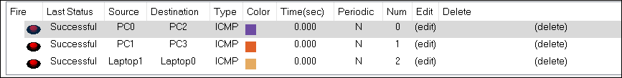

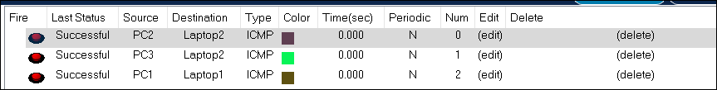

**5. Tree Topology :**

A tree topology is a special type of structure where many connected elements are arranged like the branches of a tree. In a tree topology, there can be only one connection between any two connected nodes. Because any two nodes can have only one mutual connection, tree topologies create a natural parent and child hierarchy.

**Configuring by following the steps given above.**

**1. Build the network topology :**

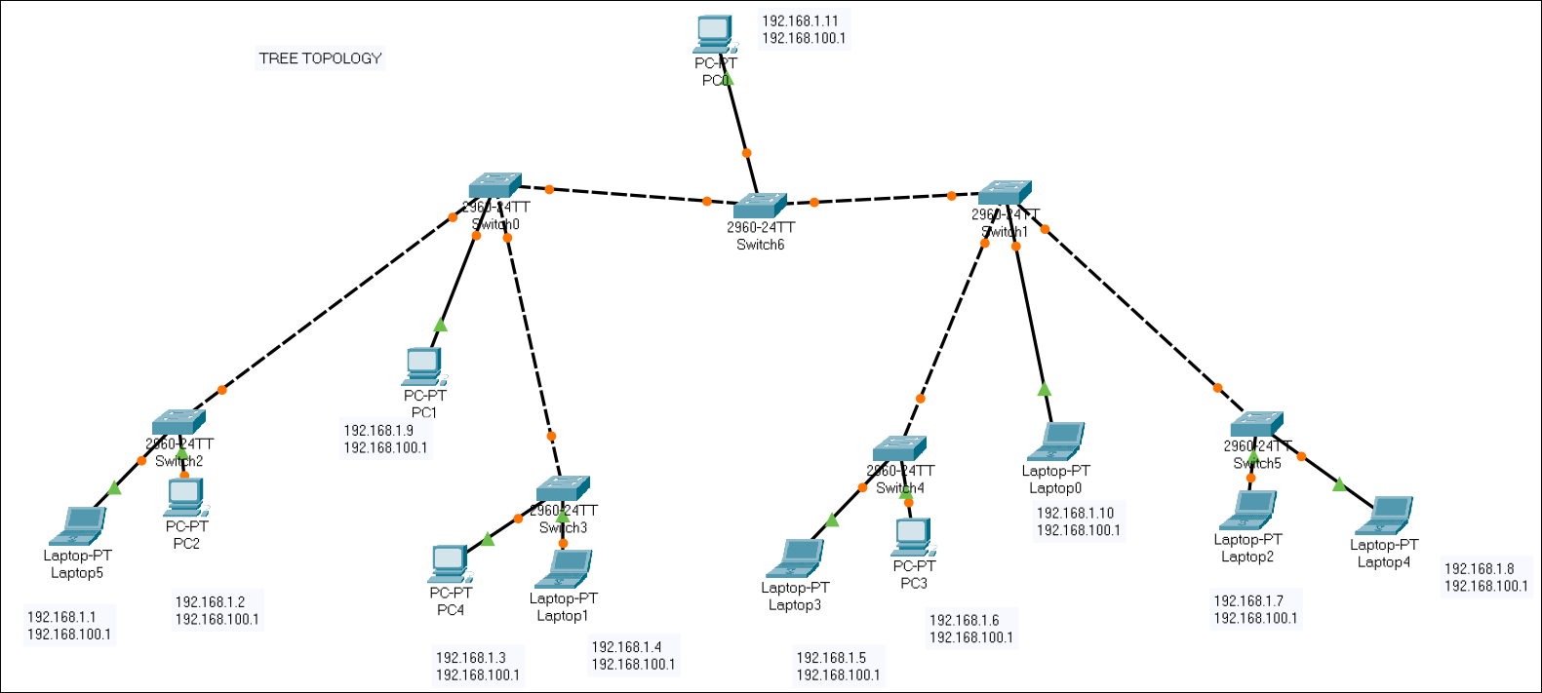

**2. Configuring IP address after connection :**

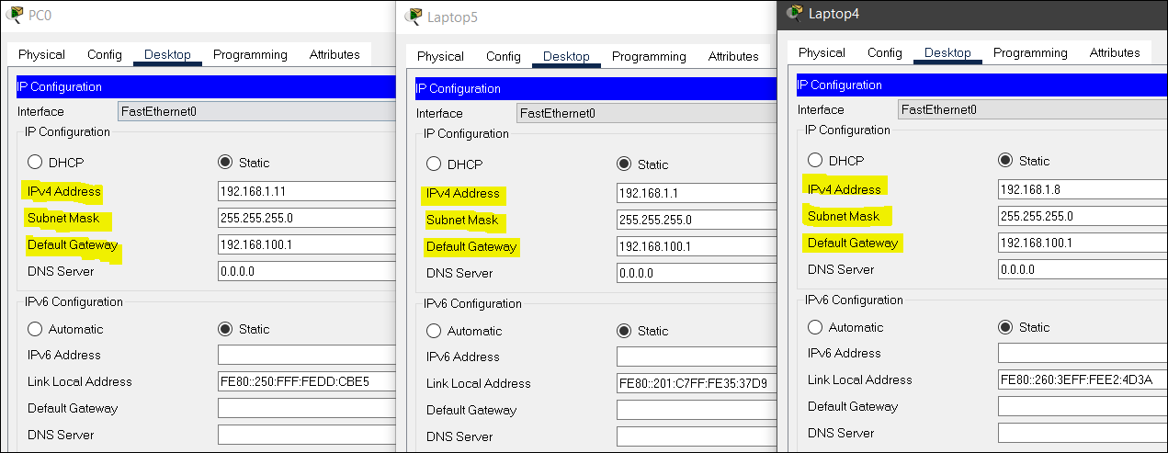

**3. Output :**

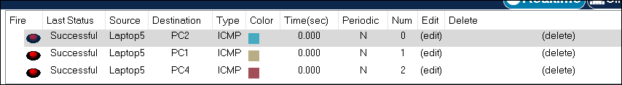

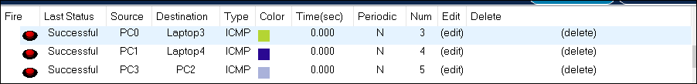

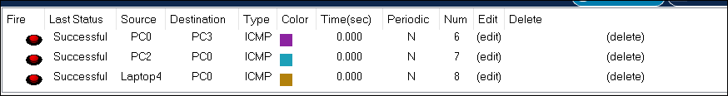

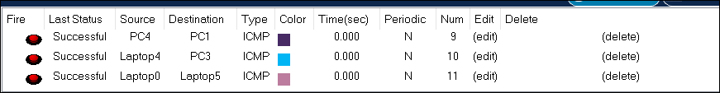

**5. Hybrid Topology :**

A combination of two or more topology is known as hybrid topology. For example, a combination of Ring Topology and Star Topology is also a Hybrid Topology. This is scalable as we can further connect other computer networks with the existing networks with different topologies.

**Configuring by following the steps given above.**

**1. Build the network topology and configuring :**

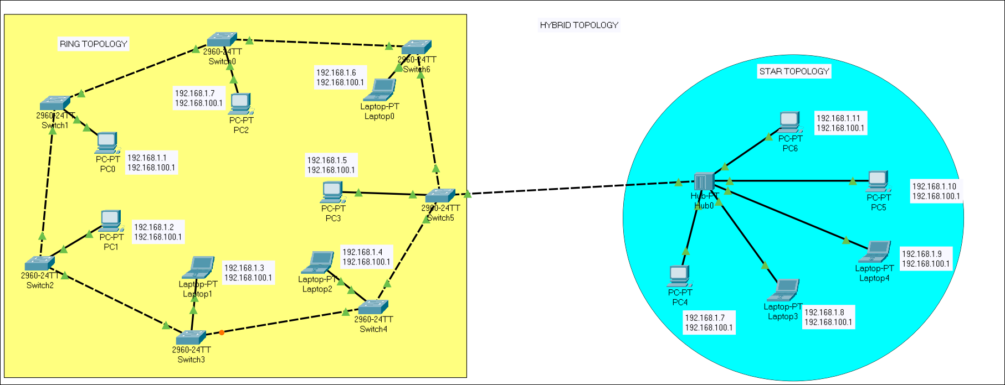

**2. Output :**

