

**CSE3003 : Computer Networks**

**Name :** Gudi Varaprasad

**Reg. No. :** 19BCE7048

School of Computer Science and Engineering

**Lab Slot :** L39 + L40

**Date :** 24 – 03 – 2021

**Submitted to :** . Dr. R. Nandha Kumar sir

**Wireless Access point Configuration in different network Topology**

**Date : 24-03-2021**

**Wireless Access point Configuration for Topology Type 1 :**

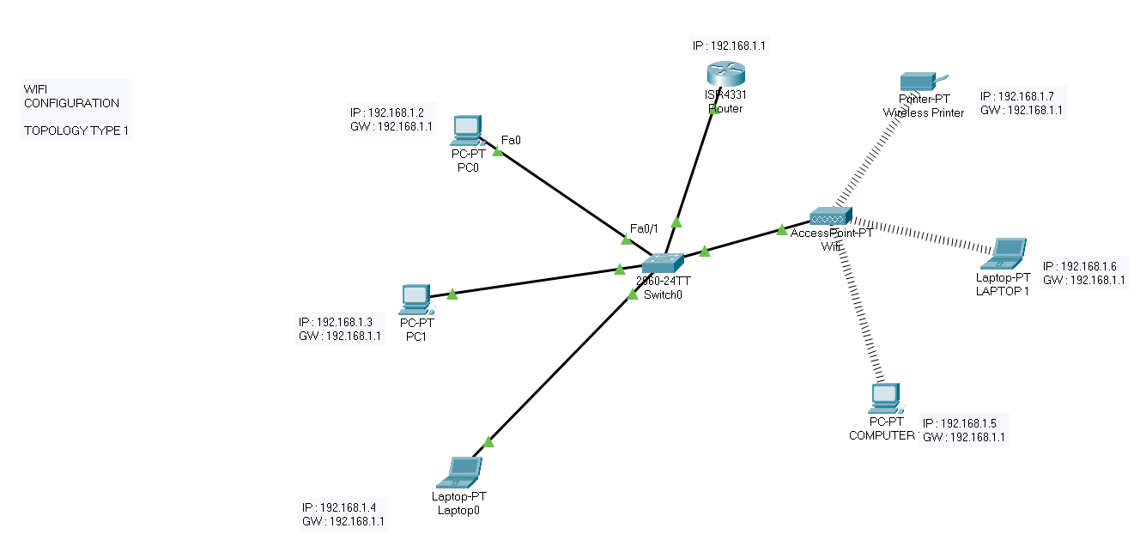

**Adding a wireless network to an existing wired network**

* Adding a WAP to your existing wired network is useful to accommodate those devices that are only capable of wireless connection. It is like creating another network only for wireless devices but still be a part of your existing wired network.
* Adding a WAP in the existing network is like joining two networks together to form a single network for both wired and wireless devices such as shown in the picture above.

**Here, I have three pc connected from Wireless routers with following configuration.**

* DHCP is configured and enabled on Wireless router
* IP pool for DHCP is 192.168.1.1 to 192.168.1.7
* PC are configured to receive IP from DHCP Server
* No security is configured
* Default SSID is configured to Default
* Topology is working on infrastructure mode
* Default user name and password is admin
* IP of wireless is set to 192.168.1.1

**Now your task is to :**

* Configure Static IP on PC and Wireless Router
* Change SSID to Wifi
* Secure your network by configuring WAP key on Router
* Connect PC by using WAP key.

**Working :**

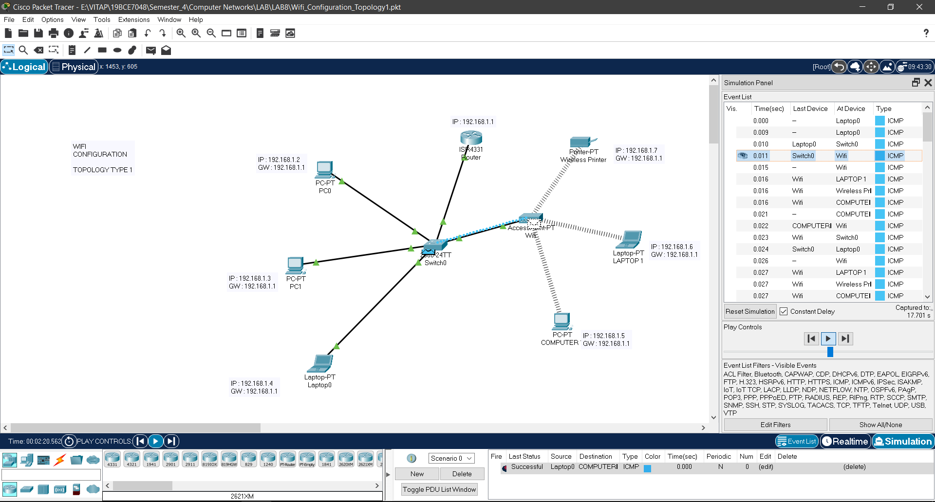

**Sending a packet from Laptop0 to PC Computer through an Access Point**

**Similarly, is the case for sending from any source to laptop1 through the Access Point.**

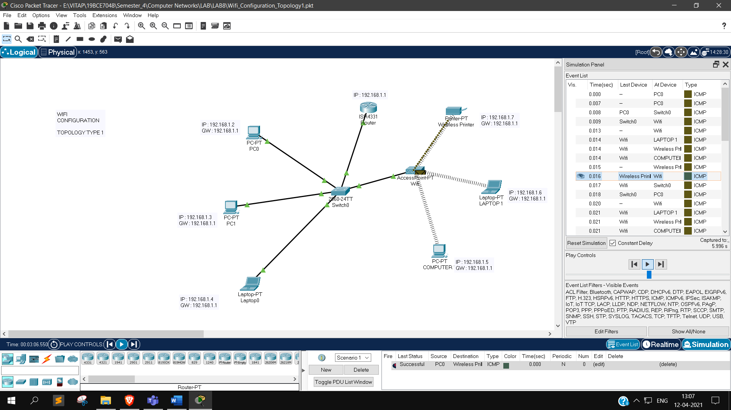

**Sending a packet from PC0 to Wireless Printer through an Access Point**

**Wireless Access point Configuration for Topology Type 2 :**

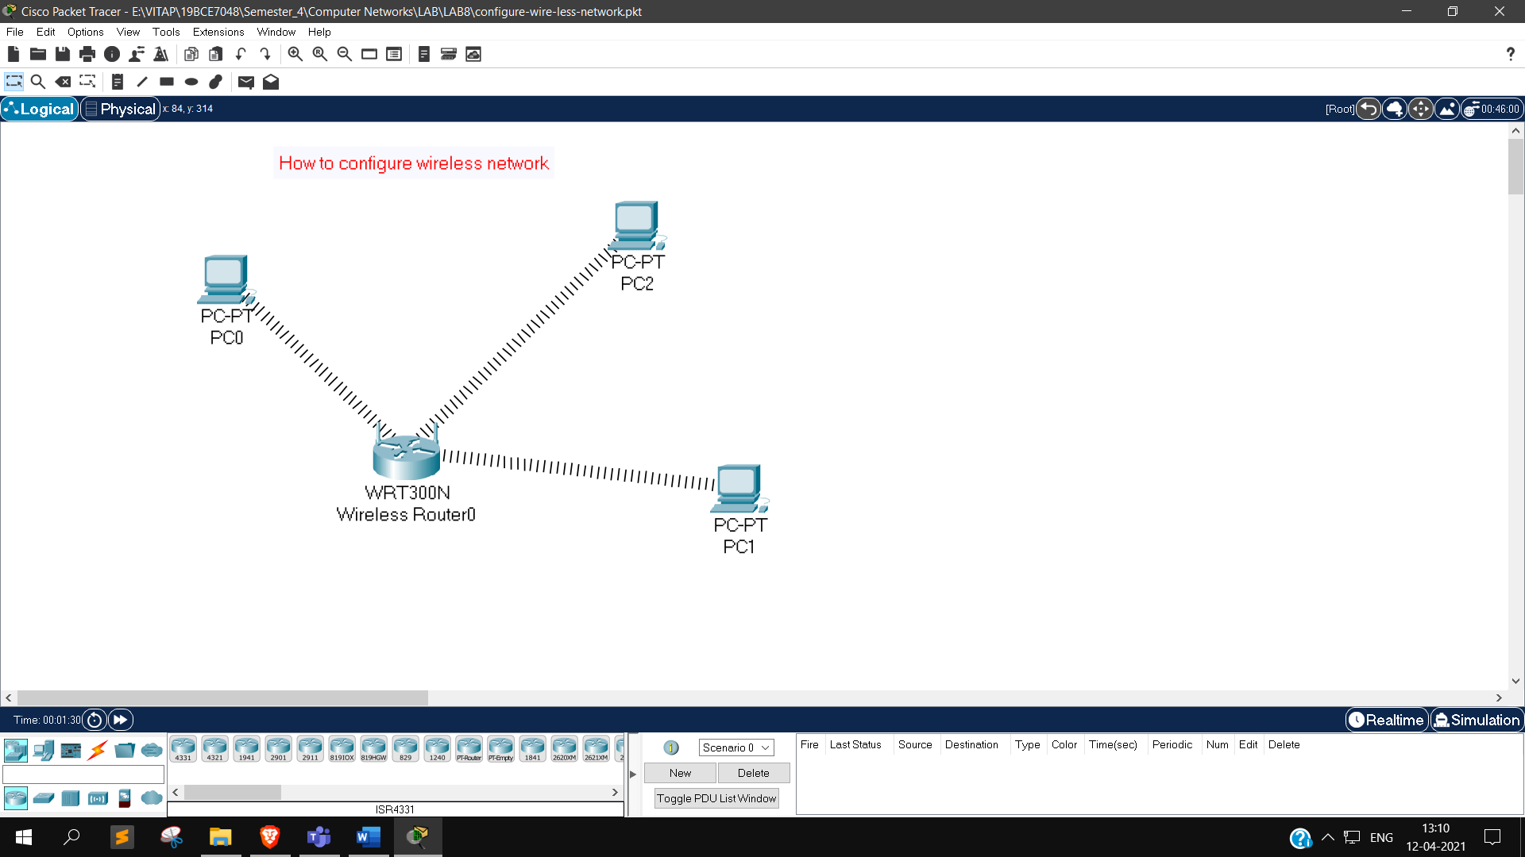

**In this type, I have 3 PC connected from Wireless routers with following configuration :**

* DHCP is configured and enabled on Wireless router
* IP pool for DHCP is 192.168.0.100 to 192.168.0.150
* PC are configured to receive IP from DHCP Server
* No security is configured
* Default SSID is configured to Default
* Topology is working on infrastructure mode
* Default user name and password is admin
* IP of wireless is set to 192.168.0.1

**Now your task is to :**

* Configure Static IP on PC and Wireless Router
* Change SSID to MainNetwork
* Change IP address of router to 10.0.0.1 and 10.0.0.2 of PC0 10.0.0.3 of PC1 10.0.0.4 of PC2
* Secure your network by configuring WAP key on Router
* Connect PC by using WAP key

**Working :**

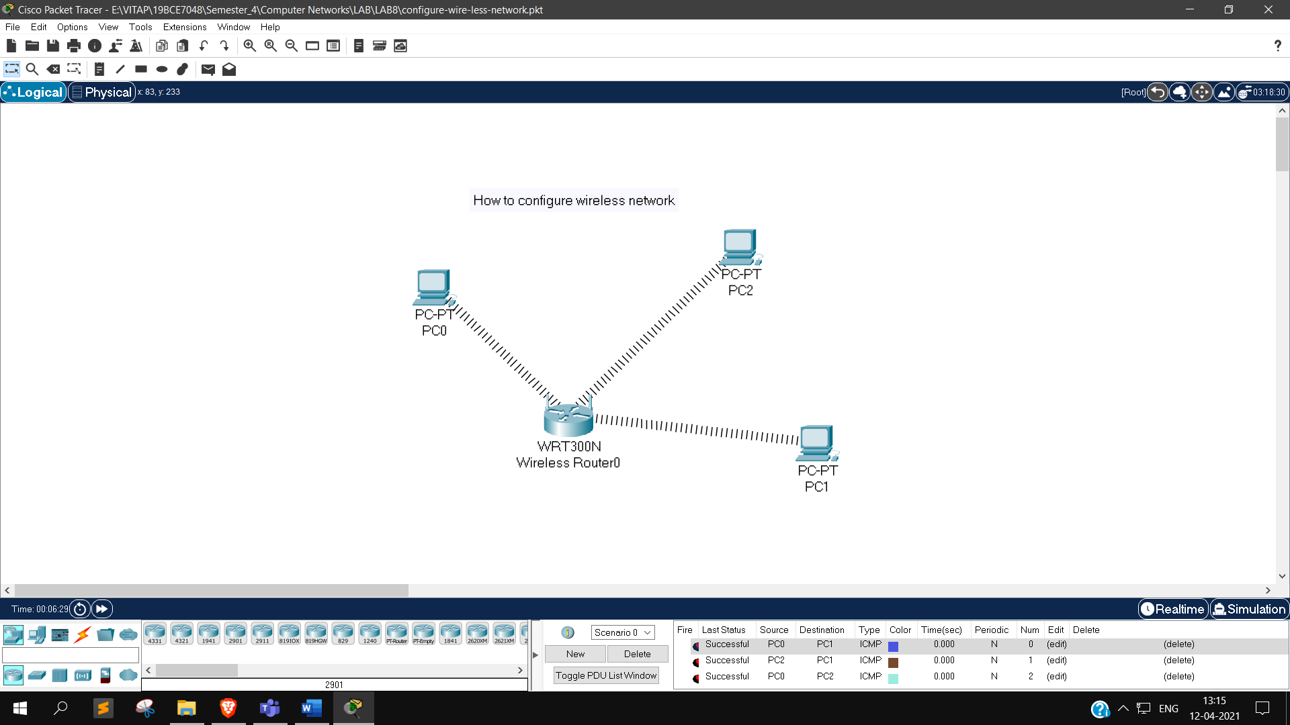

**Sending a packet from PC0 to PC1, PC2 to PC1, PC0 to PC2 through an Access Point**

**Wireless Access point Configuration for Topology Type 3 :**

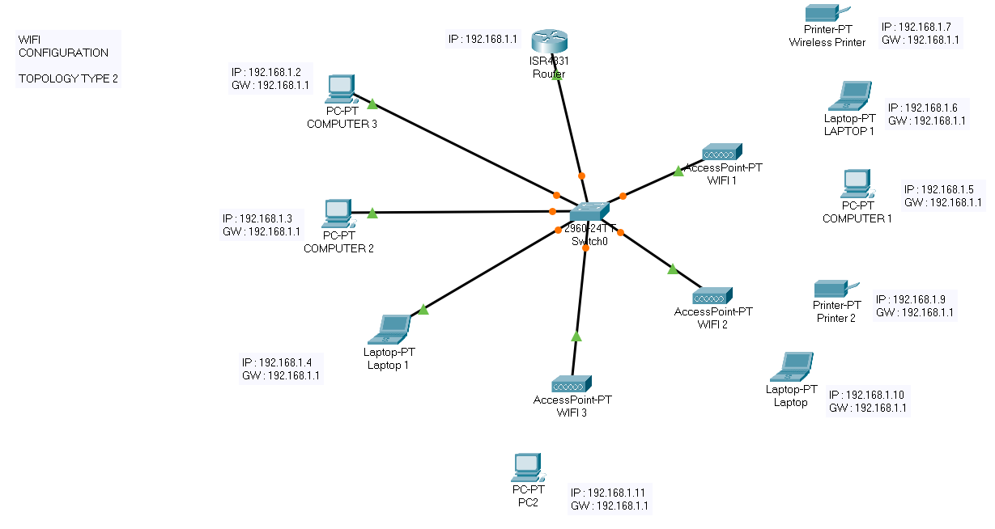

**Here, I have taken three Access Points and configured the network as above.**

**Working :**

