

**CSE3003 : Computer Networks**

**Name :** Gudi Varaprasad

**Reg. No. :** 19BCE7048

School of Computer Science and Engineering

**Lab Slot :** L39 + L40

**Date :** 12 – 04 – 2021

**Submitted to :** . Dr. R. Nandha Kumar sir

**EX:9 Simple VLAN Configuration**

**Date : 12-04-2021**

**Creating and configuring 2 VLANs ( CSE, ECE ) :**

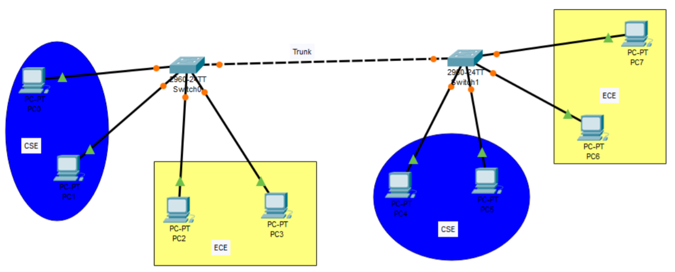

**Objectives:**1. Verify the default VLAN configuration  
2. Configure the VLANs  
3. Assign VLANs to ports.  
 **Background / Scenario :**Modern switches use virtual local-area networks (VLANs) to improve network performance by separating large Layer 2 broadcast domains into smaller ones. VLANs can also be used as a security measure by controlling which hosts can communicate. In general, VLANs make it easier to design a network to support the goals of an organization.

VLAN trunks are used to span VLANs across multiple devices. Trunks allow the traffic from multiple VLANS to travel over a single link, while keeping the VLAN identification and segmentation intact. In this lab, you will create VLANs on both switches in the topology, assign VLANs to switch access ports, verify that VLANs are working as expected, and then create a VLAN trunk between the two switches to allow hosts in the same VLAN to communicate through the trunk, regardless of which switch the host is actually attached to.

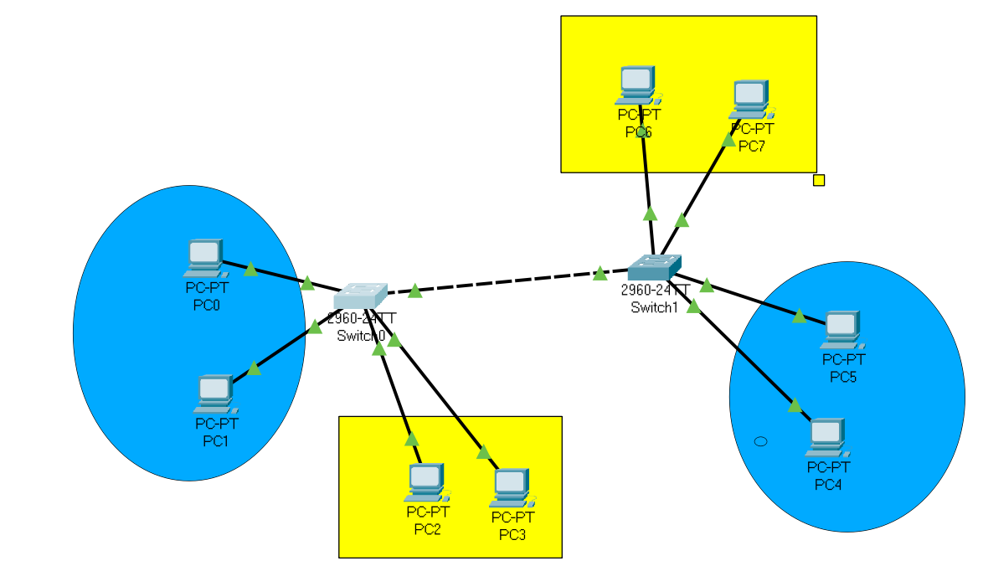

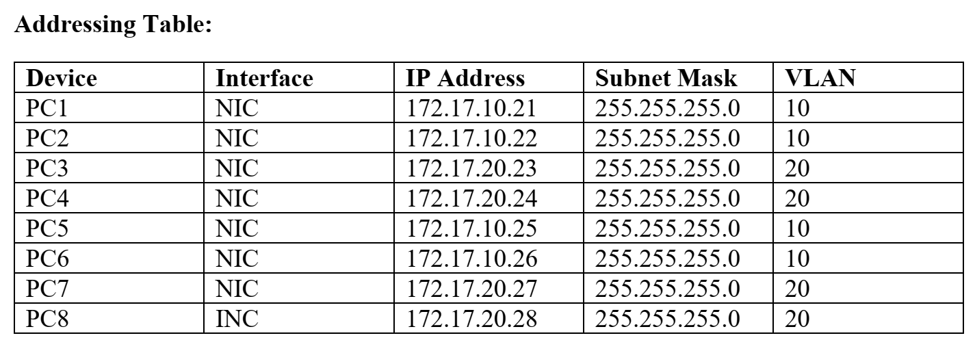

**1. Verify the default VLAN configuration :**Switch> en  
Switch> enable  
Switch# sh  
Switch# show vlan  
VLAN Name Status Ports  
---- -------------------------------- --------- -------------------------------  
1 default active Fa0/1, Fa0/2, Fa0/3, Fa0/4  
Fa0/5, Fa0/6, Fa0/7, Fa0/8  
Fa0/9, Fa0/10, Fa0/11, Fa0/12  
Fa0/13, Fa0/14, Fa0/15, Fa0/16  
Fa0/17, Fa0/18, Fa0/19, Fa0/20  
Fa0/21, Fa0/22, Fa0/23, Fa0/24  
Gig0/1, Gig0/2  
1002 fddi-default active  
1003 token-ring-default active  
1004 fddinet-default active  
1005 trnet-default active  
VLAN Type SAID MTU Parent RingNo BridgeNo Stp BrdgMode Trans1 Trans2  
---- ----- ---------- ----- ------ ------ -------- ---- -------- ------ ------  
1 enet 100001 1500 - - - - - 0 0  
1002 fddi 101002 1500 - - - - - 0 0  
1003 tr 101003 1500 - - - - - 0 0  
1004 fdnet 101004 1500 - - - ieee - 0 0  
1005et 101005 1500 - - - ibm - 0 0

**2. Configure the VLANs :**

**Step 1** : Cable the network as shown in the topology.  
Attach the devices as shown in the topology diagram, and cable as necessary.

**Step 2 :** Initialize and reload the switches as necessary.

**Step 3 :** Configure basic settings for each switch.  
• Configure the host name as shown in the above topology.  
• Configure the IP address listed in the Addressing Table for VLAN 1 on the switch.  
• Administratively deactivate all unused ports on the switch.  
• Copy the running configuration to the startup configuration.

**Step 4: Test connectivity.**Verify that the PC hosts can ping one another. Note: It may be necessary to disable the PCs firewall to  
ping between PCs.  
**PC0, PC1 can ping PC4, PC5  
PC2, PC3 can Ping PC6, PC7  
Pings to PCs with others fail.**

**3. Creat VLANs on the Switches :  
a.** Create the VLANs on switch S1.  
**b.** S1(config)# vlan 100  
**c.** S1(config-vlan)# name CSE  
**d.** S1(config-vlan)# ex  
**e.** S1(config)# vlan 200  
**f.** S1(config-vlan)# name ECE  
**g.**  S1(config-vlan)# ex  
**h.** Create the VLANs on switch S2.  
**i.**  S2(config)# vlan 100  
**j.** S2(config-vlan)# name CSE  
**k.** S2(config-vlan)# ex  
**l.** S2(config)# vlan 200  
**m.** S2(config-vlan)# name ECE  
**n.** S2(config-vlan)# ex

**4a. Configuring VLAN : ( Switch 1 )**

Switch> en  
Switch> enable  
Switch> conf  
> Switch(config)# interface fastEthernet 0/1  
> Switch(config-if)# switchport mode access  
> Switch(config-if)# switchport access vlan 100  
> Switch(config-if)# ex  
> Switch(config)# interface fastEthernet 0/2  
> Switch(config-if)# switchport mode access  
> Switch(config-if)# switchport access vlan 100  
> Switch(config-if)# ex  
> Switch(config)# interface fastEthernet 0/3  
> Switch(config-if)# switchport mode access  
> Switch(config-if)# switchport access vlan 200  
> Switch(config-if)# ex  
> Switch(config)# interface fastEthernet 0/4  
> Switch(config-if)# switchport mode access  
> Switch(config-if)# switchport access vlan 200  
> Switch(config-if)# ex  
> Switch(config)#

**4b. Configuring VLAN : ( Switch 2 )**

Switch> en  
Switch> enable  
Switch> conf  
> Switch(config)# interface fastEthernet 0/1  
> Switch(config-if)# switchport mode access  
> Switch(config-if)# switchport access vlan 100  
> Switch(config-if)# ex  
> Switch(config)# interface fastEthernet 0/2  
> Switch(config-if)# switchport mode access  
> Switch(config-if)# switchport access vlan 100  
> Switch(config-if)# ex  
> Switch(config)# interface fastEthernet 0/3  
> Switch(config-if)# switchport mode access  
> Switch(config-if)# switchport access vlan 200  
> Switch(config-if)# ex  
> Switch(config)# interface fastEthernet 0/4  
> Switch(config-if)# switchport mode access  
> Switch(config-if)# switchport access vlan 200  
> Switch(config-if)# ex  
> Switch(config)#

**4c. Configuring VLAN : ( Switch 1 and Switch 2 Trunk)**

Switch> en  
Switch> enable  
Switch> conf  
> Switch(config)# interface fastEthernet 0/5  
> Switch(config)# switchport mode trunk  
> Switch(config)# interface fastEthernet 0/5  
> Switch(config-if)# switchport nonnegotiate

**After trunk, the fastEthernet port status will change from down to up.**

**5. Checking the status of vlans :**

Switch> show vlan

VLAN Name Status Ports

---- -------------------------------- --------- -------------------------------

1 default active Fa0/6, Fa0/7, Fa0/8, Fa0/9

Fa0/10, Fa0/11, Fa0/12, Fa0/13

Fa0/14, Fa0/15, Fa0/16, Fa0/17

Fa0/18, Fa0/19, Fa0/20, Fa0/21

Fa0/22, Fa0/23, Fa0/24, Gig0/1

Gig0/2

**100 CSE active Fa0/1, Fa0/2**

**200 ECE active Fa0/3, Fa0/4**

1002 fddi-default active

1003 token-ring-default active

1004 fddinet-default active

1005 trnet-default active

VLAN Type SAID MTU Parent RingNo BridgeNo Stp BrdgMode Trans1 Trans2

---- ----- ---------- ----- ------ ------ -------- ---- -------- ------ ------

1 enet 100001 1500 - - - - - 0 0

**100 enet 100100 1500 - - - - - 0 0**

**200 enet 100200 1500 - - - - - 0 0**

1002 fddi 101002 1500 - - - - - 0 0

**Output :**

**Between same VLAN case : (Successful)**

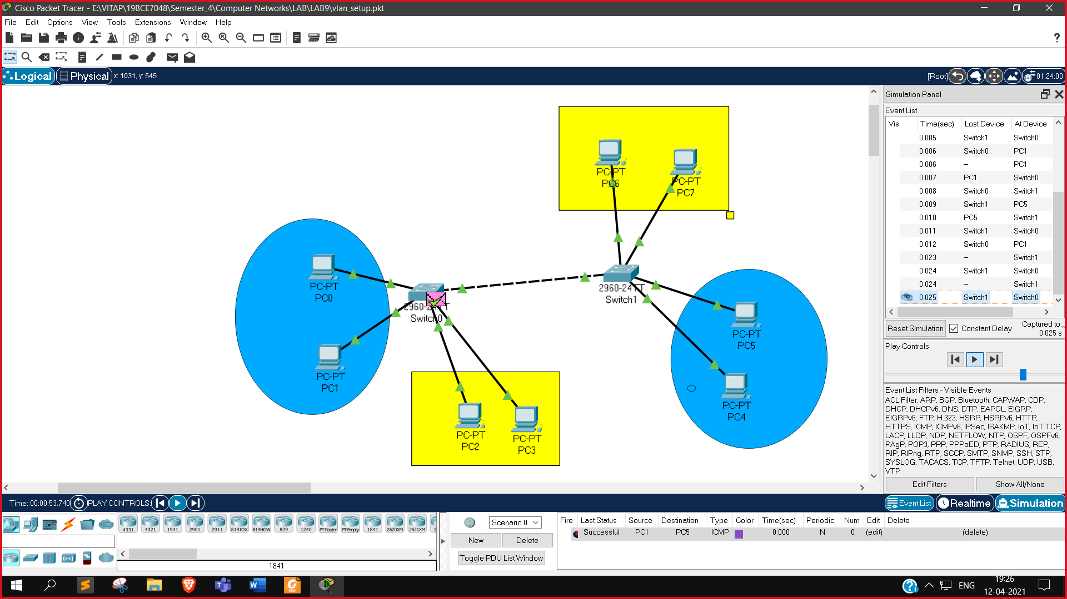

**Sending a packet from PC1 to PC5 after configuring VLAN 100 (name CSE)**

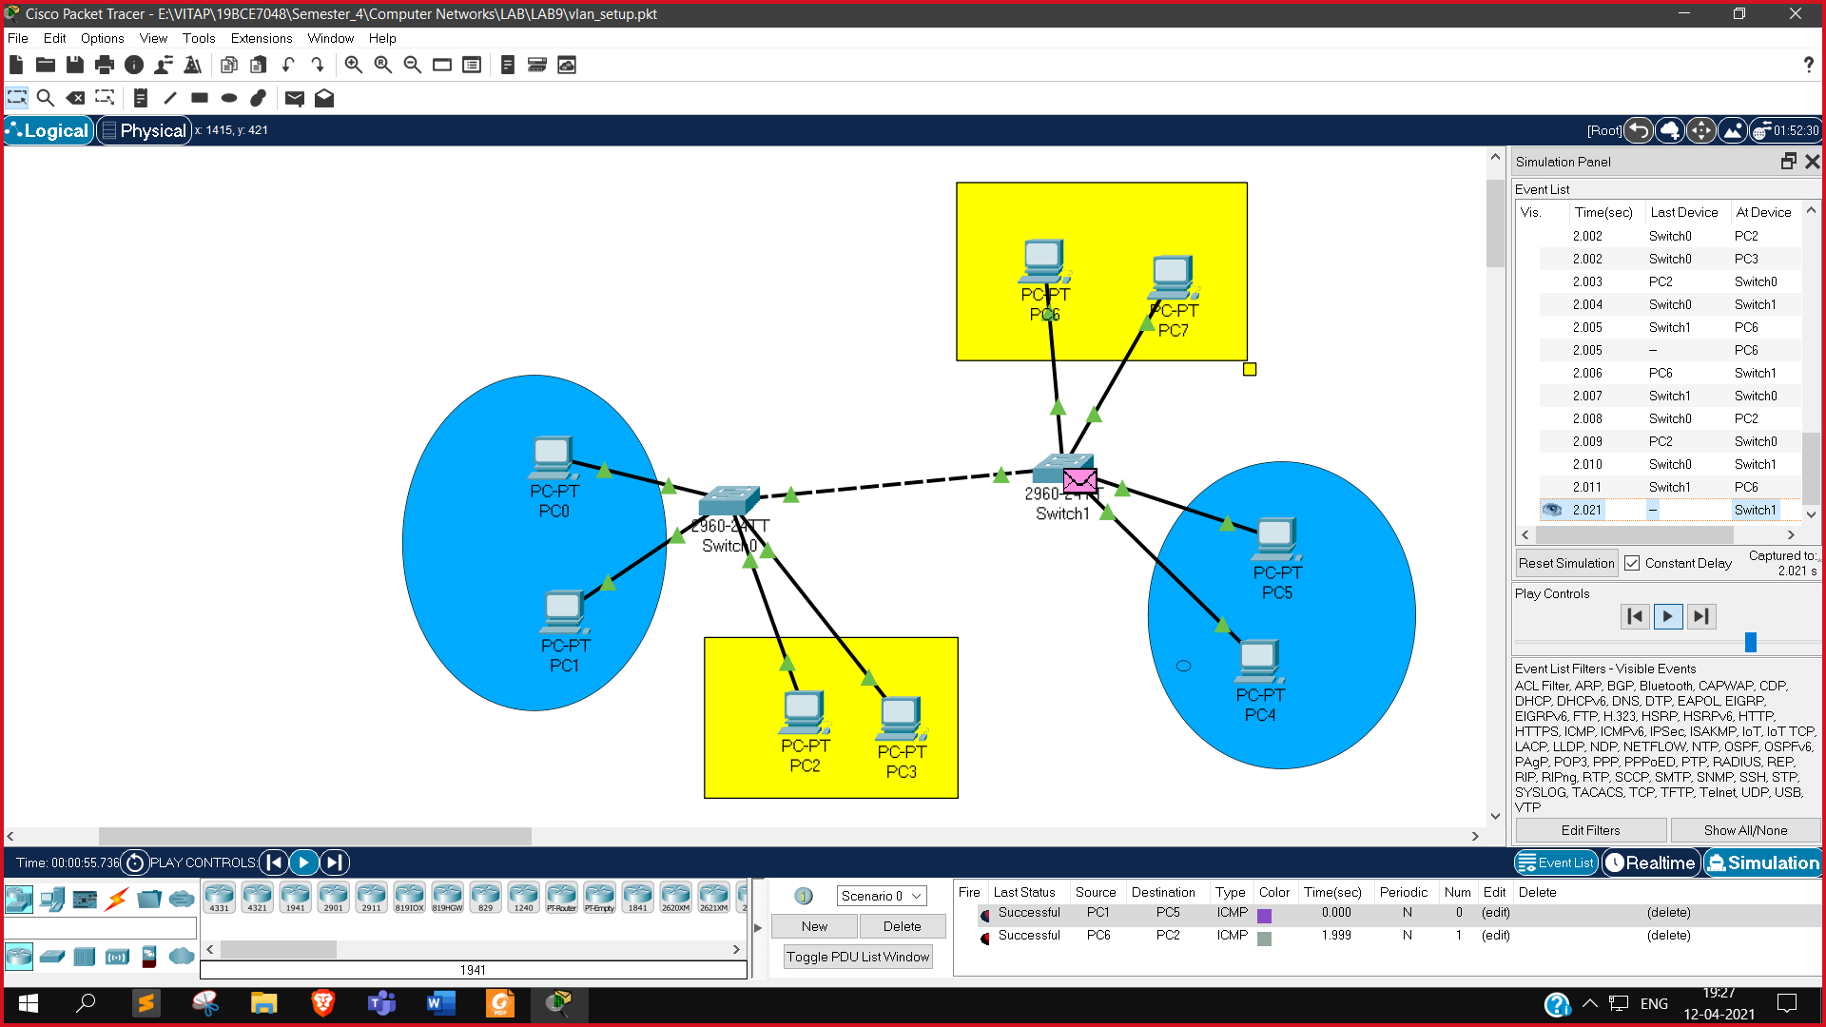

**Sending a packet from PC6 to PC2 after configuring VLAN 200 (name ECE)**

**Between different VLAN case : (Failed)**

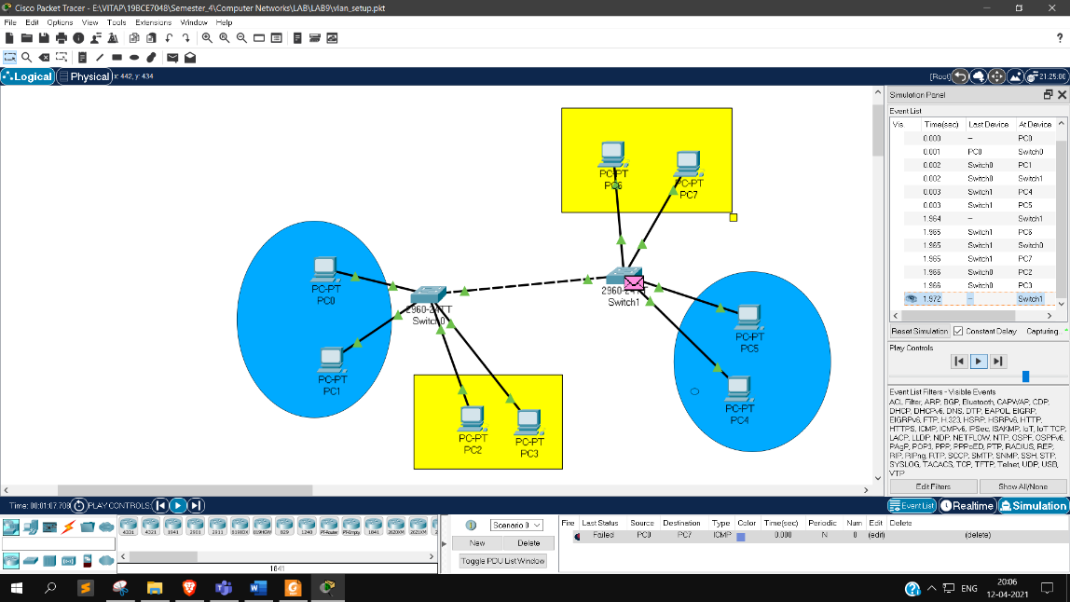

**Sending a packet from PC0 to PC7 in different VLANs**

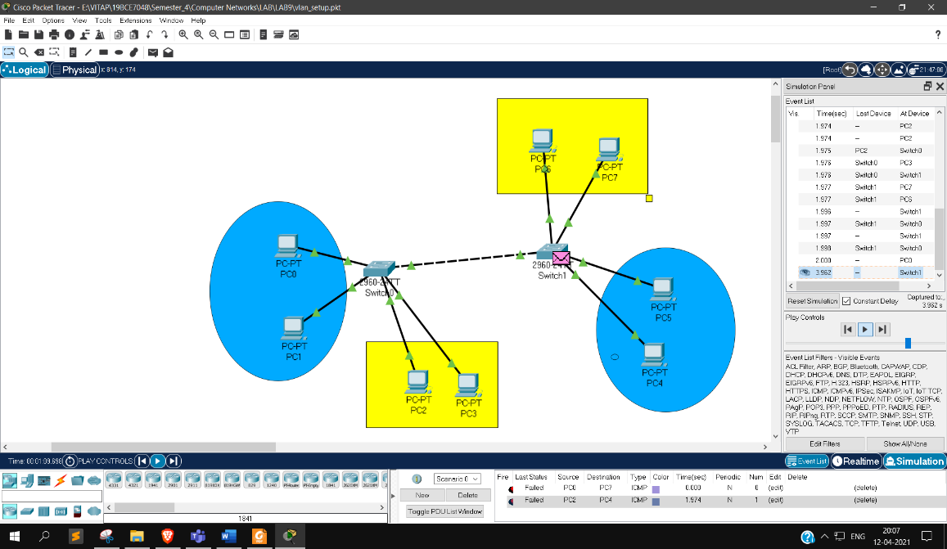

**Sending a packet from PC2 to PC4 in different VLANs**