**FDA Lab - 7**

1. Fill the missing value of the given table

|  |  |  |  |  |
| --- | --- | --- | --- | --- |
| Item Type | Sales Channel | Order Priority | Units Sold | Unit Price |
| Baby Food | Offline | 1 | 9925 | 255.28 |
| Cereal | Online | 2 | 2804 | 205.7 |
| Office Supplies | NA | 3 | 1779 | NA |
| Fruits | Online | 1 | 8102 | 9.33 |
| Office Supplies | Offline | NA | 5062 | 651.21 |
| Baby Food | Online | 1 | NA | 255.28 |
| Household | NA | 3 | 4187 | 668.27 |
| Vegetables | Online | 2 | 8082 | 154.06 |
| Personal Care | Offline | 1 | 6070 | 81.73 |
| Cereal | Online | 2 | NA | 205.7 |
| Vegetables | Online | NA | 124 | 154.06 |
| Clothes | Offline | 2 | 4168 | NA |
| Clothes | NA | NA | 8263 | 109.28 |
| Household | Offline | 3 | 8974 | 668.27 |

1. FillSales Channel by mode by finding the highest frequency of the entry.
2. Fill Order Priority by mode by finding the highest frequency of the entry.
3. FillUnits Sold by median. First sort it in ascending order and then find median.
4. FillUnit Price by mean.
5. (a)Write a R program to print the pattern using user define function Patt ( ) given below and take number of rows as input from the user.

1

3*2

4*5*6

10*9*8*7

11*12*13*14*15

(b) Write the R Program to create 5X5 matrix and display only negative number which is prime number present in the above matrix.

0 5 6 -2 4

-4 0 8 1 0

9 4 7 9 2

1 7 6 -8 3

-5 6 7 8 9

(c) Write R program using function **PF( )** to print all prime factors of n. Take n as input from the user.

input = 21 output =3,7

input=315 output=3, 3, 5, 7

1. Create a Data frame **EMP** as given below

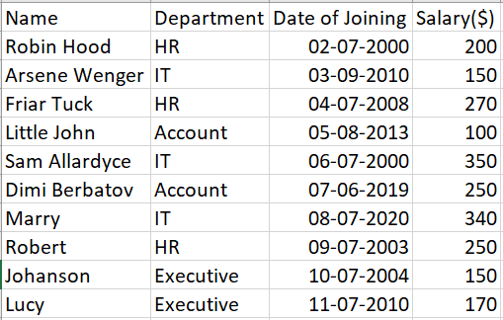

**(a)**Calculate the Year of experience with respect to current date and append to the data frame as **Experience** column, add Gender column, and name the data frame as **UEMP**.

**(b)**Display the data where **female** is from **IT department** who got more than equal to **300$** salary from the **UEMP**.