**Project Synopsis**

**On**

**Parking Management System**

A mini – project synopsis submitted in partial fulfilment of the requirement for the award of Degree of

**Bachelor of Engineering**

**(Fifth Semester)**

**In**

**COMPUTER SCIENCE & ENGINEERING**

**Session 2022-2023**

**Prescribed By**

**Dr. Babasaheb Ambedkar Technological University, Lonere (DBATU)**



**Guided By**

**Prof. Anand Donald Submitted By**

**Gudiya Prasad (CSEB573)**

**Achal Ragit (CSEB582)**

**Sneha Wankar (CSEB579)**

**Achal Waghmare (CSEB563)**

**DEPARTMENT OF INFORMATION TECHONLOGY**

**RAJIV GANDHI COLLEGE OF ENGINEERING**

**RESEARCH & TECHNOLOGY**

**Table of Content**

|  |  |
| --- | --- |
| 1) | Introduction |
| 2) | Aim and objectives of project |
| 3) | Methodology:  a)software description  b) hardware description |
| 4) | Module description |
| 5) | Algorithm description |
| 6) | Database description |
| 7) | E-R / Class diagram |
| 8) | Expected output |
| 9) | Future scope |
| 10) | Conclusion |
| 11) | Reference |

***ABSTRACT***

Due to the increasing population in urban cities, there is an exponential rise in the number of vehicles which is leading to major problems leading to poor traffic management and congestion. Another major problem faced by the vehicle owners is the availability of parking space. The idea of Smart Cities is slowly gaining pace with the ever increasing technologies. Therefore, in the proposed parking system we are integrating the Wireless Sensor Technology with the Android Application so that the user can book or pre-book a slot. The vehicle owner will be able to reserve a slot for his/her vehicle from anywhere and will be provided with a QR code which will be scanned on the entry of the parking area. Another feature our system provides is providing information about the near-by parking areas which comes handy when the current parking area is full.

**INTRODUCTION**

Now days in many public places such as malls, multiplex systems, hospitals, offices, market areas there is a crucial problem of car parking. The car-parking area has many lanes/slots for car parking. So to park a car one has to look for all the lanes. Moreover this involves a lot of manual labour and investment. So there is a need to develop an automated parking system that indicates directly the availability of vacant parking slots in any lane right at the entrance. The project involves a system including infrared transmitter- receiver pair in each lane and an LED/ LCD display outside the car parking gate. So the person desirous to park his vehicle is well in formed about the status of availability of parking slot. Conventional parking systems do not have any intelligent monitoring system and the parking lots are monitored by security guards. A lot of time is wasted in searching vacant slot for parking and many a times it creates jams. Conditions become worse when there are multiple parking lanes and each lane with multiple parking slots. Use of parking management system would reduce the human efforts and time with additional comfort. In the proposed system, the display unit and the LED sindicate the status of the parking lanes viz. a GREEN LED indicates a vacant slot and a RED LED indicates the unavailability . The system would not only save time but the software and hardware would also manage the Check-in and check-outs of the cars under the control of RFID readers/ tags with additional features of automatic billing, green communication, entry/exit data logging and obstacle indication during parking using ultrasonic sensors.

**AIM**

**OBJECTIVES**

We can park our vehicle in our own slot by paying.

• Because of that there is no towing problems.

• And our vehicle has been parked as a secure condition.

• There is no risk for vehicle owner for parking the car.

• In case of any damages and problem of vehicle that will claim by parking management.

• As the world is facing many threads daily, robberies are done easily with no track to trace, bomb blasts occur with the use of vehicle, so if a proper system is adopted each and every record can be saved and anyone can be track easily therefore mainly is to make a better and fast software, most important user-friendly

• Maintain records in short time of period.

• Determines the parking area is full or not.

• Enhances the visitor’s experience.

**METHODOLOGY**

1. **SOFTHWARE DESCRIPTION**

**MODULE DESCRIPTION**

**a).Data Records**

* **Staff records**: - It helps to provide details of staff that uses the Vehicle parking management System. It provides the descriptions of staffs like:

-Staff first, middle and last name

-Address

-Contact Number

-Gender.

* **User Records:** - This record helps for the authorization for using Vehicle Parking Management System. It Provides the Username and Password for the User (staff).It also includes the level of authority that means it separates the normal users and administrator.
* **Vehicle Records: -** This most important record which focuses in our Vehicle Parking Management System. It stores the essential Vehicle records like:

-Vehicle Number

-Vehicle Type

-Vehicle Entry Time

-Vehicle Exit Time

**b).Reports**

* **Vehicle Parking Detail: -** This report is very essential in this system. This report provides a brief summary of vehicle activities. It shows the overall Entry and Exit time. It shows the User at time of Entry and Exit .It also provides the facility for examining the total vehicle details according to date wise.
* **Transaction Detail:-**This report will show the Transaction between the customer and the System. . It shows the cost of the vehicle after using the facility of parking. It will show the number of transaction by date wise. It will also have User at time of the Transaction.

**ALGORITHM DESCRIPTION**

**DATABASE DESCRIPTION**

**E-R DIAGRAM**

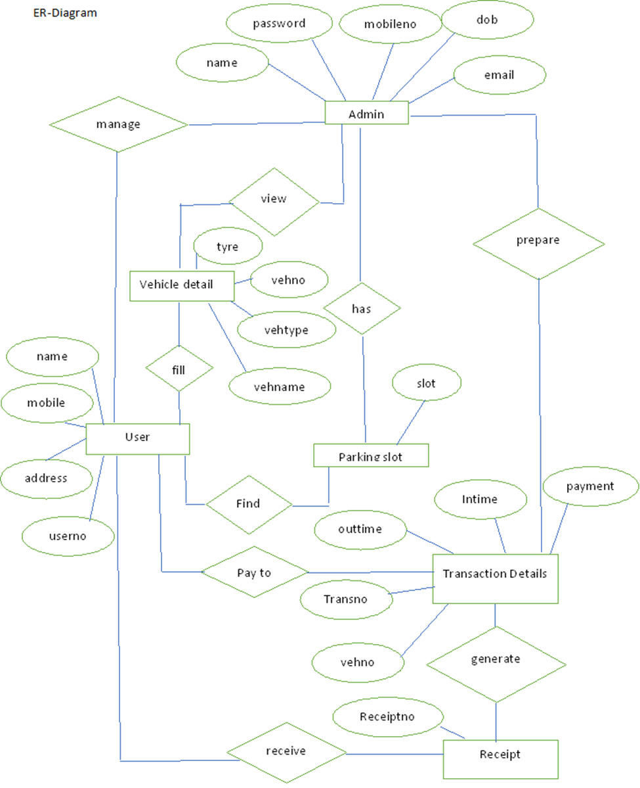

**CLASS DIAGRAM**

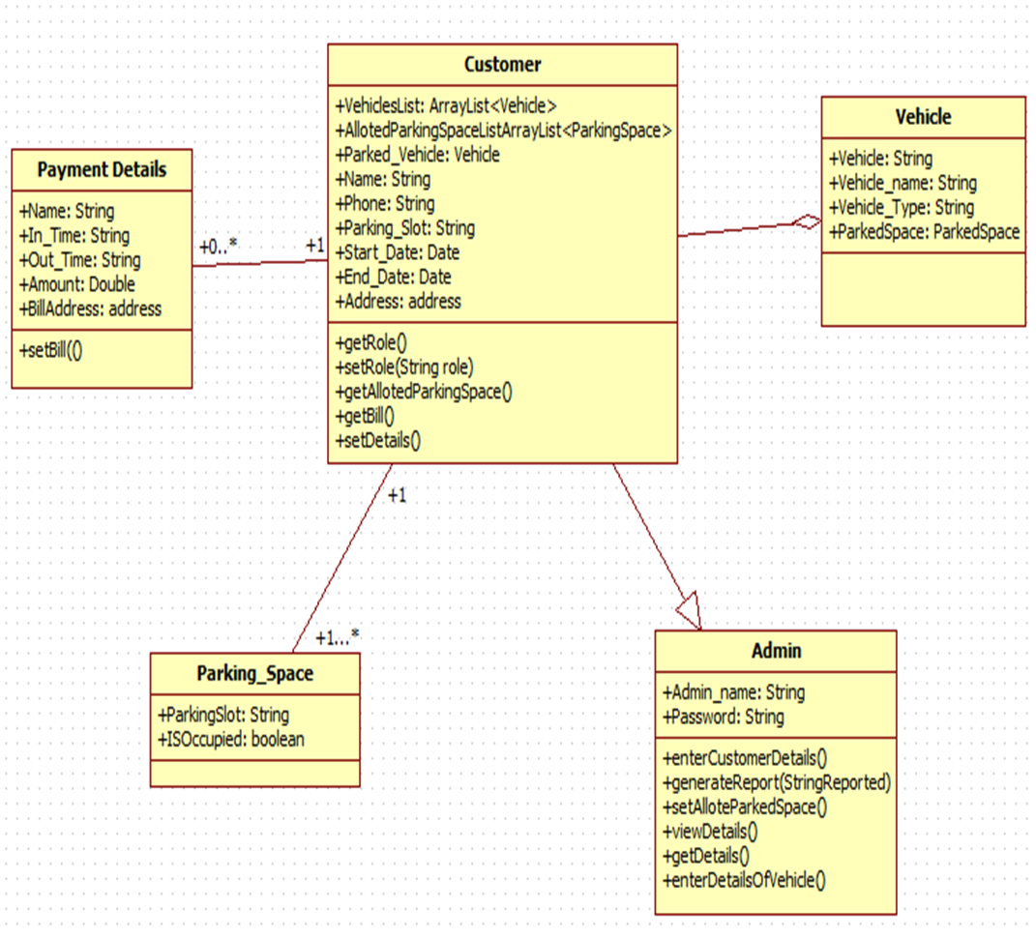

**EXPECTED OUTPUT**

**FUTURE SCOPE**

In the modern age. Many people have vehicles. Vehicle is now a basic need. Every place is under the process of urbanization. There are many corporate offices and shopping centers etc. There are many recreational places where people used to go for refreshment. So, all these places need a parking space where people can park their vehicles safely and easily. Every parking area needs a system that records the detail of vehicles to give the facility. These systems might be computerized or non-computerized. With the help of computerized system we can deliver a good service to customer who wants to park their vehicle into the any organization’s premises.

Vehicle parking management system is an automatic system which delivers data processing in very high speed in systematic manner. Parking is a growing need of the time. Development of this system is very useful in this area of field. We can sell this system to any organization. By using our system they can maintain records very easily. Our system covers the every area of parking management. In coming future there will be excessive need of Vehicle parking management system.

**CONCLUSION**

Smart Parking Management System (SPMS) is used to book parking slots without any great effort by the user using an android device. The user can check the status of parking area and book the parking slot in advance. This will result in overcoming many problems which are being created due to the bad management of the traffic. Mobile computing has proven as the best area of work for researchers in the areas of database and data management so this application is applied in Android Mobile OS. This application is utilized by can be applied nook and corner due to its easy usage and effectiveness.

**REFERENCE**

[1] Faiz Ibrahim Shaikh, Pratik Nirnay Jadhav, Saideep Pradeep Bandarkar, Omkar Pradip Kulkarni, Nikhilkumar B. Shardoor “Smart Parking System Based on Embedded System and Sensor Network”, International Journal of Computer Applications (0975 – 8887) Volume 140 – No.12, April 2016 International Journal of Pure and Applied Mathematics Special Issue 171.

[2] Thanh Nam Pham1, Ming-Fong Tsai1, Duc Binh Nguyen1, Chyi-Ren Dow1, And Der-Jiunn Deng2 “A Cloud-Based Smart-Parking System Based on Internet-of-Things Technologies”,IEEE Access, Received July 24, 2015, accepted August 16, 2015, date of publication September 9, 2015, date of current version September 23, 2015.

3] El Mouatezbillah Karbab, Djamel Djenouri, Sahar Boulkaboul, Antoine Bagula, CERIST Research Center, Algiers, Algeria University of the Western Cape, Cape town, South Africa,”Car Park Management with Networked Wireless Sensors and Active RFID”„,978-1-4799-8802-0/15 ©2015 IEEE.

[4] Mr. Basavaraju S R “Automatic Smart Parking System using Internet of Things (IOT)”, (International Journal of Scientific and Research Publications, Volume 5, Issue 12, December 2015) .

[5] M. M. Rashid, A. Musa, M. Ataur Rahman, and N. Farahana, A. Farhana, “Automatic Parking Management System and Parking Fee Collection Based on Number Plate Recognition.”, International Journal of Machine Learning and Computing, Vol. 2, No. 2, April 2012,Published 2014.

[6] Hilal Al-Kharusi, Ibrahim Al-Bahadly, “Intelligent Parking Management System Based on Image Processing”, World Journal of Engineering and Technology, 2014, 2, 55-67.

[7] X. Zhao, K. Zhao, and F. Hai, ``An algorithm of parking planning for smart parking system,'' in Proc. 11th World Congr. Intell. Control Autom. (WCICA), 2014, pp. 4965_4969.

[8] L. Mainetti, L. Palano, L. Patrono, M. L. Stefanizzi, and R. Vergallo,``Integration of RFID and WSN technologies in a smart parking system,''in Proc. 22nd Int. Conf. Softw., Telecommun. Comput. Netw. (SoftCOM), 2014, pp. 104_110.

[9] Harmeet Singh, Chetan Anand, Vinay Kumar, Ankit Sharma, “Automated Parking System With Bluetooth Access”, International Journal Of Engineering And Computer Science ISSN:2319-7242,Volume 3 Issue 5, May 2014, Page No. 5773-5775