A Tale of Two Futures: AI-Driven Growth vs. Foundational Industrialization
A Theoretical Analysis | Current Time: 2026-03-20 13:05:17 Friday
The global economy stands at a pivotal juncture, directing an unprecedented surge of capital towards artificial intelligence. In 2025 alone, total AI spending is projected to approach $0.5 trillion, with AI firms having already captured a staggering 61% of all global venture capital. This intense focus on the digital frontier begs a profound theoretical inquiry: what if this immense capital, along with the intellectual and human resources it commands, were instead redirected towards massive physical industrial and infrastructure projects designed to address humanity's most pressing foundational challenges? This analysis explores this hypothetical alternate timeline, contrasting the "Software/Intelligence Multiplier" with the "Physical/Hardware Capacity Multiplier," and evaluating their respective impacts on living standards, sustainability, and the fundamental bottlenecks of human progress.

The Software/Intelligence Multiplier (Current Reality: AI)
In our current timeline, AI is lauded as the ultimate intelligence multiplier. Investment focuses on developing algorithms, training large language models (LLMs), and building the digital infrastructure necessary to house these computational behemoths. This approach promises to catalyze progress by augmenting human intellect and automating complex tasks.

Promises of the AI Trajectory
- Productivity and Efficiency Boost: AI is demonstrating significant potential to enhance productivity across various sectors. The IMF notes that almost 40% of global employment is exposed to AI, with advanced economies facing both risks and opportunities. Businesses are investing heavily in AI for cost reduction, with 93% of leaders planning to do so within 18 months and some already seeing 10-19% cost reductions in supply chain management.
- Industry Transformation and Economic Growth: From healthcare to finance, AI is reshaping how work is done by enabling "smarter" software that can predict trends, personalize services, and create new digital products. This investment is already a significant driver of GDP growth, with some metrics in 2025 comparable to or exceeding the dot-com boom.

The Hidden Costs and Challenges
This rapid digital expansion comes with considerable physical costs. The AI boom is fundamentally a hardware boom, creating enormous demands and unforeseen challenges:
- Massive Capital Expenditure: Cumulative global investment in AI-specific hardware is projected to exceed $1.4 trillion over the next decade, with 70-80% of hyperscaler capital expenditure now AI-related. This creates risks of capital concentration and rapid hardware obsolescence.
- Intensive Environmental Footprint: AI's insatiable demand for energy and water creates a significant environmental burden. The International Energy Agency (IEA) estimates global data center electricity demand could more than double by 2030, while US data centers alone could consume 9% of the nation's power. This demand, if met by fossil fuels, could actively counteract climate goals.
- Deepening Inequality: The IMF warns that AI could worsen inequality both within and between nations, as its benefits may disproportionately accrue to high-skilled workers and wealthier economies that possess the infrastructure to harness it.
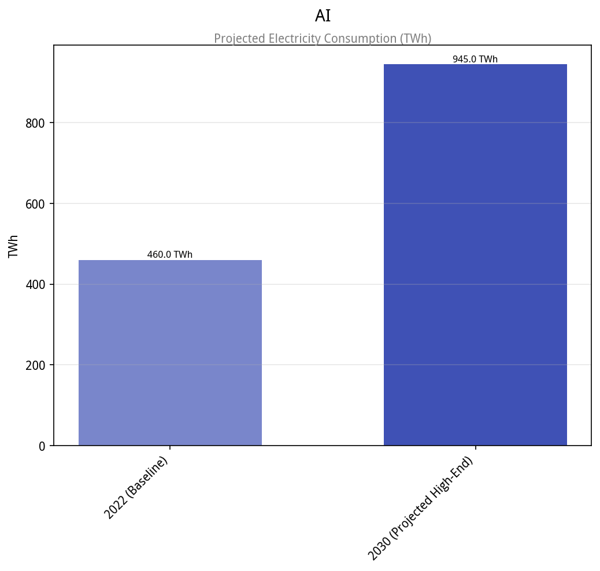

The Physical/Hardware Capacity Multiplier (Alternate Timeline: Industrial)
In an alternate timeline, the $0.5 trillion in annual AI spending is redirected towards foundational physical projects. This scale of investment is comparable to the $0.6 trillion per year that BNEF estimates is needed to achieve global Net Zero by 2050. This "Physical/Hardware Capacity Multiplier" focuses on expanding the fundamental carrying capacity of civilization.

Four Pillars of a Foundational Industrial Push

1. Energy: A Global 'Apollo Program' for Clean Power
The Multiplier: A concerted global push for a 100% renewable grid, supplemented by a massive R&D program for nuclear fusion. Recent momentum in fusion, with over $9 billion in private VC and major government commitments, suggests viability is closer than ever. Commercial fusion could supply 10-50% of global electricity by 2100, generating trillions in societal value.
The Impact: A stable, near-limitless supply of clean energy would drastically lower energy costs, eliminate the largest source of greenhouse gas emissions, and reduce geopolitical dependencies on fossil fuels, creating millions of jobs across all skill levels.

2. Transport: Worldwide High-Speed Vacuum/Rail Network
The Multiplier: Connecting major economic hubs with ultra-fast, carbon-neutral transport systems like Hyperloop or Maglevs, capable of speeds exceeding 1,125 km/h. These systems are more energy-efficient than air travel and can run entirely on renewable energy.
The Impact: This would revolutionize logistics, trade, and personal mobility, shrinking the globe, reducing transportation emissions, and fostering regional development by making distant areas more accessible.

3. Resources: Solving Global Water Scarcity and Food Insecurity
The Multiplier: Investment in large-scale desalination plants, advanced water recycling, and efficient irrigation to tackle water stress, which affects 2.4 billion people. Simultaneously, a push for industrial-scale automated vertical farming would enable hyper-efficient, localized food production with minimal land and water use.
The Impact: This would directly address the fundamental human needs of clean water and food security, stabilizing regions prone to conflict over resources, improving public health, and making populations more resilient to climate shocks.

4. Space: Permanent Moon Bases and Orbital Manufacturing
The Multiplier: Instead of training next-generation LLMs, this capital could establish permanent lunar habitats and orbital factories. The lunar economy is projected to exceed €142 billion by 2040, focusing on resource utilization (water ice, metals) and advanced manufacturing in microgravity.
The Impact: This would unlock a new frontier for humanity, providing strategic resources for Earth, creating entirely new industries, and fostering a long-term vision for our species' expansion beyond its home planet.
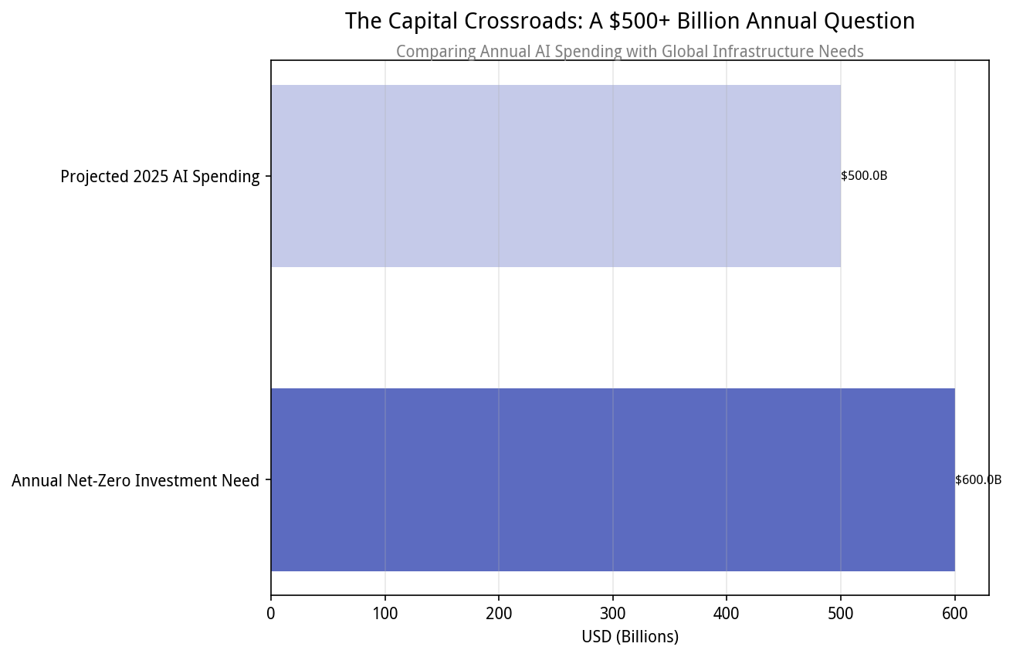

Comparative Analysis: Two Visions of Progress

Global Standards of Living: 'Smarter' Software vs. 'Cheaper' Physical Goods
The choice between these timelines presents a fundamental question about the nature of progress. Our current path emphasizes digital convenience, hyper-personalized services, and intellectual augmentation. Life becomes increasingly mediated by intelligent systems. However, this risks prioritizing informational wealth over tangible well-being, especially for those whose labor is displaced or who lack access to advanced technology. The cost of basic living may remain high.
The alternate path prioritizes foundational abundance. Universal access to clean, affordable energy, plentiful fresh water, and high-quality food would directly elevate the baseline standard of living for billions. It focuses on reducing the cost of *basic necessities* rather than primarily enhancing digital experiences. This timeline offers a more physically secure, resource-rich, and equitable existence.

Sustainability: Which Path Solves the Climate Crisis Faster?
The AI-first path offers powerful tools for climate action: optimizing renewable grids, accelerating materials discovery for batteries, and enhancing climate modeling. However, it presents a dangerous paradox. Its own massive and rapidly growing energy and water demands create a significant counter-challenge.
"The rapid growth of AI infrastructure could make net-zero targets harder to reach if decarbonization does not catch up with the computing demand."
The industrial path, by contrast, directly confronts the climate crisis through systemic, physical solutions. A global fusion and 100% renewable grid is the ultimate answer to decarbonization. While the construction would have an initial environmental impact, the *goal* is to build inherently sustainable systems. It offers a more direct, if slower, route to climate resilience.

The 'Bottleneck' Problem: Is Our Bottleneck Intelligence or Physical Capacity?
This is the most critical distinction. The AI-centric view assumes our primary bottleneck is a lack of "intelligence" to solve problems. Yet, as AI capabilities advance, their deployment is increasingly constrained by physical and institutional realities.
"The bottleneck is the world, not the model."
AI's dependence on massive energy supplies, robust grid infrastructure, critical materials, efficient cooling, and streamlined permitting processes means that purely intellectual advancements are outpacing the physical capacity to deploy them. The demand for AI is creating tension in supply chains, workforce availability, and grid reliability.
The alternate, industrial-focused timeline posits that a lack of abundant clean energy, accessible fresh water, and efficient transport are the true limiting factors to human flourishing. By investing in these areas, this timeline aims to fundamentally expand the physical envelope of human civilization, creating a new era of material abundance that can then be optimized and leveraged by intelligence—including any future AI developed within this more robust physical framework.

Conclusion: An Integrated Future
The theoretical analysis reveals two profoundly divergent visions for human progress. Our current AI-centric trajectory promises to unlock unprecedented intellectual capabilities but faces growing challenges related to its environmental footprint, its potential to exacerbate inequality, and its deep reliance on a physical infrastructure it is already beginning to strain.
The alternate timeline, prioritizing massive physical industrial and infrastructure projects, offers a vision of foundational abundance. It directly tackles existential threats like climate change and resource scarcity, aiming to build a physically resilient and resource-rich world that removes many of today's "real-world" bottlenecks.
Ultimately, an optimal future might necessitate a strategic fusion of both approaches. Leveraging AI's formidable intellectual multiplier to design, optimize, and accelerate the implementation of large-scale physical infrastructure projects could represent the most robust path forward. This integrated strategy would harness "smarter" software to build a world of "cheaper" and more abundant physical goods and energy, creating a sustainable, equitable, and flourishing global civilization. The choice is not merely between software and hardware, but about prioritizing the foundational elements of well-being while intelligently deploying advanced tools for their realization.

