Document Generated: 2026-03-23 11:52:39

iVenture Studio
A Formal Go-to-Market Strategy for the United States Market

Executive Summary
This document outlines the strategic Go-to-Market (GTM) plan for iVenture Studio's entry into the United States market. Our mission is to empower US-based Solopreneurs, AI-Native Agencies, and Small-to-Medium-sized Businesses (SMBs) with our groundbreaking no-code autonomous executive teams. Offered as an "Agents-as-a-Service" (AaaS) model, our platform is built on a foundation of NVIDIA NemoClaw-hardened security, ensuring enterprise-grade safety and reliability.
Our strategy is multifaceted, focusing on a precisely defined target market, a compelling value proposition, and a unique cultural narrative that bridges Icelandic resilience with the American entrepreneurial spirit. We will establish trust through a robust commitment to US compliance standards, including the US AI Executive Order and the NIST AI Risk Management Framework, coupled with a strict US-based data residency policy. A competitive tiered pricing model is designed to facilitate adoption and scale with our customers' growth. The phased roadmap detailed herein ensures a structured, strategic rollout, from initial market foundation to achieving market leadership.

Market Analysis & Target Audience
The US market presents a significant opportunity for iVenture Studio. Our target audience consists of three core segments, each with distinct needs and pain points that our AaaS platform is uniquely positioned to solve.

Target Segment 1: Solopreneurs
Profile: A rapidly growing demographic of single-person businesses, freelancers, and consultants. They are agile and ambitious but are often overwhelmed by the need to manage all aspects of their business—from strategy and marketing to finance and operations.
Pain Points:
- Resource Limitation: Inability to hire specialized staff due to budget constraints.
- Operational Overload: Spending excessive time on administrative tasks instead of core, revenue-generating activities.
- Scalability Challenge: Difficulty growing the business beyond the founder's personal capacity.
iVenture Solution: Our autonomous agents (e.g., an AI Marketing Lead, an AI Operations Manager) act as a force multiplier, automating complex tasks and providing strategic insights, allowing solopreneurs to function like a larger, more structured organization at a fraction of the cost.

Target Segment 2: AI-Native Agencies
Profile: Modern, tech-forward marketing, creative, or consulting agencies that leverage AI as a core part of their service delivery. They are sophisticated users who demand powerful, reliable, and secure AI tools.
Pain Points:
- Development Overhead: The high cost and complexity of building, securing, and maintaining a proprietary AI agent framework.
- Security & Reliability Concerns: Need for a robust backend that can be trusted with sensitive client data and deliver consistent performance.
- Speed to Market: Desire to rapidly prototype and deploy new AI-powered services for their clients without being bogged down by infrastructure development.
iVenture Solution: Our AaaS platform provides the secure, scalable, and pre-built infrastructure these agencies need. By integrating iVenture Studio, they can focus on client strategy and service innovation, leveraging our NVIDIA NemoClaw-hardened agents as the engine for their offerings.

Target Segment 3: SMBs (1-10 Employees)
Profile: The backbone of the US economy, these small businesses are characterized by their ambition to grow and compete against larger incumbents. They are cost-conscious but recognize the need for technology to gain a competitive edge.
Pain Points:
- Talent Gap: Inability to afford a full executive team (e.g., CMO, CFO, COO).
- Competitive Disadvantage: Lacking the strategic horsepower and operational efficiency of larger corporations.
- Complexity of Tools: Overwhelmed by a fragmented landscape of single-purpose software tools that don't communicate with each other.
iVenture Solution: We offer a "C-Suite in a box" with our no-code autonomous executive teams. SMBs can deploy an AI agent to oversee marketing campaigns, analyze financial health, or optimize operational workflows, leveling the playing field and enabling data-driven decisions without the enterprise-level headcount.

Value Proposition & Cultural Alignment

Core Value Proposition
iVenture Studio delivers autonomy, security, and scalability to the American entrepreneur. We provide a no-code platform for deploying autonomous executive agent teams, democratizing access to the strategic capabilities previously reserved for large enterprises.
- No-Code Autonomous Executive Teams: Users can, without writing a single line of code, assemble and deploy AI agents that perform the functions of key executive roles. This moves beyond simple task automation to strategic oversight and execution.
- Agents-as-a-Service (AaaS): Our flexible subscription model allows businesses to scale their "AI workforce" up or down as needed, ensuring they only pay for the capacity they require. This provides unparalleled agility.
- NVIDIA NemoClaw-Hardened Security: Security is not an afterthought; it is our foundation. By leveraging NVIDIA's state-of-the-art framework for testing and securing generative AI models, we provide our users with verifiable protection against adversarial attacks, data leakage, and model vulnerabilities, building a critical layer of trust.

Cultural Alignment: The Icelandic-American Frontier Spirit
To build a genuine connection with the US market, we will anchor our brand narrative in a shared history of resilience and pioneering. This is not merely marketing; it is an authentic reflection of our company's origins and ethos.

Metaphor of Resilience: The 1973 Heimaey Eruption
Our founder's story is one of profound resilience, forged in the fires of the 1973 Heimaey volcanic eruption in Iceland. When the earth split open, threatening to consume the town and its vital harbor, the islanders did not flee. They fought back. They pumped millions of tons of seawater onto the advancing lava flows, a bold and unprecedented feat of engineering and sheer will, ultimately saving the harbor and their way of life. They stared into the abyss and chose to build.
This spirit—of turning a catastrophic event into a foundation for a stronger future—is the same "Frontier Spirit" that defines the American entrepreneur. Every solopreneur, every agency founder, every SMB owner faces their own "volcano"—be it market disruption, financial hardship, or competitive pressure. iVenture Studio is the tool that helps them not just survive, but build, innovate, and triumph over adversity.

A Bridge of Trust: From Leif Erikson to Digital Pioneers
The connection between Iceland and America is historic, dating back over a millennium to when the Icelandic explorer Leif Erikson became the first European to set foot in North America. This was a journey of immense courage, vision, and a desire to explore new frontiers. We will respectfully evoke this shared history to position iVenture Studio as the modern inheritor of this pioneering legacy—venturing not across oceans, but into the new digital frontier of artificial intelligence, building a bridge of trust and partnership between our two nations.

Compliance, Security, and Trust
We recognize that for AI to be adopted, it must be trustworthy. iVenture Studio is committed to the highest standards of security, ethics, and regulatory compliance. This commitment is a core pillar of our product and our GTM strategy.
- Alignment with the US AI Executive Order: Our development and deployment principles are fully aligned with the White House Executive Order on the Safe, Secure, and Trustworthy Development and Use of Artificial Intelligence. We are dedicated to ensuring our AI systems are safe, interpretable, and beneficial.
- NIST AI Risk Management Framework (RMF): We proactively integrate the NIST AI RMF into our entire product lifecycle. This governs how we map, measure, and manage risks associated with our AI models, from initial design to ongoing operations, ensuring a structured approach to AI governance.
- US-Based Data Residency: To meet the stringent data sovereignty and privacy requirements of our US customers, all client data will be processed and stored exclusively within data centers located on US soil. This provides legal and regulatory certainty.
- Technology-Hardened Security: Our security posture is technologically enforced by NVIDIA NemoClaw. This advanced toolkit helps us systematically evaluate and mitigate a wide range of threats specific to large language models, including jailbreaking, prompt injection, and the generation of unsafe content, ensuring the integrity and safety of our autonomous agents.

Pricing Strategy
Our pricing is designed to be accessible, transparent, and scalable, enabling businesses of all sizes to leverage the power of autonomous AI. The four-tiered model supports customers from their initial spark of an idea to building a business empire.
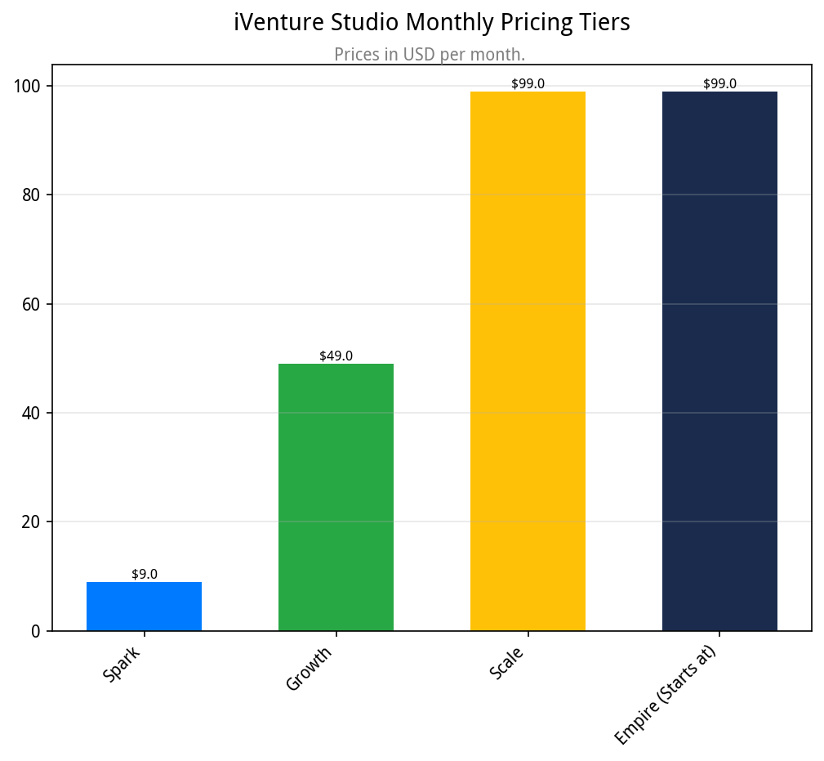

Tier Breakdown & Features
Tier | Monthly Price (USD) | Target User | Key Features
Spark | $49 | Solopreneurs & Hobbyists | - 1 Active Autonomous Agent  - Access to Core Agent Models  - Standard Support
Growth | $149 | Growing Solopreneurs & Small Teams | - Up to 5 Active Agents  - Advanced Agent Models  - Priority Support  - Basic Integrations
Scale | $299 | SMBs & AI-Native Agencies | - Up to 15 Active Agents  - Full Suite of Agent Models  - Team Collaboration Features  - Advanced Integrations
Empire | $999 | Established SMBs & Agencies | - Unlimited/Custom Agent Deployment  - API Access  - Dedicated Account Manager  - Enterprise-Grade Security & Compliance

Go-to-Market Roadmap
Our entry into the US market will be executed in a strategic, phased approach to build momentum, gather feedback, and ensure sustainable growth.

Phase 1: Foundation & Pre-Launch (Q2-Q3 2026)
- Activities: Finalize US legal entity and compliance documentation. Establish US-based data center infrastructure. Launch a closed beta program with a select group of 50-100 US-based solopreneurs and agencies to gather feedback and testimonials.
- Goal: Validate product-market fit, refine onboarding, and secure foundational social proof.

Phase 2: Official Launch & Market Penetration (Q4 2026 - Q1 2027)
- Activities: Execute public launch. Initiate targeted digital marketing campaigns on LinkedIn, Twitter, and relevant tech publications. Launch a PR campaign focused on the founder's story, our unique cultural angle, and our security-first approach. Engage with key influencers and podcasts in the SMB and AI space.
- Goal: Generate initial brand awareness, drive user acquisition for Spark and Growth tiers, and establish a strong market presence.

Phase 3: Scaling & Service Expansion (Q2-Q3 2027)
- Activities: Introduce new specialized agent roles based on user feedback (e.g., AI Legal Analyst, AI HR Coordinator). Develop and release API access for Empire-tier clients. Form strategic partnerships with complementary SaaS platforms (e.g., CRMs, accounting software).
- Goal: Increase customer lifetime value, drive upgrades to Scale and Empire tiers, and create a sticky ecosystem.

Phase 4: Market Leadership & Thought Leadership (Q4 2027 & Beyond)
- Activities: Host the inaugural "Autonomy Summit," a virtual conference for users and the broader AI community. Publish industry whitepapers and research on the impact of AaaS on small businesses. Launch a certification program for agencies building on the iVenture Studio platform.
- Goal: Solidify iVenture Studio's position as a thought leader and the market standard for autonomous AI business solutions.
© 2026 iVenture Studio. All Rights Reserved.
This document is confidential and proprietary to iVenture Studio.
  - Produced for: Genesis Node

