**OCR4all**

Training

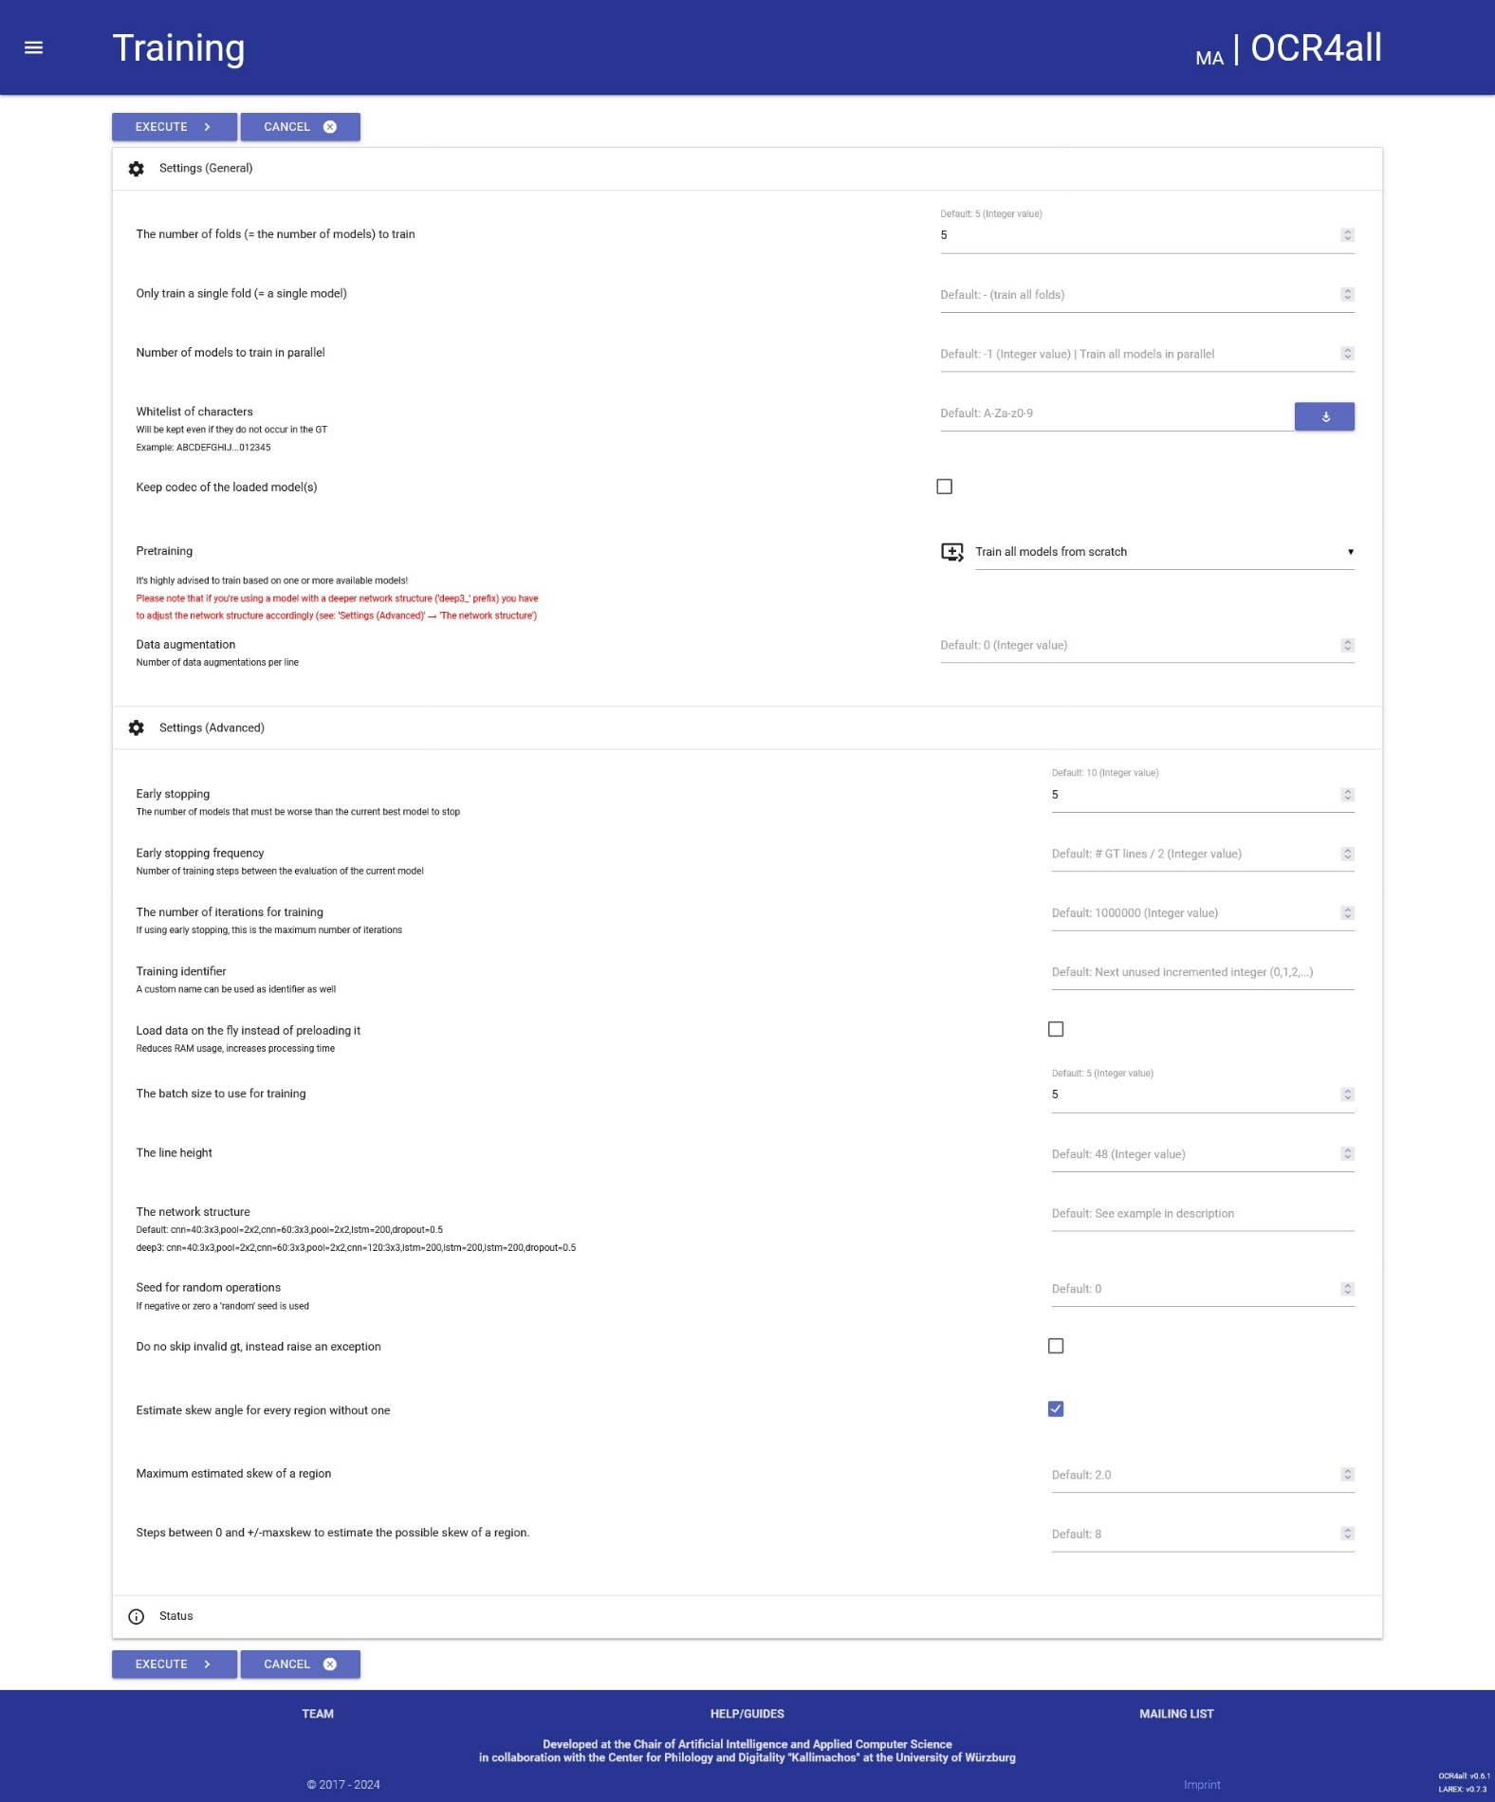

Einstellungen Trainingsmodell 1:

Settings (General)

1. Whitelist of characters: German default

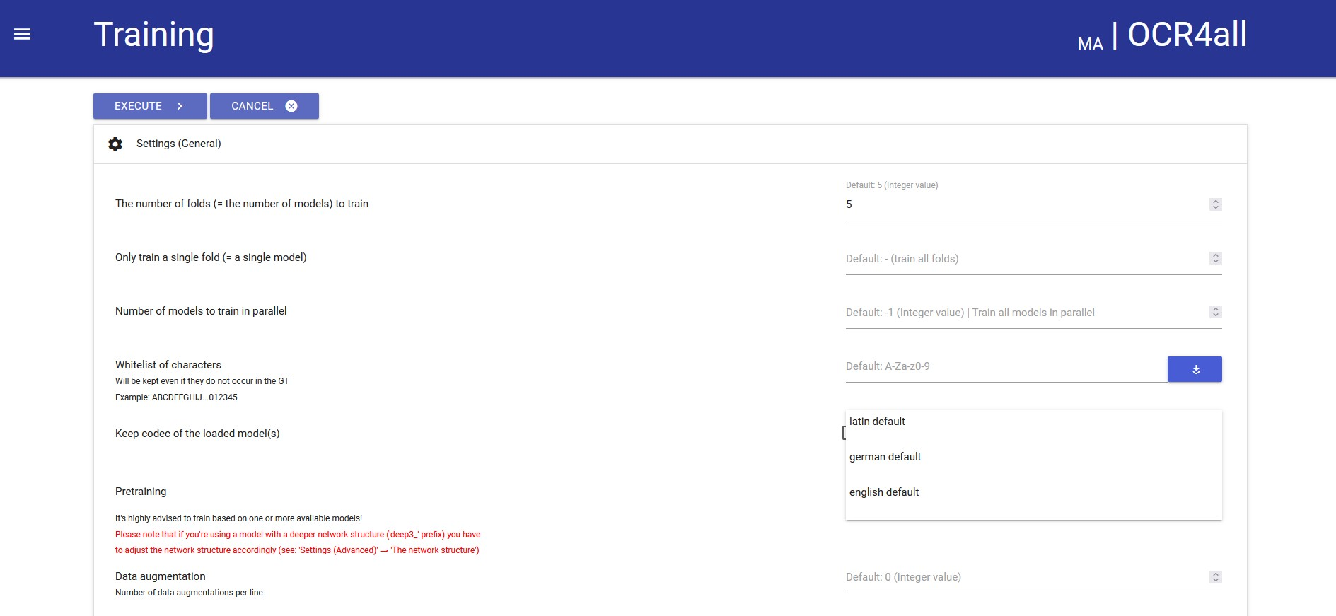

1. Keep codec of the loaded model(s): Haken gesetzt
2. Pretraining: Train each model based on different available models
3. Pretraining for model 1-5: default/deep3_antiqua-hist/0 bis default/deep3_antiqua-hist/4 ausgewählt

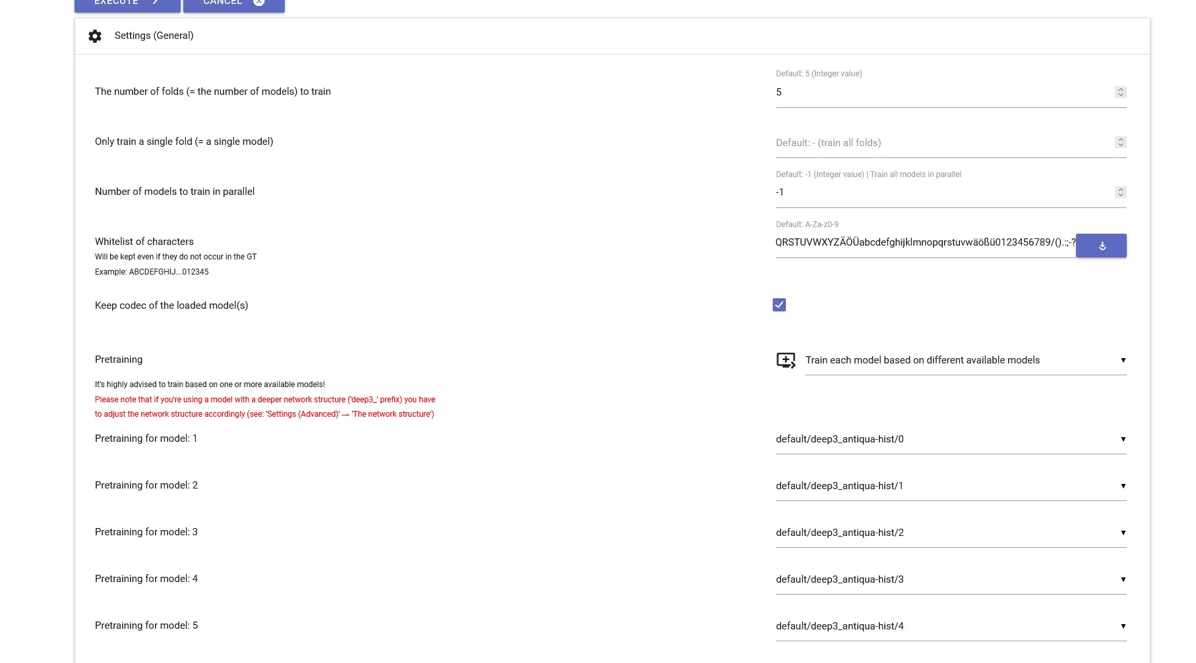

Settings (Advanced)

1. The network structure: deep3: cnn=40:3x3,pool=2x2,cnn=60:3x3,pool=2x2,cnn=120:3x3,lstm=200,lstm=200,lstm=200,lstm=200,dropout=0.5

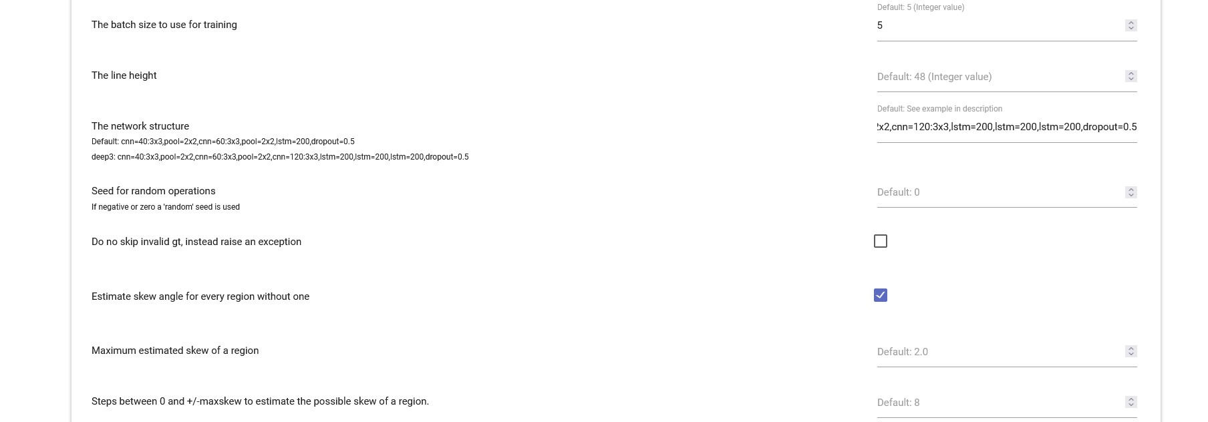

Einstellungen Trainingsmodell 2:

Settings (General)

1. Whitelist of characters: German default



1. Keep codec of the loaded model(s): Haken gesetzt
2. Pretraining: Train each model based on different available models
3. Pretraining for model 1-5: default/uw3-modern-english/0 bis default/uw3-modern-english /4 ausgewählt

