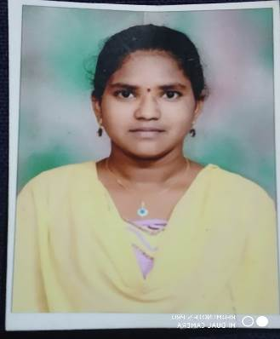**VIJAYALAKSHMI GUDURU**

**Contact :** 6305761120

**Email :** [vijayaguduru20**@gmail.com**](mailto:vijayaguduru20@gmail.com)

# CAREER OBJECTIVE

To be a part of such an organization to which helps me in enhancing my skills & to help in the growth of the organization.

# ACADEMICS

|  |  |  |  |  |
| --- | --- | --- | --- | --- |
| QUALIFICATION | INSTITUTE | BOARD/UNIVERSITY | YEAR OF PASSING | PERCENTAGE/CGPA |
| B. Sc (STAT) | CAREER DEGREE COLLEGE, GUNTUR | ACHARYA NAGARJUNA UNIVERSITY | 2019-2022 (pursuing) | 7.5 CGPA |
| INTERMEDIATE | SRICHAITANYA JR COLLEGE, GUNTUR | STATE BOARD OF INTERMEDIATE EDUCATION | 2017-2019 | 9.9 CGPA |
| S.S.C | YADAVA E.M HIGH SCHOOL, GUNTUR | STATE BOARD OF SECONDARY EDUCATION | 2016-2017 | 9.7 CGPA |

**TECHNICAL SKILLS**

* Basic knowledge in C Programming , JAVA and HTML
* Subjects Interested: Statistics and web technology

# ACHIEVEMENTS

* Elected as SPL in High School
* Received Scholarships from TULASI SEEDS and YKR Memorial Scholarships
* I got RASHTRA BHASHA certificate from DBPS

# PERSONAL PROFILE

* Date of Birth : 20-11-2001

|  |  |  |
| --- | --- | --- |
| ● | Father’s Name | : GUDURU SIVAJI |
| ● | Mother’s Name | : GUDURU DURGA |
| ● | Permanent Address | : D.No.16/11/14,Chennamvari Street, Old Guntur, Guntur, Andhra Pradesh, Pin : 522001. |
| ● | Hobbies | : Listening music, cooking and making crafts. |
| ● | Nationality | : INDIAN |
| ● | Languages Known | : Telugu, English. |

* Strengths : Leadership Qualities, Adaptability and Flexibility

# PROJECT DETAILS

● Project Title : NEWS PORTAL PROJECT IN PHP AND MYSQL

|  |  |  |
| --- | --- | --- |
| ● | User Interface Design | : HTML,JAVA SCRIPT,CSS |
| ● | Software | :Xampp |
| ● | Database | :MySql 5.x |
| ● | Description | : The main objective of News portal system is |
|  |  | to manage the details of Latest posts, types, |
|  |  | Contents. It’s contain web pages that are  Generated in real-time |

# DECLARATION

I hereby declare that all the above-mentioned information is true and correct to the best of my knowledge

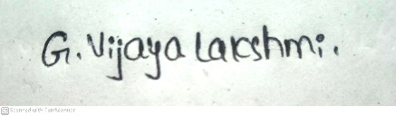**PLACE :** GUNTUR.

(VIJAYALAKSHMI GUDURU).