Report Midterm Exercise CNN Lab on hardware-software codesign
  - Gaëtan Jenni

Initial Hardware
For the first design, the objective was to just have something fully functional, without any optimizations.
An issue blocked me during more than a week. Everything was working in the C-testbench in Vitis, also in the template to test the 2D convolution. Everything was also correct in my software (allocate DMA memory, etc…). It was therefore hard to find out what was the issue.
I verified the register’s addresses with the Vivado debugger, and everything seemed correct:
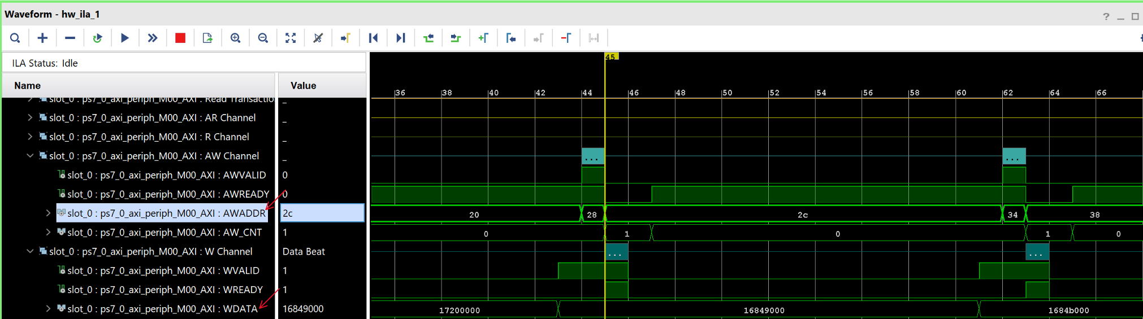
I finally found that the issue was because I defined the type of the TFXP and TFXP_MULT as unsigned instead of signed in the HLS application.
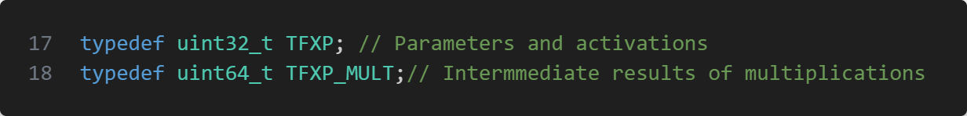
What is weird is why the template to test the 2D convolution was working. It seems to test only unsigned values, but I didn’t invest more time to know why this template was not working.

HW2 - caching filters coefficients
The access to the memory is taking a lot of clock cycle, so if we success to reduce this number to the minimum. To do that a good solution is to retrieve memory data and save in the cache with some buffers.
We can calculate first the number of memory access done by the initial hardware to access the filters coefficients:
$$Naccess=numFilters*numChannels*inputWidth*inputHeght*9$$
But these filter’s coefficients are the same for all the inputWidth and inputHeight, so we can reduce this number of accesses a lot if we cache for each filter all the coefficients needed:
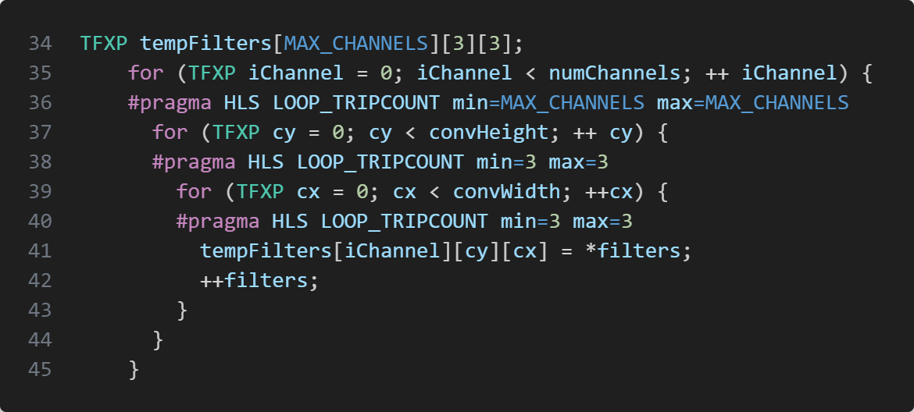
With this modification the number of accesses to the memory for the filter’s coefficient is reduced to:
$$Naccess=numFilters*numChannels*9$$
We can see in the result array that it as expected also reduces the total time of the CNN application, because the convolution time is a lot reduced.

HW3 - Caching input rows
Then we can do the same things with the input rows. The initial number of accesses is the following:
$$Naccess=numFilters*numChannels*inputWidth*inputHeght*9$$
The specificity for the inputs is that we first access to the first 3 rows, and the row 2-3-4, and then 3-4-5, like a moving average. We can therefore reuse each time the 2 last rows instead of reading them in the memory again:
Initialization of the first 3 rows (done for each new filter):
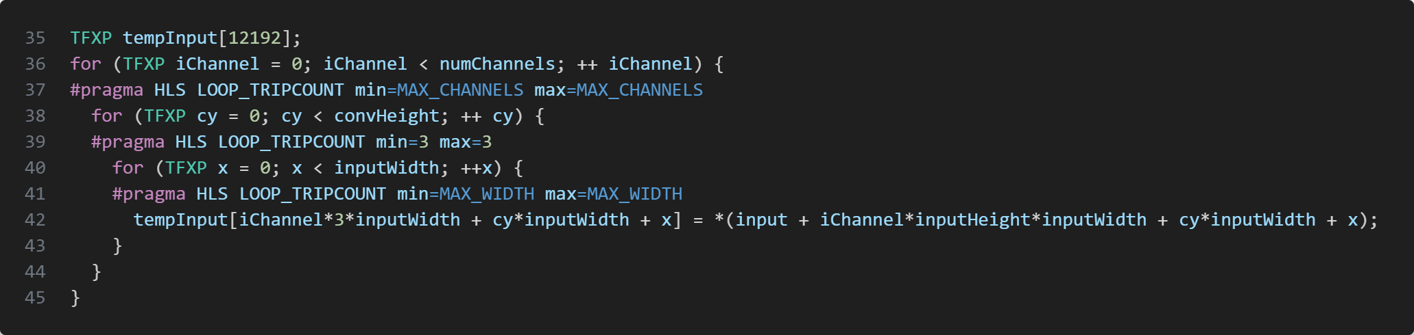
The 12192 number is calculated by retrieving his maximum value (calculated in the array of maximum array size further).
Then, each time we need a new row of pixels (so when y increase by one), we retrieve it from the memory, but the 2 other rows remain in cache:
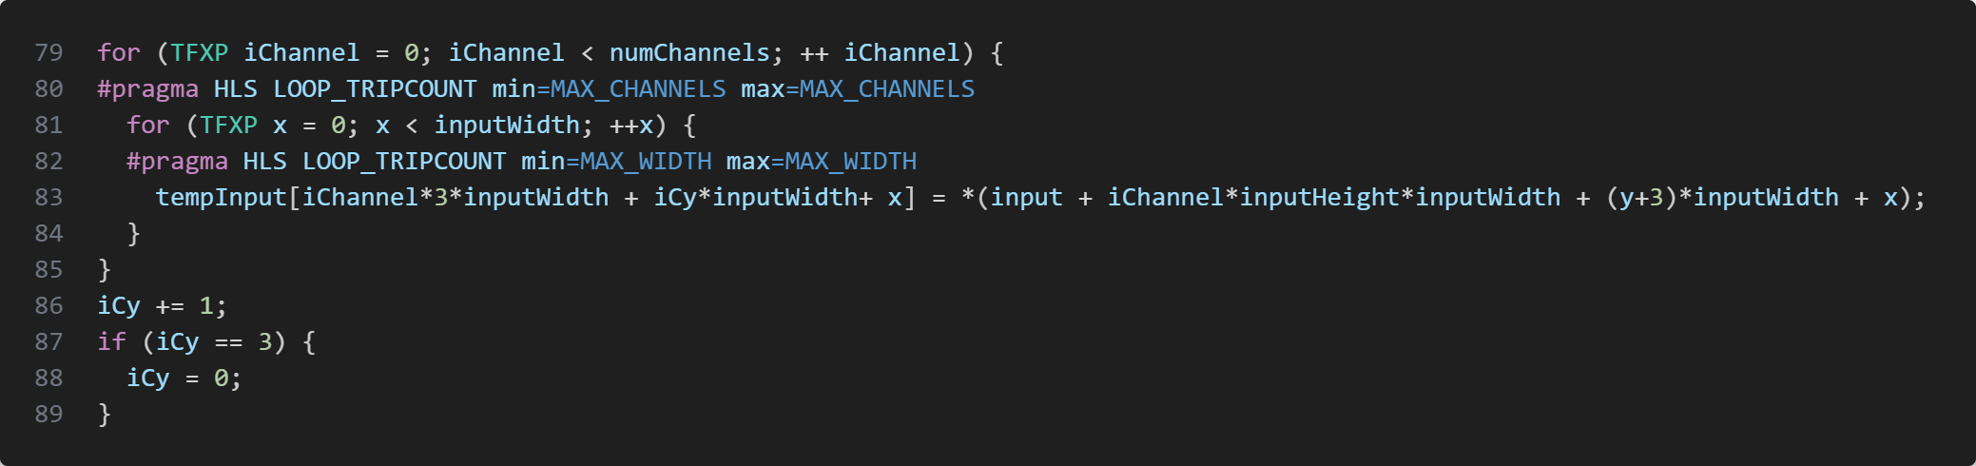
The iCy is there to know at which index is the first row to use.
The number of accesses to the memory for the input is now:
$$Naccess=numFilters*numChannels*inputWidth*(3+inputHeight)$$
The number of accesses to memory is therefore a lot reduced now.
(I noticed later that this was the objective of the point 2.4 : “Optional: Re-use of the caching of the previous rows”, but I directly implemented it by thinking it was already the objective of the point 2.2).

HW4 – Parallelize the computation of the 9 multiply-accumulate
To be able to parallelize the computation of the 9 multiply-accumulate calculation, we need to first partition the 2 arrays where the coefficients and the input values are saved. The type of the partition must be “cycle” to access the first 9 values in one cycle:
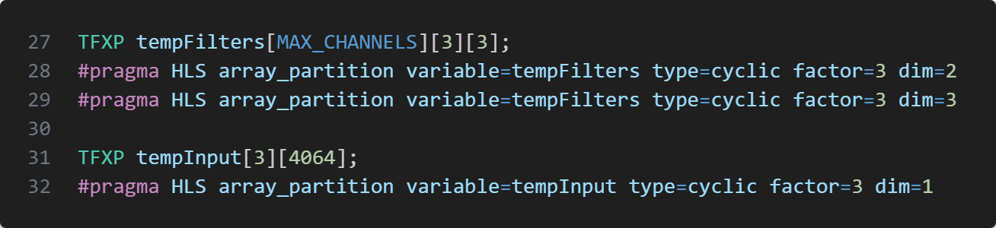
Then we can unroll the 2 convolution loop by 3:
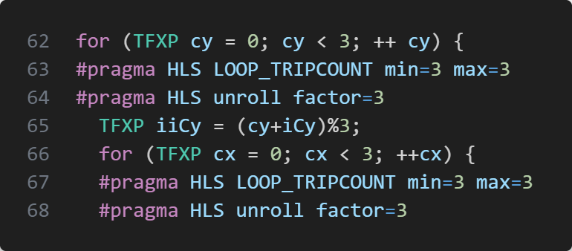
I noticed that I needed to replace the “convWidth” and “convHeight” variables by 3 to have a constant number of loops. Without it Vitis was not able to unroll the loop.
We can clearly see in the scheduler viewer the parallelization of the 9 multiplications (the multiplication is named by “res”):
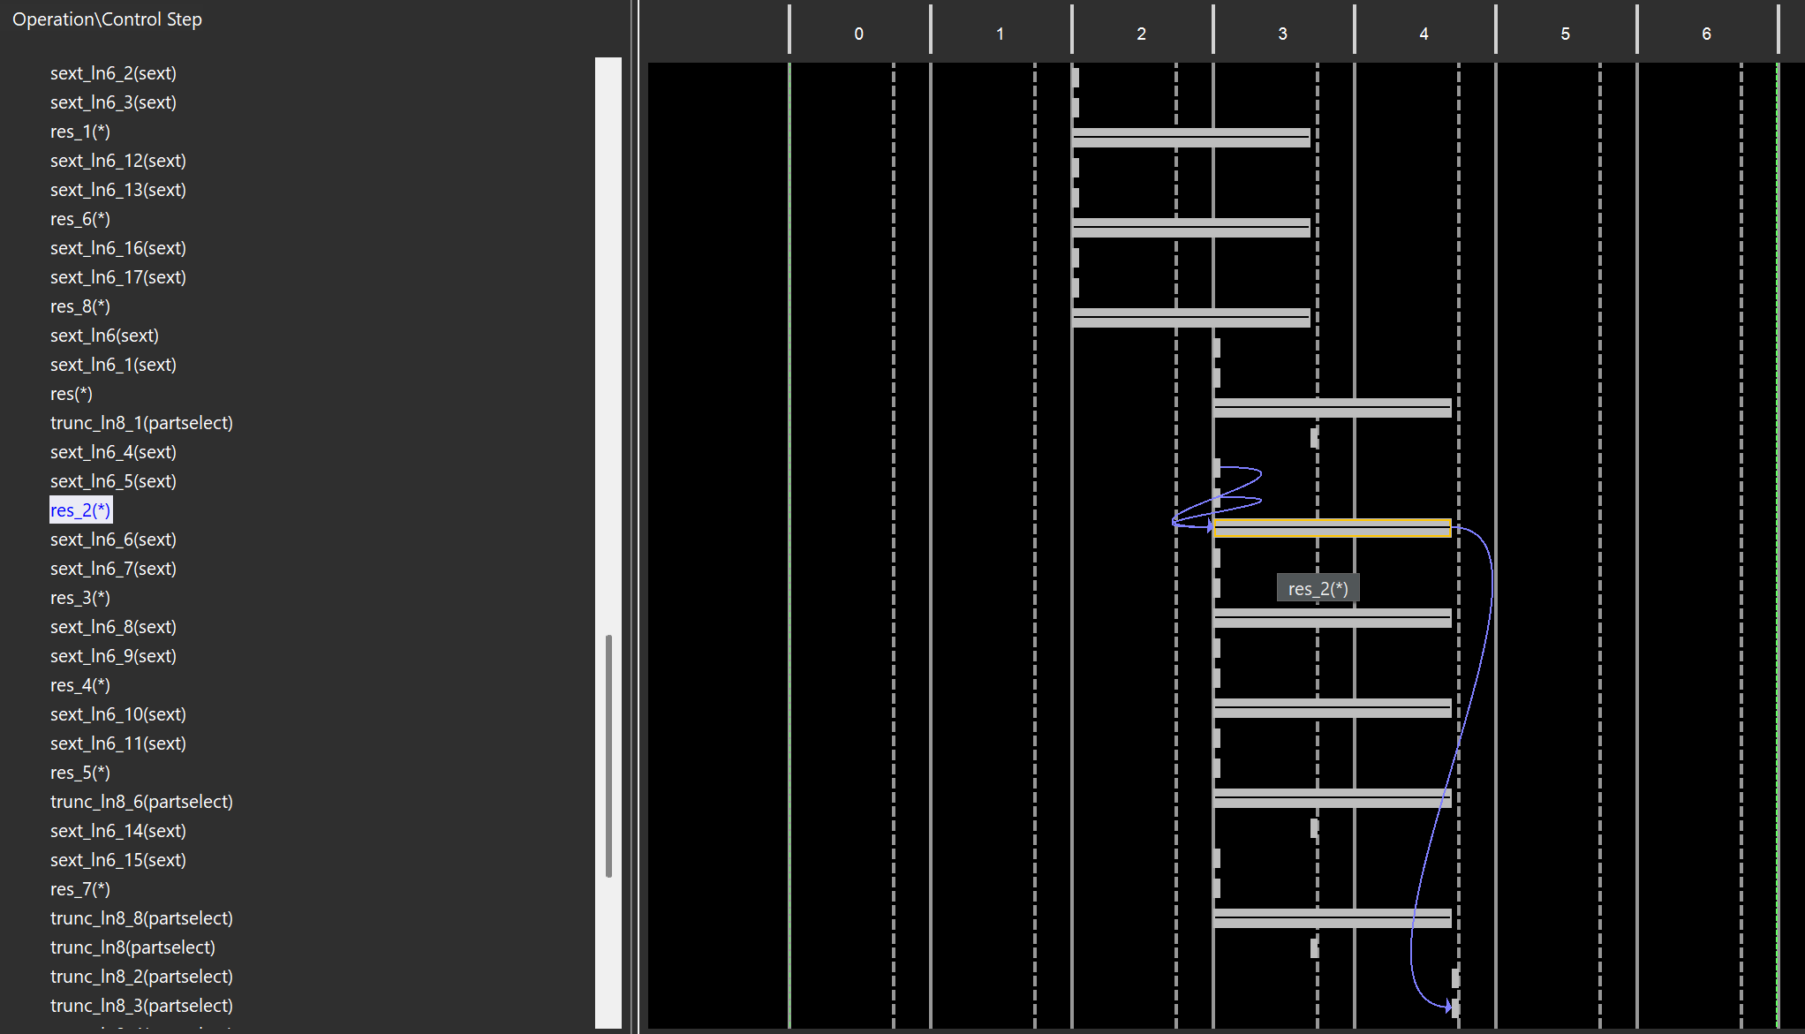
The 9 multiplications are not 100% parallel but pipelined, 3 are starting in cycle 2 and the 6 others in cycle 3.
These updates divide the total convolution time by nearly 9, as expected.

HW5 – Parallelizing the computation of output filters
The next step was to implement the parallelization of several output filters. To be able to do that, the filters coefficients need to be stored not only for one filter but for several one:
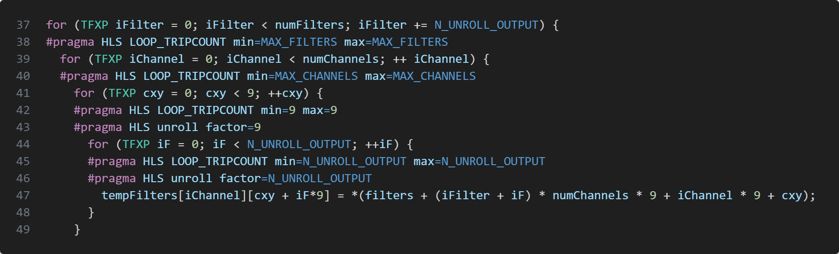
We can see that we also change the number of filters to increase at each loop (red arrow).
The partition of the tempFilters array need therefore to be changed to be able to unroll 9*N_UNROLL_OUTPUT (which is the number of output filters we want to unroll):
The accumulation variable is therefore also partitioned by the number of unroll output.
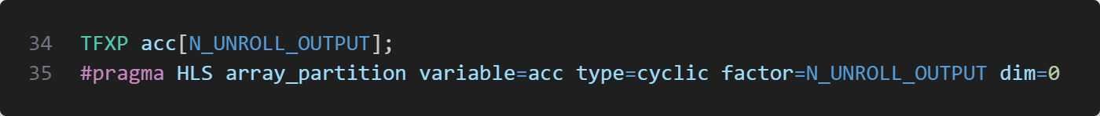
Then we can try to unroll the loop that makes the 9 multiplications:
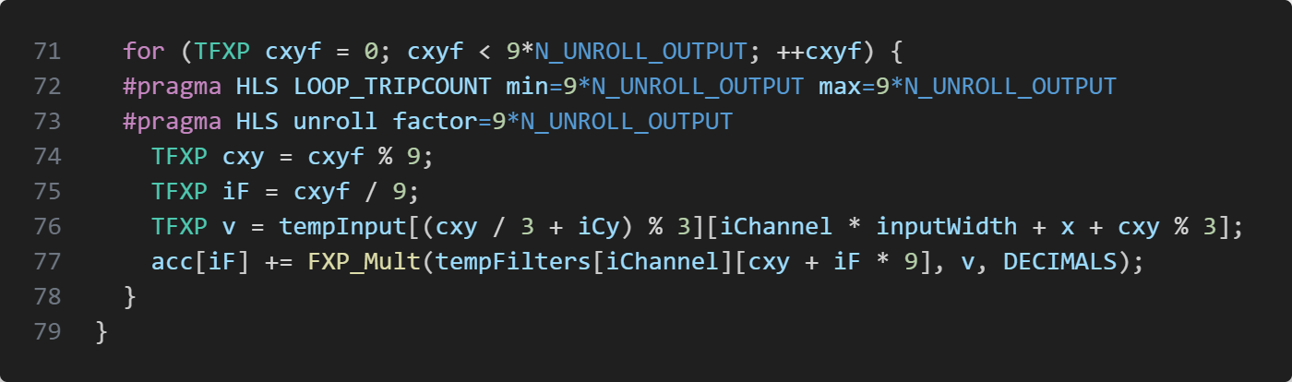
I defined N_UNROLL_OUTPUT with 4. We can see in the schedule viewer the 9*4 multiplications parallelized but like before everything is done in 3 cycles because Vitis pipelined them.
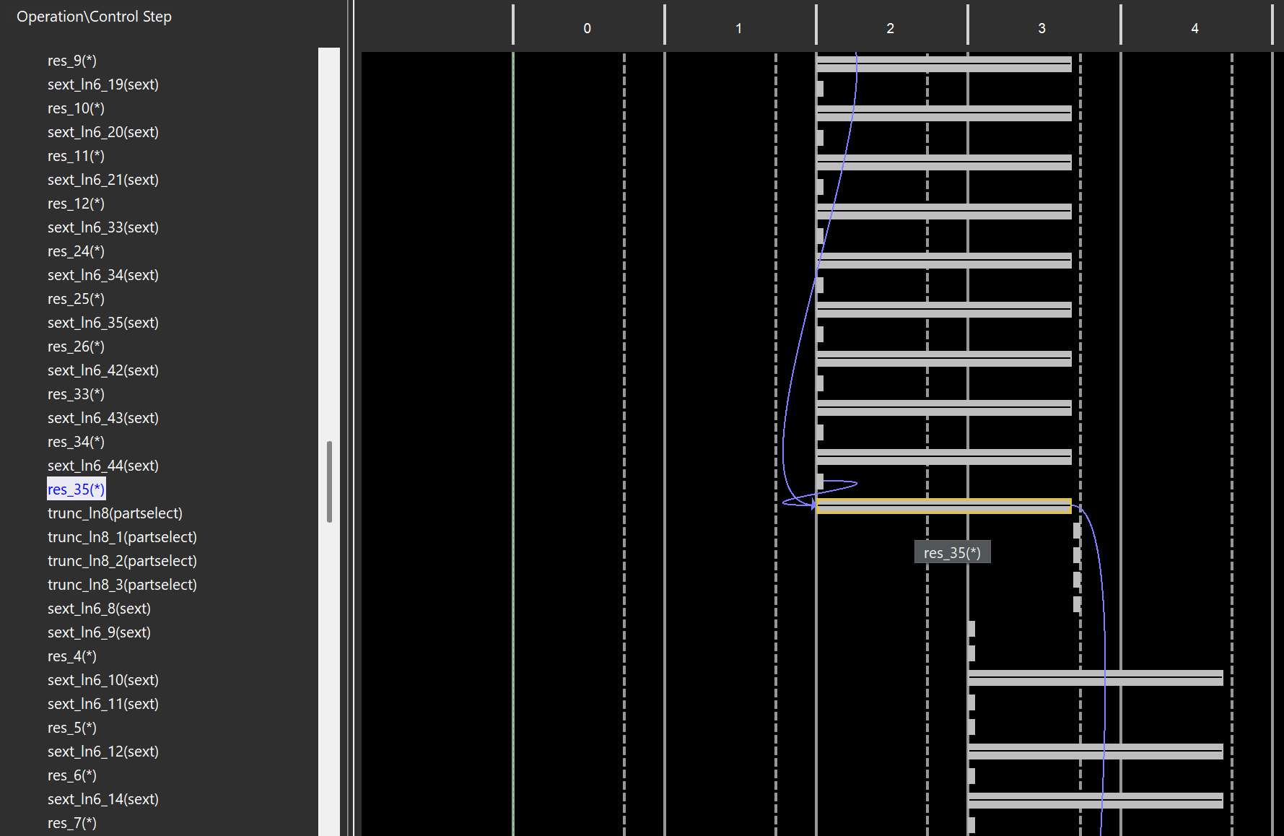
By testing the hardware, the time only passes from 5.032s to 3.174s, which is far from a division of 4, but the multiplication time seems to be divided by 4.

HW6 – Add the “ReLu” and “AddBiases” functions to the HW
Until now, the “AddBiases” and “ReLu” functions are done in the software. We can accelerate them by doing them directly in HW.
To be able to do that, a new register was added on the AXI bus to transmit the biases to the hardware side. This was simply done by testing if the result of the accumulation is negative (by testing the 32nd bit), and
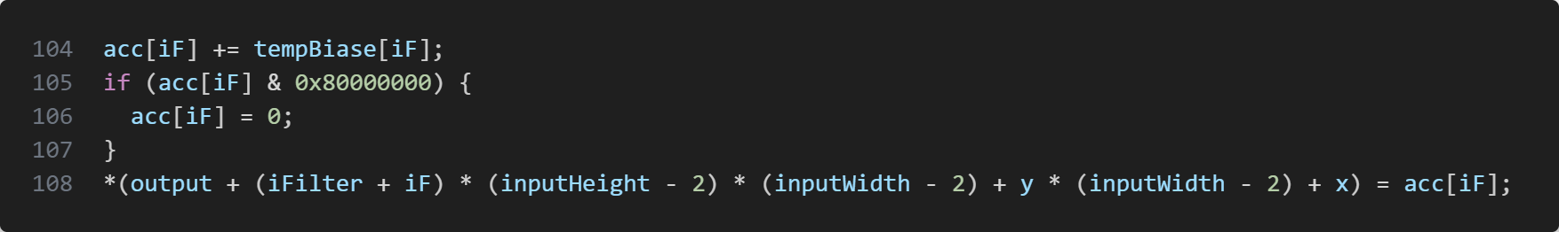
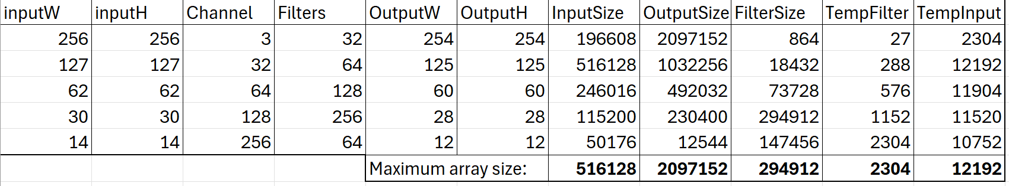
A calculation of all maximum array size of the HLS design was done.

Each maximum array size was then used to define the depth of the AXI bus inside the HLS design.

HW7 – Overlapping data transfers with computation
Another optimization would be to retrieve in the RAM the next input row needed, in same time than doing the computation. To be able to do that, a function was created to retrieve the next data:
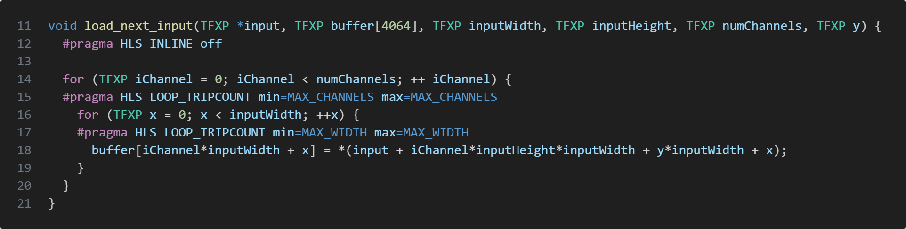
And then inside the loop we call the function with the pragma “DATAFLOW” to parallelize it:
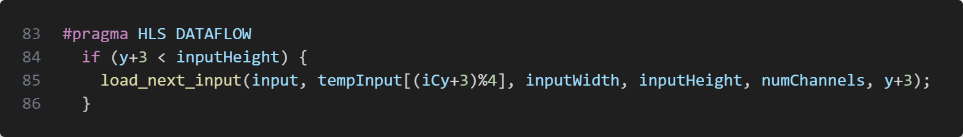
Additionally, we need to partition the tempInput array to write and read the
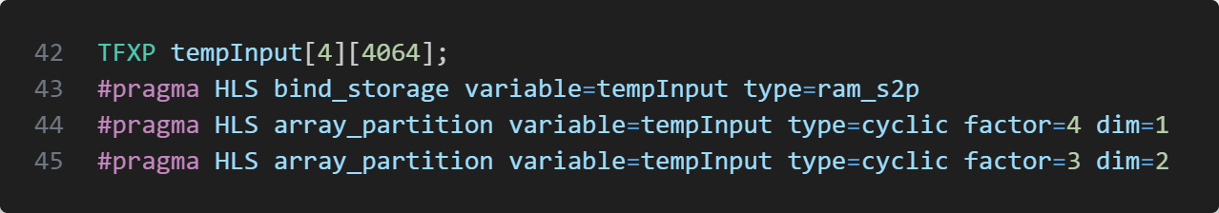
But when I tested with the hardware, the result was correct, but it slowed down a lot (37 seconds). I tried some other things but didn’t find what was the issue.

Results and conclusion
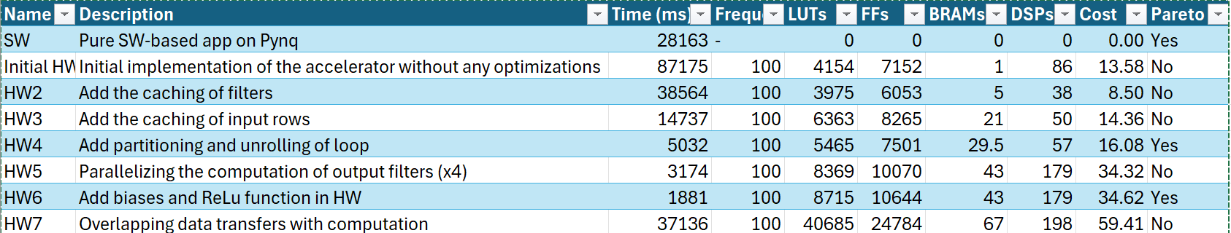
The weird number is the 86 DSPs generated by Vivado for the InitialHW. And then for the HW2 only 38 DSPs were synthesized.
There are therefore 3 pareto design: the software, HW4 and HW6: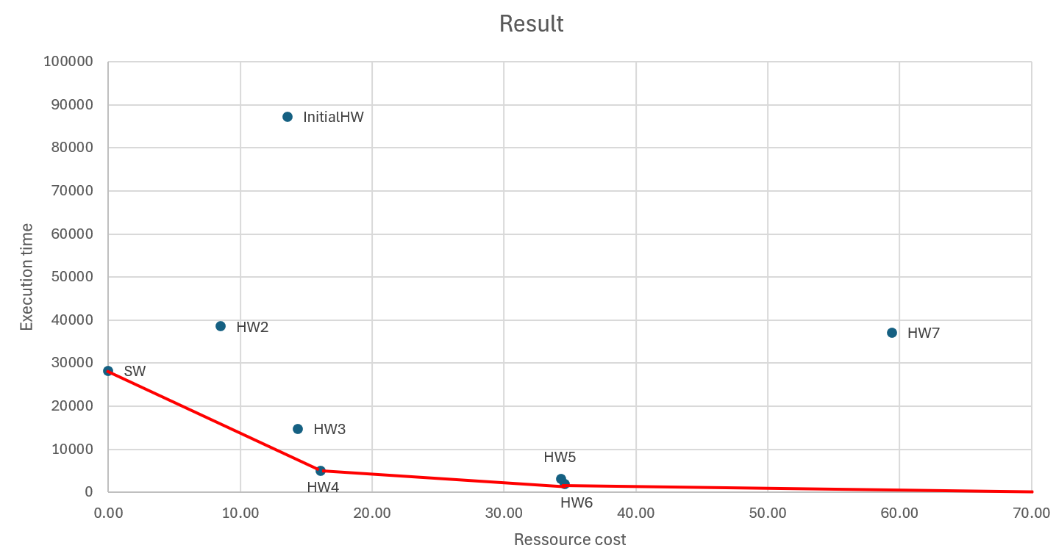
The final design with the HW is 15 times faster than the pure SW version.

