RivalSpace Inc Ship

Technician Handbook

Modules

Each Cockpit ship will include up to X modules that must be Fixed. Each module is independent and can be Fixed in any order. Instructions for repairing modules can be found in Section 1.

"Needy" modules present a special case and are described in Section 2.

Strikes

When the Pilot makes a mistake, the ship will record a strike which will be displayed on the indicator above the countdown timer. Ship will blow upon the third strike, Also every strike will make the countdown faster

Gathering Information

Some repairing instructions will require specific information about the Vehicle, such as the serial number. This type of information can typically be found on the top, bottom, or sides of the cockpit. See Appendix A, B, and C for identification instructions that will be useful in fixing certain modules.

1. **Modules:**

**Wires:**

<boring intro about wires>

Wire module is made of 3 wires, depending on their color user should cut ONLY ONE:

* If there are no green wires, cut the first wire.
* Otherwise, if the last wire is red, cut the second wire.
* Otherwise, if there is more than one blue wire, cut the last blue wire.
* Otherwise, cut the last wire.

**Keypad:**

<boring intro about keypads and occult symbols>

|  |  |
| --- | --- |
| A | B |
| C | D |

Only one column below has all four of the symbols from the keypad, user should press them in order from top to down



**Color 2x2 square:**

One color will flash, depending on it user should press the corresponding one, error will go back to stage 1

If the ship name has an X:

|  |  |  |  |
| --- | --- | --- | --- |
| Red flash | Blue Flash | Yellow Flash | Green Flash |
| Yellow button | Green Button | Red Button | Blue Button |

Else:

|  |  |  |  |
| --- | --- | --- | --- |
| Red flash | Blue Flash | Yellow Flash | Green Flash |
| Blue button | Red Button | Green Button | Yellow Button |

**Morse Code:**

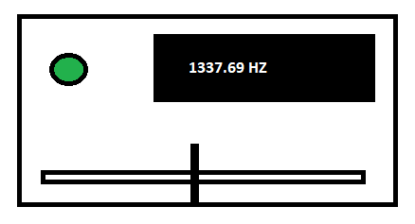

Player must setup a slider at a given frequency based on the word list

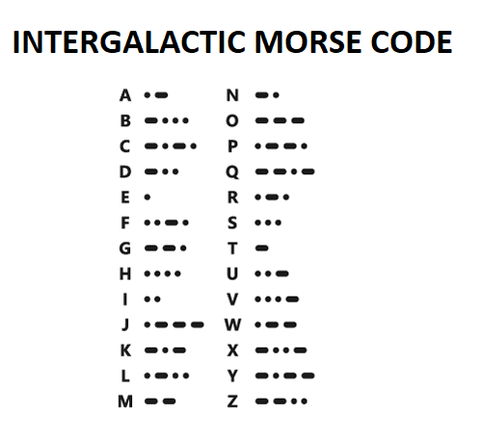

bars : 45

beer: 31

cash: 80

care: 6

cars: 99