Gueris Arriaza

Final Project Documentation

My project is a fantasy league App where you as a user can own a team with their players and simulate games against other players to get a score and see who has the highest score. Each team has an Overall score which determines their rankings and five players in five different positions. These players also have a score which affects the team score and a ranking, ranking players based on their position on the team.

Recursion

In the App class I use recursion to check if the user credentials are valid if so, you move on if not it will ask again.

Array List

In my Excel Reader class, I have two methods that return Array List’s.

Quicksort

Is used to sort through players and return the list.

HashMap

A HashMap is used in my User Verification class to match passwords to user’s

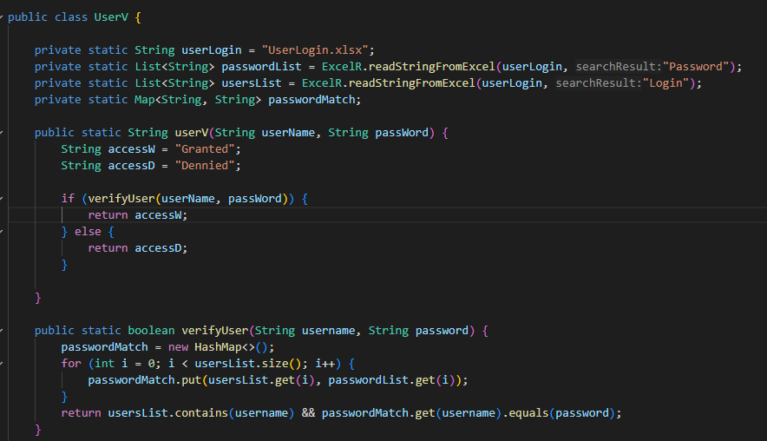

Insertion Sort

Used to sort through teams to make sure all team rankings reflect their overall score.

Binary Search Tree

Created a binary search tree to give players the option to search for a specific player or team.

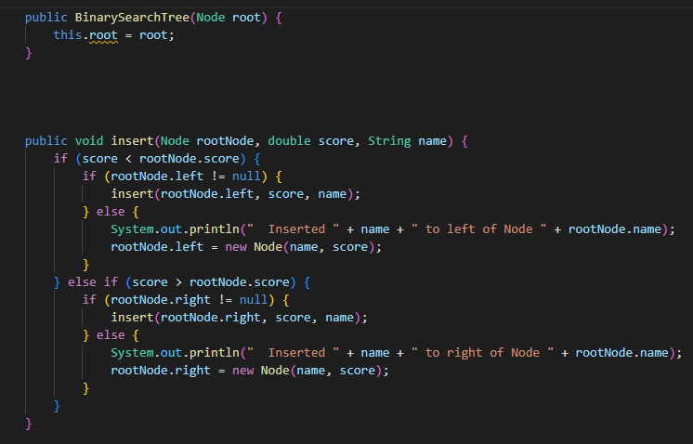

Binary Seach

Is used to search through the binary search tree

