**Exercise on SQLite and Firebase**

**SQLite**

We consider a table *student* with 2 attributes *id* and *name.* **We consider the *query* and *insert* methods of the class *SQLiteDatabase*** (<https://developer.android.com/reference/android/database/sqlite/SQLiteDatabase.html>).

Rename this file into LastNameFirstNameAndroidSQLiteExercise.docx and push it (with the answers) at the root of your GitHub repository for the course.

*IN THE QUESTIONS BELOW, DO NOT USE SQL BUT USE THE PARSE METHOD THAT IS PROVIDED IN JAVA.*

1. How do you write select * from student using the provided *query* method?

StudentDatabaseHelper dbHelper = new StudentDatabaseHelper (this.getActivity ());

SQLiteDatabase db = dbHelper.getWritableDatabase ();

**db.query (”student”, null, null, null, null, null, null);**

1. How do you write select name from student using the provided *query* method?

StudentDatabaseHelper dbHelper = new StudentDatabaseHelper (this.getActivity ());

SQLiteDatabase db = dbHelper.getWritableDatabase ();

**db.query (”student”, name, null, null, null, null, null);**

1. How do you write select * from student where name = ‘Smith’ using the provided *query* method?

StudentDatabaseHelper dbHelper = new StudentDatabaseHelper (this.getActivity ());

SQLiteDatabase db = dbHelper.getWritableDatabase ();

**String [] idArray= {"id"};**

**db.query (“student”, idArray, “name=’Smith’”, null, null, null, null);**

1. How do you write insert into student (id, name) values (10,’John’)?

StudentDatabaseHelper dbHelper = new StudentDatabaseHelper (this.getActivity ());

SQLiteDatabase db = dbHelper.getWritableDatabase ();

**ContentValues values= new ContentValues ();**

**values.put (id, 10);**

**values.put (name,”John”);**

**db.insert (“student”, null, values);**

**Firebase**

Create an application called *FirebaseStudent* that will save the id and first name of a person in a Firebase database when we press *Submit.*

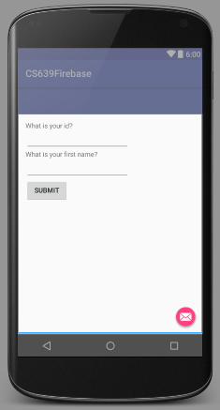

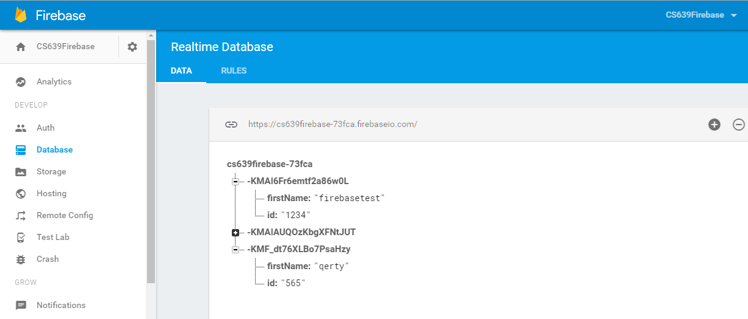

In addition to the project to be pushed in GitHub, push a screenshot of the real time database with data related to your name (see above). We want to be able to see the name of the database and the data.