INTERNSHIP REPORT
ON
DATA SCIENCE MASTER VIRTUAL INTERNSHIP
Industry-oriented learning in Data Engineering, Machine Learning and AI Applications
Submitted
To
School of Computer Science and Engineering
IILM University, Greater Noida, U.P.
In partial fulfilment of the requirement of degree of
B.Tech CSE


BY
Roll No.: 2410030922
Name: G U F R A N A L I
B.Tech CSE | Semester V
Batch: 2024–28 (3CSE12)

CANDIDATE’S DECLARATION
I, GUFRAN ALI, hereby declare that the internship report titled “Data Science Master Virtual Internship” has been prepared by me to fulfil the academic requirement for the award of the degree of Bachelor of Technology in Computer Science and Engineering at IILM University, Greater Noida.
The report presents my learning and practical exposure during the eight-week virtual internship completed during April–June 2026. The technical descriptions and observations included in this report are based on the internship certificate, the learning activities and practical material associated with the internship, and the references listed at the end of the report.
I have acknowledged the sources used in preparing this report and have not knowingly reproduced another person’s work as my own. I understand that I am responsible for the accuracy and originality of the submitted report and for complying with applicable academic and copyright requirements.
Signature: GUFRAN ALI
Student Name: GUFRAN ALI
Roll No.: 2410030922

ACKNOWLEDGEMENT
I would like to express my sincere gratitude to everyone who supported me during the completion of my Data Science Master Virtual Internship. The internship gave me an opportunity to move beyond classroom concepts and work through a structured virtual learning environment focused on data science and practical analytical workflows.
I am thankful to EduSkills Foundation for providing the virtual internship platform and learning structure, and to Siemens for supporting the internship program. I also acknowledge the role of the AICTE and the National Internship Portal ecosystem reflected in the internship completion certificate.
I am grateful to the School of Computer Science and Engineering, IILM University, Greater Noida, for encouraging industry-oriented learning as part of the B.Tech CSE program. I also thank my faculty members and peers for their guidance and discussions during the learning process.
Finally, I express my gratitude to my parents for their constant support and encouragement.
GUFRAN ALI
Roll No.: 2410030922

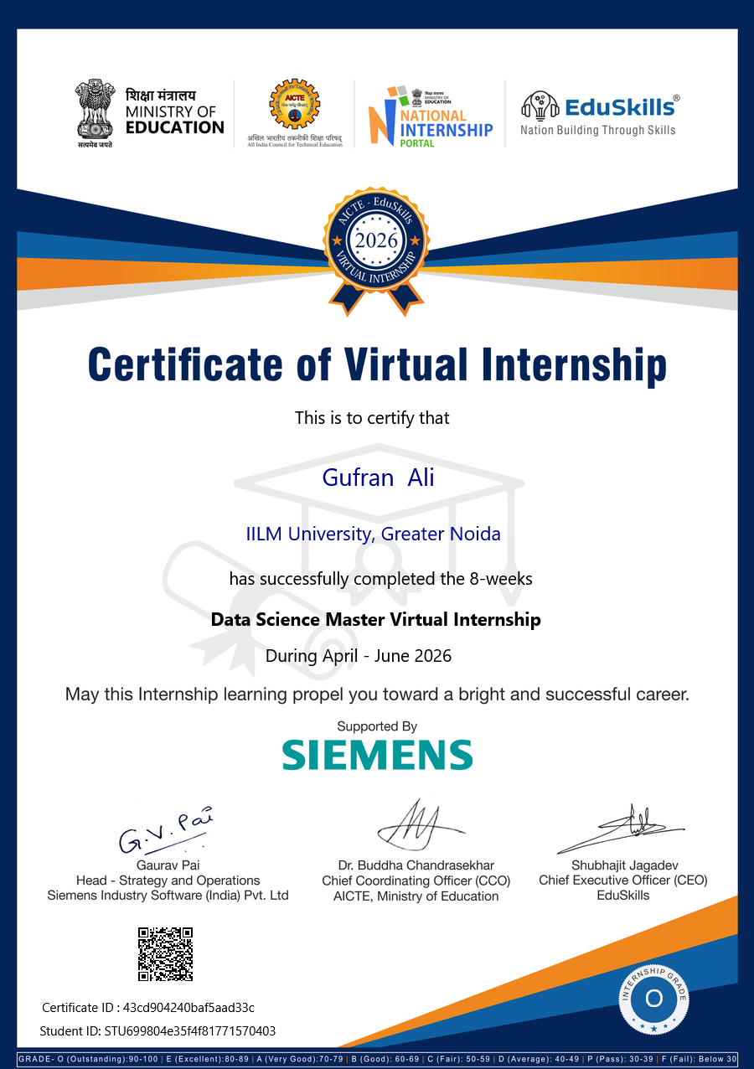
INTERNSHIP COMPLETION CERTIFICATE

TABLE OF CONTENTS
Chapter No. | Chapter Name | Page No.
1. | Candidate’s Declaration | i
2. | Acknowledgement | ii
3. | Internship Completion Certificate | iii
4. | Project Description | 1
4.1 | Introduction | 1
4.2 | Organization Profile | 2
4.3 | Problem Statement | 3
4.4 | Project Objectives | 3
4.5 | Scope of the Project | 4
4.6 | Technologies and Tools Used | 5
4.7 | System Architecture | 6
4.8 | Methodology | 7
4.9 | Expected Outcomes | 9
4.10 | Certificates of Completion and Communication Proof | 10
5. | Bibliography / References | 11

LIST OF FIGURES
Figure 4.1 Data Science Internship Workflow
Figure 4.2 Practical Data Science Architecture

LIST OF TABLES
Table 4.1 Internship at a Glance
Table 4.2 Technology and Tool Summary
Table 4.3 Expected Learning Outcomes
4. PROJECT DESCRIPTION
4.1 Introduction
The Data Science Master Virtual Internship was an eight-week learning experience completed during April–June 2026 through the EduSkills virtual internship platform, with the program supported by Siemens. The internship certificate issued to the student records successful completion of the program at IILM University, Greater Noida. The certificate also records the internship as an eight-week Data Science Master Virtual Internship and awards Grade O (Outstanding).
The purpose of the internship was to develop practical familiarity with the data science lifecycle rather than treating data science as a collection of isolated algorithms. The learning process therefore connected data preparation, exploratory analysis, modelling, validation and interpretation. Practical exercises in the associated visual data-science environment reinforced the idea that a useful model depends not only on the algorithm but also on the quality and structure of the data entering it.
The internship was particularly relevant to a B.Tech CSE curriculum because it brought together programming, databases, statistics, machine learning and software workflow concepts in one applied setting. The experience also provided a clearer view of how data moves from a raw dataset to a form in which analytical or predictive methods can be applied.
Table 4.1 Internship at a Glance
Parameter | Details
Internship title | Data Science Master Virtual Internship
Duration | 8 weeks
Period | April – June 2026
Mode | Virtual
Delivery platform | EduSkills Foundation
Industry support | Siemens
University | IILM University, Greater Noida
Program | B.Tech Computer Science and Engineering
Semester | V
Student ID | STU699804e35f4f81771570403
Certificate result | Grade O – Outstanding (90–100)

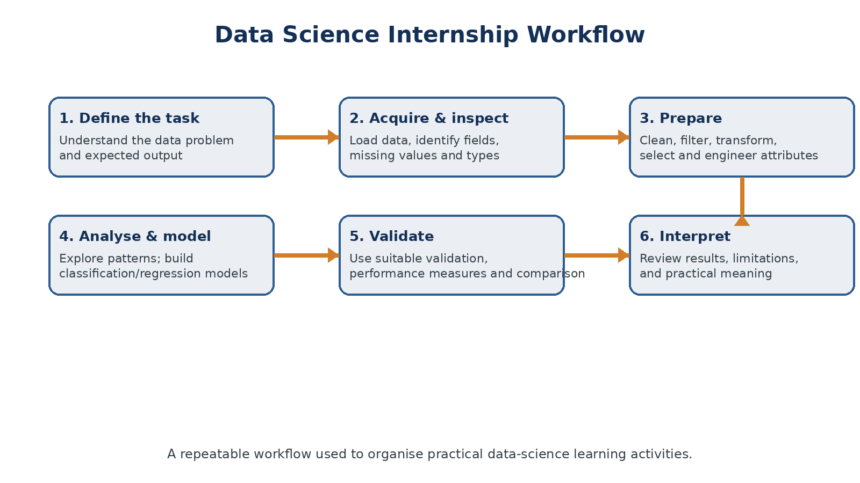
Figure 4.1 Data Science Internship Workflow
Figure 4.1: A consolidated view of the practical data-science workflow used to organise the internship learning activities.
4.2 Organization Profile
EduSkills Foundation is a not-for-profit organization focused on building an Industry 4.0-ready digital workforce in India. Its stated approach is to bridge the gap between academia and industry by connecting students, faculty members, educational institutions and industry-oriented skilling initiatives. EduSkills also operates an AICTE–EduSkills virtual internship ecosystem, which provides students with structured exposure to technology domains.
Siemens is a technology company with major activities in Digital Industries, Smart Infrastructure and Mobility. Its Digital Industries business explicitly combines data, software, automation and industrial AI to support digital transformation and decision-making. This industry context is relevant to a data science internship because it demonstrates where data-driven methods fit within larger digital systems.
For this internship, the roles of the two organisations are best understood as complementary: EduSkills provided the virtual learning and internship delivery environment, while Siemens supported the internship program. The certificate supplied with this report visually records the participation of the Ministry of Education, AICTE, National Internship Portal, EduSkills and Siemens.
4.3 Problem Statement
A major challenge for a student learning data science is the gap between understanding individual concepts and applying them as a connected workflow. Knowing what classification, regression, data transformation or model validation means is not sufficient unless the learner can decide when to use each step, prepare the input data correctly and interpret the resulting output.
The internship therefore addressed the practical problem of developing a repeatable approach for turning datasets into meaningful analytical results. The focus was not limited to a single algorithm; instead, the learning process emphasised data preparation, workflow construction, model building, validation and interpretation.
4.4 Project Objectives
• Understand the stages of an end-to-end data science workflow and the relationship between them.
• Develop practical skills in preparing, filtering, transforming and selecting data attributes.
• Gain exposure to classification, regression, validation and model-comparison workflows.
• Understand how feature preparation and data quality influence model performance.
• Learn to interpret analytical outputs rather than treating model results as final answers without context.
• Develop disciplined habits for documenting a reproducible analytical process.
• Relate data-science techniques to the broader software and engineering concepts studied in B.Tech CSE.
4.5 Scope of the Project
The scope of this internship report is the technical learning and practical exposure obtained through the Data Science Master Virtual Internship. It covers the major workflow stages encountered during the internship and documents the tools, techniques and learning outcomes that can be reasonably supported by the available internship material.
The practical scope includes data inspection and preparation, transformation and filtering, exploratory analysis, supervised learning concepts, model validation and performance comparison. The associated learning material also exposes the learner to visual process design, feature handling, text processing, and the interpretation of model outputs.
The report does not claim ownership of a proprietary industrial dataset or a production system. The exercises are treated as training and applied-learning activities. This distinction is important because a virtual internship can provide industry-aligned exposure without implying that the student worked on confidential Siemens production data.
4.6 Technologies and Tools Used

Technology / Tool | Role in the Internship | Learning Focus
Python / Python-based data science concepts | Programming and analytical thinking | Data handling, modelling concepts and automation
RapidMiner / Altair AI Studio ecosystem | Visual data-science workflow design | Data preparation, modelling, validation and process organisation
Machine Learning methods | Predictive analysis | Classification, regression, feature engineering and evaluation
Data visualisation | Result interpretation | Patterns, trends and model-performance views
Structured datasets | Practical input | Transactions, examples and tabular records used for exercises
Web / virtual learning platform | Internship delivery | Online assessments, learning material and completion tracking

The practical material associated with the internship includes visual workflow exercises covering data transformation, filtering, aggregation, classification and regression, as well as model validation and performance comparison. The RapidMiner Academy documentation describes the same general learning structure through the areas of Applications & Use Cases, Machine Learning, Data Engineering, and Administration and Deployment.
4.7 System Architecture
The internship can be represented as a layered analytical architecture rather than as a conventional software application. Data enters through structured datasets, is prepared and transformed, then moves into analysis and modelling. The resulting models are validated and compared before the learner interprets the output and documents the workflow.
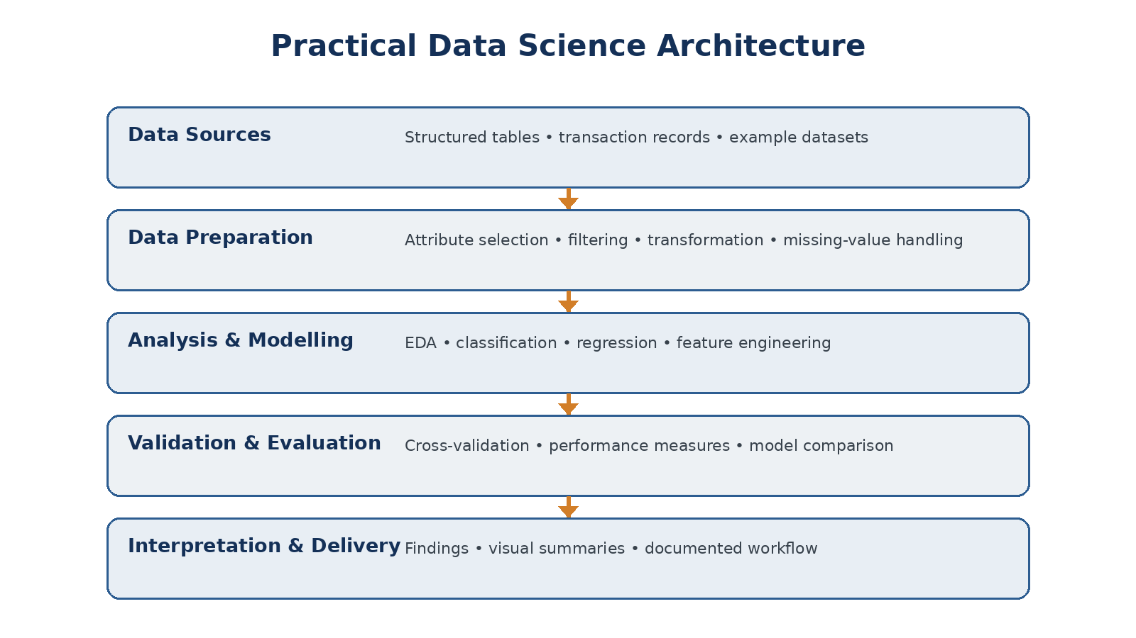
Figure 4.2: Layered architecture representing the practical data-science workflow used during the internship.
4.8 Methodology
The methodology followed during the internship was iterative. A dataset was first understood in terms of its attributes, types and quality. The next stage was preparation, where irrelevant or unsuitable attributes could be filtered, values transformed and the dataset reshaped for analysis. Once the input was suitable, analytical or predictive methods could be applied.
For supervised learning activities, the workflow progressed from selecting a target and relevant attributes to training a model and evaluating it on appropriate validation output. The practical material also demonstrates model comparison, including classification-error and ROC-curve views. This helped reinforce the difference between simply building a model and assessing whether the model is useful.
An important part of the methodology was process organisation. Visual workflow tools make individual operations explicit, allowing the learner to inspect the sequence of transformations and understand how one operator’s output becomes the next operator’s input. This makes the workflow easier to reproduce, explain and modify.
• Requirement understanding – identify the analytical question and expected result.
• Data inspection – review attributes, data types, missing values and general structure.
• Data preparation – filter, transform, select, aggregate or reshape attributes as required.
• Exploration – inspect patterns and relationships before modelling.
• Model construction – apply an appropriate classification or regression approach.
• Validation – use a suitable validation strategy and examine performance measures.
• Comparison – compare alternative models or process choices where relevant.
• Interpretation – connect the output to the original analytical objective and document limitations.
4.9 Expected Outcomes

Outcome | Evidence / Learning Activity | Value for B.Tech CSE
Data preparation skill | Filtering, attribute selection, transformation and aggregation exercises | Connects data handling with programming and database concepts
Machine learning workflow understanding | Classification, regression, validation and model comparison | Strengthens AI/ML foundation
Analytical thinking | Interpreting data and performance outputs | Improves problem-solving and reasoning
Visual workflow design | Operator-based process construction | Builds understanding of modular computational pipelines
Evaluation discipline | Performance views and validation workflows | Encourages evidence-based model selection
Professional documentation | Structured report and presentation | Improves communication of technical work

The completion certificate provides a direct outcome of the internship: successful completion of the eight-week program with Grade O (Outstanding), corresponding to the 90–100 range printed on the certificate. Beyond the grade, the principal outcome is a more connected understanding of the data science lifecycle and the ability to reason about data preparation, modelling and evaluation as parts of one process.
4.10 Certificates of Completion and Communication Proof
A copy of the internship completion certificate is attached in this report. The certificate identifies GUFRAN ALI, IILM University, Greater Noida, and records successful completion of the eight-week Data Science Master Virtual Internship during April–June 2026. It also identifies Siemens as the supporting organisation.
The university format requires certificates of completion and other communication-mail proof to be attached. The available material supplied for this report contains the completion certificate but does not contain an internship communication email. No email has been fabricated for this report. If required by the evaluator, the original selection/offer/completion email can be appended after this page.
COMMUNICATION MAIL PROOF
Attach the original internship selection / offer / completion communication here if required by the evaluator.

5. BIBLIOGRAPHY / REFERENCES
[1] Internship completion certificate issued for GUFRAN ALI, Data Science Master Virtual Internship, April–June 2026. Provided as part of the internship documentation.
[2] IILM University, School of Computer Science and Engineering, “Internship Report Format updated 26-27,” supplied document used for report structure and formatting requirements.
[3] EduSkills Foundation, “About – EduSkills Foundation,” official website. https://eduskillsfoundation.org/index.php/about/
[4] Siemens, “India Investor Relations – Siemens Limited India,” official website. https://www.siemens.com/en-us/company/investor-relations-india/
[5] Siemens, “Digital Industries,” official website. https://www.siemens.com/en-us/company/about/businesses/digital-industries/
[6] Altair RapidMiner Academy, “Machine Learning and RapidMiner Tutorials,” official learning platform. https://academy.rapidminer.com/
[7] Altair, “AI Studio Academic Hub,” official academic resource. https://web.altair.com/academic-hub-ai-studio
[8] Selected practical screenshots and learning material from the internship-related files, created with the help of image processing artificial intelligence agents, used only to describe the technical learning activities represented in the report.

