**PROJECT DOCUMENTATION**

**RECKLESS DRIVING DETECTION SYSTEM**

**GROUP MEMBERS:** GUFRAN BHATTI (64386), SARIM AMIR (63686), ABDUL BARI (10233)

1. **CORE PROPERTIES:**

**NETWORK:**

Our system cannot be used without the internet. We want our system to notify the reckless driving of a person’s car and also the location.

**DISTRIBUTED:**

There is only one user interface (car panel) but at the backend, many machines are operating like message sending, location, sensors, and alerts.

**TRANSPARENCY:**

Because users don’t know how the backend work means users don’t know how the actual system performs multiple tasks like sending messages/location or many tasks

**AUTONOMOUS:**

Our system can automatically sense and perform their task according to the situation.

**CONTEXT-AWARE:**

It is context-aware because it can identify who is driving, when to send notifications and when to alert.

**HCI:**

In this system, HCI is minimum because the car panel which only has one interface can perform multiple tasks.

**INTELLIGENT:**

Our system checks the user means the driver. If the driver is a child, it performs the task. When a driver is an adult person there don’t need to send a notification to parents only alert the driver.

1. **CONTEXT ENVIRONMENT:**

**IDENTIFYING RELEVANT CONTEXT:**

In our system, the environment is human and physical both. Physical because we measure physical quantities like acceleration and longitude/latitude. And human because it is for humans to prevent reckless driving.

**SPECIFYING CONTEXT-AWARE BEHAVIOUR:**

1) Identifying who is driving the car

2) Calculate the acceleration of the car through the accelerometer

3) Location of car

4) Sending alerts to parents

**INTEGRATING WITH MECHANISM FOR ACQUISITION OF CONTEXTUAL INFORMATION:**

1) If a person drove recklessly notify their parents

2) If a person drove recklessly alert the car and send location to their parents

1. **CATEGORIES OF CONTEXT:**

To make our system context-aware we will fill all five categories of context

1. **Physical:** Speed, acceleration, location, gyro-sensitivity
2. **Computing:** Connected to the internet
3. **User context:** When a person starts the engine our system will identify who is driving the car
4. **Temporal:** Note the time when the engine is turned on until the engine is turned off again
5. **Structural:** Record the average speed of the user and maintain it along with routes that he was previously driven to
6. **NATURE OF CONTEXT:**

* Active (Because our system will perform action according to the context)

1. **NATURE OF ENVIRONMENT:**

**PHYSICAL ENVIRONMENT:**

Because here we measure physical quantities like acceleration, speed, longitude/latitude, etc.

**HUMAN ENVIRONMENT:**

Because it is for humans to prevent reckless driving.

1. **DESIGNING THE UBIQUITOUS SYSTEM:**

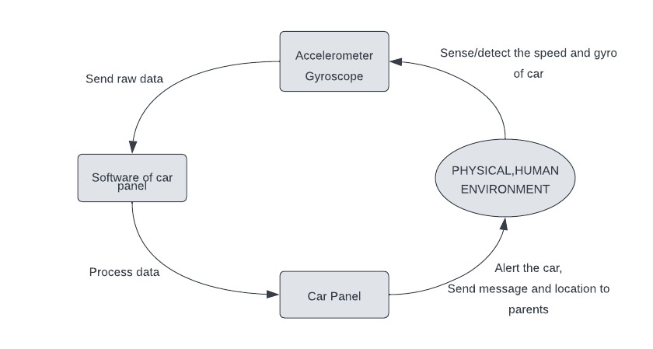

1. **SENSORS USED:**

**PHYSICAL SENSORS:** Accelerometer, Gyroscope.

1. **ELEMENTS OF IOT:**

**THINGS:** Accelerometer and gyroscope as sensors, car panel as actuator and smart device.

**GATEWAY:** Since LTE technology is used, the cellular towers will be used as gateways.

**INTERNET:** LTE technology.

**APPLICATION:**  Our application will run in the background of android in car panel.

1. **IMPLICIT INTERACTION FRAMEWORK:**

**ABSTRACTION AUTOMATION:** Our project lies in the third quadrant of implicit interaction framework. It is reactive and runs in the background (person unaware, system initiates). It is reactive because our system detects reckless driving and for that the driver first had to drive reckless if our system wants to alert. Since it runs in the background, the person is unaware and system initiates the software.