Cassandra

Nosql database
Stores values in the form of key value pairs
Highly robust because works in the principle of clustering (no master/slave concept) there is no constant master so whenever you query Cassandra cluster you get data from one of the nodes and you can configure them under your wish(by number of nodes per data)

Architecture

There are rings in the cluster, basically each node is connected to each other.
So, when a request comes to the cluster it hits one of the nodes and it processes the request.
For ex, you are writing something onto the db, so that particular node gets the data and then it writes onto the db on its own node.
Concept of gossip
That node tells the other nodes “Ok I got the data and I have updated”.
Essentially inside Cassandra nodes communicate with each other through the form of gossiping.
And even though the cluster is connected with 10 nodes you can define how many nodes that particular data can be replicated to.
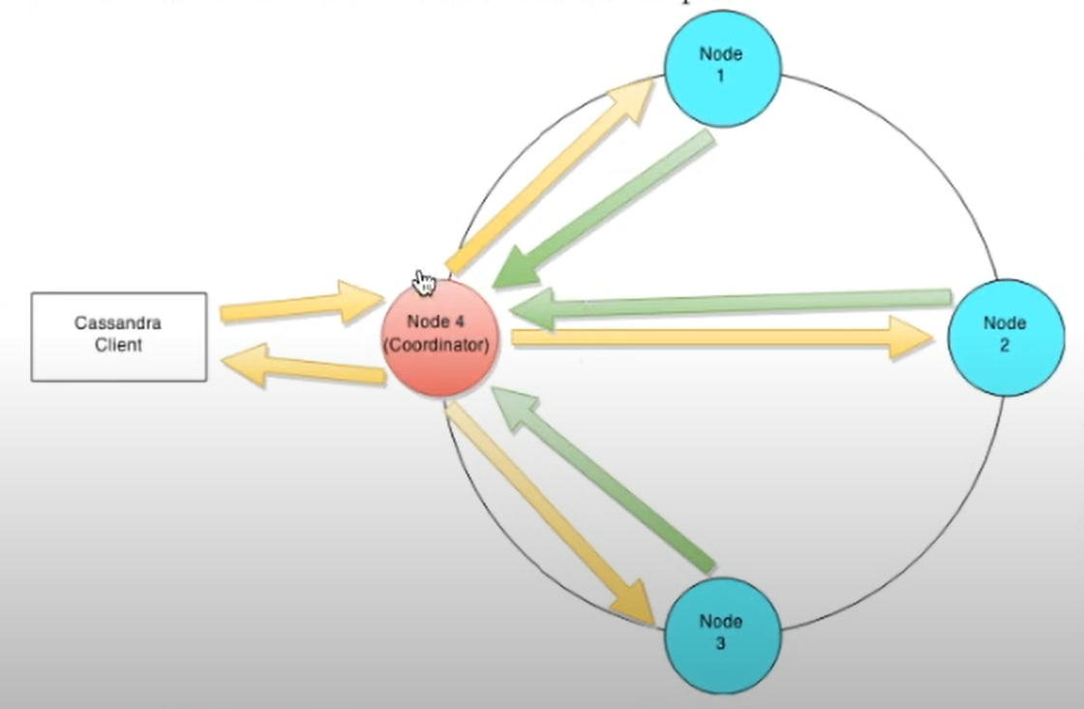

Main reason why people are using Cassandra → is very fast in writing data because of the clustering concept. (You write in one node and that node gossips with other nodes)

How does nodes work?
Write operations at a node level.
Whenever you write something it goes to the commit log and the memory table and from it the data gets flushed onto the disk so that is the SS table so the data get flushed out of the disk and that is where index and keys are getting created and gets posted onto the disk.
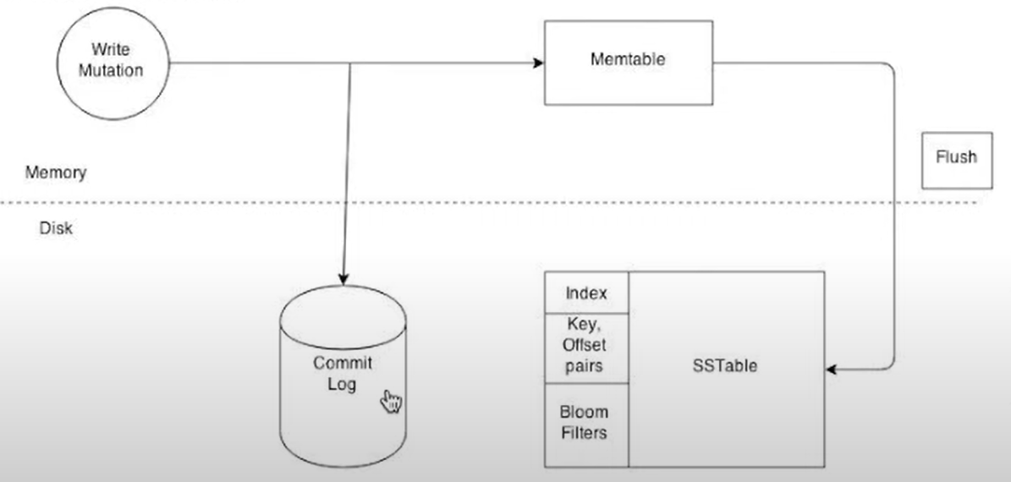

The read has a similar concept, you just get the data, it doesn’t go to the commit log but it can directly take it from the SS table and the it pushes to the memory table and from the mem table it takes T subsequent values.

Cassandra Key space → is the Schema
Inside it you can have column family which is nothing but a table structure. You can have multiple columns and inside each you have a key column name and a value and that is how they are mapped. Inside each column you can have a a key column name and value. You can have unstructured data inside the column family → one row can have four cols the next row can have only two.

What is the technology? https://www.tutorialspoint.com/cassandra/cassandra_introduction.htm
Apache Cassandra is a highly scalable, high-performance distributed database designed to handle large amounts of data across many commodity servers, providing high availability with no single point of failure. It is a type of NoSQL database.
Apache Cassandra is an open source, distributed and decentralized/distributed storage system (database), for managing very large amounts of structured data spread out across the world. It provides highly available service with no single point of failure.
Listed below are some of the notable points of Apache Cassandra −
- It is scalable, fault-tolerant, and consistent.
- It is a column-oriented database.
- Its distribution design is based on Amazon’s Dynamo and its data model on Google’s Bigtable.
- Created at Facebook, it differs sharply from relational database management systems.
- Cassandra implements a Dynamo-style replication model with no single point of failure, but adds a more powerful “column family” data model.
What type of applications use the technology?
- Used in web based applications that serve large number of clients and the quantity of data processed is web-scale (Petabyte) large
  - Denormalization of data benefits if large tables need to be joined, which slows down querying, or business structure that requires retention
- Cassandra is being used by some of the biggest companies such as Facebook, Twitter, Cisco, Rackspace, ebay, Twitter, Netflix, and more.
- a. Cassandra Storage
  - One of the major applications of Cassandra is storage. The broad coverage of Cassandra enables the user to store any kind of data. This data is stored in various nodes that Cassandra provides. Cisco WebEx, InWorldz, Formspring, OpenX are some companies using Cassandra for storage.
- b. Back-end development applications
  - Users can also use Cassandra for back-end development of their applications. Many software and applications have front-end and back-end. Cassandra provides a wide platform for the development of the back-end. It also provides a huge database of the data. Talentica software uses back-end for analytics.
- c. Cassandra Monitoring
  - Many applications are based on a wide scale of user activity. Developers can also use Cassandra to monitor the user activity. This user activity can be based on the different parameter, media, art, music etc. CERN, Cloudkick and many such companies use Cassandra monitoring.
- d. Time-series-based applications
  - Time-series-based applications are basically the applications in real time. These applications include hits on the internet browser, traffic light data, GPS location tracking data etc. These applications require heavy write systems. Cassandra is best for these kinds of applications.
- e. Cassandra Analytics
  - Cassandra provides a platform to analyse data collected from various sources. These sources may include social media, product feedback catalogues, retail inputs and lookups. Developers can use Cassandra to retrieve and analyse this data. Ooyala is using Cassandra Analytics applications.
- f. Cassandra Messaging
  - Nowadays, people use messaging services all the time. This eventually, demands a need for a platform to manage these message data. Therefore, Cassandra acts as a platform for the message providers for their database management.

What kind of data does it store? https://www.simplilearn.com/tutorials/big-data-tutorial/cassandra-data-model

Some of the features of Cassandra data model are as follows:
- Data in Cassandra is stored as a set of rows that are organized into tables.
- Tables are also called column families.
- Each Row is identified by a primary key value.
- Data is partitioned by the primary key.
- You can get the entire data or some data based on the primary key.
- Cassandra data model provides a mechanism for data storage. The components of Cassandra data model are keyspaces, tables, and columns.

Keyspaces
- Cassandra data model consists of keyspaces at the highest level. Keyspaces are the containers of data, similar to the schema or database in a relational database. Typically, keyspaces contain many tables.

Tables
- Within the keyspaces, the tables are defined. Tables are also referred to as Column Families in the earlier versions of Cassandra. Tables contain a set of columns and a primary key, and they store data in a set of rows.

Columns
- Columns define the structure of data in a table. Each column has an associated type, such as integer, text, double, and Boolean.

Keyspaces
As mentioned earlier, keyspaces in Cassandra are similar to the schema in a relational database. Some of the features of keyspaces are:
- A keyspace needs to be defined before creating tables, as there is no default keyspace.
- A keyspace can contain any number of tables, and a table belongs only to one keyspace. This represents a one-to-many relationship.
- Replication is specified at the keyspace level. For example, replication of three implies that each data row in the keyspace will have three copies.
- Further, you need to specify the replication factor during the creation of keyspace. However, the replication factor can be modified later.

Tables
A table contains data in the horizontal and vertical formats, referred to as rows and columns respectively. Some of the features of tables are:
- Tables have multiple rows and columns. As mentioned earlier, a table is also called Column Family in the earlier versions of Cassandra.
- It is still referred to as column family in some of the error messages and documents of Cassandra.
- It is important to define a primary key for a table.

Columns
Column represents a single piece of data in Cassandra and has a type defined.
Some of its features are:
- Columns consist of various types, such as integer, big integer, text, float, double, and Boolean.
- Cassandra also provides collection types such as set, list, and map.
- Further, column values have an associated time stamp representing the time of update.
- This timestamp can be retrieved using the function writetime

