[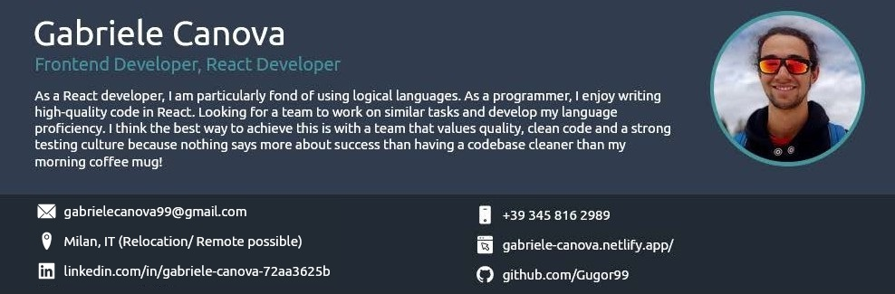](https://gabriele-canova.netlify.app/)

# TECHNICAL SKILLS CERTIFICATES

**Front End**

### JavaScript (ES6+), Vue.js, HTMLS, CSS3, JSON, Webpack, Vite, Figma

**Back End**

### REST, Node, Firebase

**Principles & Methodologies**

### Responsive Design, Agile, Scrum

**Testing & Other**

Git, Vscode, Netlify, Graphic Design

# EDUCATION

**Frontend Developer**

Scrimba

*01/2023* • *12/2023*

**LANGUAGES**

## Scrimba (01/2023 - 12/2023)

*Frontend Developer Career Path*

# PERSONAL PROJECTS

## Quizzcall

* Web App built with React using APls
* <https://quizzle-react-gaby.netlify.app/>

## FirebaseGrocer

* JavaScript-powered Web App with Firebase for real-time updates
* <https://grochery-list-gaby.netlify.app/>

## VansLife

* Web App made with React Router with mock authentication and robust error handling
* <https://vans-life-react-gaby.netlify.app/>

## Tenzies

* Web Game built with React replicating the rules of the classic game
* <https://tenzies-reac-gaby.netlify.app/>

## Twimba

* Web App built with Javascript simulating the popular social media

### Italian

*Native or Bilingual Proficiency*

### Spanish

*Professional Working Proficiency*

### English

*Full Professional Proficiency*

### French

*Elementary Proficiency*

experience

* <https://twimba-gaby.netlify.app/>