Arrays

* An array is a group of variables of the same type that are referred to by the same name
* Each piece of data in an array is known as an array element
* An example of an array would be

* The top row is filled with indices, each element in an array is refreced by an index.
* The bottom row are the values at each index
* This array is a visual representation of an integer array
* We use arrays so that multiple data items of same data type can be accessed using a single name

# Disadvantages

* We must know how many elements in the array we will need before we make the array
* Not all indexes are used, and results in unused memory.

# Using Arrays (Java)

* We can create arrays
* We can modify/update the value at different indices in the array
* We can read the value at different indices in the array
* We can use loops to iterate through every element (value in an array)

**JAVA EXAMPLES**

* int[] array= new int[5]; //initializes an array of size 10
* array[1]; //Reads the value of the array at index 1 (in example above would be 19)
* The statement above doesn’t do anything in Java but by reading the value at an index, we can use it for other purposes
* int num = array[1]; //initialize and set integer num to the value at index 1 of the array (19)
* array[1]++; //increase the value at index 1 of the array by 1 (so now array[1]=20)

# Worst Case Time Complexity

* Accessing an element: O(1)
* Inserting an element (if array is full, n elements copied to bigger array): O(n)
* Deleting an element (must traverse through array to find value to delete): O(n)

# Useful Knowledge for Array Problems

**Swapping Elements in an Array**

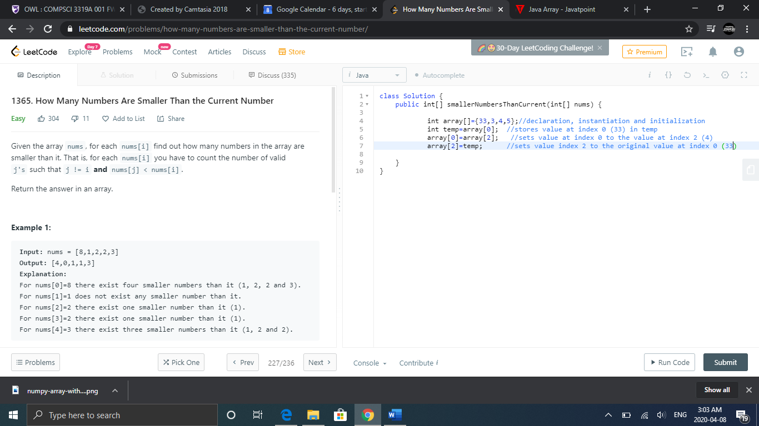

After this code…

array =[4,3,33,5]